График добавлен. 2019-05-10 13:03:34

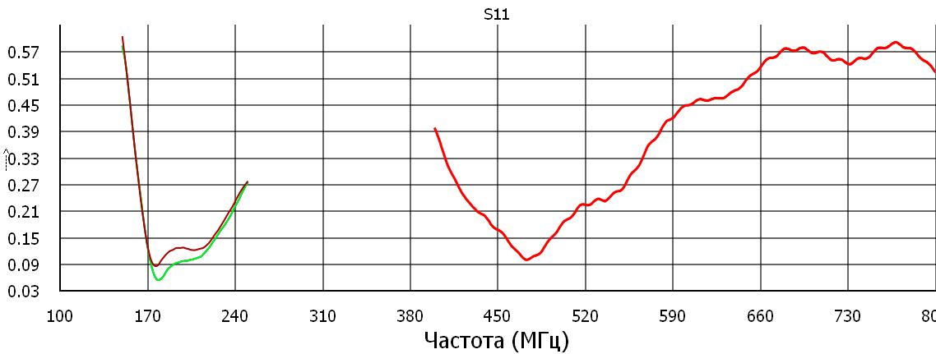

D:/opencv/Python/stend/s1p.s1p

s68.s2p

s69.s2p

s78.s2p

График добавлен. 2019-05-10 13:25:01

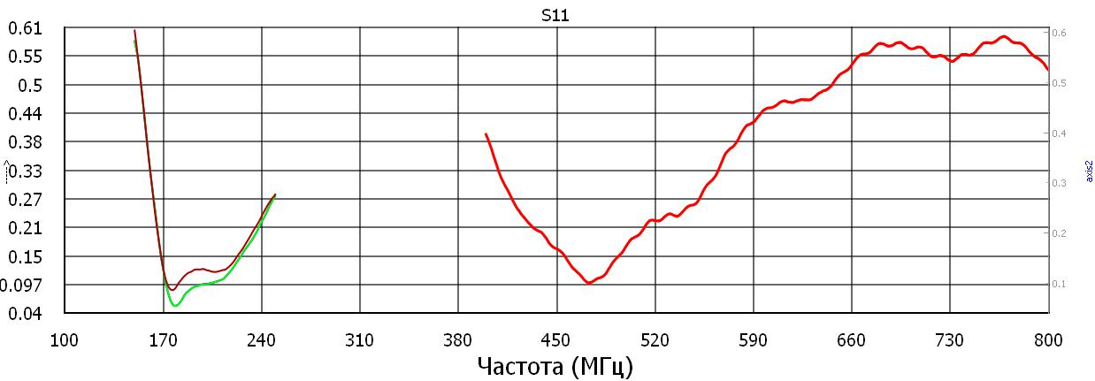

D:/opencv/Python/stend/s1p.s1p

s68.s2p

s69.s2p

s78.s2p

График добавлен. 2019-05-10 13:45:36

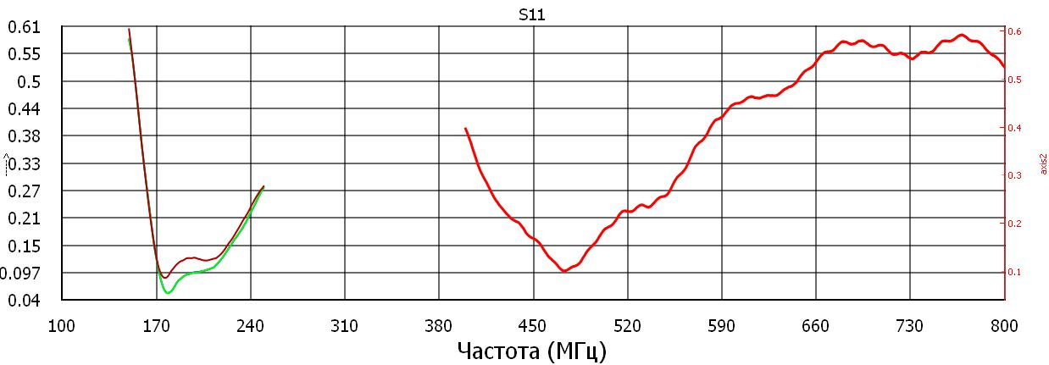

D:/opencv/Python/stend/s1p.s1p

s68.s2p

s69.s2p

s78.s2p

График добавлен. 2019-05-10 13:46:26

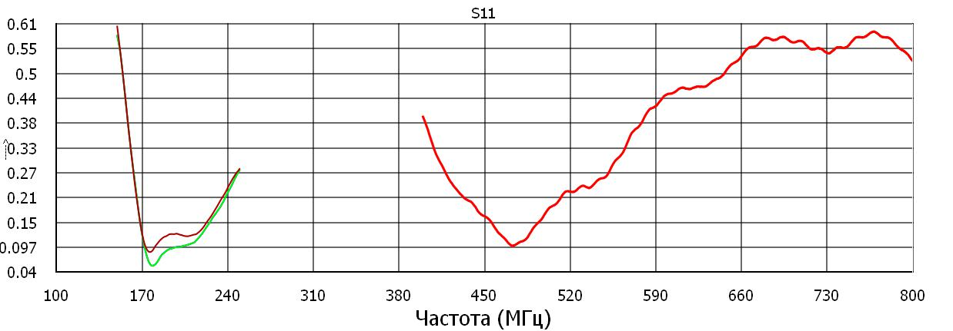

D:/opencv/Python/stend/s1p.s1p

s68.s2p

s69.s2p

s78.s2p

График добавлен. 2019-05-10 14:08:42

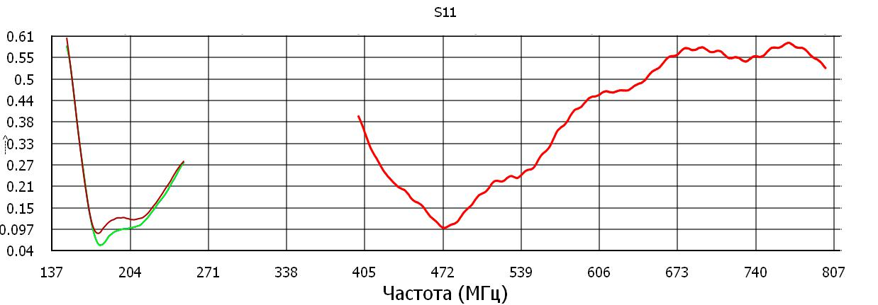

D:/opencv/Python/stend/s1p.s1p

s68.s2p

s69.s2p

s78.s2p

График добавлен. 2019-05-10 14:10:56

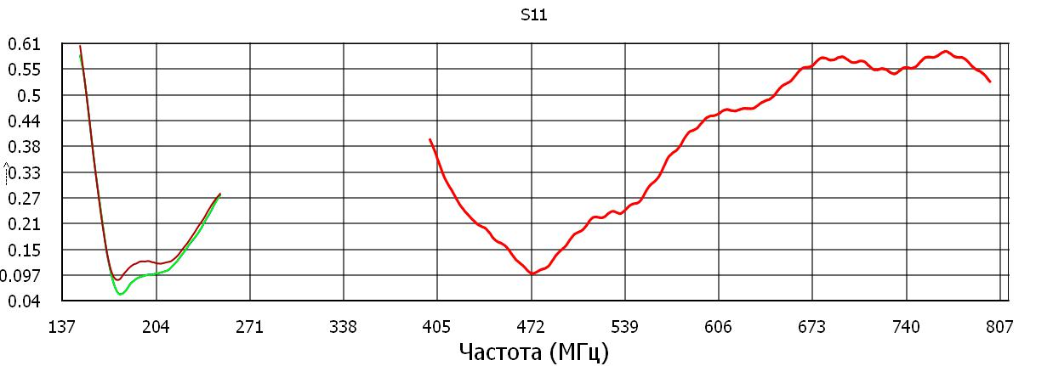

D:/opencv/Python/stend/s1p.s1p

s68.s2p

s69.s2p

s78.s2p