FACE RECOGNITION
ATTENDANCE SYSTEM
Second-Year Computer Science Engineering Project
Technology Stack: Python, Tkinter, SQLite, OpenCV Haar Cascade and LBPH
Platform: Windows with Python 3.11+
Project Type: Desktop-based Automated Attendance System
Submitted as a mini project for the Second-Year Computer Science Engineering curriculum.

Certificate and Declaration
This report presents the design and implementation of the Face Recognition Attendance System, a desktop application developed as an educational Computer Science Engineering project. The work demonstrates local database design, graphical user interface development, computer vision, and software testing using Python.
The system is intended for controlled academic demonstrations. It captures student face samples with consent, trains a local LBPH recognizer, and records attendance without requiring a cloud service.

Academic Integrity Statement
The implementation is modular and the documentation explains the purpose of each component, the design choices, known limitations, and the tests that should be performed before a classroom demonstration.

Student Signature: ____________________
Faculty Guide Signature: ____________________

Acknowledgement
The project acknowledges the guidance normally provided by department faculty, the support of classmates who assist with testing, and the open-source Python and OpenCV communities whose tools make hands-on computer vision education accessible.

Abstract
Manual attendance is slow, repetitive, and vulnerable to proxy marking or transcription mistakes. This project implements a local Face Recognition Attendance System that registers a student, captures face images through a webcam, trains an OpenCV LBPH model, recognizes faces in real time, and automatically records Present status in an SQLite database.
The application uses a Tkinter interface so it can run easily on Windows in Visual Studio Code. A Haar Cascade detects a face in every camera frame before the recognizer predicts the student label. The database guarantees that a student receives no more than one attendance entry on the same date. Operators can search records and export them to CSV. The final solution is suitable as a clearly scoped academic project and an extensible base for more advanced biometric attendance research.

Keywords
- Face recognition
- Automated attendance
- OpenCV
- LBPH
- Haar Cascade
- SQLite
- Tkinter

Table of Contents
- 1. Introduction and Objectives
- 2. Technology Background
- 3. Requirements and Module Design
- 4. Data Design and ER Diagram
- 5. Architecture, Use Cases, and Workflow
- 6. Implementation Details
- 7. Testing and Results
- 8. Limitations and Future Scope
- 9. Conclusion and References

List of Figures
- Figure 1: Entity Relationship Diagram
- Figure 2: System Architecture
- Figure 3: Attendance Workflow
- Figure 4: Use Case Diagram
- Figure 5: Attendance Sequence Diagram

List of Tables
- Table 1: Functional Requirements
- Table 2: Module Responsibilities
- Table 3: Database Data Dictionary
- Table 4: Test Summary

1. Introduction and Objectives
Attendance is an essential administrative activity in schools and colleges. Paper registers require time at the start of every class and are difficult to consolidate for reporting. RFID cards and manual spreadsheets reduce some work but do not confirm that the registered person is physically present. Face recognition offers a contactless way to associate a visible person with a stored student record.

Problem Statement
The problem is to build a low-cost, local desktop system that captures student face samples, identifies a known student through a webcam, and records attendance without duplicate entries on the same day.

Objectives
- Provide administrator-only access to attendance functions.
- Register student metadata and collect 50-100 local face samples.
- Train an OpenCV LBPH recognizer from the local dataset.
- Detect and recognize faces in real time with a visible confidence indicator.
- Store Present attendance once per day and make records searchable/exportable.
- Offer maintainable modules, clear errors, and repeatable tests.

Scope
The project is designed for one local Windows computer with one connected webcam. It deliberately uses SQLite and local folders instead of a network server, making setup simple for a laboratory demonstration. It is not presented as a high-security biometric access-control system.

2. Technology Background
Technology | Role in the System | Reason for Selection
Python 3.11+ | Application language | Readable syntax and strong ecosystem for GUI, databases, and vision.
Tkinter | Desktop GUI | Bundled with Python and appropriate for a lightweight Windows desktop interface.
SQLite | Local database | Serverless, reliable, and easy to back up as a single file.
OpenCV Haar Cascade | Face detection | Fast classical detector used to locate a face before recognition.
OpenCV LBPH | Face recognition | Practical educational recognizer that works with grayscale local images.
CSV | Interchange/export | Readable by Excel and other spreadsheet applications.

Haar Cascade Detection
The Haar Cascade classifier scans grayscale frames for facial patterns. Its output is a rectangle around the detected face. The application crops and resizes that region to 200 x 200 pixels before sending it to the recognizer. This reduces background variation and keeps training data consistent.

LBPH Recognition
Local Binary Patterns Histograms encode local intensity differences around pixels. The LBPH recognizer compares a captured face crop against the trained histograms and returns a label plus a distance. A lower distance indicates a closer match. The application displays a derived percentage for usability but uses a conservative distance threshold to decide whether the face is known.

3. Requirements and Module Design

Functional Requirements
ID | Requirement | Implementation
FR-01 | Administrator login | Local password dialog using environment-configurable credentials.
FR-02 | Student registration | Validated ID, name, department, semester, and webcam capture.
FR-03 | Model training | LBPH model saved as trainer/trainer.yml.
FR-04 | Automatic attendance | Recognition inserts Present through a unique SQLite constraint.
FR-05 | Record management | Search, CSV export, deletion, statistics, and backup.

Module Responsibilities
Module | Responsibility
main.py | Builds the dark-mode dashboard and coordinates all user actions.
login.py | Validates administrator credentials before access is granted.
register.py | Stores student details, captures face crops, lists and deletes students.
train.py | Reads dataset images, trains LBPH, writes the model and metadata.
recognize.py | Runs webcam detection/prediction and marks attendance.
attendance.py | Displays, searches, and exports attendance records.
database.py | Encapsulates SQLite schema, queries, export, and statistics.
utils.py | Provides project paths, validation, camera, cascade, and LBPH helpers.

4. Data Design and ER Diagram
The SQLite database contains two tables. Students preserves the identity details used during registration. Attendance is intentionally denormalized with the student name so exported records remain easy to read, while student_id is constrained with date to prevent duplicate daily attendance.
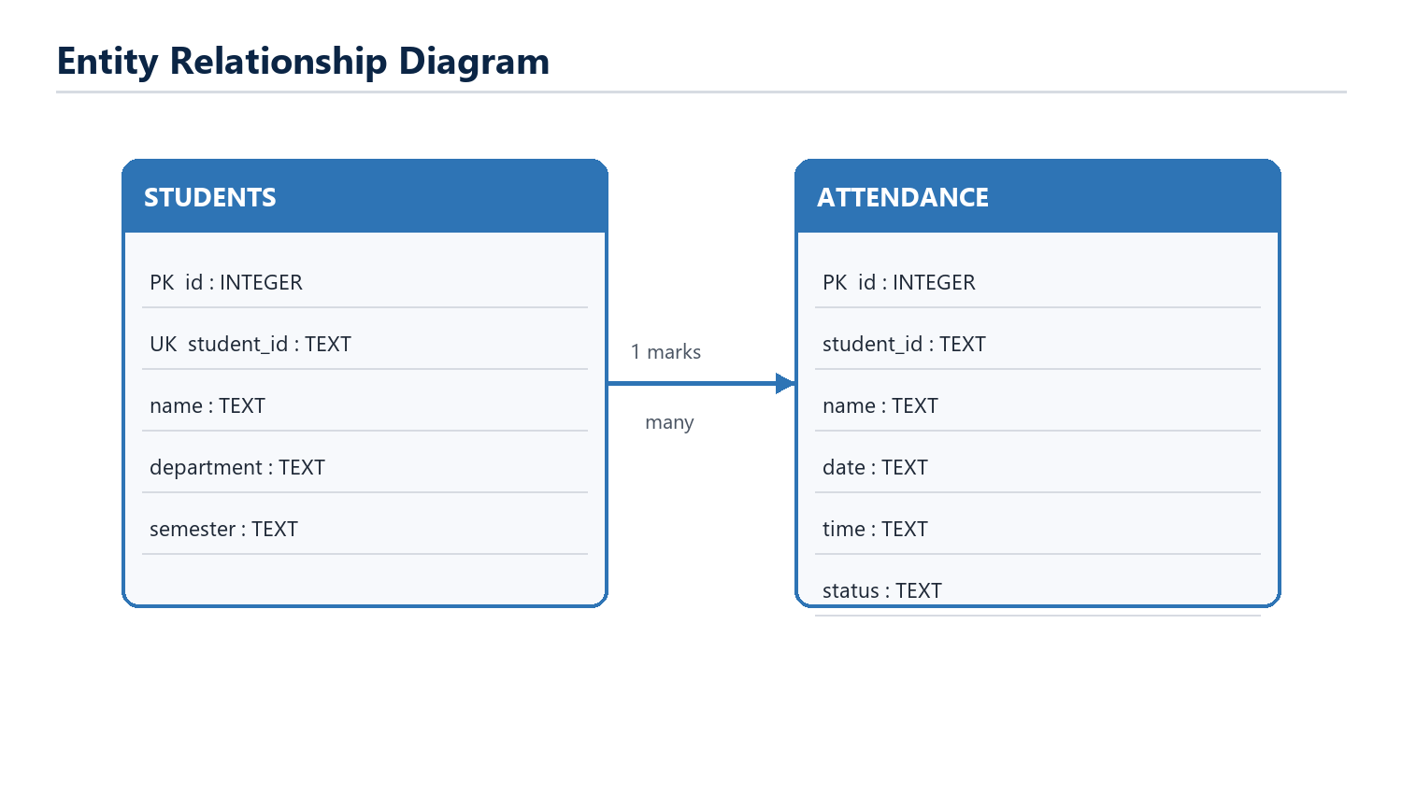
Figure 1. Entity Relationship Diagram

Data Dictionary
Table | Key Fields | Purpose
Students | id (PK), student_id (UNIQUE) | Stores registered student identity and academic fields.
Attendance | id (PK), UNIQUE(student_id, date) | Stores each student's daily Present record and timestamp.

5. Architecture, Use Cases, and Workflow
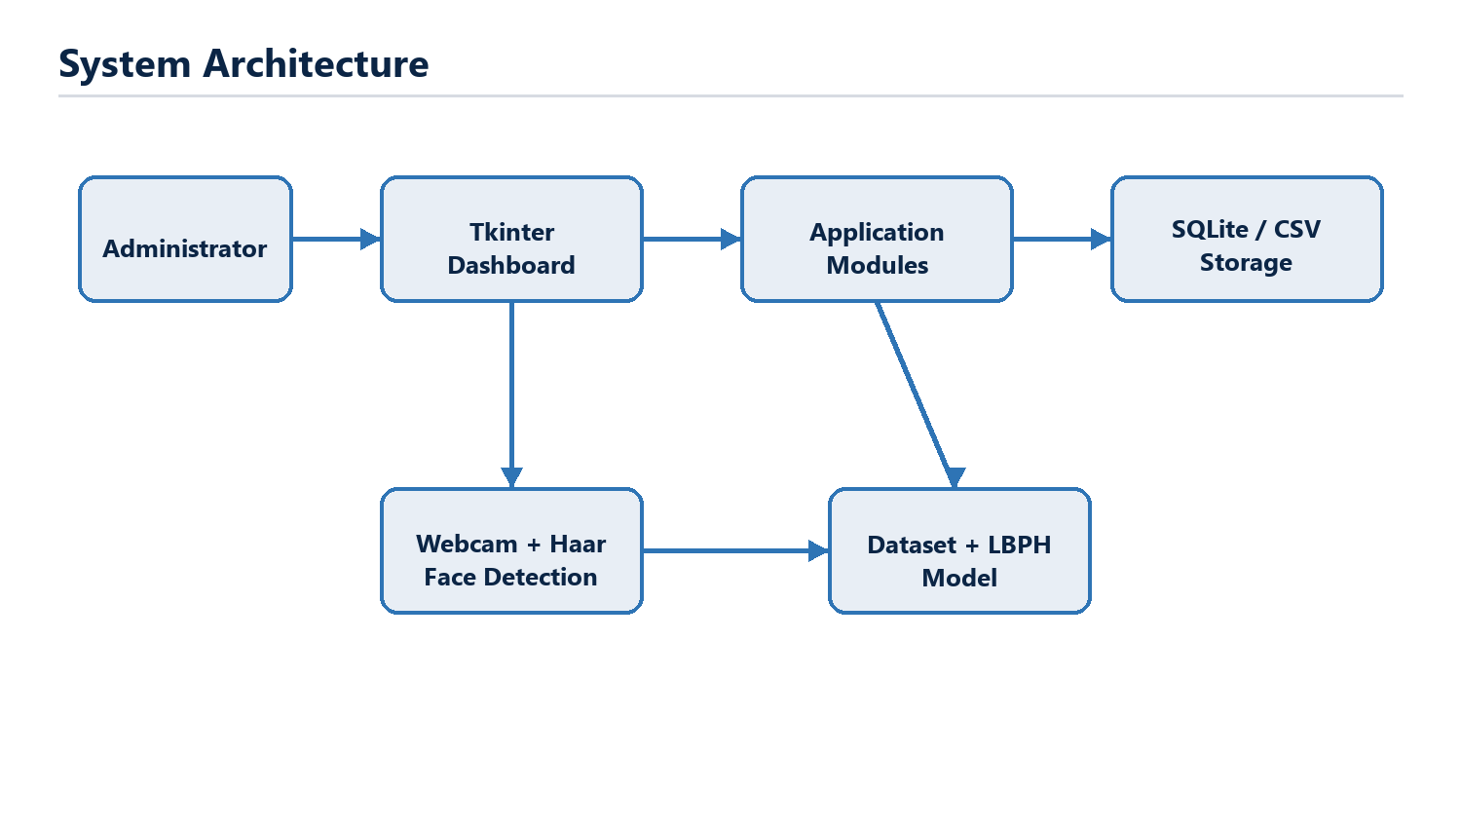
Figure 2. System Architecture
The GUI directs each action to a dedicated module. Registration and recognition interact with the webcam. Training consumes saved face crops and produces a local model. The database module is the single point for persistence and export, which keeps SQL logic separate from interface code.
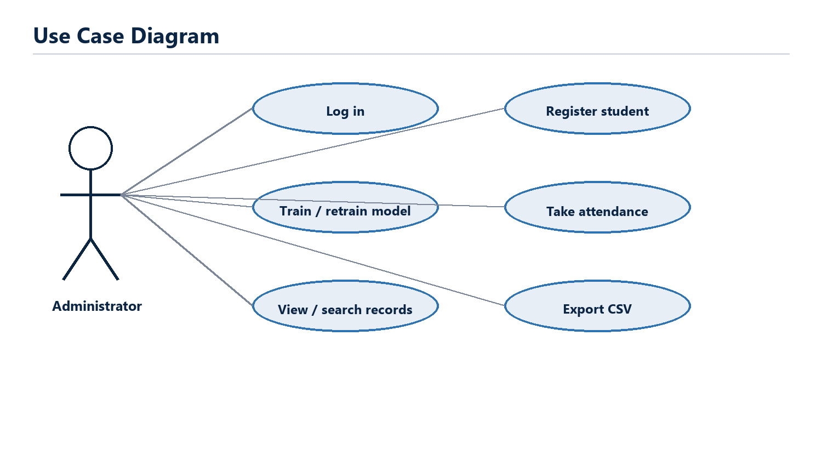
Figure 3. Use Case Diagram

5.1 Attendance Workflow and Sequence
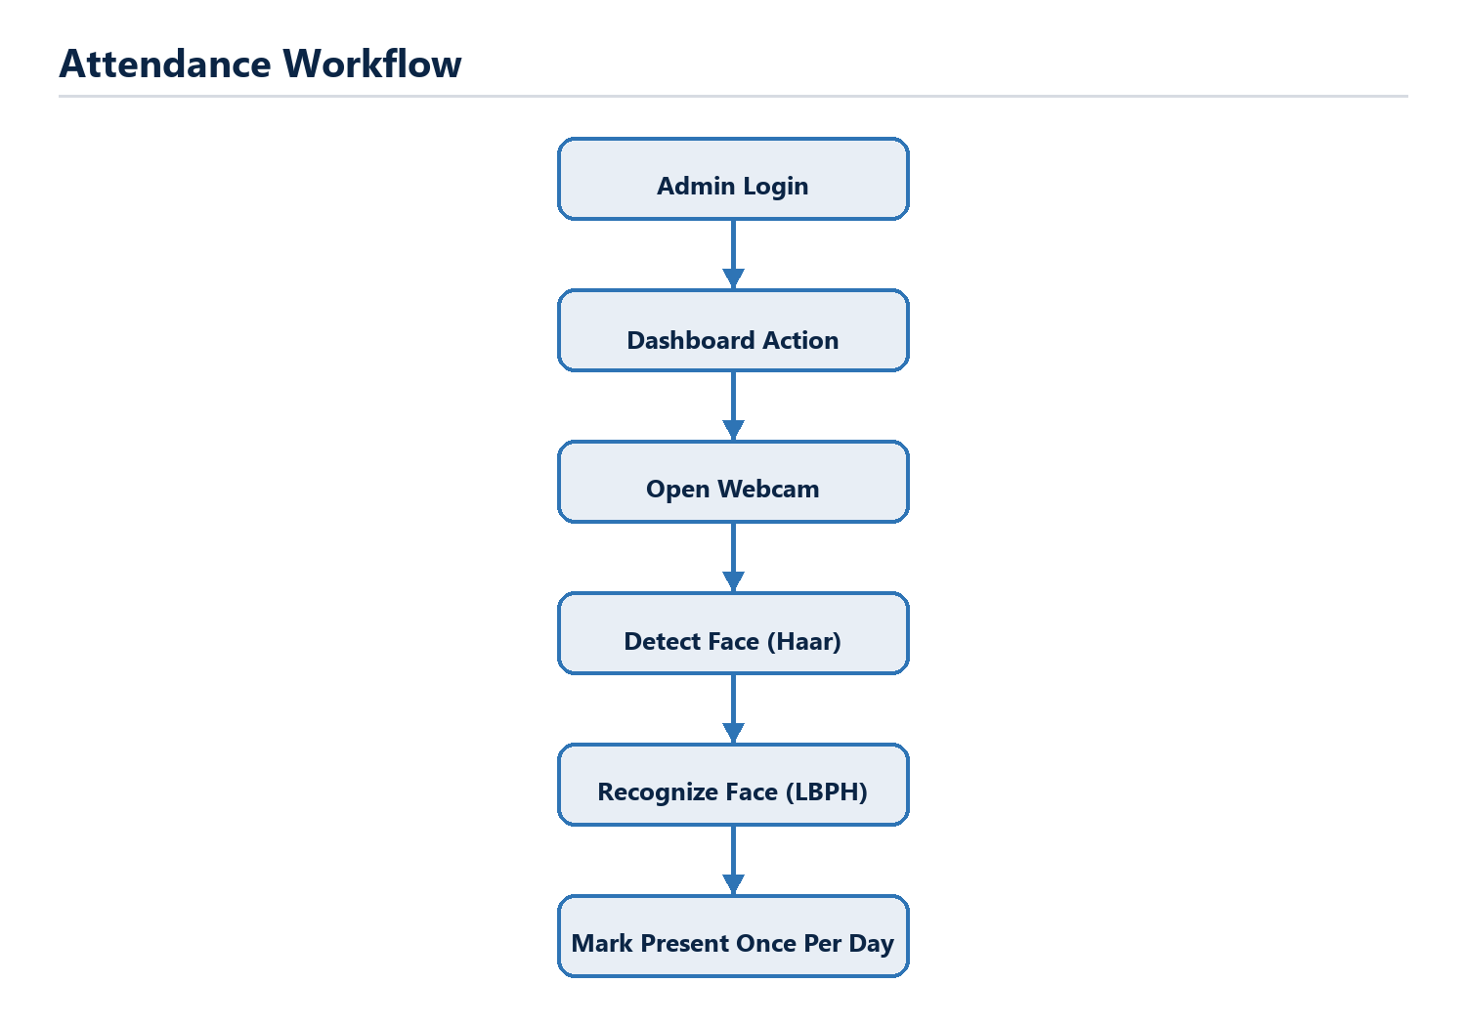
Figure 4. Attendance Workflow
The workflow begins after successful administrator login. A face must first be detected, then matched below the LBPH distance threshold. For a valid student, the system attempts an insert. The database's UNIQUE(student_id, date) constraint safely rejects any repeated daily entry.
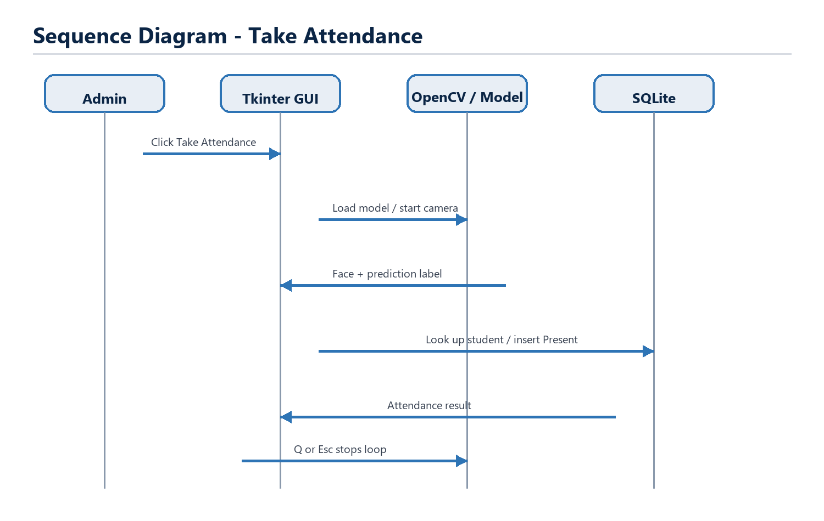
Figure 5. Attendance Sequence Diagram

6. Implementation Details

Registration and Dataset Capture
Before opening the camera, the application validates all text fields and inserts the student using a unique Student ID. Captured images are grayscale face crops stored as user.<database-id>.<image-number>.jpg. If capture produces no usable image, the newly inserted student is removed to avoid an incomplete record.

Model Training and Recognition
Training reads valid dataset filenames, resizes each crop to a consistent size, and trains the LBPH recognizer. The model is saved to trainer.yml along with lightweight JSON metadata. During recognition, the saved label is an internal student database ID, which allows the program to support Student IDs containing letters as well as numbers.

Duplicate Prevention and Error Handling
- Students.student_id has a UNIQUE constraint to reject duplicate registration.
- Attendance has UNIQUE(student_id, date), preventing duplicate daily Present entries even when the camera sees repeated frames.
- Camera open/read failures, missing model files, corrupt images, and missing OpenCV-contrib support result in actionable messages.
- Deleting a student removes their face images and attendance history; the dashboard reminds the operator to retrain the model.
- A timestamped SQLite backup can be generated from the dashboard.

Security and Privacy
The default password is suitable only for an academic demonstration. The login credentials can be changed through environment variables. Face images are biometric data; students should be informed, consent should be obtained, access to the device should be restricted, and dataset retention should follow institutional policy.

7. Testing and Results
The project includes a unittest suite that exercises data storage, duplicate handling, CSV export, synthetic-image LBPH training, confidence threshold logic, and invalid-webcam handling. Camera-dependent behavior is additionally tested manually on the intended Windows device.
Test | Expected Outcome | Result
Student registration | Valid student is stored; duplicate ID is rejected. | Pass - automated
Model training | Synthetic face crops create a readable trainer.yml. | Pass - automated
Attendance recording | Second insert for the same student/date is blocked. | Pass - automated
CSV export | Header and matching records are written in UTF-8 CSV. | Pass - automated
Invalid webcam | CameraError is raised without a crash. | Pass - automated
Unknown face | Threshold helper returns unknown; no record is created. | Pass - automated/manual
Live recognition | Known face is displayed and marked once per day. | Manual on target webcam

Test Command
python -m unittest discover -s tests -v

Acceptance Criteria
- A valid registration stores student data and face images.
- Training creates trainer/trainer.yml from local samples.
- A recognized student receives only one Present record per date.
- The attendance viewer returns filtered records and CSV output.
- A missing model or unavailable webcam is handled gracefully.

8. Limitations and Future Scope

Current Limitations
- Haar Cascade and LBPH are classical methods; low light, side profiles, masks, and large pose changes reduce accuracy.
- The solution is designed for a single local camera and SQLite database, not a multi-classroom network deployment.
- The on-screen confidence percentage is a transformed LBPH distance, not a statistically calibrated probability.
- The simple local login should be strengthened for production use with password hashing and user management.

Future Scope
- Replace LBPH with a modern deep-learning face embedding model and liveness detection.
- Add multi-user roles, password hashing, audit logs, and encrypted backups.
- Synchronize attendance with an institution server or LMS through a secure API.
- Add course/class schedules, subject-wise attendance, charts, and absence alerts.
- Use a camera selection option and a responsive multi-camera deployment mode.
- Add consent forms, retention policies, and automatic deletion rules for biometric data.

Deployment Recommendation
For a classroom demonstration, use a well-lit room, a fixed webcam, a small group of registered participants, and 70 varied face samples per participant. Retrain the model immediately after changing student records and verify the exported CSV before presenting results.

9. Conclusion
The Face Recognition Attendance System demonstrates a complete desktop workflow: secure entry, student registration, local dataset capture, LBPH training, real-time recognition, duplicate-safe attendance storage, record search, and CSV export. Separating GUI, database, capture, training, recognition, and reporting modules makes the code understandable for second-year students and easier to test or extend.
The project deliberately favors a practical, offline architecture that can run on a typical Windows laptop with Python and a webcam. Although the chosen recognition approach has limits, it provides a strong foundation for learning how computer vision components interact with a user interface and persistent data layer.

References
- OpenCV Documentation. Face Recognition with Local Binary Patterns Histograms (LBPH). https://docs.opencv.org/
- OpenCV Documentation. Cascade Classifier Detection. https://docs.opencv.org/
- Python Documentation. tkinter - Python interface to Tcl/Tk. https://docs.python.org/3/library/tkinter.html
- SQLite Documentation. SQLite is a self-contained SQL database engine. https://www.sqlite.org/docs.html

Appendix: Project Files
The source folder contains main.py, login.py, register.py, train.py, recognize.py, attendance.py, database.py, and utils.py. Supporting folders hold the database, dataset, trained model, Haar cascade, CSV exports, test cases, and the diagram source files.

