**Application of Union Find in Undirected Graph Algorithm Problems**

https://github.com/Neo-Hao/union-find

**Union Find / Disjoint Set**

Union-find is a data structure that keeps track of a set of elements partitioned into a number of disjoint subsets. It typically has three operations:

* ***makeSet***: Create a set using the only one element that is given
* ***findSet***: Determine which subset a particular element is in. *findSet* typically returns an item from this set that serves as its "representative"; by comparing the result of two Find operations, one can determine whether two elements are in the same subset.
* ***union***: Join two subsets into a single subset.

Time Complexity:

* Naïve Approach: O(n) for per *findSet* and *union* operation.
* Optimized approach: Amortized O(α(n)) per operation, where α(n) is less than 5 for all remotely practical values of n.

Naïve Approach:

|  |  |
| --- | --- |
| makeSet(v):  n = Node(v)  n.parent = n  findSet(n):  if n.parent == n:  return n  return findSet(n.parent)  union(n1, n2):  i = findSet(n1)  j = findSet(n2)  if i == j:  return  else:  j.parent = i | class Node(object):  def __init__(self, v):  self.v = v  self.parent = None  class Union(object):  def __init__(self):  self.table = {}  # makeSet method  def makeSet(self, v):  # input: vertex  node = Node(v)  node.parent = node  self.table[v] = node  # union method  def union(self, v1, v2):  # input: vertex1, vertex2  i = self.findSet(v1)  j = self.findSet(v2)  if i == j:  return  j.parent = i  # findSet method  def findSet(self, v):  # input vertex  n = self.table[v]  return self.findSetHelper(n)  def findSetHelper(self, n):  # input node  if n.parent == n:  return n  return self.findSetHelper(n.parent) |

Optimized Approach:

|  |  |
| --- | --- |
| makeSet(v):  n = Node(v)  n.parent = n  union(n1, n2):  i = findSet(n1)  j = findSet(n2)  if i == j: return  if i.rank > j.rank:  j.parent = i  elif i.rank < j.rank:  i.parent = j  else:  j.parent = i  i.rank += 1  findSet(n):  if n.parent != n:  n.parent = findSet(n.parent)  return n.parent | class Node(object):  def __init__(self, v):  self.v = v  self.parent = None  self.rank = 0  class Union(object):  def __init__(self):  self.table = {}    # makeSet method  def makeSet(self, val):  node = Node(val)  node.parent = node  self.table[val] = node    # union method  def union(self, v1, v2):  i = self.findSet(v1)  j = self.findSet(v2)    if i == j: return    if i.rank > j.rank:  j.parent = i  elif i.rank < j.rank:  i.parent = j  else:  j.parent = i  i.rank += 1    # findSet method  def findSet(self, v):  node = self.table[v]  return self.findSetHelper(node)  def findSetHelper(self, n):  # representative itself  if n == n.parent:  return n  n.parent = self.findSetHelper(n.parent)  return n.parent |

**Cycle Detection**

Cycle detection refers to the algorithmic problem of finding a cycle in a sequence of iterated function values.

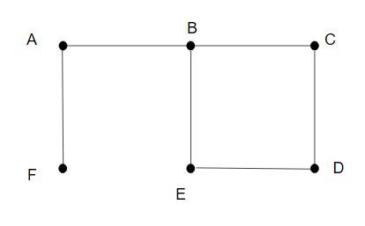

Implementations:

|  |  |
| --- | --- |
| cycleDetect(G):  foreach v ∈ G.V:  MAKE-SET(v)  foreach (u, v) in G.E:  if FIND-SET(u) ≠ FIND-SET(v):  UNION(u, v)  else:  return True  return False | def cycleDetection(edges):  union = Union()  # step 1: makeSet  for u, v in edges:  union.makeSet(u)  union.makeSet(v)  # step 2: traverse the edges  for u, v in edges:  if union.findSet(u) == union.findSet(v):  return True  else:  union.union(u, v)  return False |

Time Complexity: *O(V)*

**Kruskal's algorithm**

*Weighted Graph*:

A weighted graph refers to an edge-weighted graph, where edges have weights or values.

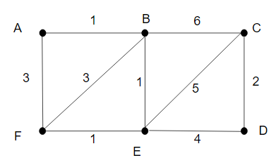

Minimum Spanning Tree:

A minimum spanning tree is a subset of the edges of a connected, edge-weighted graph that connects all the vertices together, without any cycles and with the minimum possible total edge weight.

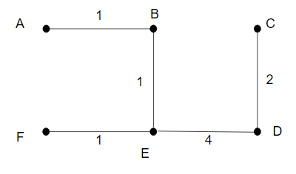

Implementation:

|  |  |
| --- | --- |
| KRUSKAL(G):  result = ∅  foreach v ∈ G.V:  MAKE-SET(v)  foreach (u, v) in G.E ordered by increasing order of weight(u, v):  if FIND-SET(u) ≠ FIND-SET(v):  result = result ∪ {(u, v)}  UNION(u, v)  return result | def kruskal(weightedEdges):  union = Union()  result = []  # step 1  for u, v in weightedEdges:  union.makeSet(v)  # step 2  weightedEdges.sort()  # step 3  for w, u, v in weightedEdges:  if union.findSet(u) != union.findSet(v):  result.append((u, v))  union.union(u, v)  return result |

Time Complexity: *O(E log E)*

Q1. Number of Connected Components in an Undirected Graph

Given n nodes labeled from 0 to n - 1 and a list of undirected edges (each edge is a pair of nodes), write a function to find the number of connected components in an undirected graph.

**Example 1:**

0 3

| |

1 --- 2 4

Given n = 5 and edges = [[0, 1], [1, 2], [3, 4]], return 2.

**Example 2:**

0 4

| |

1 --- 2 --- 3

Given n = 5 and edges = [[0, 1], [1, 2], [2, 3], [3, 4]], return 1.

Requirement:

def countComponents(self, n, edges):

"""

:type n: int

:type edges: List[List[int]]

:rtype: int

"""

Q2. Number of Islands

A 2d grid map of m rows and n columns is initially filled with water. We may perform an *addLand* operation which turns the water at position (row, col) into a land. Given a list of positions to operate, count the number of islands after each *addLand* operation. An island is surrounded by water and is formed by connecting adjacent lands horizontally or vertically. You may assume all four edges of the grid are all surrounded by water.

**Example:**

Given m = 3, n = 3, positions = [[0,0], [0,1], [1,2], [2,1]].  
Initially, the 2d grid grid is filled with water. (Assume 0 represents water and 1 represents land).

0 0 0

0 0 0

0 0 0

Operation #1: addLand(0, 0) turns the water at grid[0][0] into a land.

1 0 0

0 0 0 Number of islands = 1

0 0 0

Operation #2: addLand(0, 1) turns the water at grid[0][1] into a land.

1 1 0

0 0 0 Number of islands = 1

0 0 0

Operation #3: addLand(1, 2) turns the water at grid[1][2] into a land.

1 1 0

0 0 1 Number of islands = 2

0 0 0

We return the result as an array: [1, 1, 2].

Requirement:

def numIslands2(self, m, n, positions):

"""

:type m: int

:type n: int

:type positions: List[List[int]]

:rtype: List[int]

"""

Q3. Graph Valid Tree

Given n nodes labeled from 0 to n - 1 and a list of undirected edges (each edge is a pair of nodes), write a function to check whether these edges make up a valid tree.

For example:

Given n = 5 and edges = [[0, 1], [0, 2], [0, 3], [1, 4]], return true.

Given n = 5 and edges = [[0, 1], [1, 2], [2, 3], [1, 3], [1, 4]], return false.

Requirement:

def validTree(self, n, edges):

"""

:type n: int

:type edges: List[List[int]]

:rtype: bool

"""