1. What is the most amazing thing you've seen?

I saw the sign
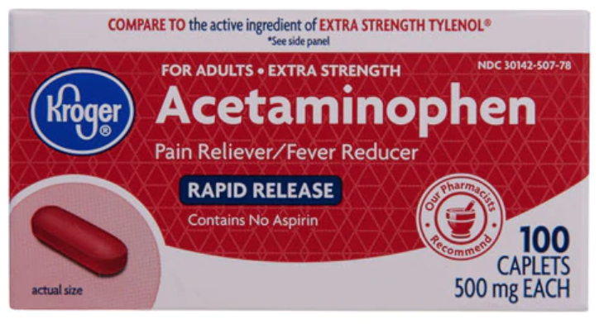
Acetaminophen

God
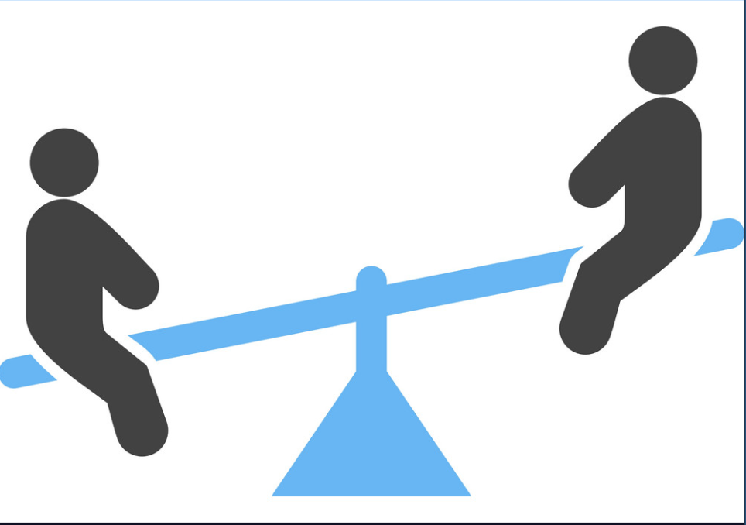
A See-Saw

2. How much wood could a wood chuck chuck, if a wood chuck could chuck wood?

Probably not much, have you seen those stubby little arms?
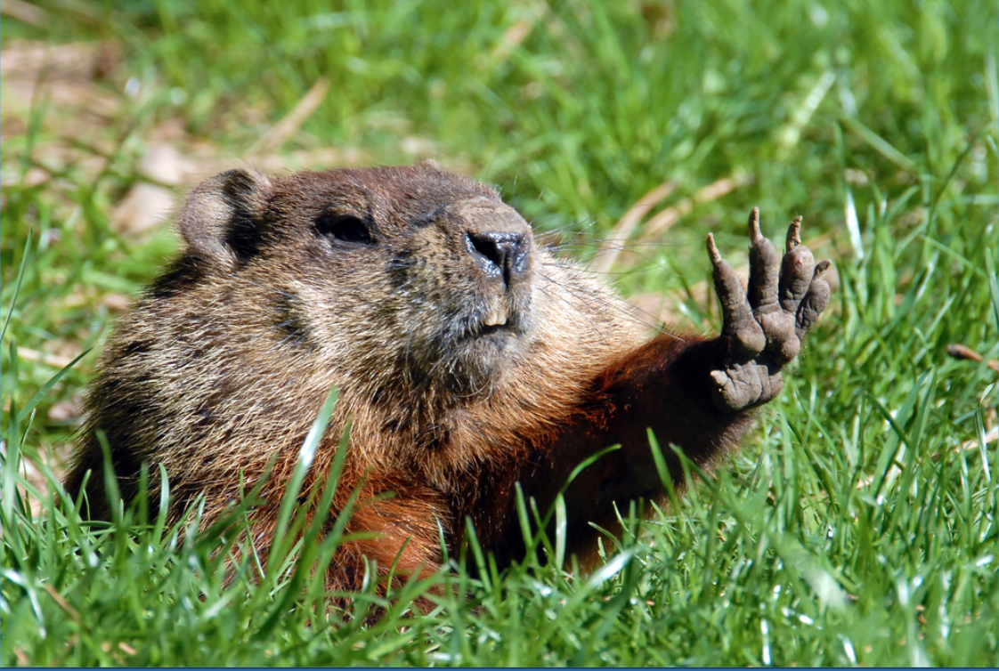

A wood chuck could chuck, as much as a wood chuck wood chuck, if a wood chuck could chuck wood.

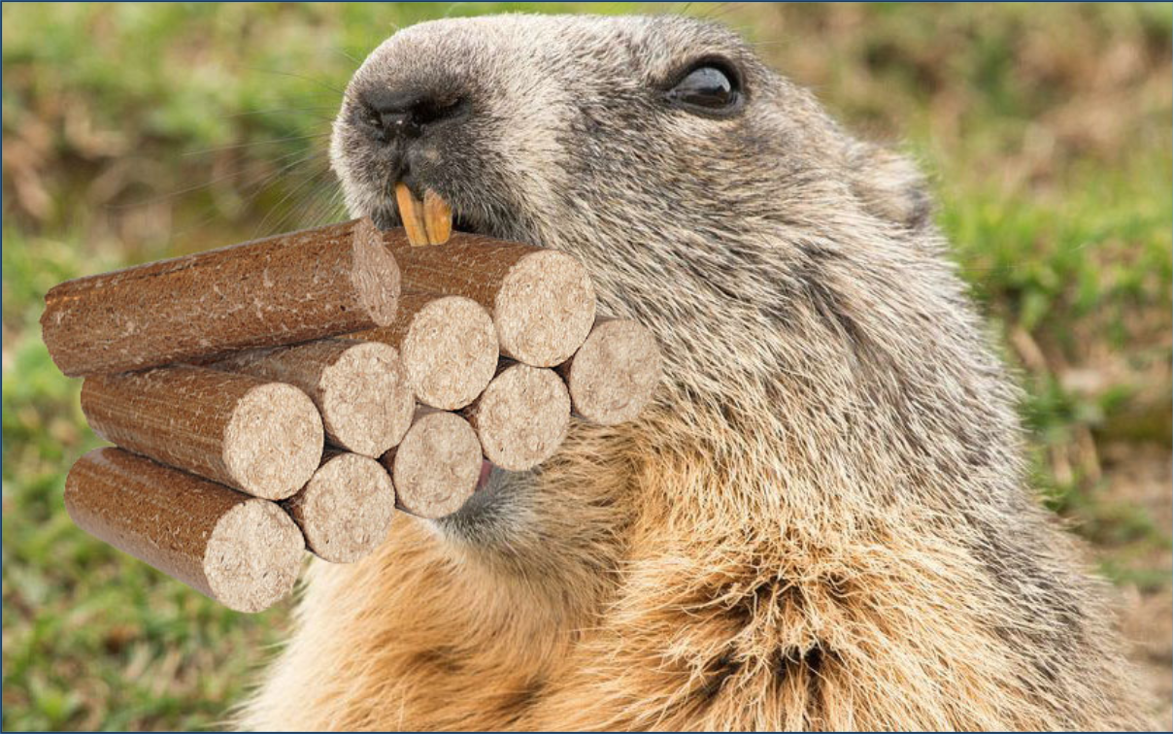
I can't give you an answer with a more in-depth evaluation of the biomechanics involved. https://www.ncbi.nlm.nih.gov/pmc/articles/PMC1357215/

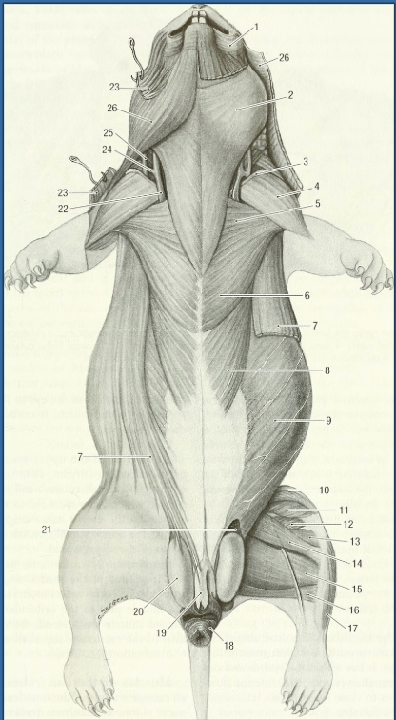

- What is love?

Baby don't hurt me.
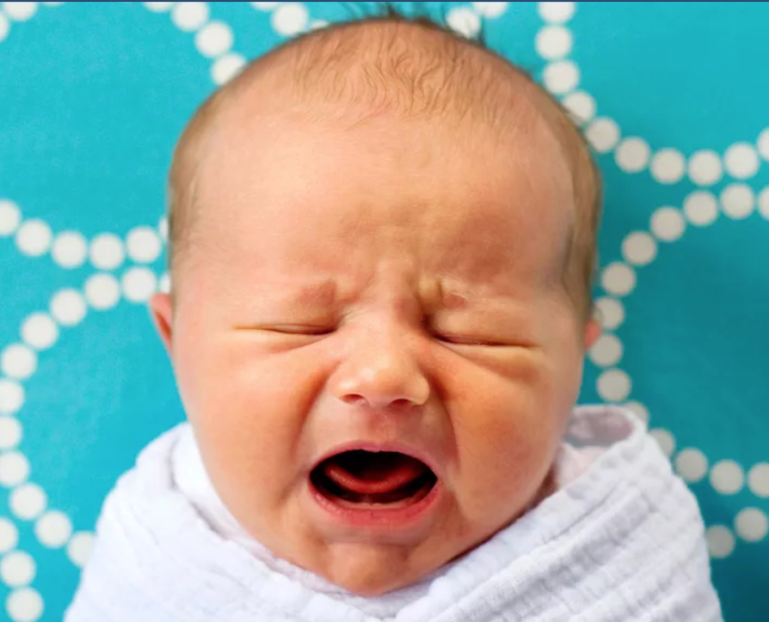
A neuro-chemical cascade triggered by a person with the intersection of specific evolutionary, cultural development characteristics that is important in the propagation of mammals.

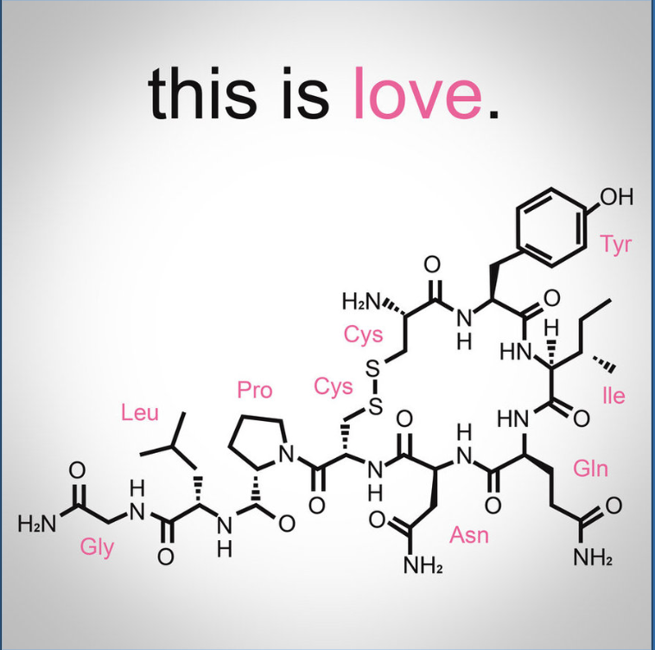

What isn't love?

- Which came first, the chicken or the egg?

The Chicken

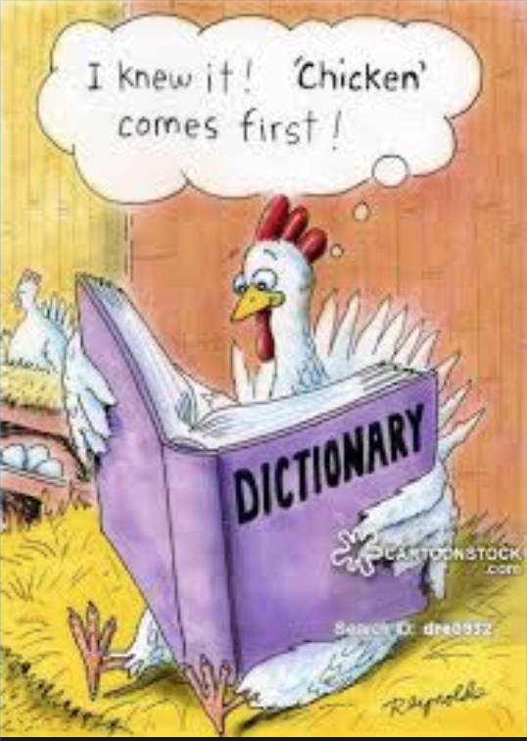
The Egg

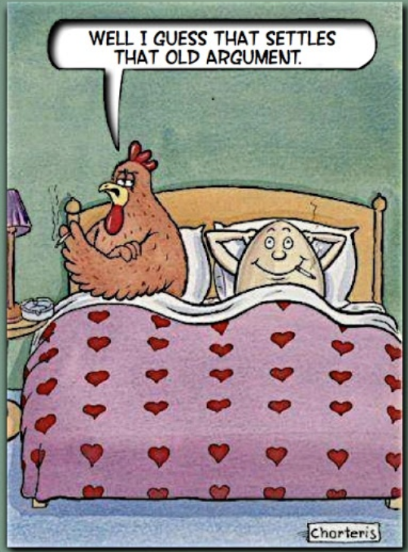

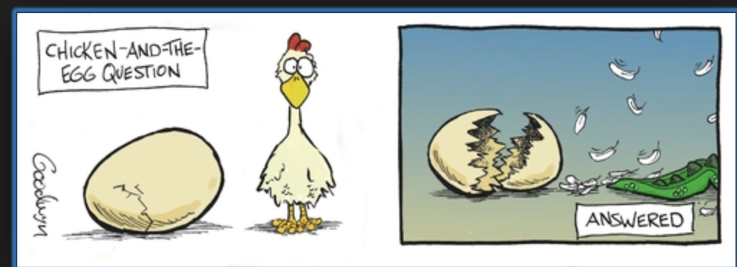
The Dinosaur

- What is the sound of one hands clapping

*Silence

*Faint sound of fingers hitting palm

*Enlightenment

