1. Creating an Alert / Case workflow :

(The following screenshots are for alert workflow, the case workflow creation will also need the similar steps)

Select the step workflows in the Alerts tab and New button under Alerts header .

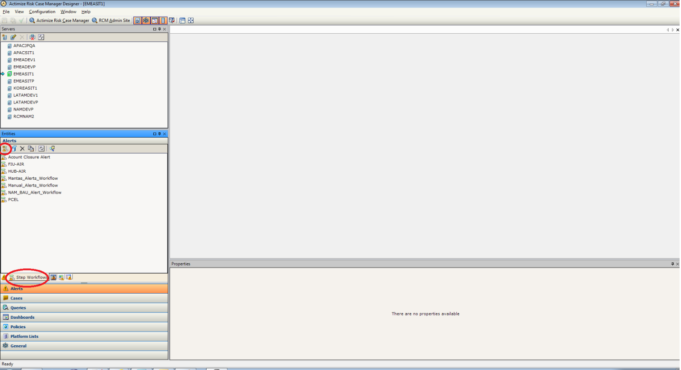

1. On the right side a new window opens in which we have to fill the name, identifier and description.

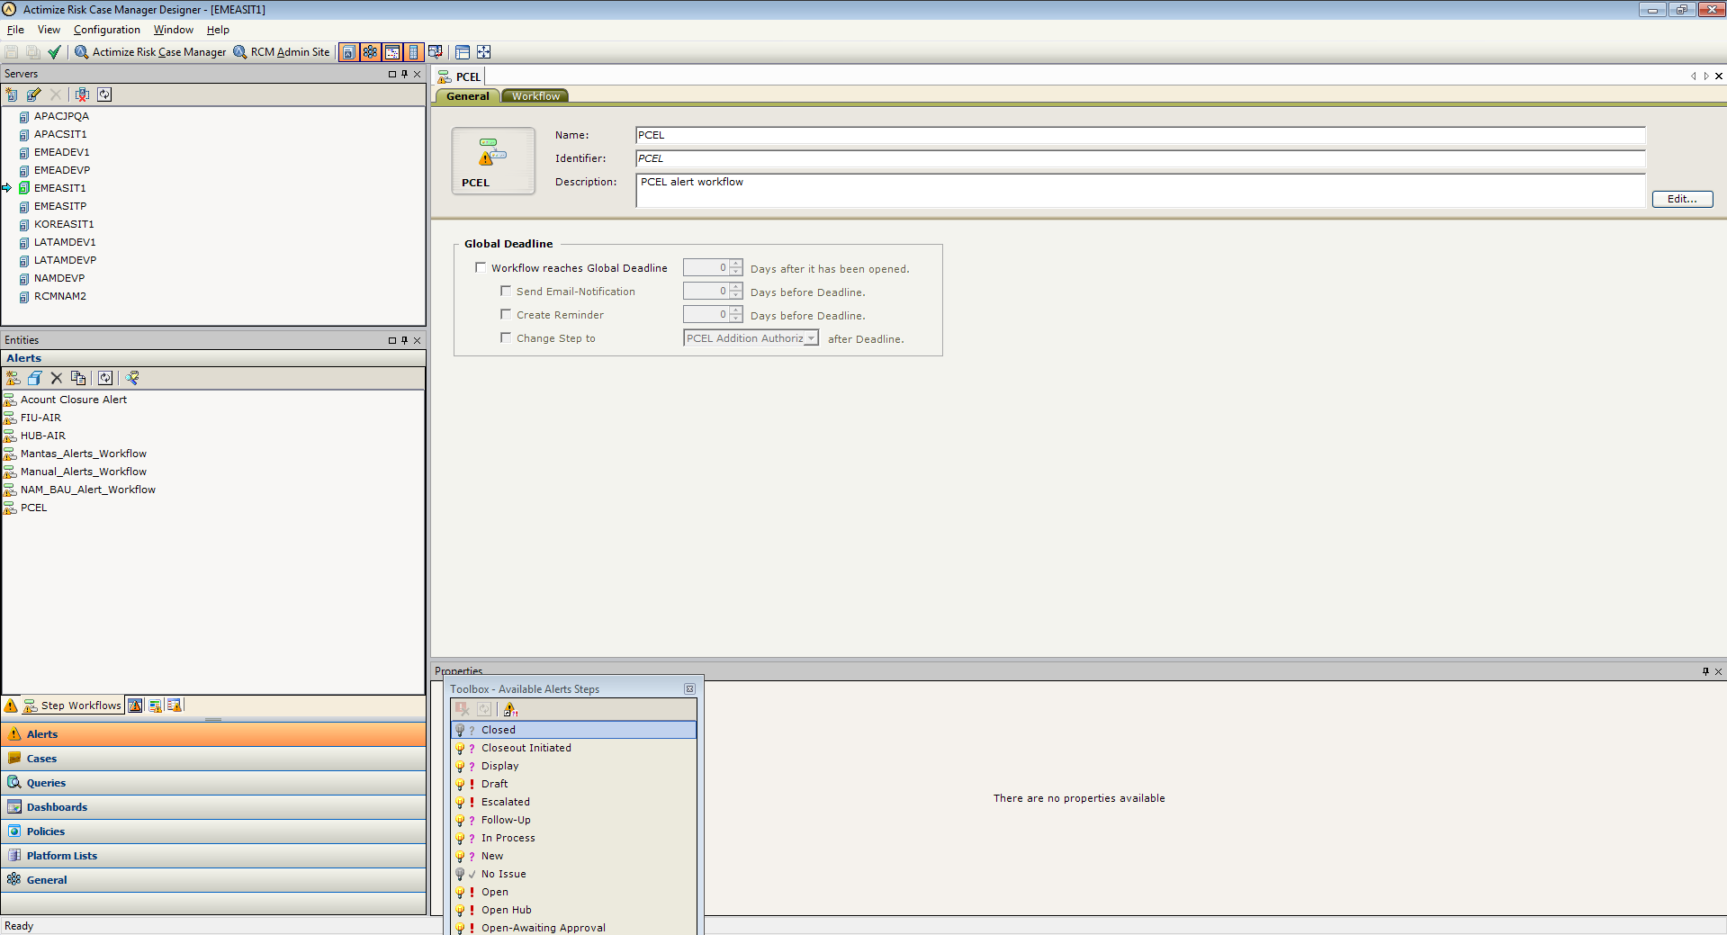

1. Under the workflow tab, we can provide the exact flow of the steps for the desired workflow to be created.

* The tool box contains the alert steps which can be dragged and dropped.

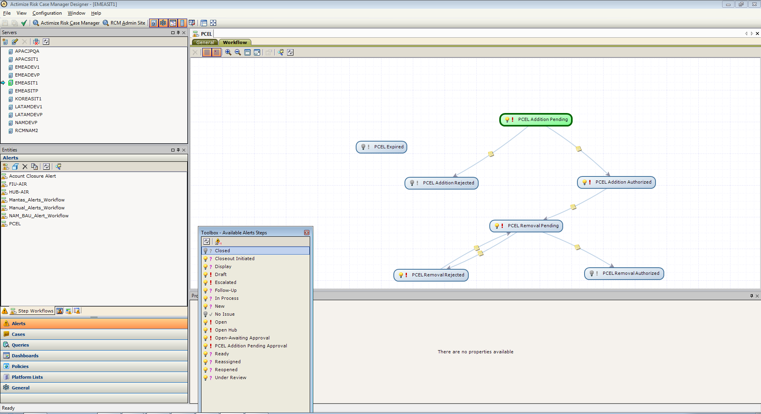

1. In the following dummy workflow, the New is the first step to be added. This is the default start node .In the properties pane

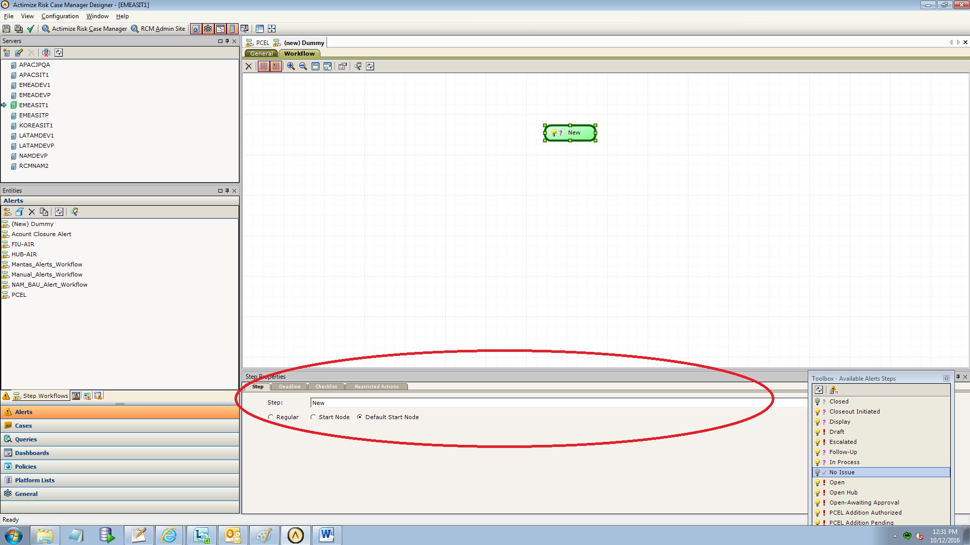

* In step properties tab we can see the different kinds of steps.
* Regular Node : Regular Node is any node other than a start node
* Default start node: It is the first node added. By default it will be the start node. Usually the start nodes will be in green color.
* Start node: Start node is added at any point of time , expected to be the starting point in the workflow and will be in green color.

1. Adding a regular node from the tool box :

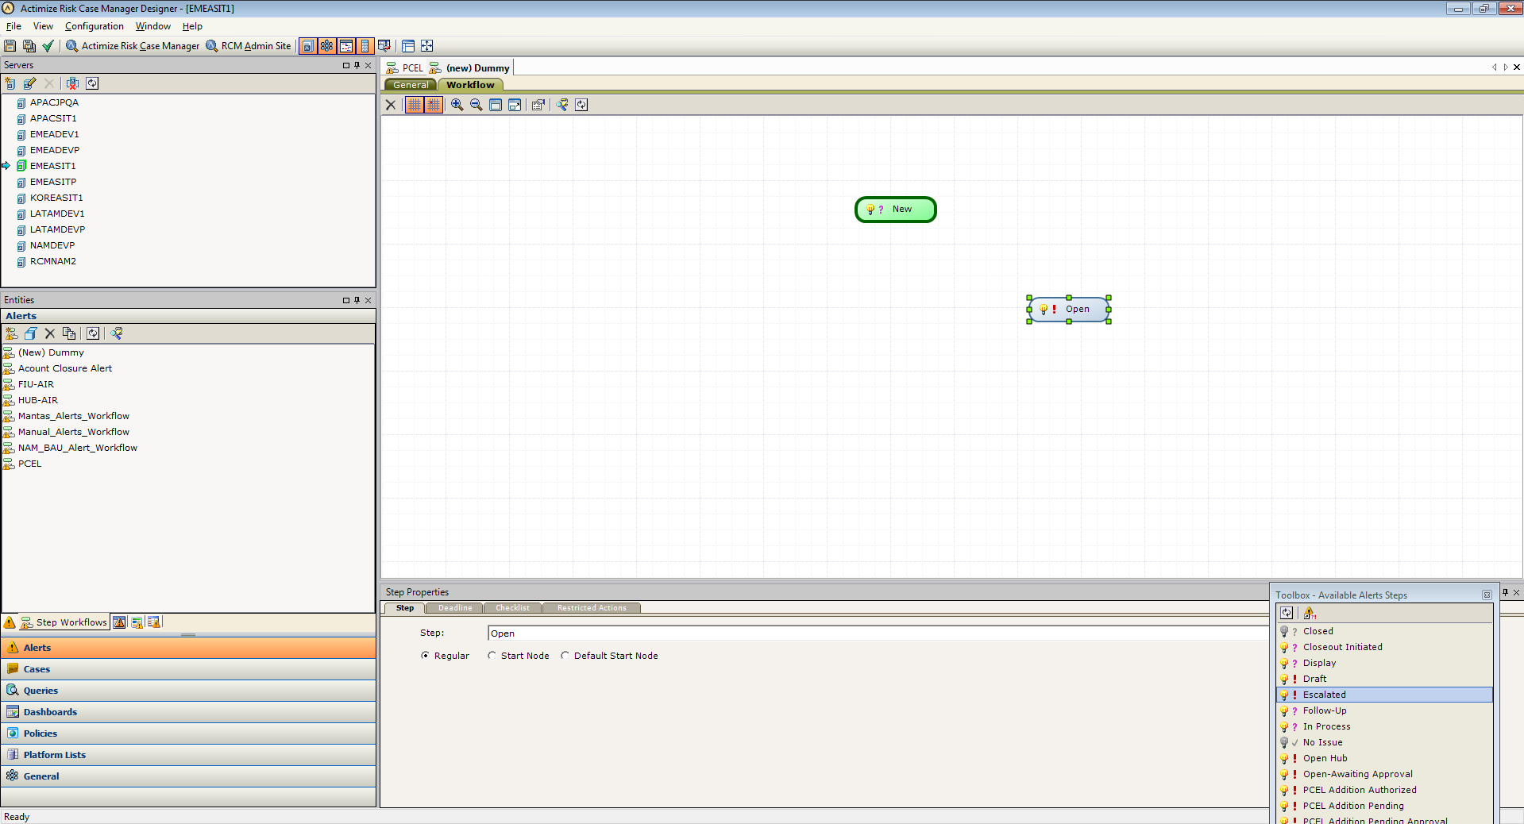

* The regular node will be in grey color .

1. Creating the transition between the two steps is simple, just click on one node and drag it to the other node. A transition appears in that direction.

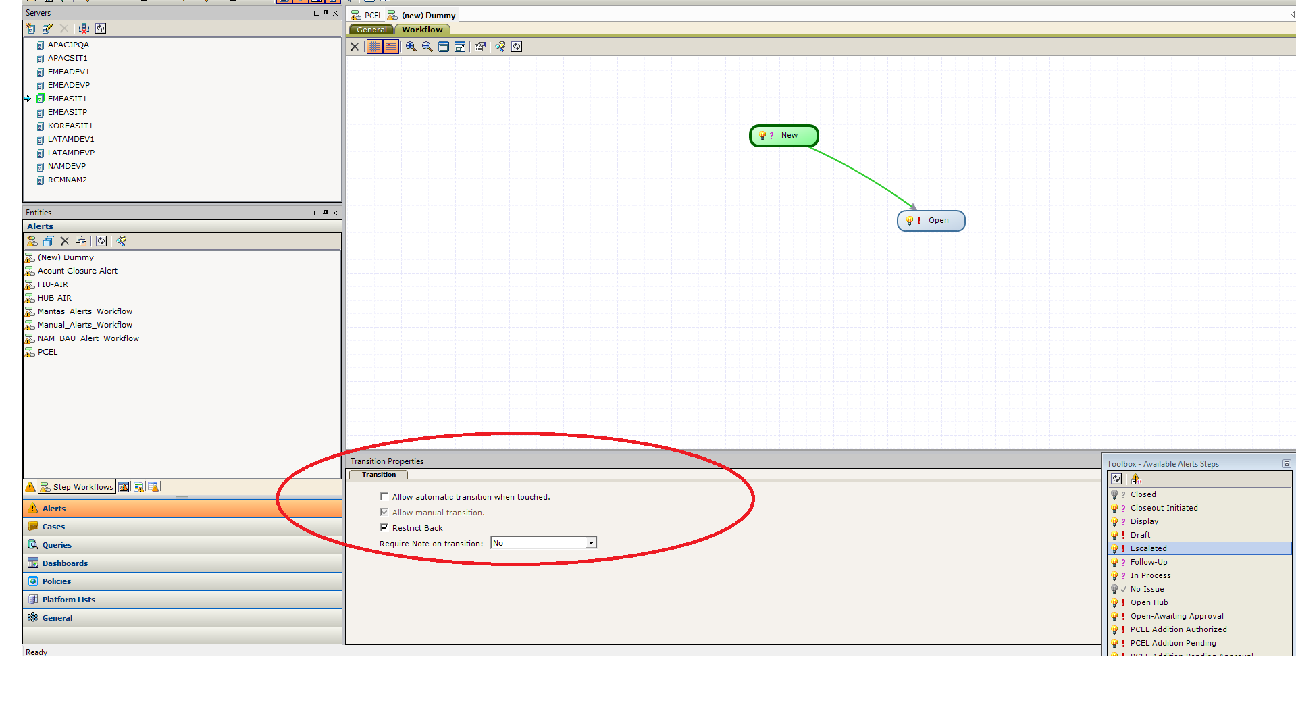

* We can modify the properties of the transition as per the requirement.
* If you Require a Note on transition , you can select accordingly from the drop down.
* Similarly with the Restrict Back, check box can be checked if the restriction has to be applied for the backward transition.

1. **Properties that can be set to a particular node :**

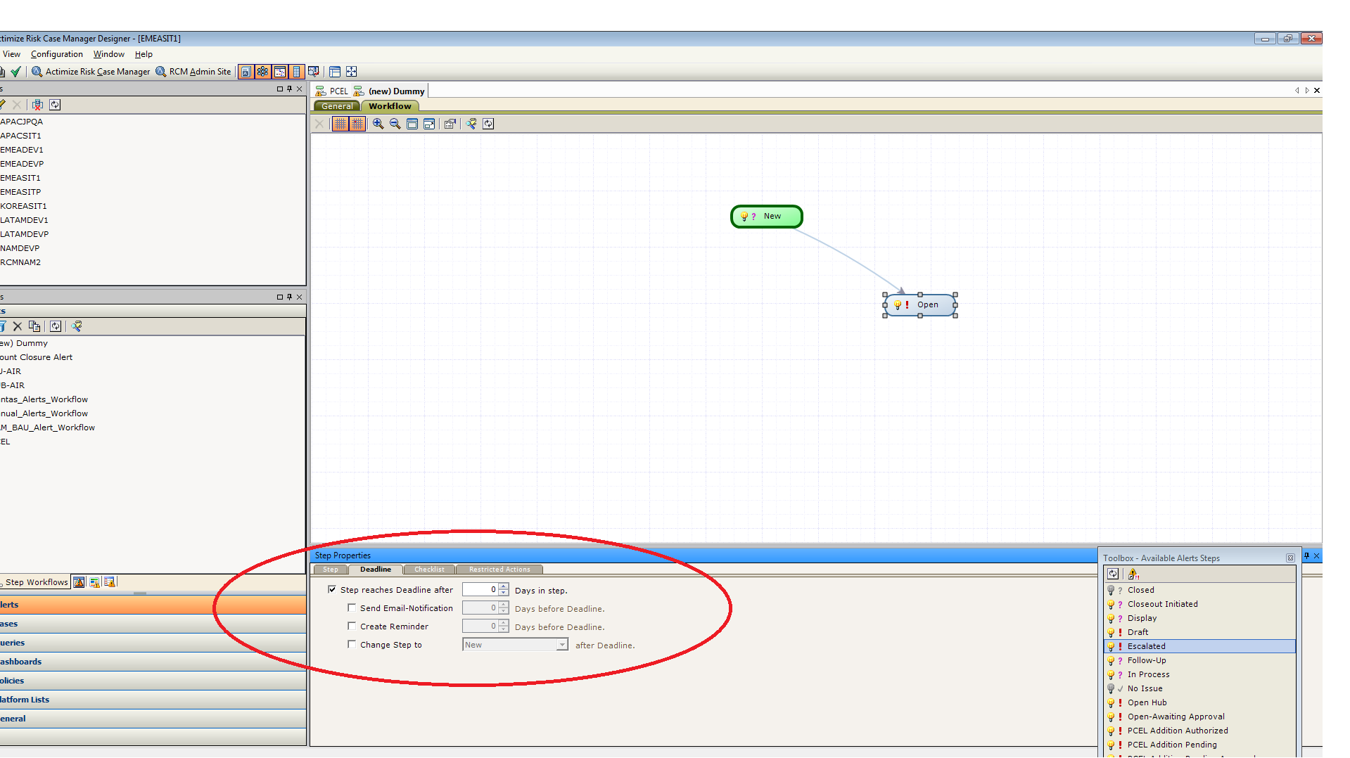

* Deadline can be set for a particular step stating how many days an alert can be present in the particular step and an email notification could also be sent to the user accordingly by checking the check box.
* We can even add checklist to check the criteria and restricted actions to restrict the particular action item in a workflow.