**Snapshot Week 06 of Group PG02**

**Project of ATSYS**

**No-Code Solution for InfluxDB**

**LeStartUP**

Zilin Song - a1833935

Jen-Hao Liu - a1893169

Dang Quy Duong - a1893592

Baojing Li - a1894836

Shih-Han Lin - a1900715

Feinan Guo - a1903270

Xiaoqing Zhao - a1904344

Hao Jiang - a1907177

Ziqi Zhang – a1909438

**Product Backlog and Task Board**

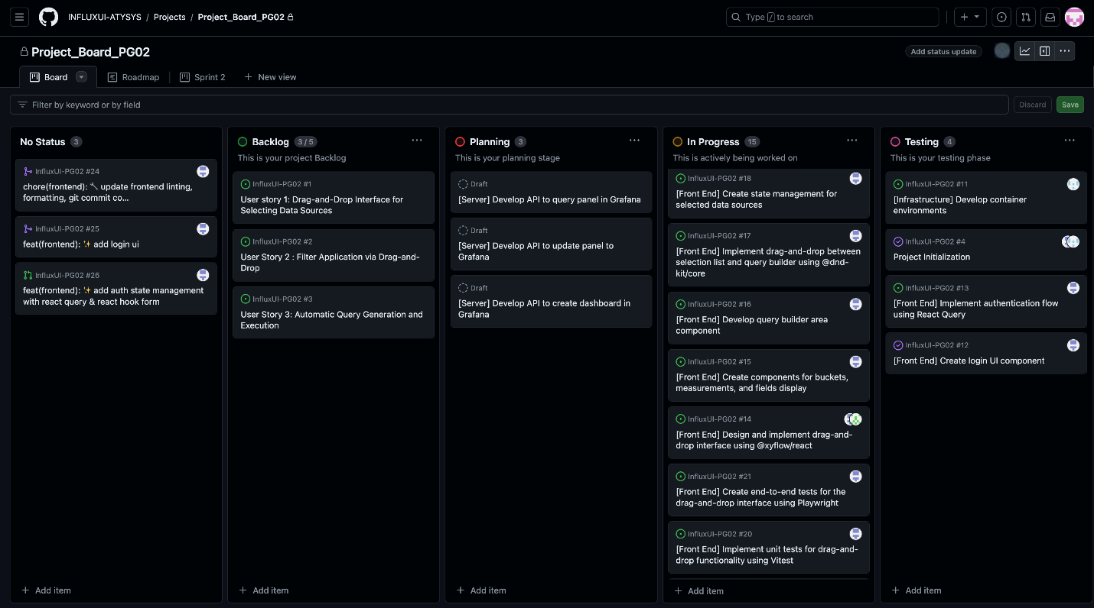

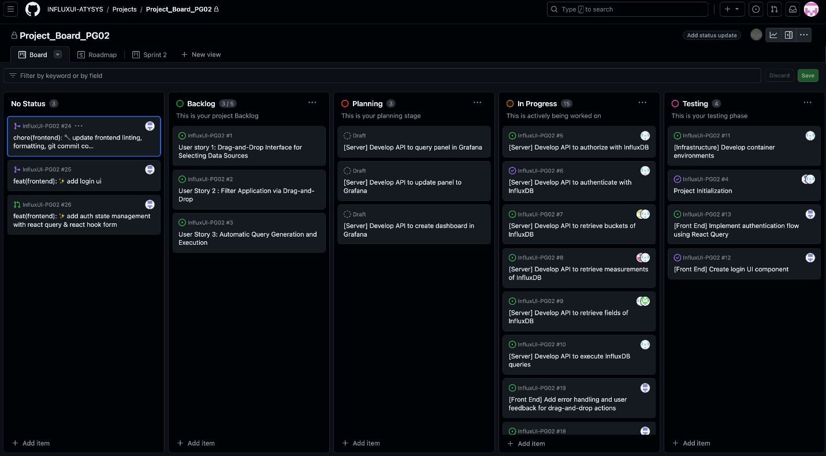Based on the characteristics of this project, our group splits into frontend and backend (server) sub teams to develop the backlog items discussed during sprint 2.

**Sprint Backlog and User Stories**

Commit changes for sprint 2

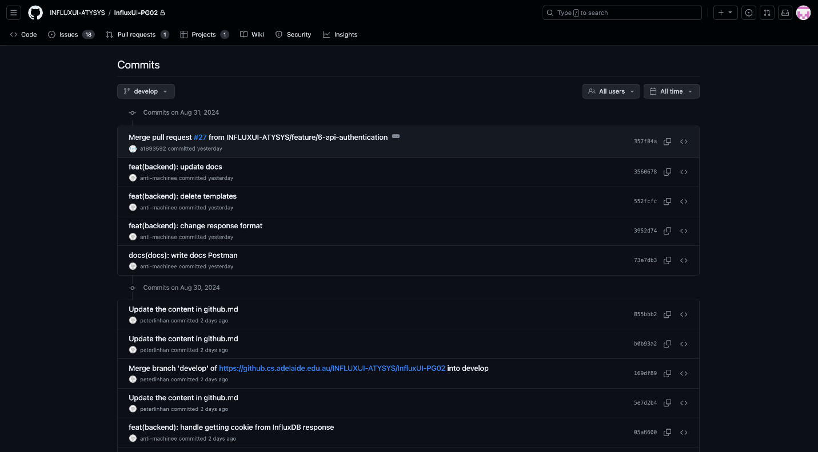

Postman API testing

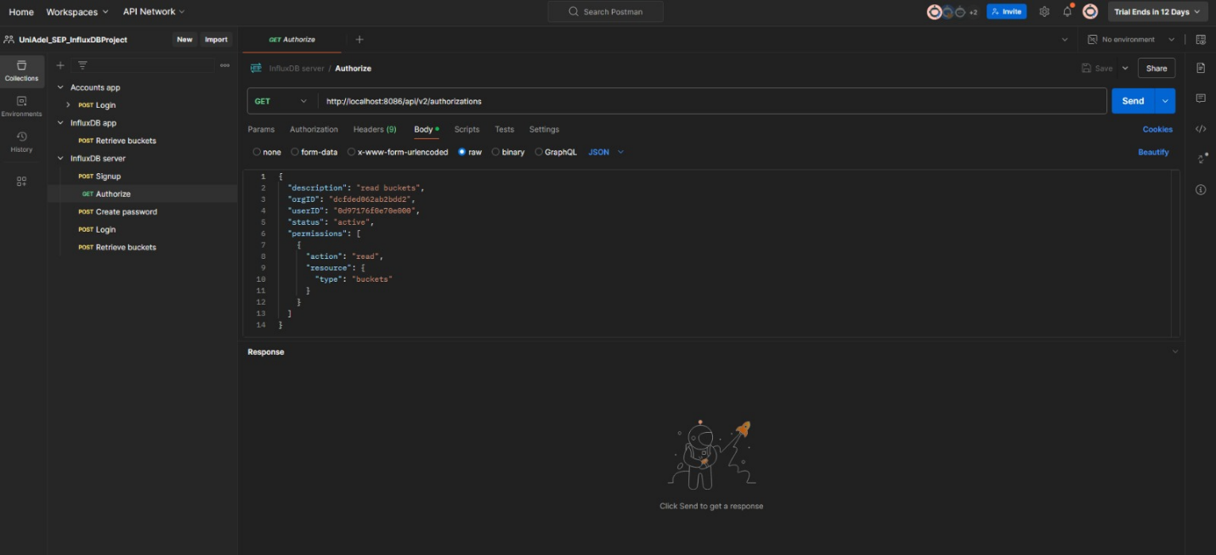

Frontend development

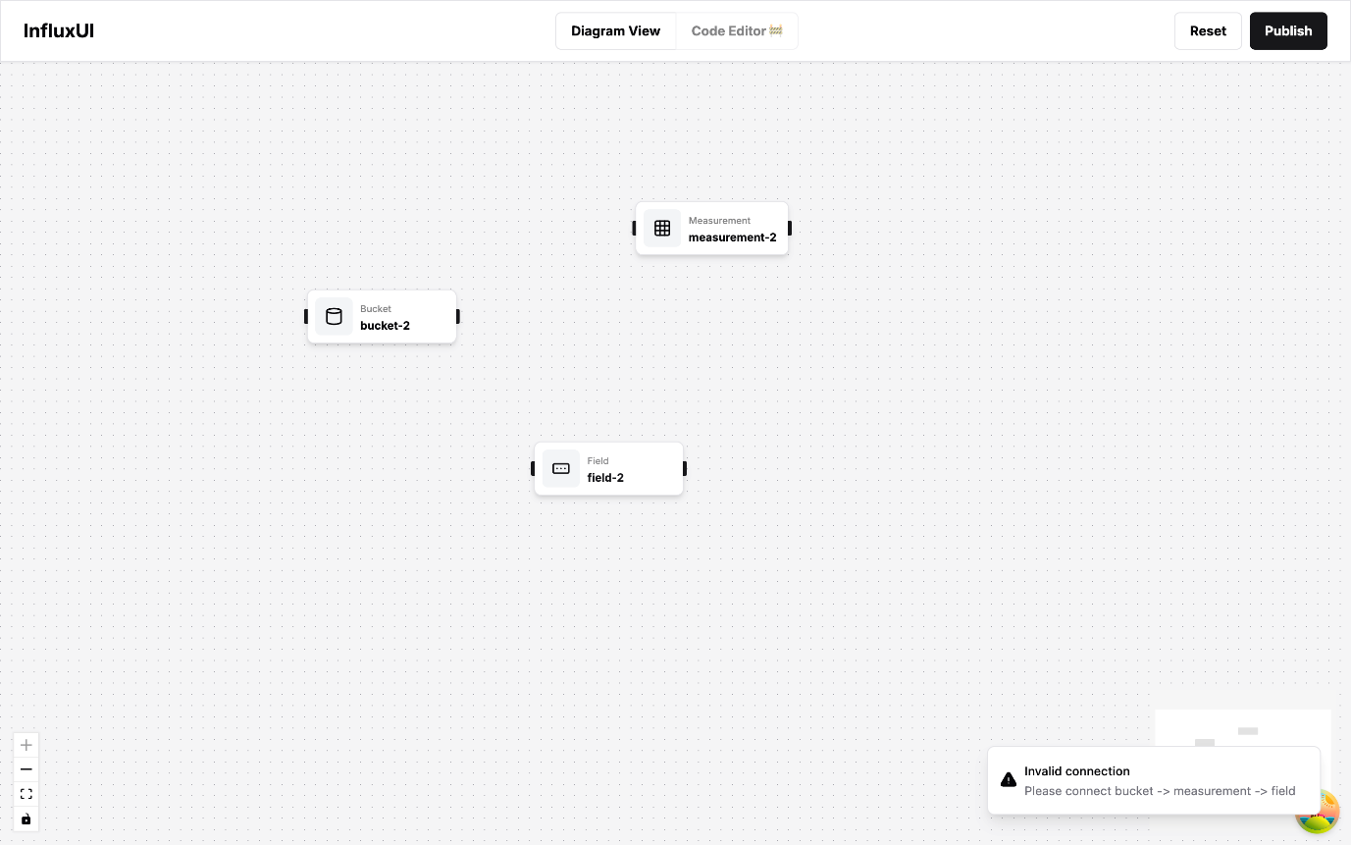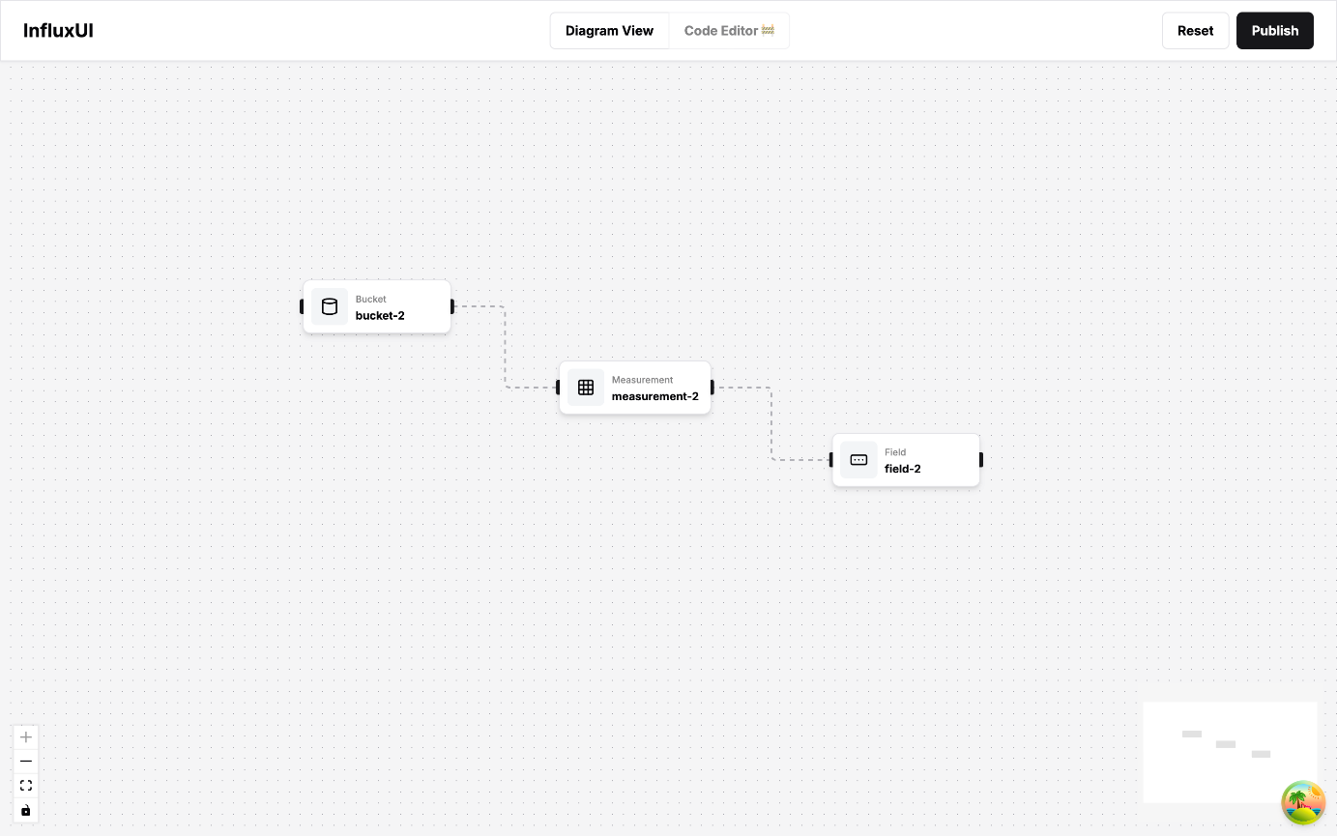

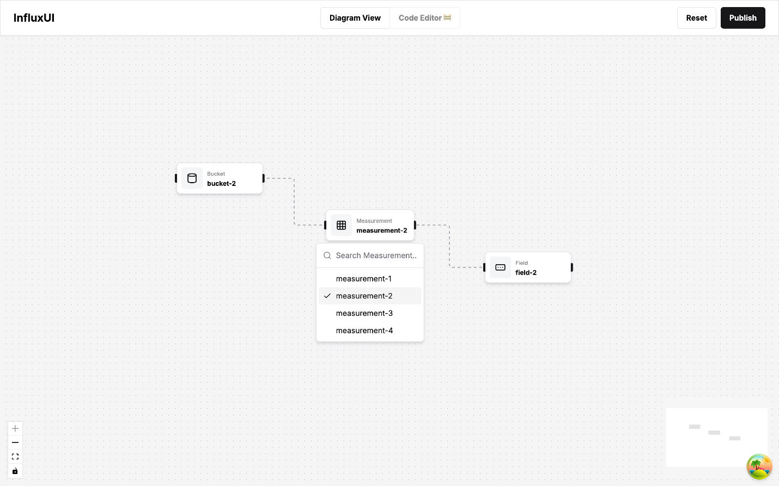

User story 1 and 2 is selected for the current sprint. While the backend team focuses on achieving the same level of authentication from InfluxDB with data integration to our application, frontend mainly based its development on drag-and-drop feature. Also, the hierarchy between bucket, measurement, and field is being handled and filter functionality is being explored.

**Definition of Done**

* Drag-and-drop functionality is fully implemented and intuitive for users.
* The interface is optimized for clarity and ease of use
* Filters work seamlessly with the drag-and-drop feature and the hierarchy navigation
* The features pass usability tests and validate the correct operations to ensure accuracy and performance

**Summary of Changes**

In the current sprint, we implemented secure authentication with InfluxDB, ensuring proper user roles and permissions while integrating real-time data seamlessly into our application. On the frontend, we developed an accessible drag-and-drop feature, making the user interface more approachable. We also mapped out and integrated the hierarchy between bucket, measurement, and field, and added filter functionality to refine data views effectively.

All code changes were thoroughly reviewed by team members, meeting the team’s coding standards, and documentation was updated to include user guides, API docs, and technical specs timely. Finally, the application was successfully deployed to a staging environment, with all the new features functioning as expected currently, bringing InfluxDB and Grafana closer to a more user-friendly system.