**Snapshot Week 07 of Group PG02**

**Project of ATSYS**

**No-Code Solution for InfluxDB**

**LeStartUP**

Zilin Song - a1833935

Jen-Hao Liu - a1893169

Dang Quy Duong - a1893592

Baojing Li - a1894836

Shih-Han Lin - a1900715

Feinan Guo - a1903270

Xiaoqing Zhao - a1904344

Hao Jiang - a1907177

Ziqi Zhang – a1909438

**Product Backlog and Task Board**

Based on the characteristics of this project, our group keep following our cooperation with the splitting subgroups of frontend and backend (server side) to develop the backlog items discussed during the end of sprint 2 and the begin of sprint 3.

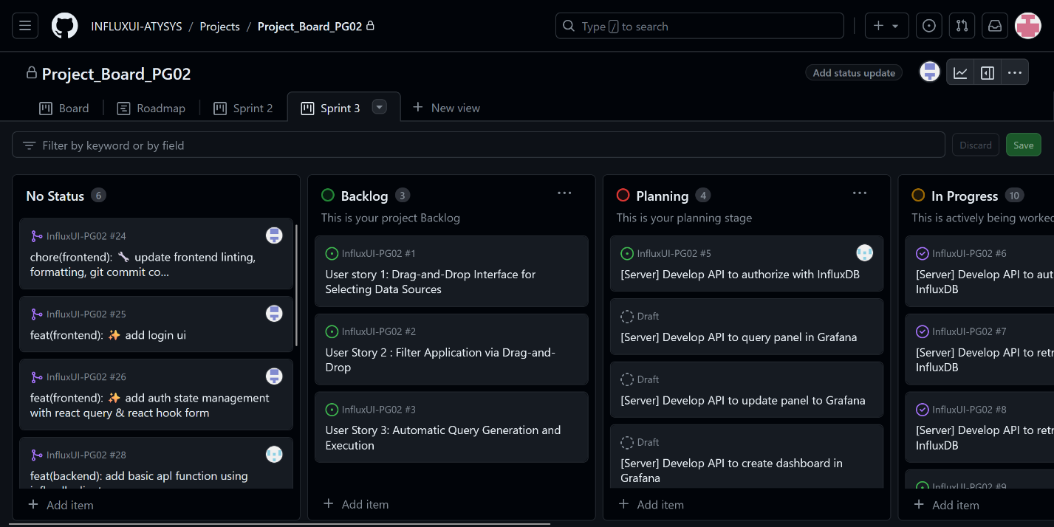

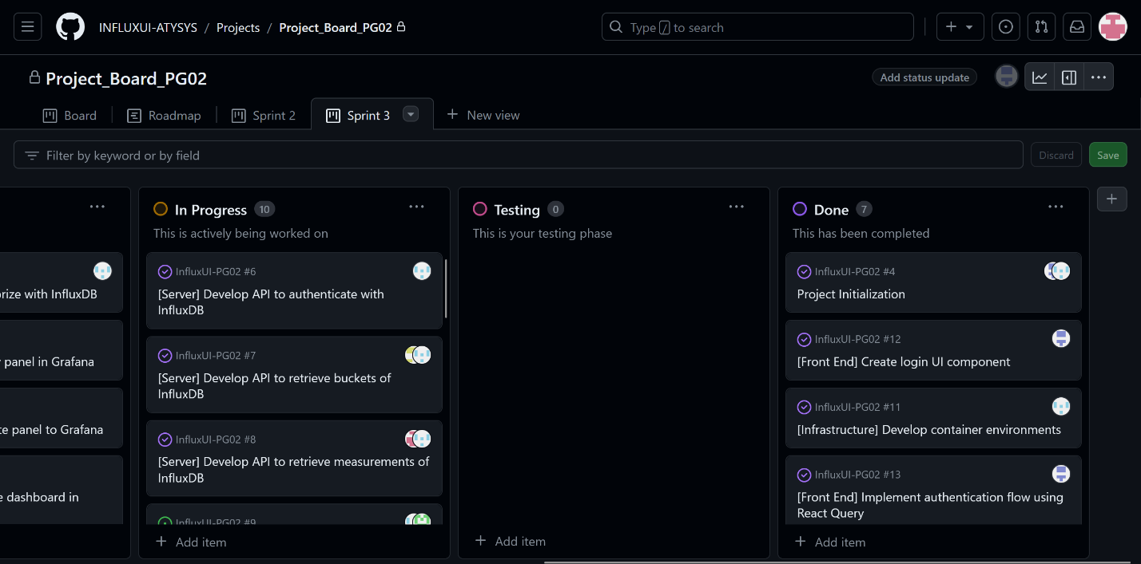

**Sprint Backlog and User Stories**

* Milestones of the end of sprint 2 and beginning of sprint 3:

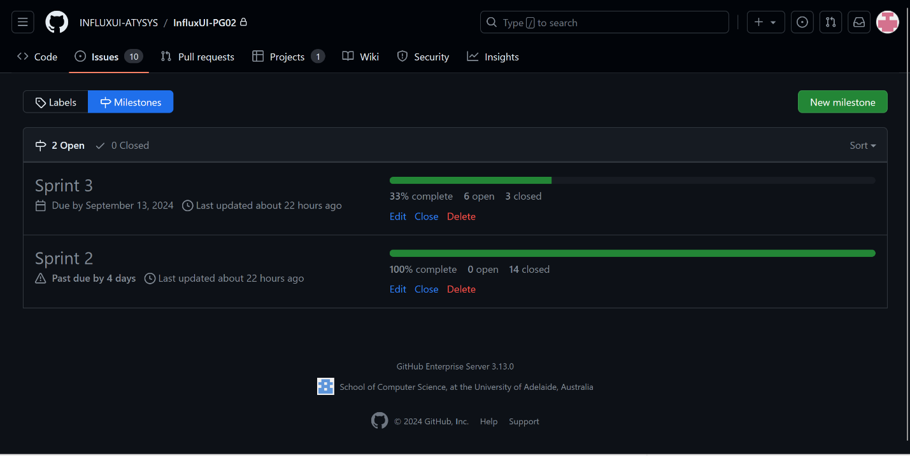

* Sprint issues we are working on:

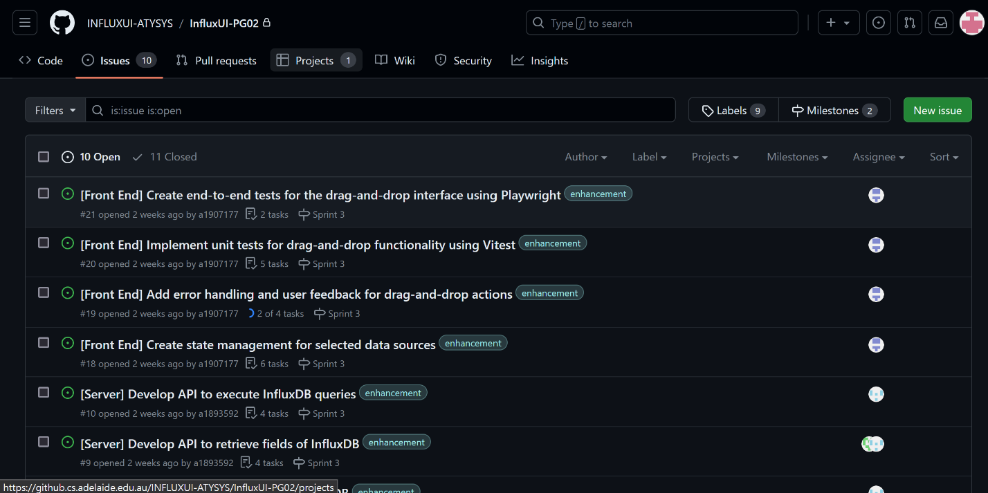

* (Backend) Postman retrieve buckets API testing:

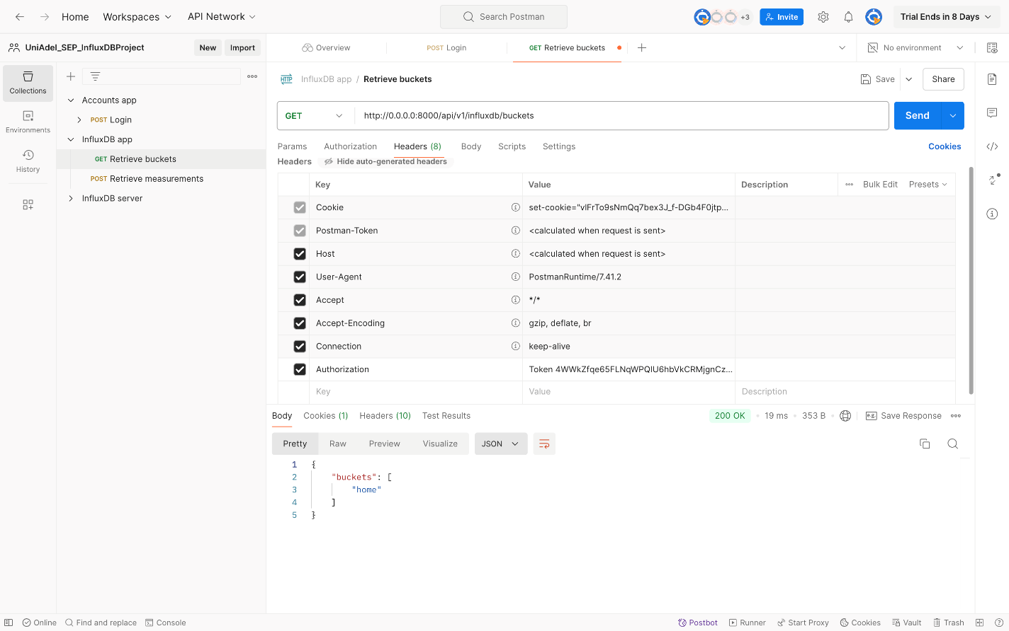

* (Backend) InfluxDB server login (running on docker: defining port on 8086)

* (Backend) Log in to InfluxDB successfully

* (Frontend) Development of drag-and-drop with the side bar for selecting data sources

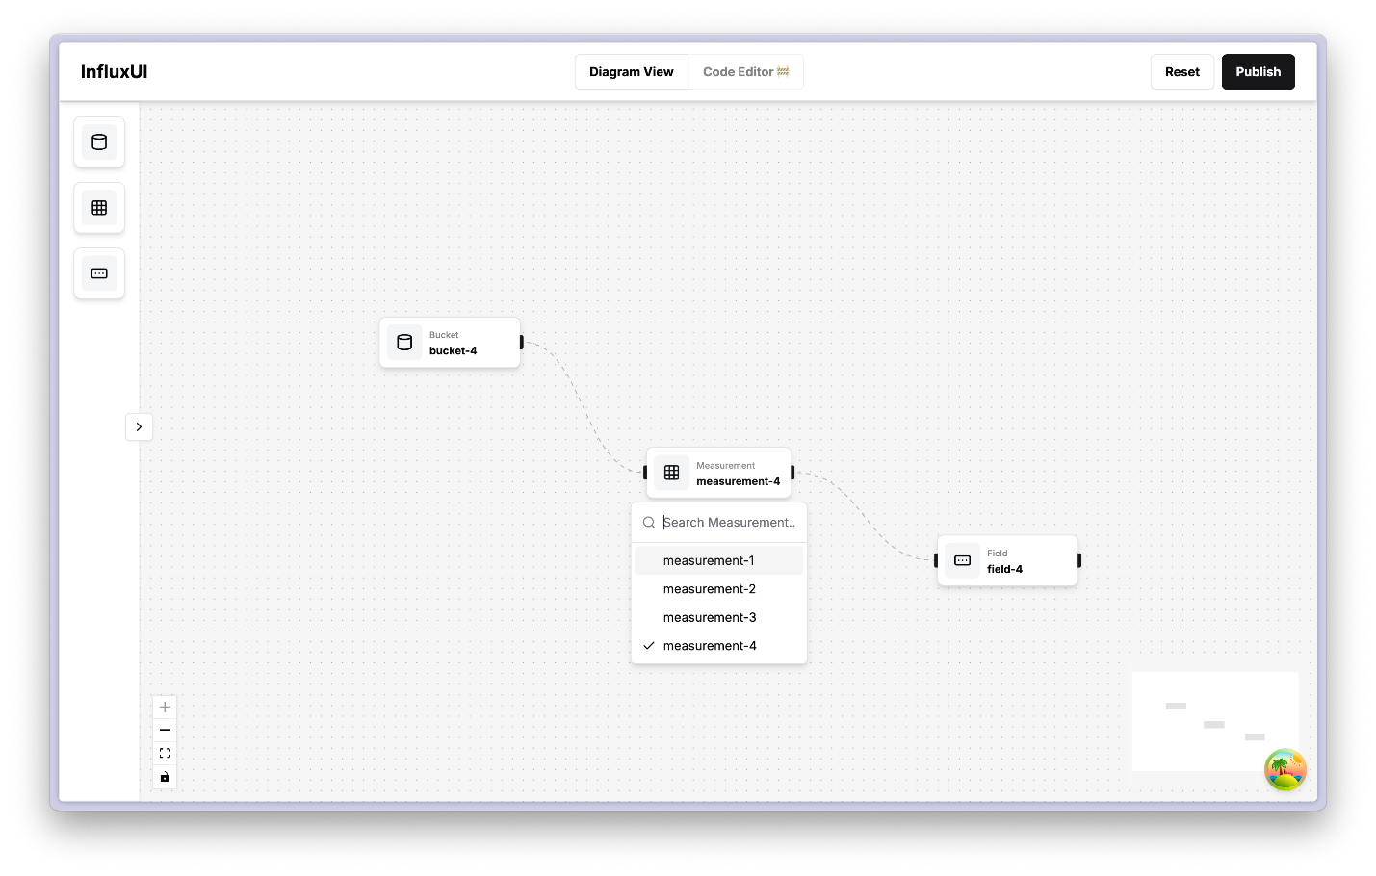

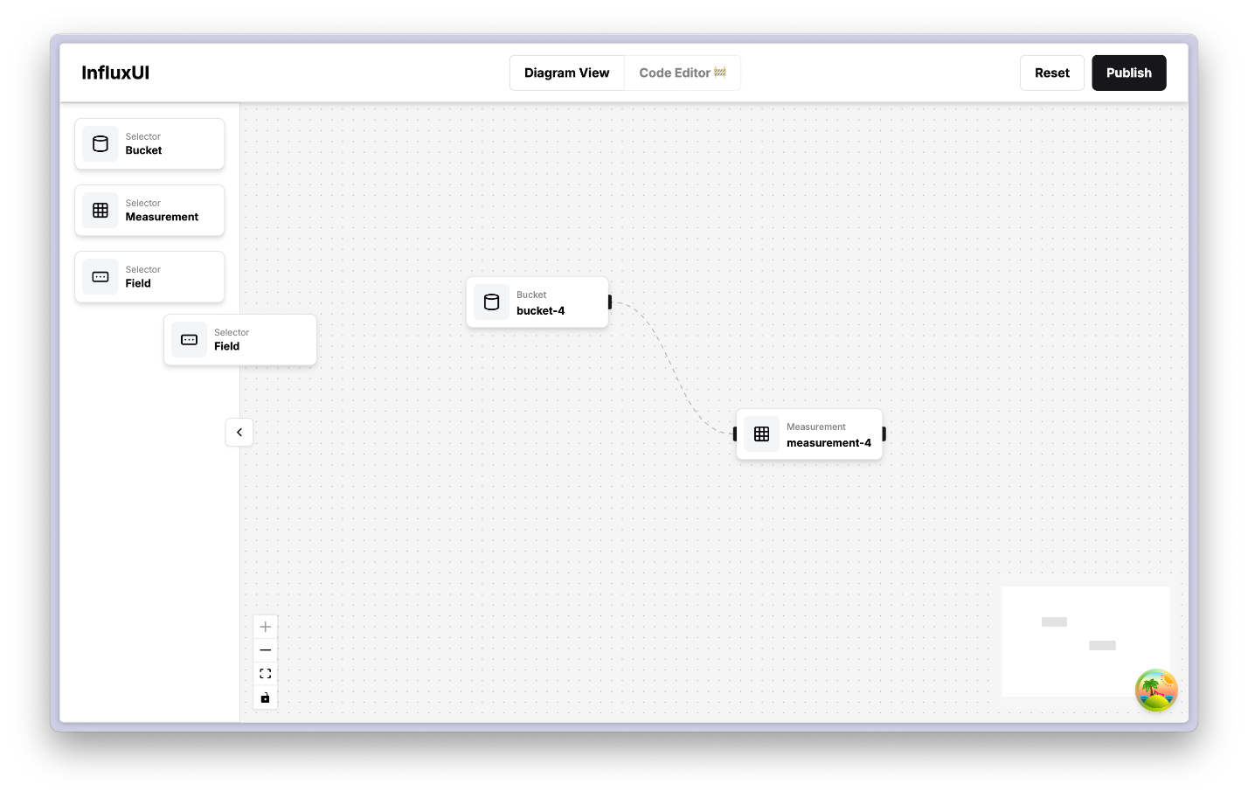

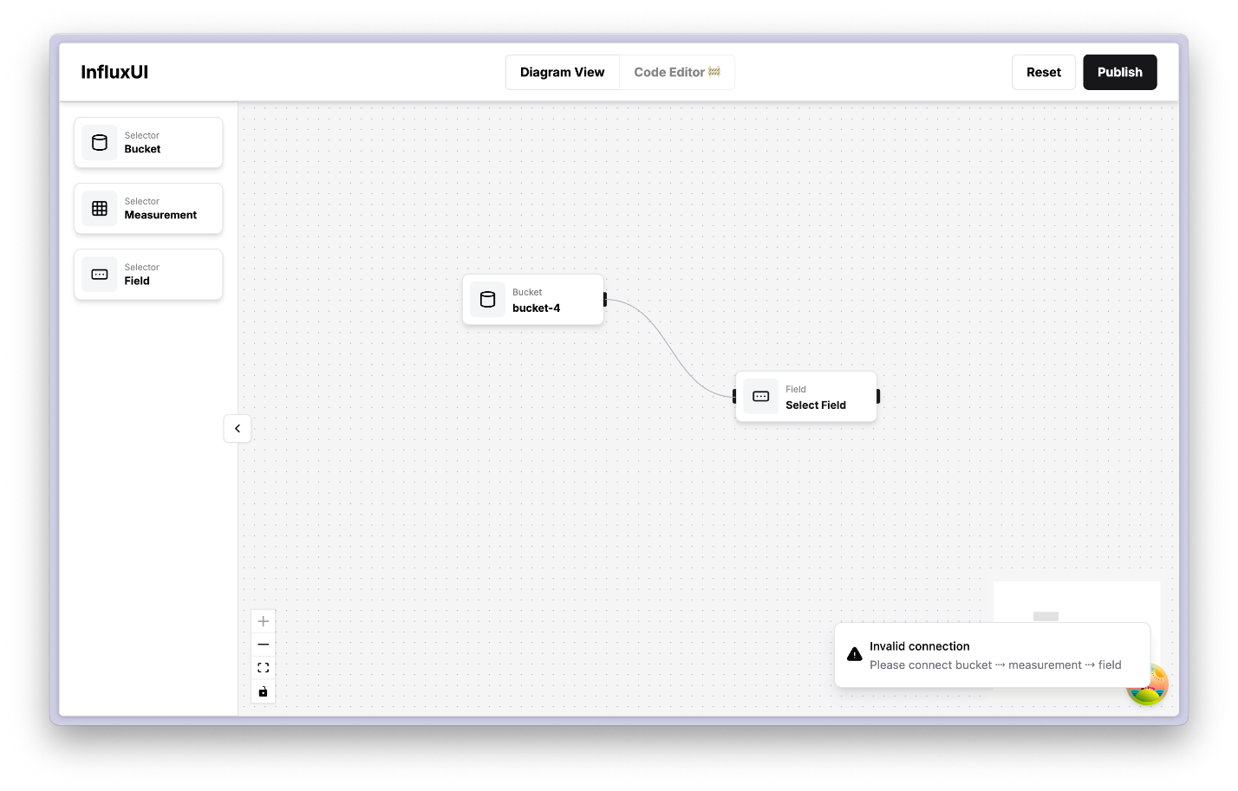

User story 1 and 2 is selected for the current sprint. For the **frontend**, the completed tasks include setting up a local login environment to redirect users to the editor page, completing the header and side sections based on the first two user stories, and implementing drag-and-drop functionalities within the editor page with hierarchy logic and filter selection.

In the **backend**, several key tasks have been completed. These include completing authentication and authorization under InfluxDB, finalizing the workflow API for authorization, allowing users to login to the application and access web data, and developing APIs to retrieve buckets and measurements from InfluxDB (although the latter still needs testing and error handling). Incomplete tasks include developing the API to retrieve fields from InfluxDB is still working on.

**Definition of Done**

* Drag-and-drop functionality is fully implemented and intuitive for selecting data sources.
* The user interface is optimized for clarity and ease of use.
* Filters work seamlessly with the drag-and-drop feature and the hierarchy navigation
* The features pass usability tests and validate the correct operations to ensure accuracy and performance
* Sending requests of retrieving buckets through Postman API test successfully.

**Summary of Changes**

* Scrum Master of sprint 3 is Ziqi Zhang – a1909438
* Frontend: Continue working on current user stories and ensure progress toward sprint goals.
* Frontend: Refine user stories 1 and 2 and collaborate with the backend team for data fetching.
* Server: Finalize the API for retrieving buckets and measurements from InfluxDB and conduct tests for authentication, buckets, measurements, and user flow.