**Snapshot Week 08 of Group PG02**

**Project of ATSYS**

**No-Code Solution for InfluxDB**

**LeStartUP**

Zilin Song - a1833935

Jen-Hao Liu - a1893169

Dang Quy Duong - a1893592

Baojing Li - a1894836

Shih-Han Lin - a1900715

Feinan Guo - a1903270

Xiaoqing Zhao - a1904344

Hao Jiang - a1907177

Ziqi Zhang – a1909438

**Product Backlog and Task Board**

While our frontend team focuses on resolving the presentation issues for measurements and fields on the interface, backend team aims to use cookies for authorization and authentication in API testing.

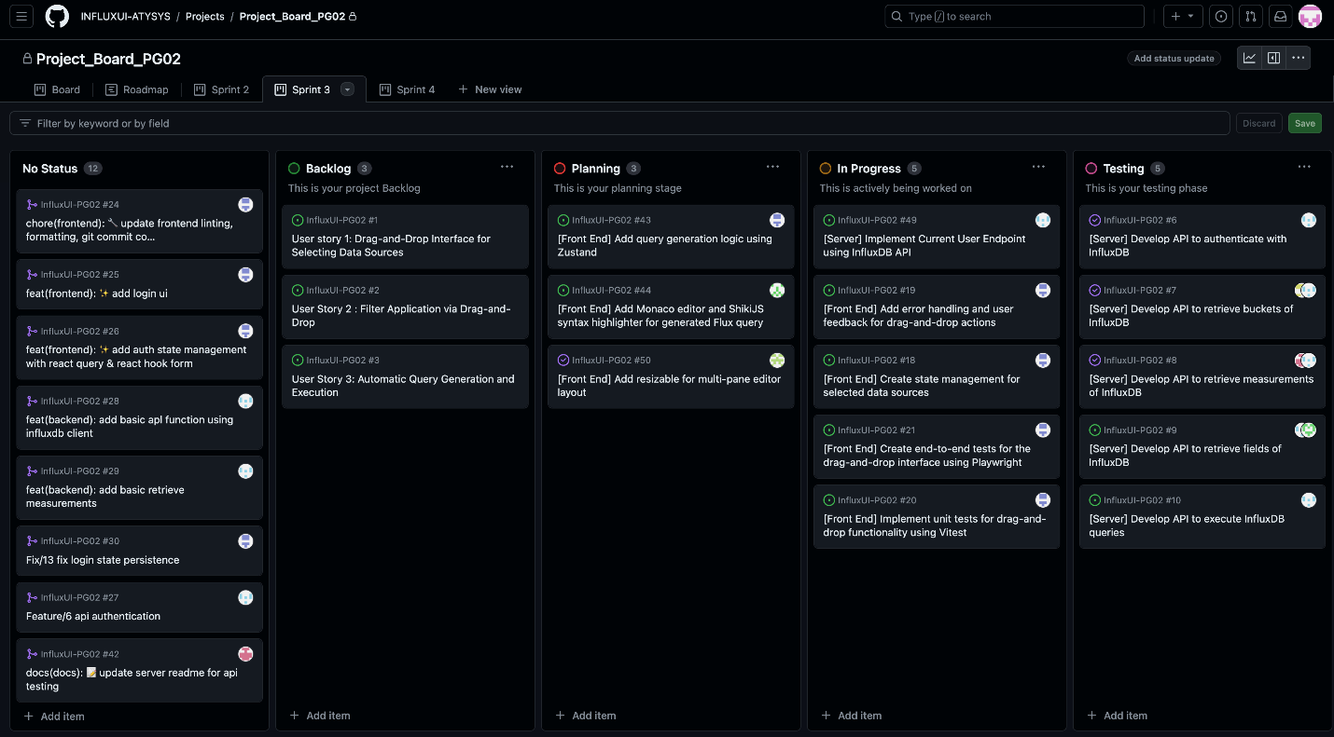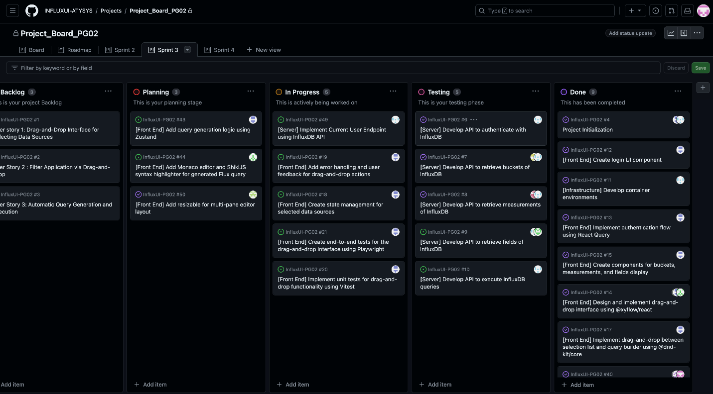

**Sprint Backlog and User Stories**

* Milestones of the end of sprint 3 and beginning of sprint 4:

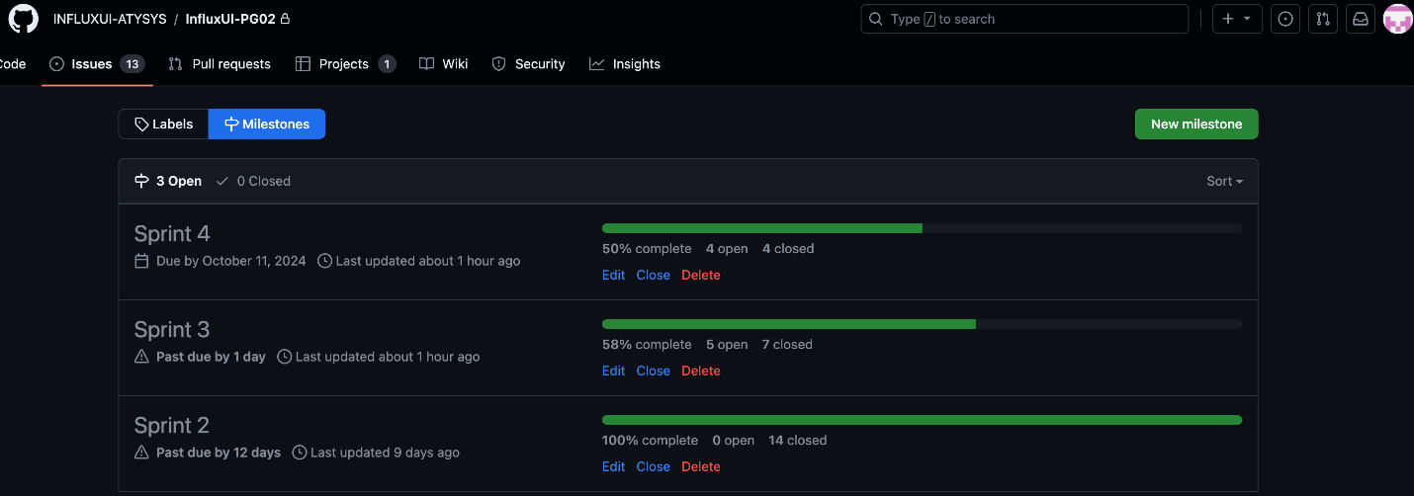

* Sprint issues we are working on:

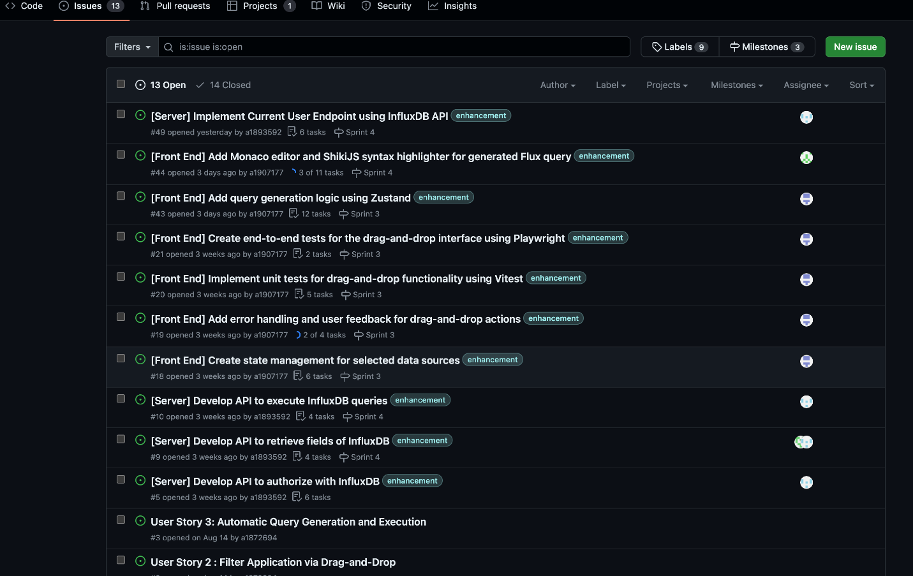

* Frontend: Implement Value Threshold Filter Component

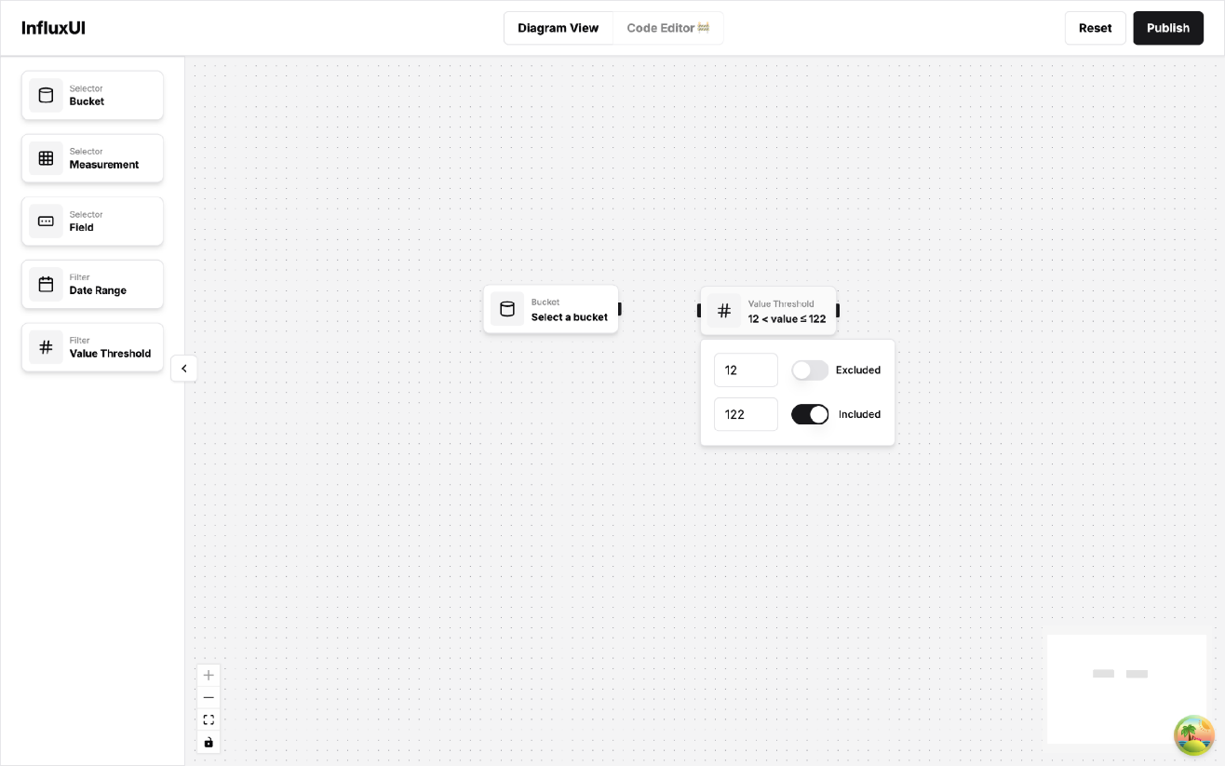

* Frontend: Implement Date Range Filter Component

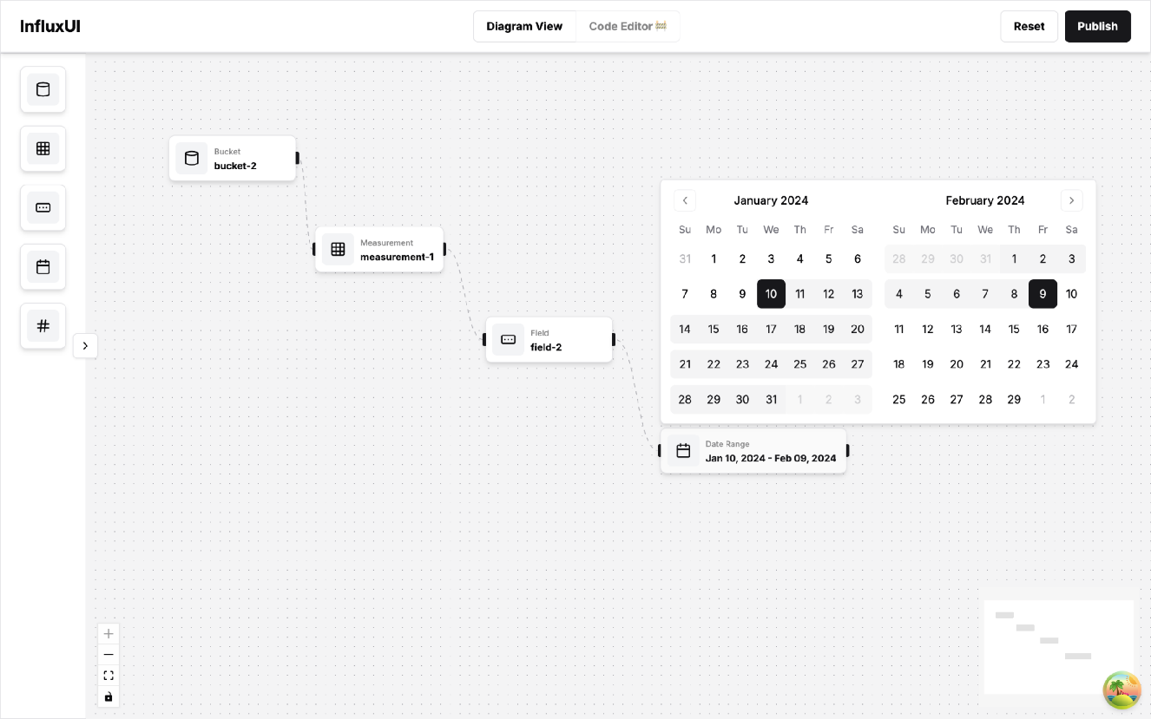

* Frontend: Implement Resizable Multi-Panel Layout

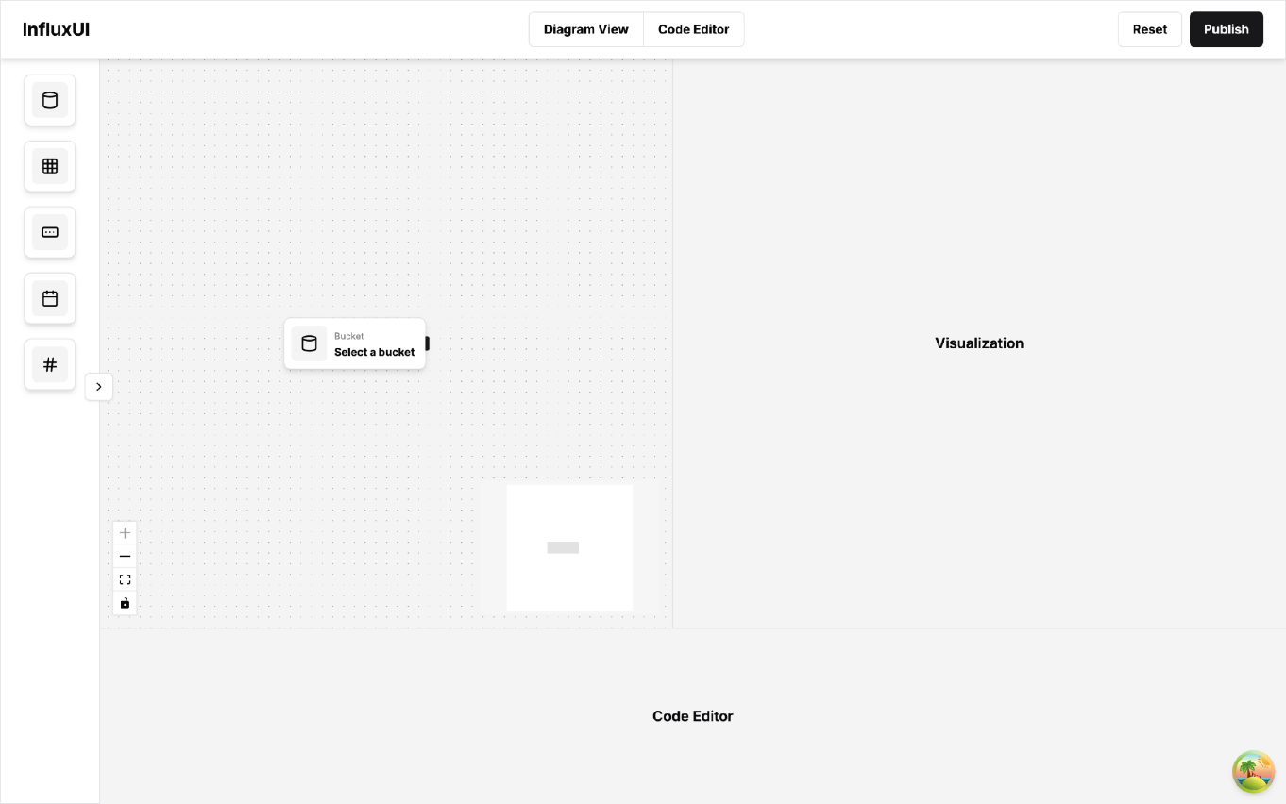

* Backend: retrieve buckets successfully via Insomnia

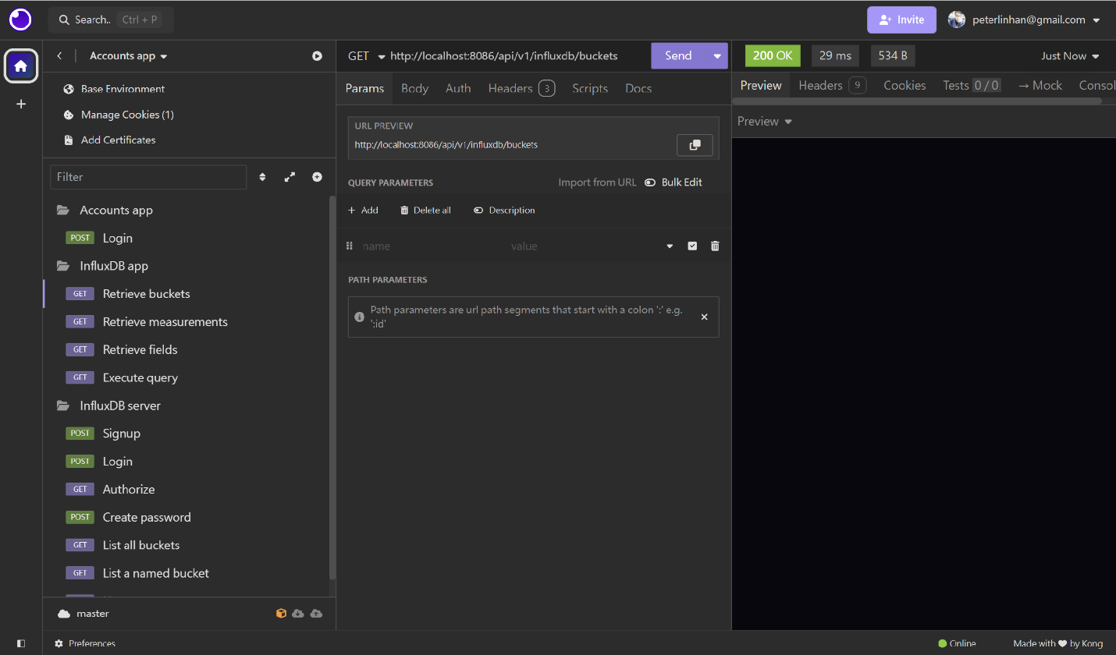

* Backend: retrieve field

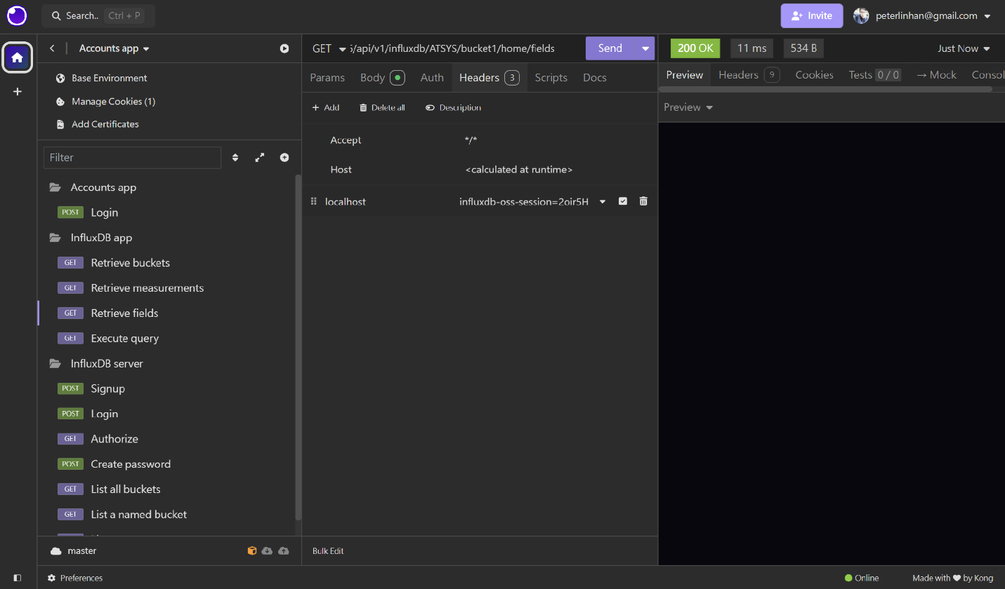

* Backend: retrieve measurements

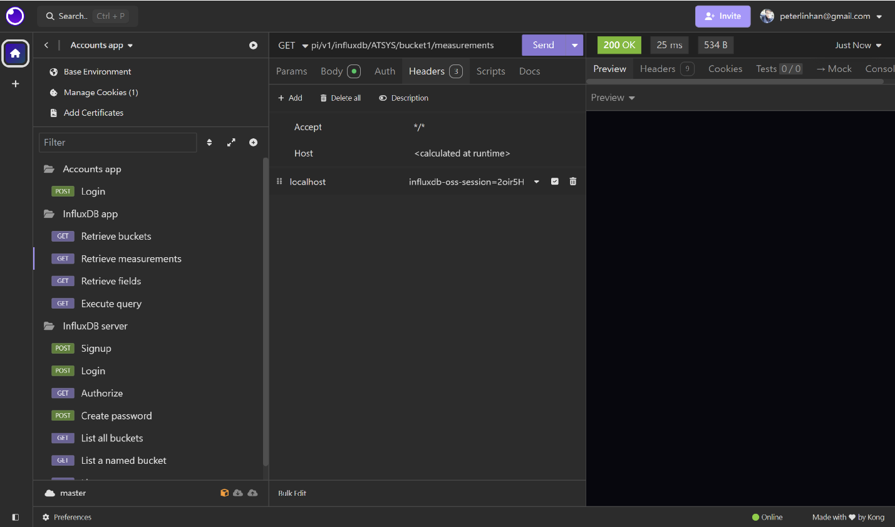

On the frontend, our team successfully completed two key backlog items: implementing the presentation of buckets and developing date range filtering functionality. And we also finished adding a resizable multi-panel layout for the editor page. Meanwhile, the backend team made strides in updating the authentication mechanism, shifting from token-based to cookie-based authentication for API testing and the 'retrieve buckets' functionality.

However, several items remain in progress, the frontend team still needs to address the presentation of measurements and fields, fix value threshold bugs, and resolve browser compatibility issues. On the backend, work continues retrieving measurements and fields from InfluxDB, as well as executing InfluxDB queries. As we move into sprint planning for the next iteration, our team is focusing on refining user stories, aligning frontend and backend API testing, and conducting user flow and edge case testing.

**Definition of Done**

* Date range and value thresholds filter components are implemented
* Multi-panel layout is added
* Frontend and backend API testing is aligned
* Buckets, measurements, and fields retrieval using cookies instead of tokens.

**Summary of Changes**

* Refine user stories 1 and 2 and collaborate with the backend team to fetch data (95% in progress)
* More user flow testing to be conducted once the API of execution of InfluxDB queries is completed.