**Snapshot Week 09 of Group PG02**

**Project of ATSYS**

**No-Code Solution for InfluxDB**

**LeStartUP**

Zilin Song - a1833935

Jen-Hao Liu - a1893169

Dang Quy Duong - a1893592

Baojing Li - a1894836

Shih-Han Lin - a1900715

Feinan Guo - a1903270

Xiaoqing Zhao - a1904344

Hao Jiang - a1907177

Ziqi Zhang – a1909438

**Product Backlog and Task Board**

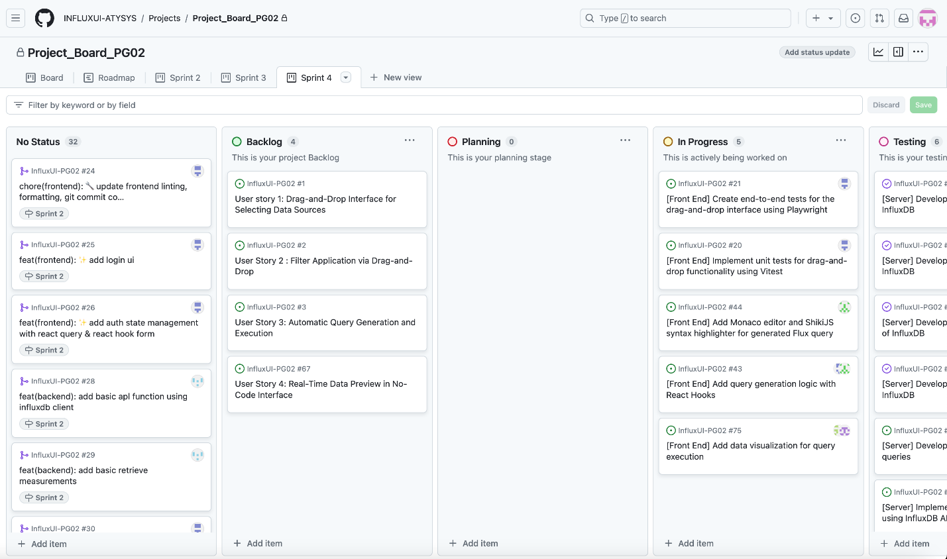

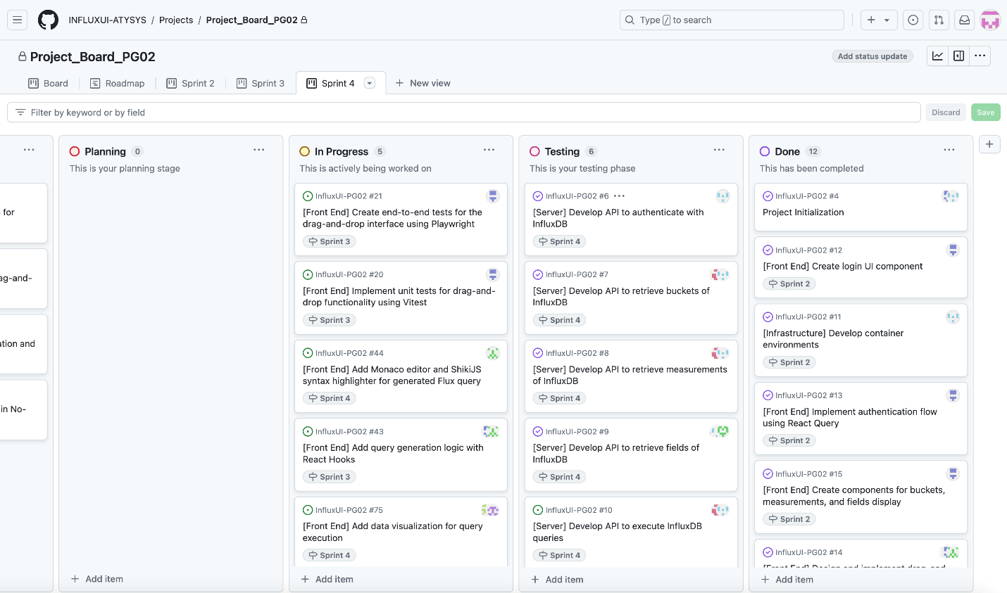

**Sprint Backlog and User Stories**

* Milestones of the end of sprint 4 and beginning of sprint 5:

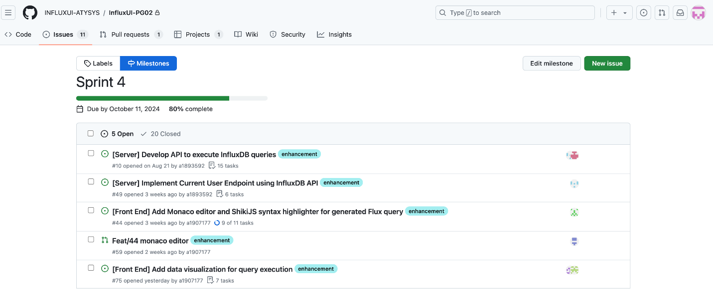

* Sprint issues we are working on:

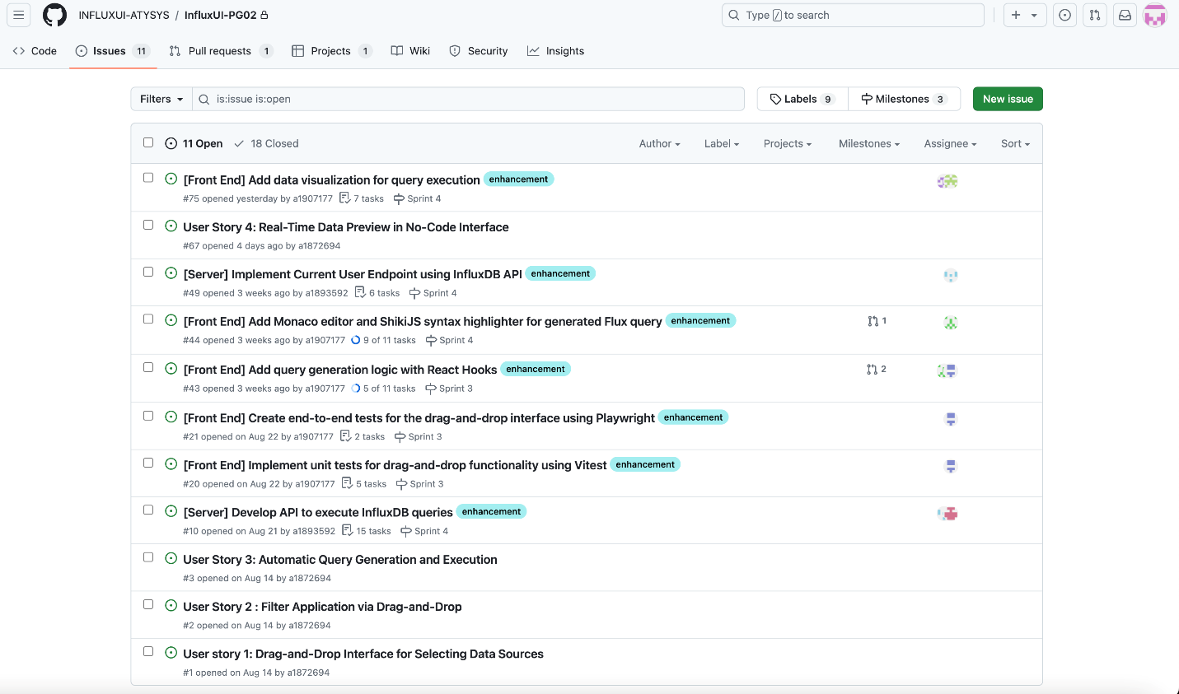

* Frontend: current side bar nodes

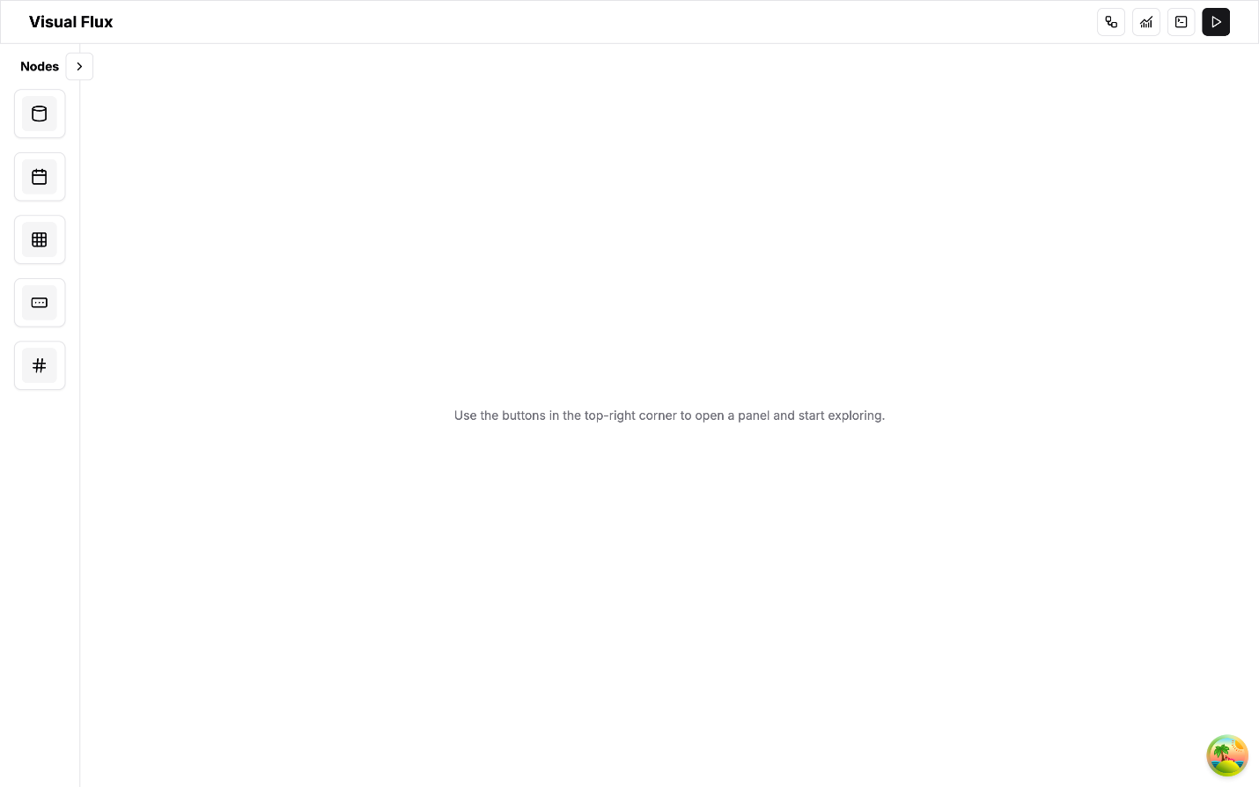

* Frontend: auto align and reset for flow state node

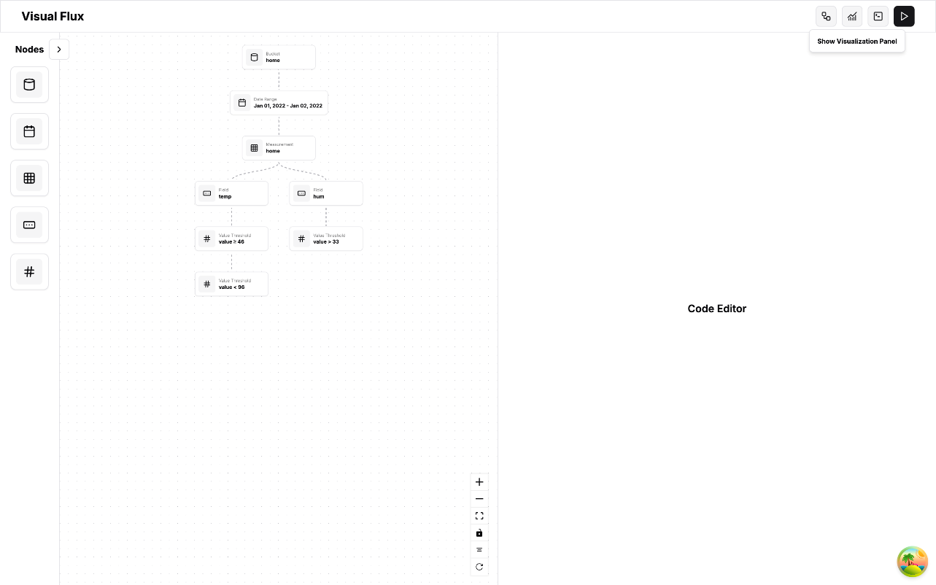

* Frontend: visualisation feature

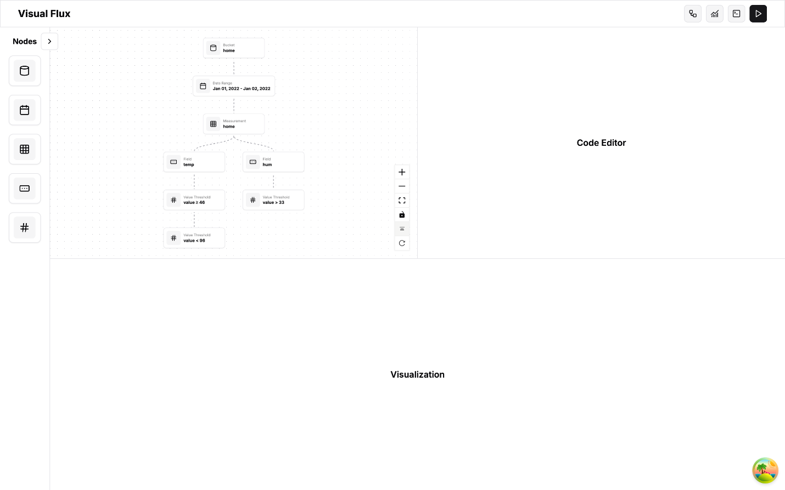

* Backend: execute query

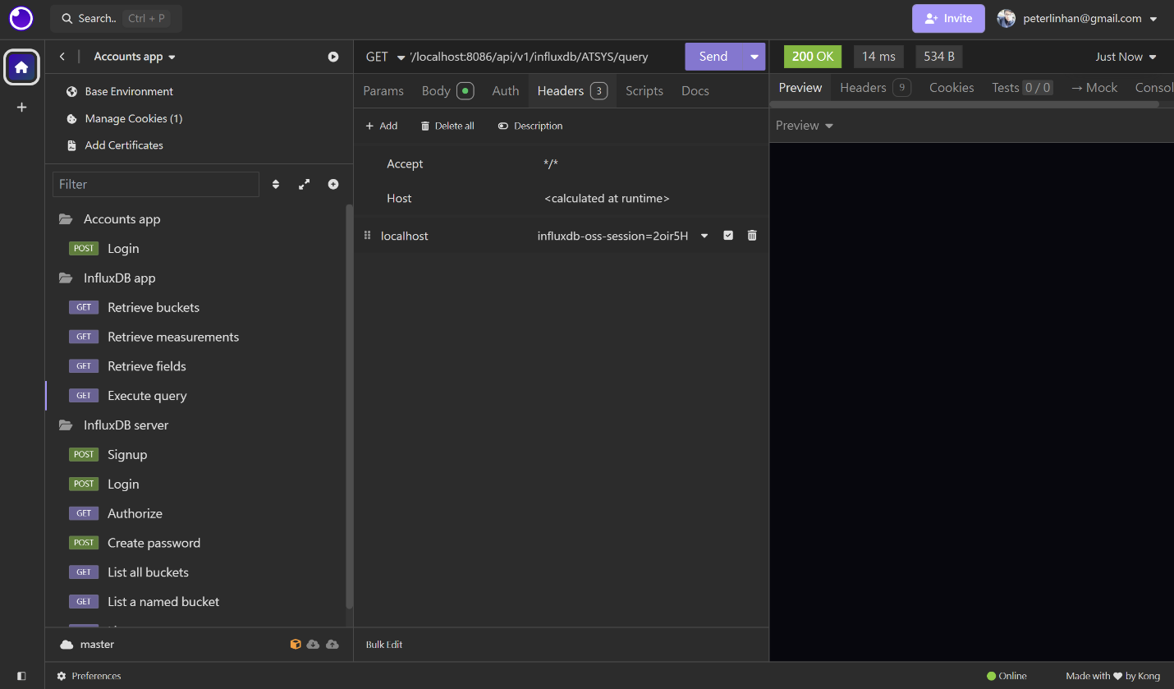

On the frontend, our team successfully added a toggle reset and execute button to enhance user control within the code editor with improved the workspace layout, making it easier to manage multiple tasks/views. Meanwhile, we also ensured that workflow progress is saved even after page refreshes and fixed several bugs that were unsolved in previous sprint.

As for the backend, our team developed and tested four key APIs for retrieving data from InfluxDB. By adopting a more RESTful design, we continued to improve flexibility by using query parameters for key values. We also implemented ISO-8601 format for time series data handling.

**Definition of Done**

* Frontend:
  + features for the current sprint are fully implemented, tested, and confirmed to function without critical bugs.
  + Usability enhancements (e.g., flow state persistence) are ensured.
* Backend:
  + The API is marked complete after it has been thoroughly tested, refactored to a RESTful structure, and confirmed to handle edge cases consistently.

**Summary of Changes**

* Improve user experience with a more intuitive and flexible UI, including multi-panel design, enhanced control nodes
* Backend APIs are now more scalable and robust, with improvements in flexibility, query parameter usage, and timestamp consistency
* Bug fixed and usability refinements enhance the product’s overall reliability and user experience