**Snapshot Week 10 of Group PG02**

**Project of ATSYS**

**No-Code Solution for InfluxDB**

**LeStartUP**

Zilin Song - a1833935

Jen-Hao Liu - a1893169

Dang Quy Duong - a1893592

Baojing Li - a1894836

Shih-Han Lin - a1900715

Feinan Guo - a1903270

Xiaoqing Zhao - a1904344

Hao Jiang - a1907177

Ziqi Zhang – a1909438

**Product Backlog and Task Board**

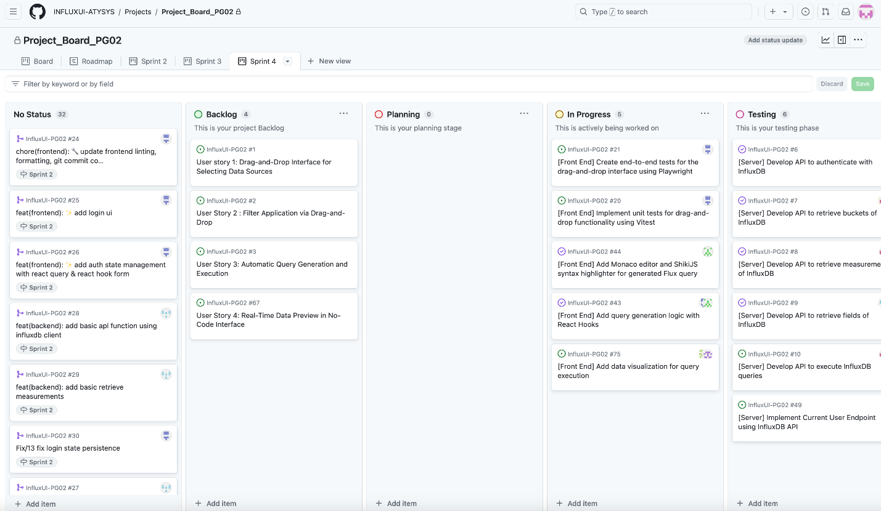

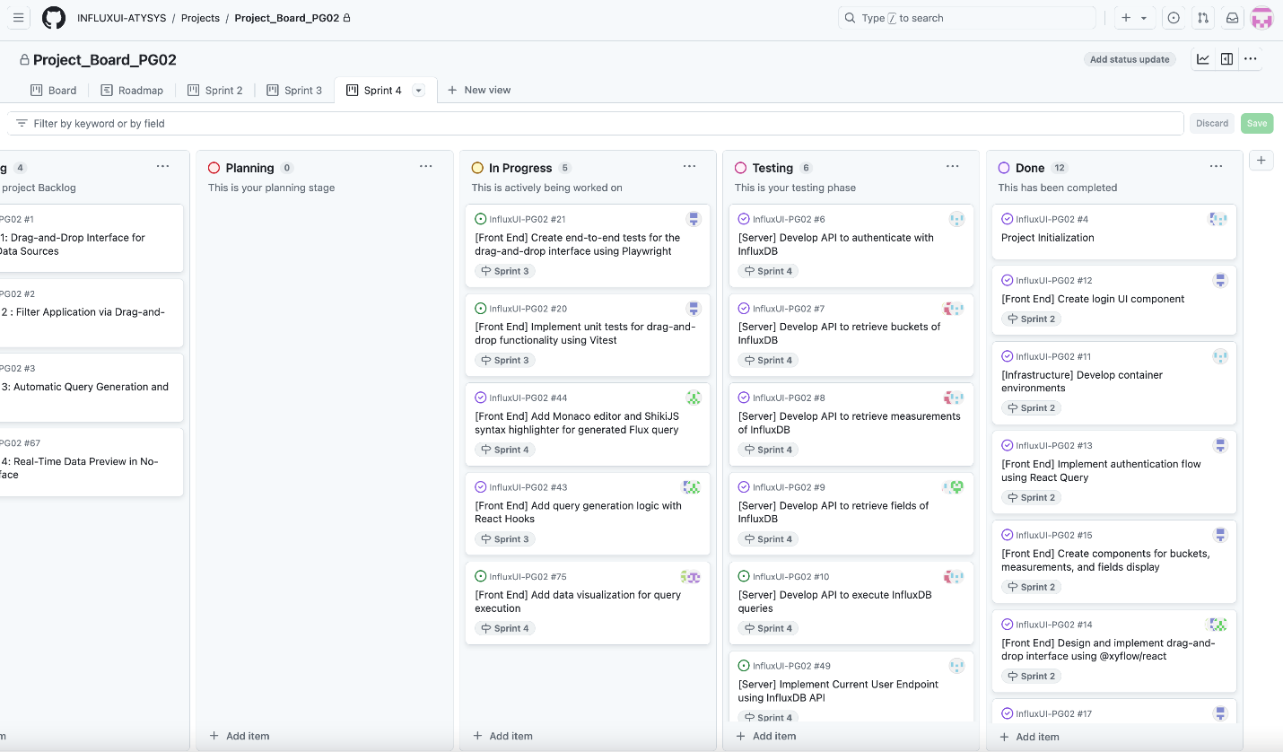

**Sprint Backlog and User Stories**

* Milestones of the end of sprint 4 and beginning of sprint 5:

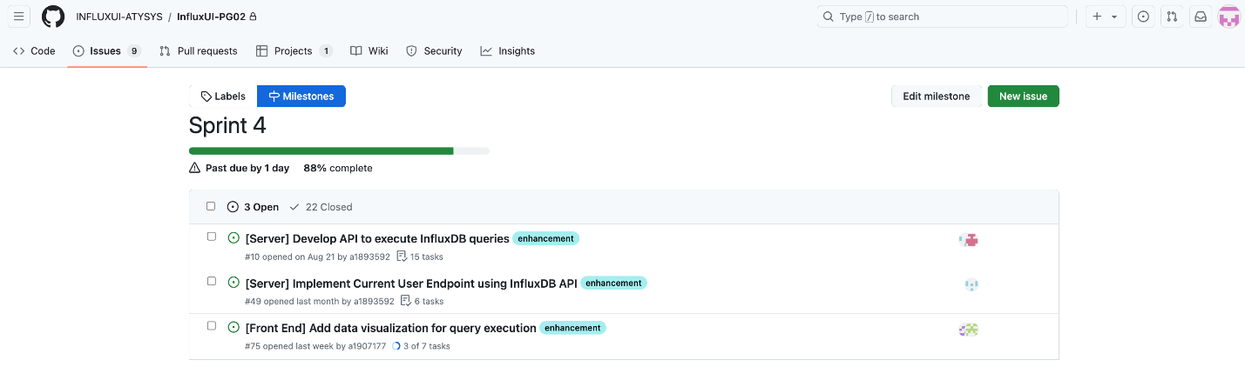

* Sprint issues we are working on:

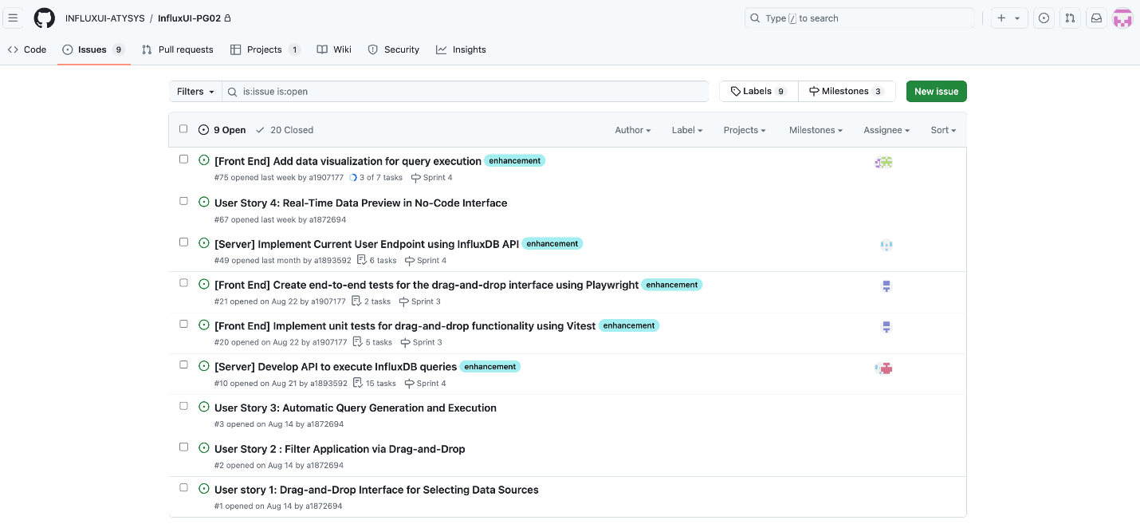

* UI: design a light mode and dark mode for user experience

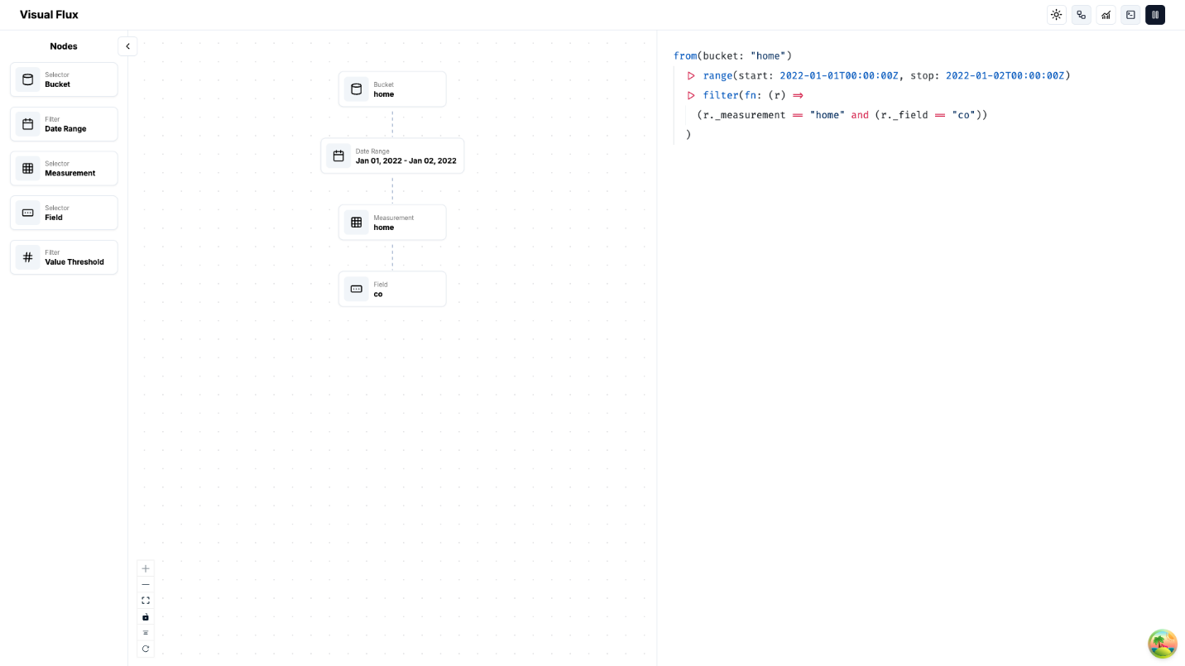

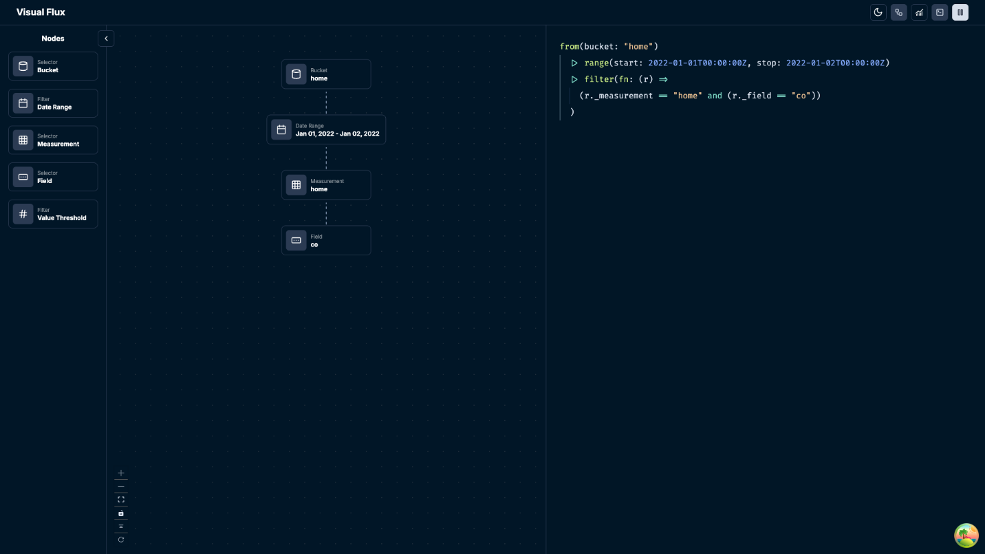

* UI: multiple-selection of drag-and-drop

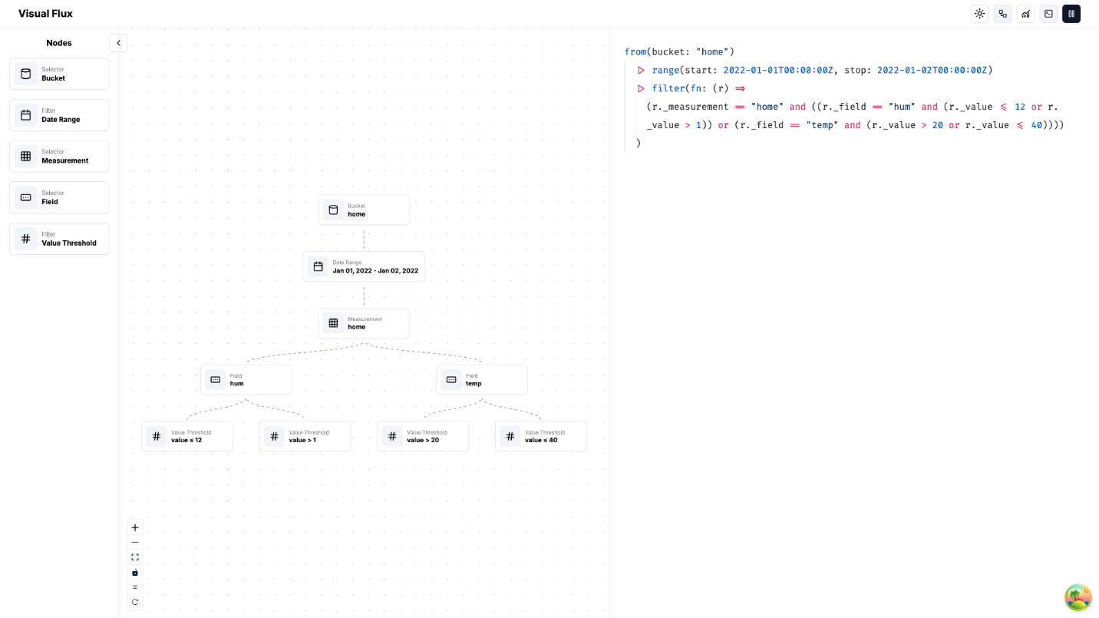

* UI: export the data to the local with a csv file

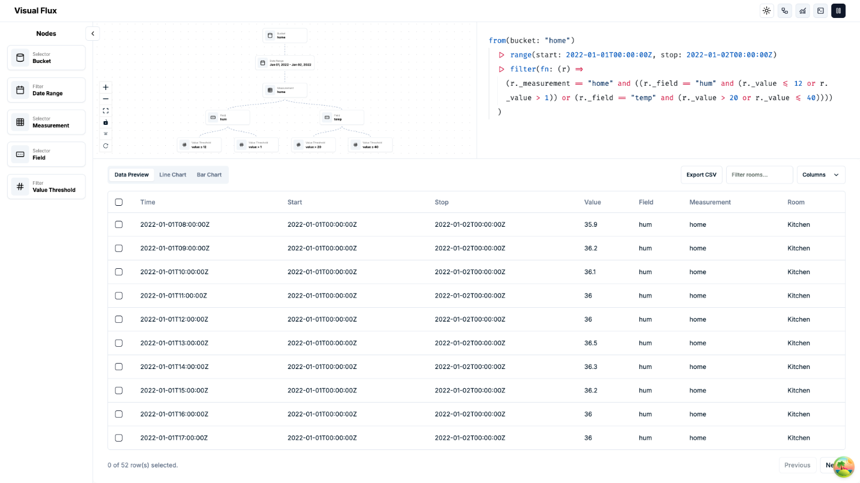

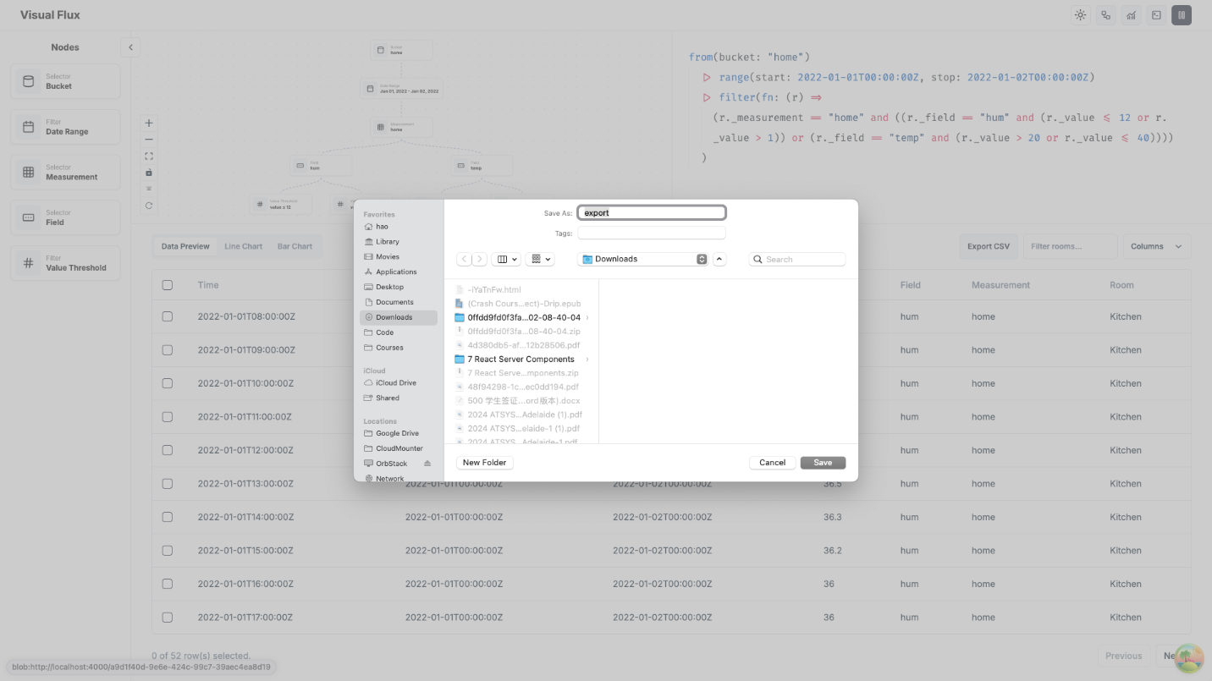

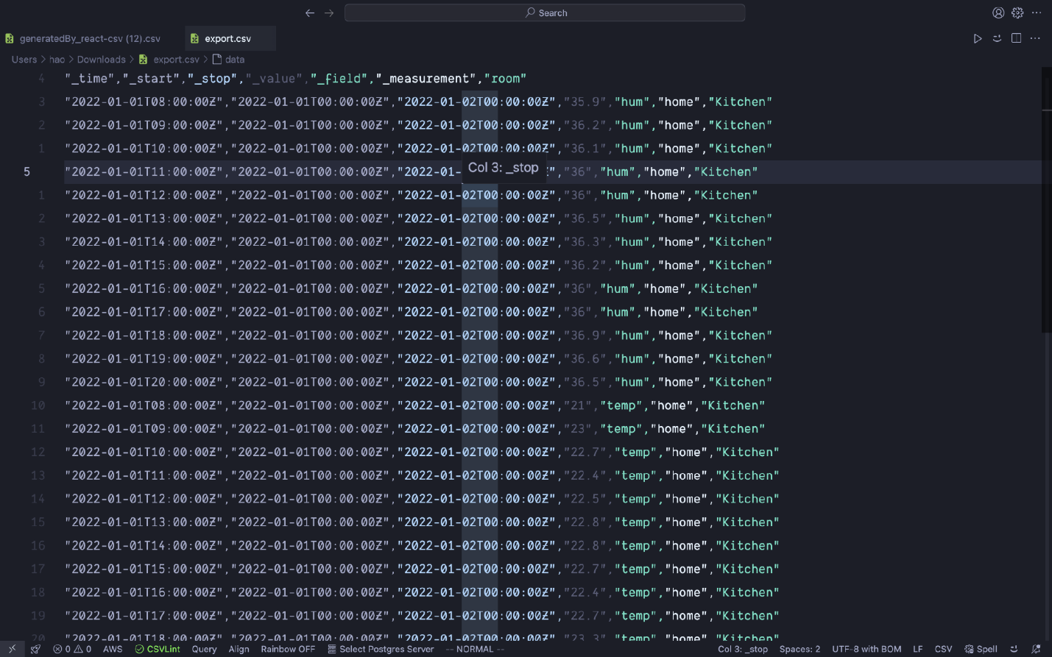

On the frontend, our team successfully modified and finalised the main user interface: top left section for drag-and-drop function, top right for code editor, bottom section for table and visualisation. Meanwhile, we also implemented multiple-selection of drag-and-drop node, with the ability to export data

As for the backend, our team completed a test plan overview and listed test case followed by specific testing process. We continued to work on final integration of frontend and server source code.

**Definition of Done**

* Frontend:
  + features for the current sprint are fully implemented, tested, and confirmed to function without critical bugs.
  + Schedule for final code integration is set after debugging and testing.
* Backend:
  + Test plans creation and corresponding documentation per process to record progress.
  + Dynamic source code integration in final production

**Summary of Changes**

* Improve user experience with a more intuitive and flexible UI, including multi-selection design and ability to export data
* Bug fixed and testing schedules to enhance the product’s overall integration progress