**Snapshot Week 11 of Group PG02**

**Project of ATSYS**

**No-Code Solution for InfluxDB**

**LeStartUP**

Zilin Song - a1833935

Jen-Hao Liu - a1893169

Dang Quy Duong - a1893592

Baojing Li - a1894836

Shih-Han Lin - a1900715

Feinan Guo - a1903270

Xiaoqing Zhao - a1904344

Hao Jiang - a1907177

Ziqi Zhang – a1909438

**Product Backlog and Task Board**

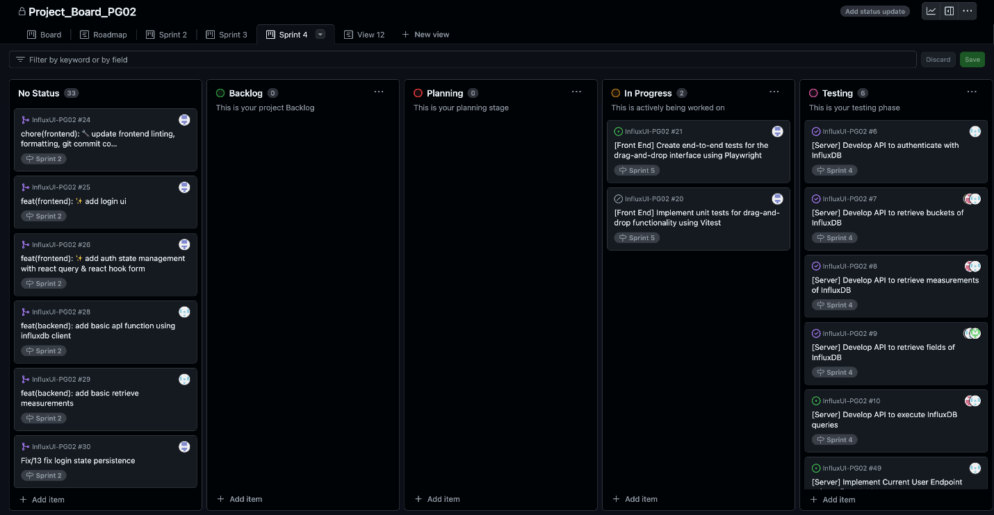

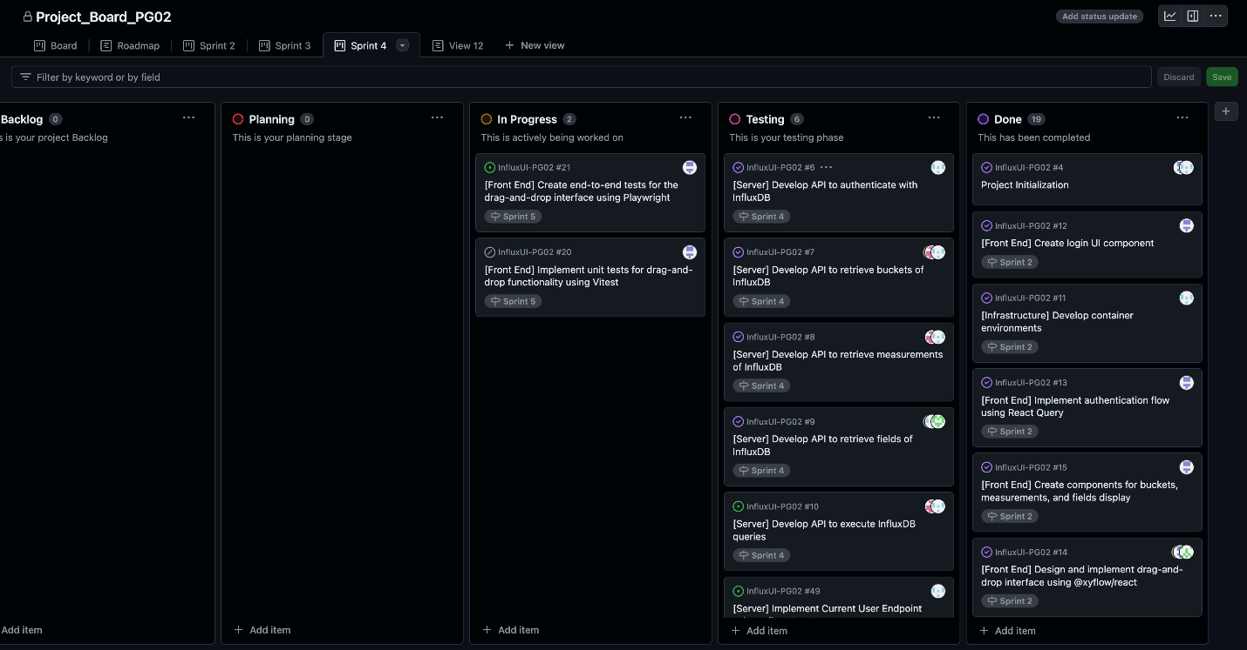

**Sprint Backlog and User Stories**

* Milestones of the end of sprint 5:

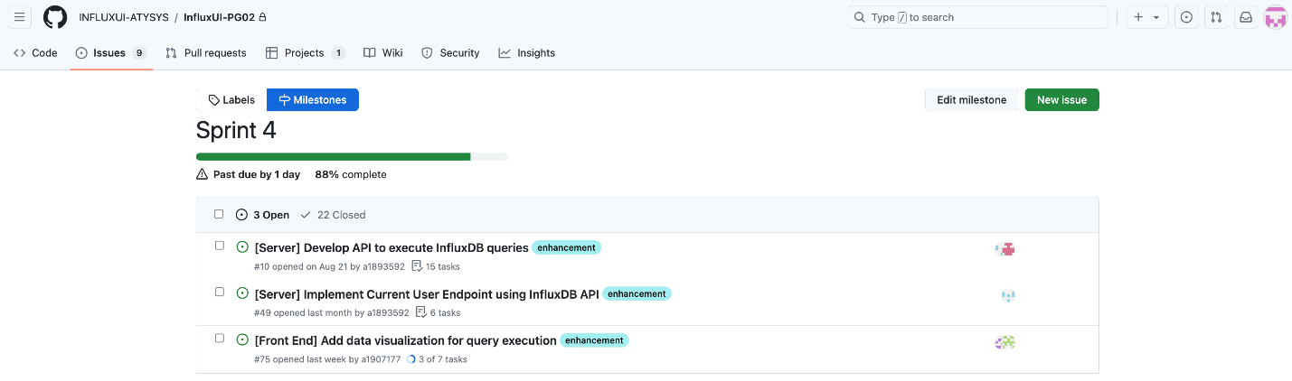

* UI: dark mode feature with all panels

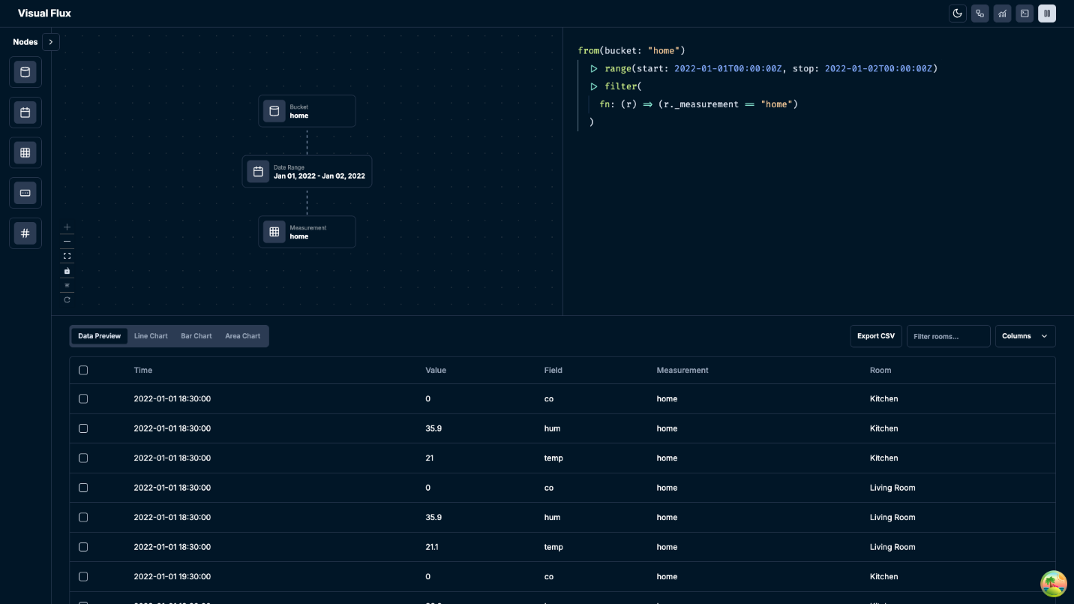

* UI: data visualisation – line chart

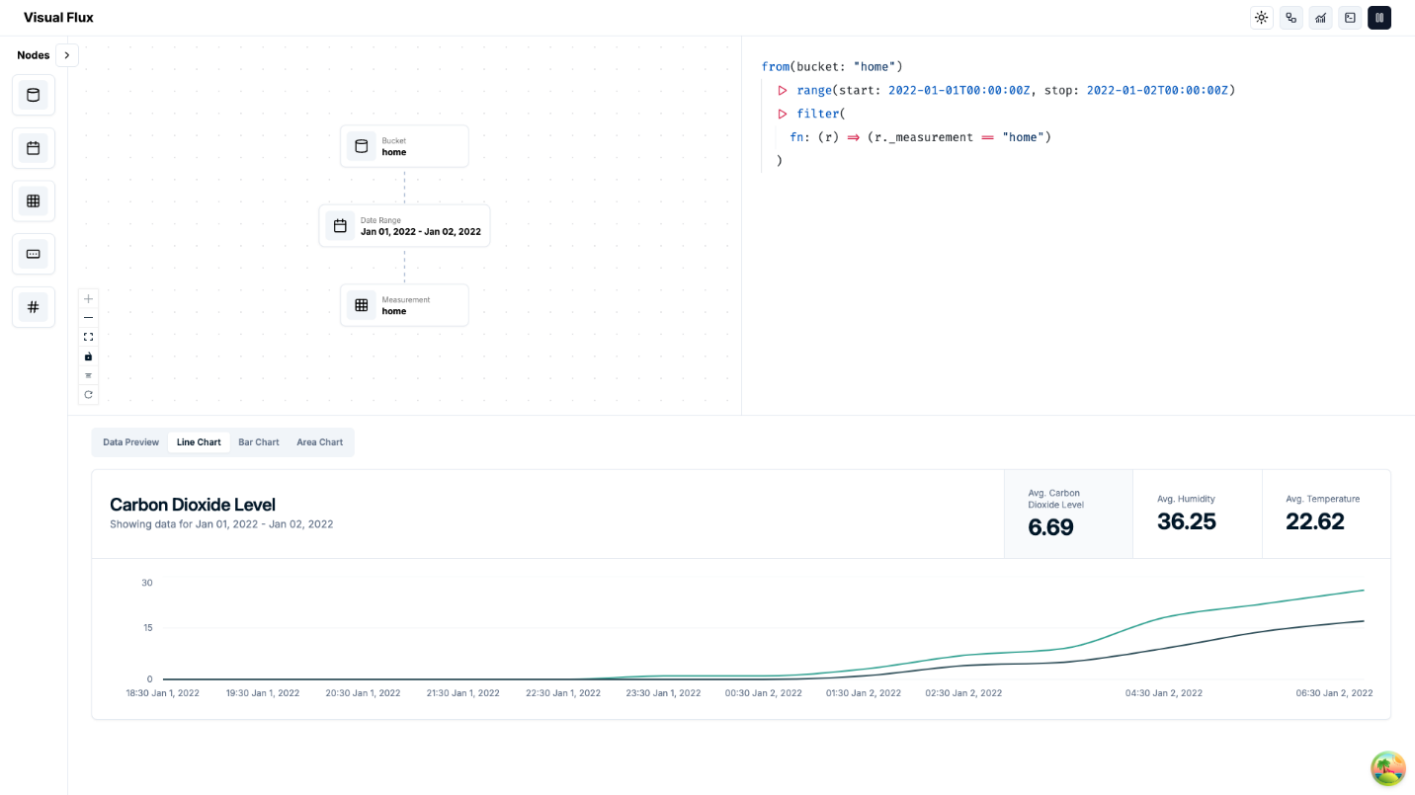

* UI: data visualisation – bar chart

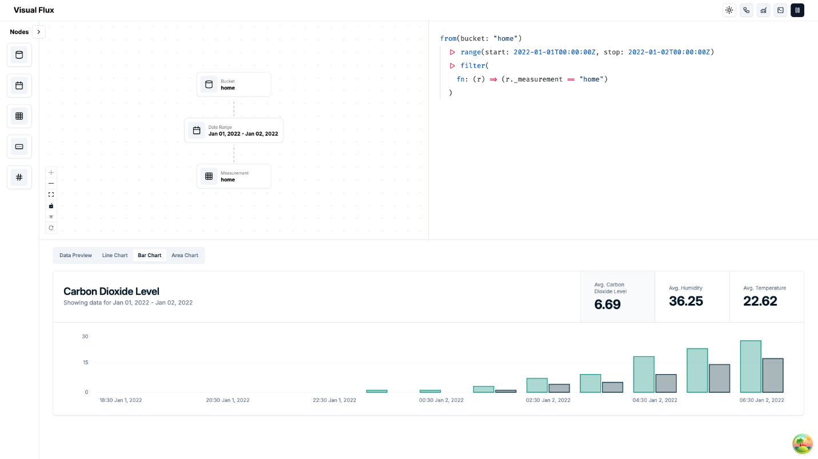

* UI: data visualisation – area chart

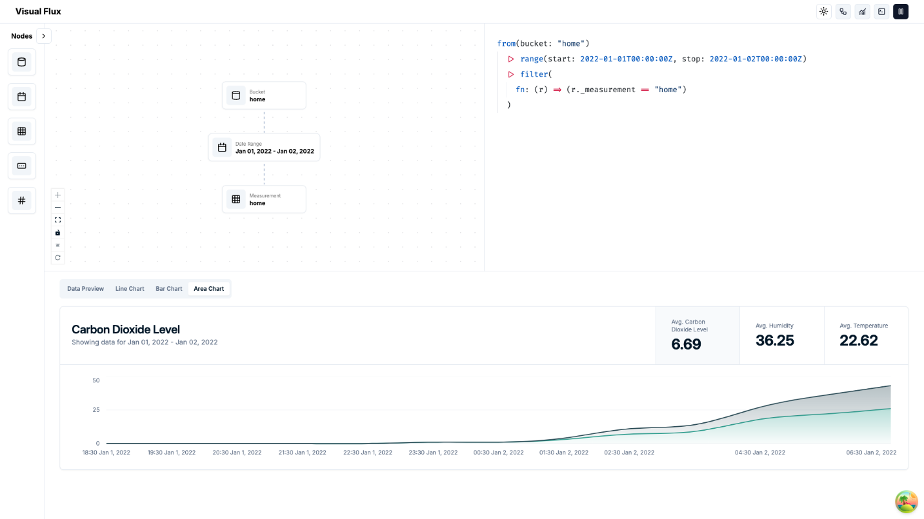

* UI: data visualisation – area chart with multi-selection

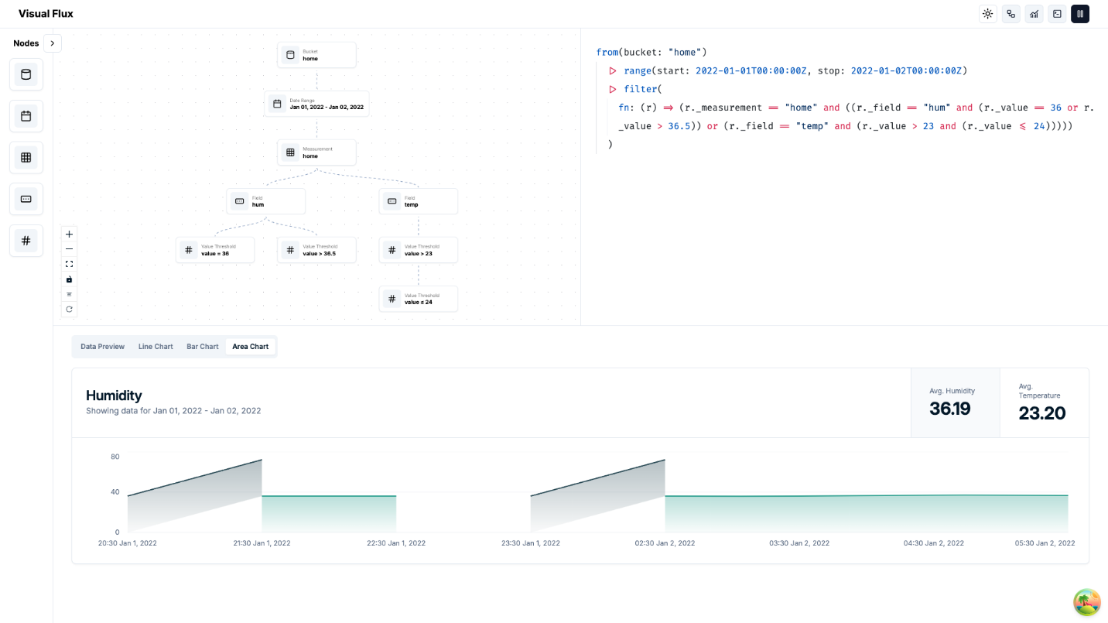

* UI: data visualisation – bar chart with multi-selection

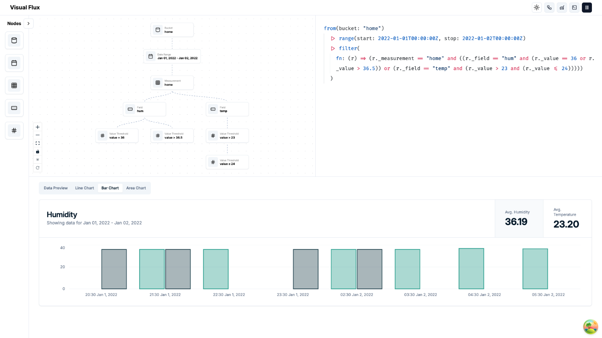

Our team successfully completed the main user interface with a selection of light and dark mode for user experience. Meanwhile, we also refined the multiple-selection of drag-and-drop node, with the ability to timely visualize data in three different charts.

**Definition of Done**

* User interface in both light and dark mode is fully functional.
* Data is accurately represented in all chart types.
* Charts can update in real-time when data changes.

**Summary of Changes**

* Three different types of charts are implemented with multiple selection of nodes for visualisation.