**Snapshot Week 12 of Group PG02**

**Project of ATSYS**

**No-Code Solution for InfluxDB**

**LeStartUP**

Zilin Song - a1833935

Jen-Hao Liu - a1893169

Dang Quy Duong - a1893592

Baojing Li - a1894836

Shih-Han Lin - a1900715

Feinan Guo - a1903270

Xiaoqing Zhao - a1904344

Hao Jiang - a1907177

Ziqi Zhang – a1909438

**Product Backlog and Task Board**

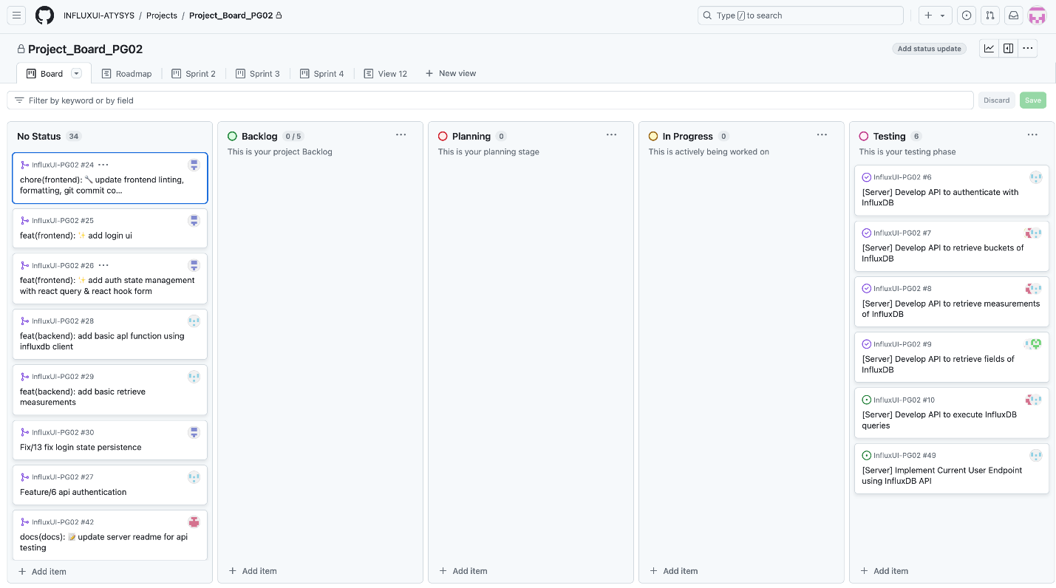

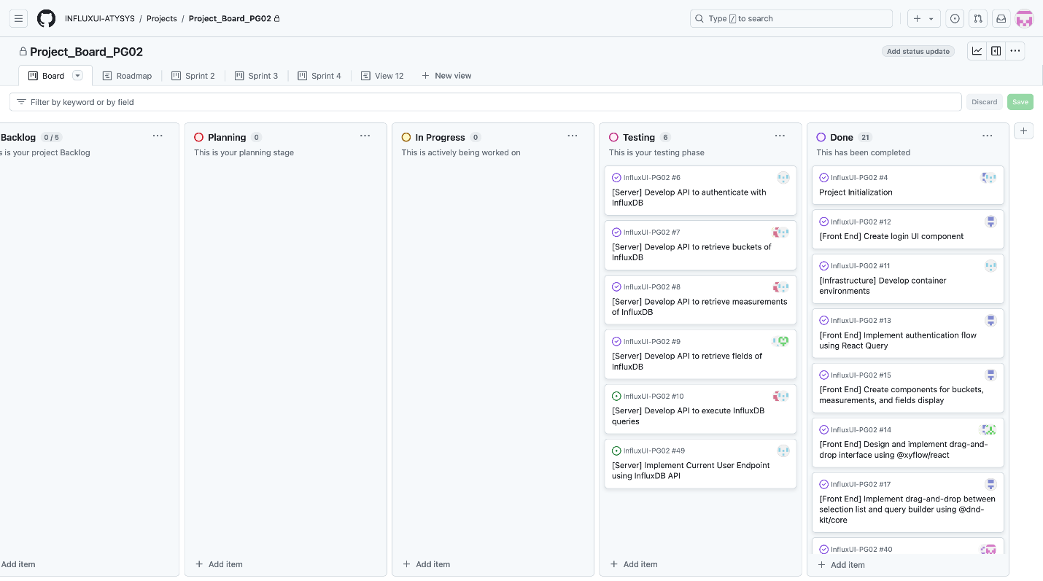

Documentation for meeting record

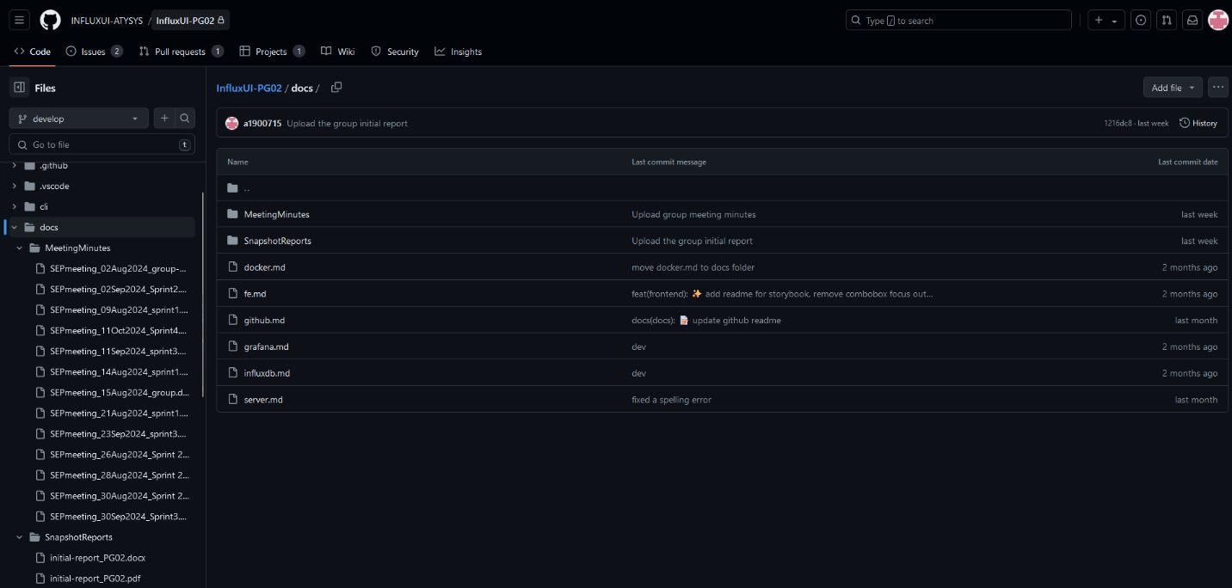

**Sprint Backlog and User Stories**

* Accessibility mode: screen reader

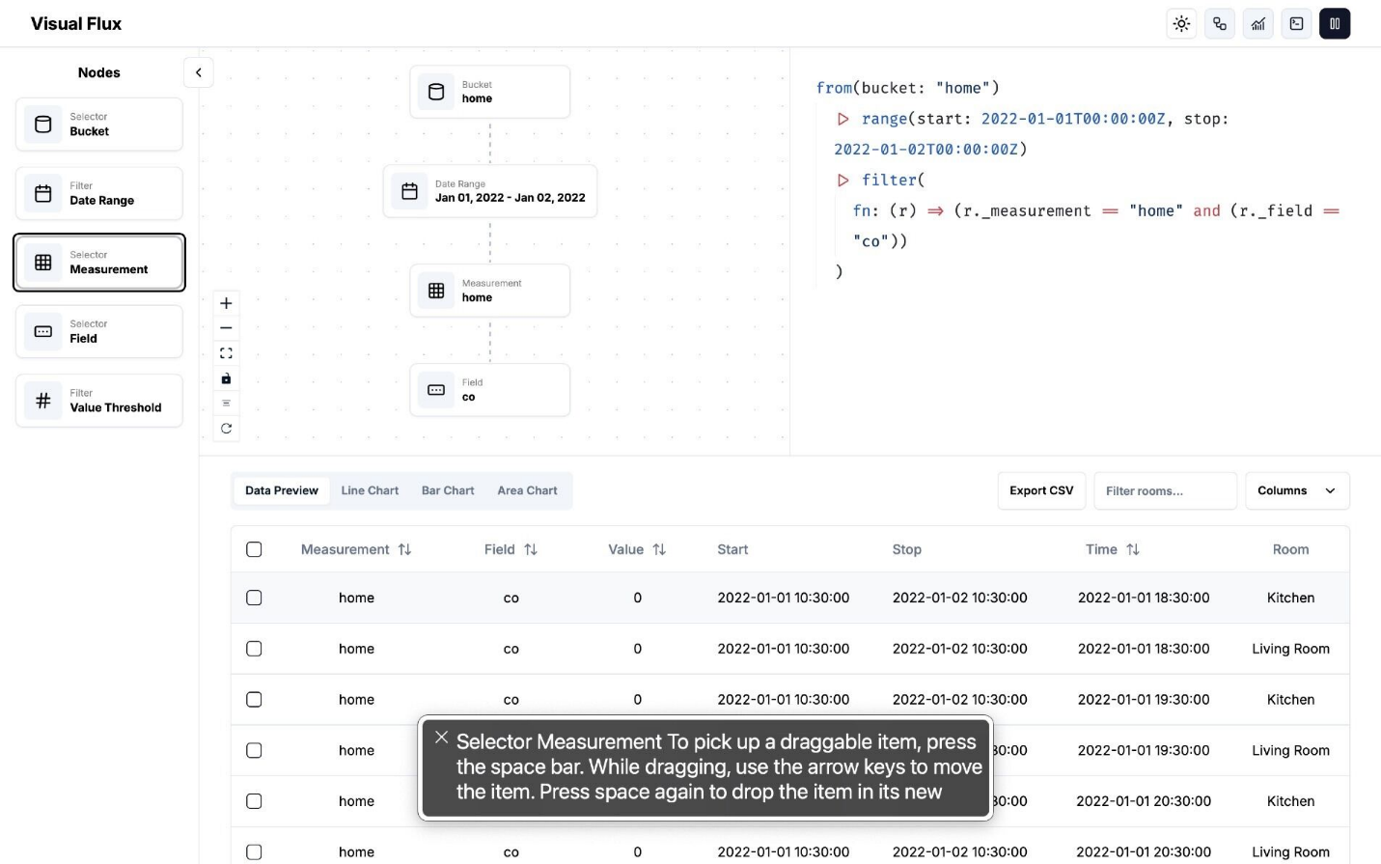

* UI: data filtering with customisable labels

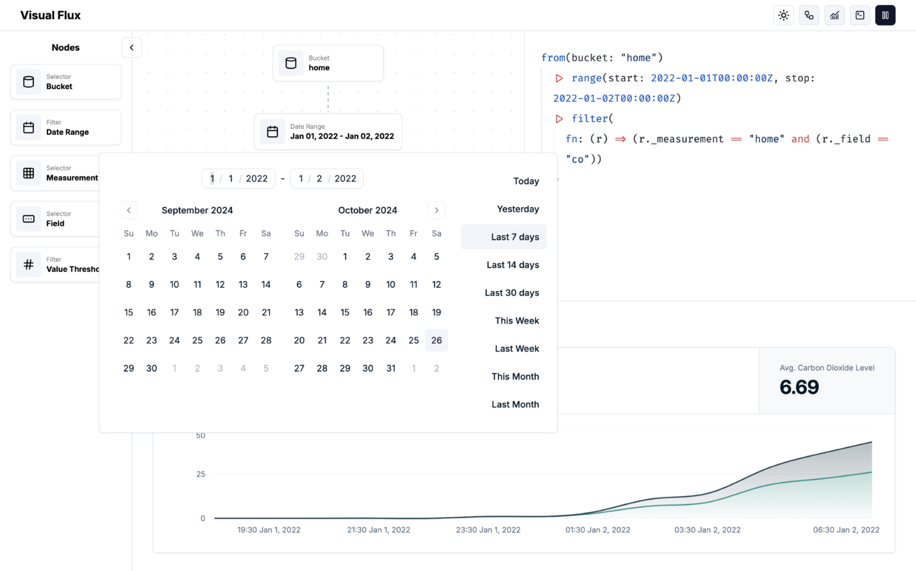

* Testing: log in

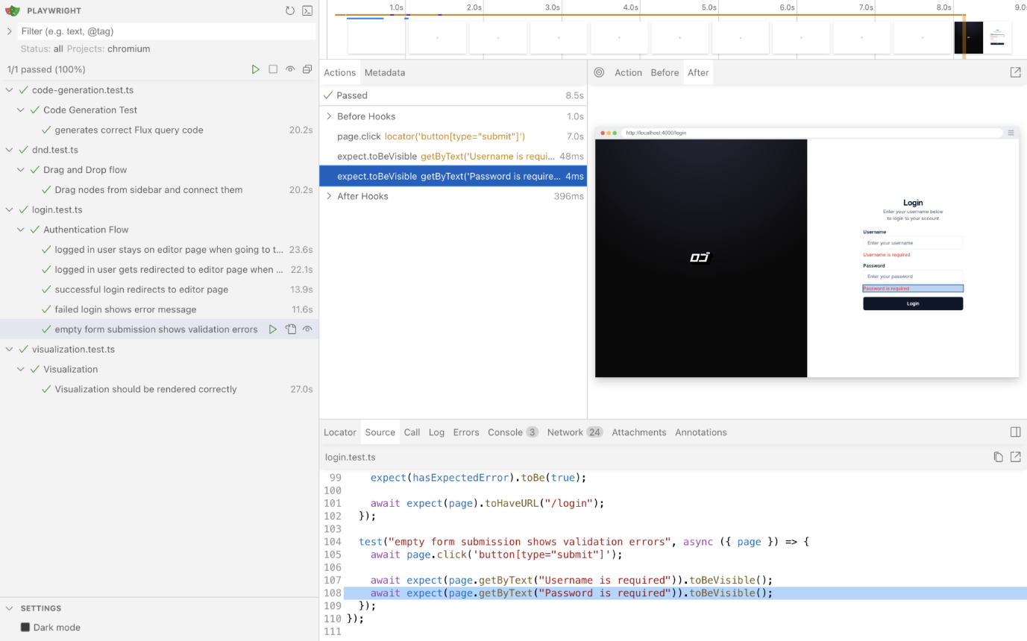

* Testing: drag and drop flow

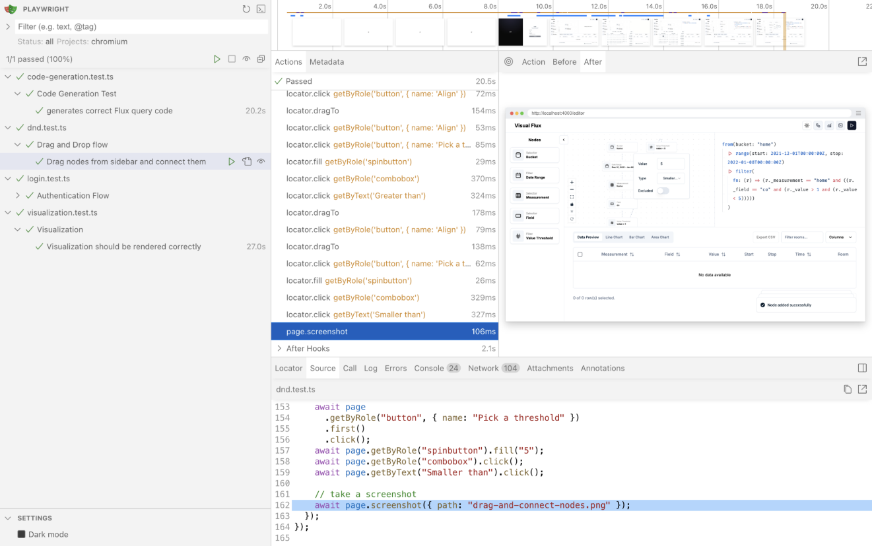

* Testing: visualisation of queries

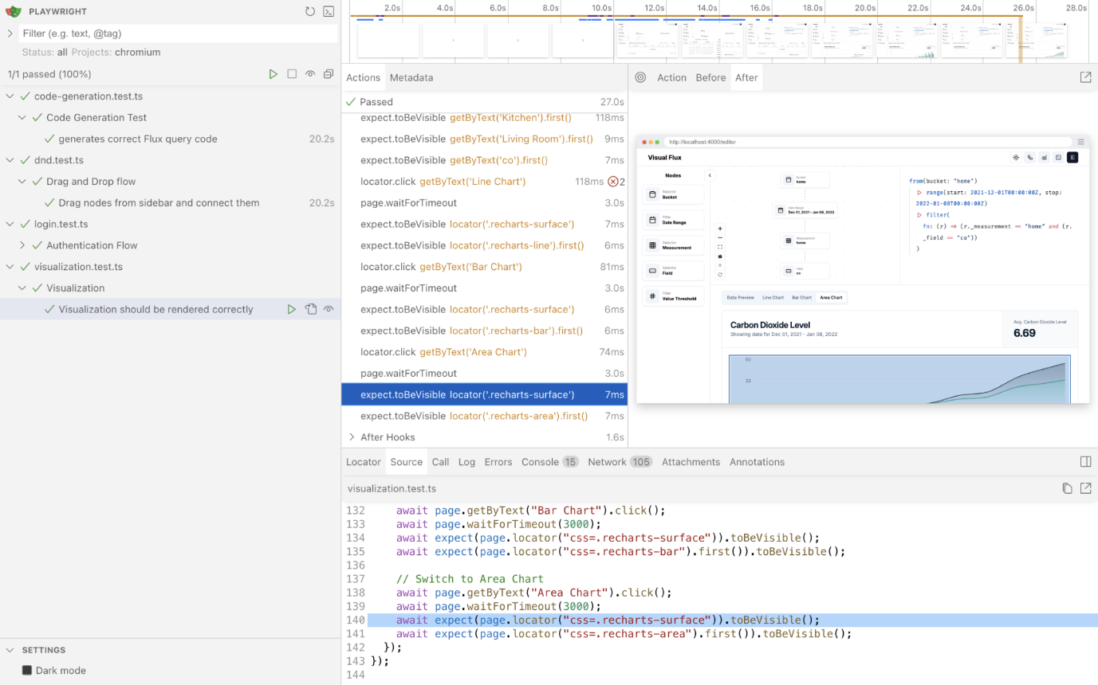

* Testing: code generation

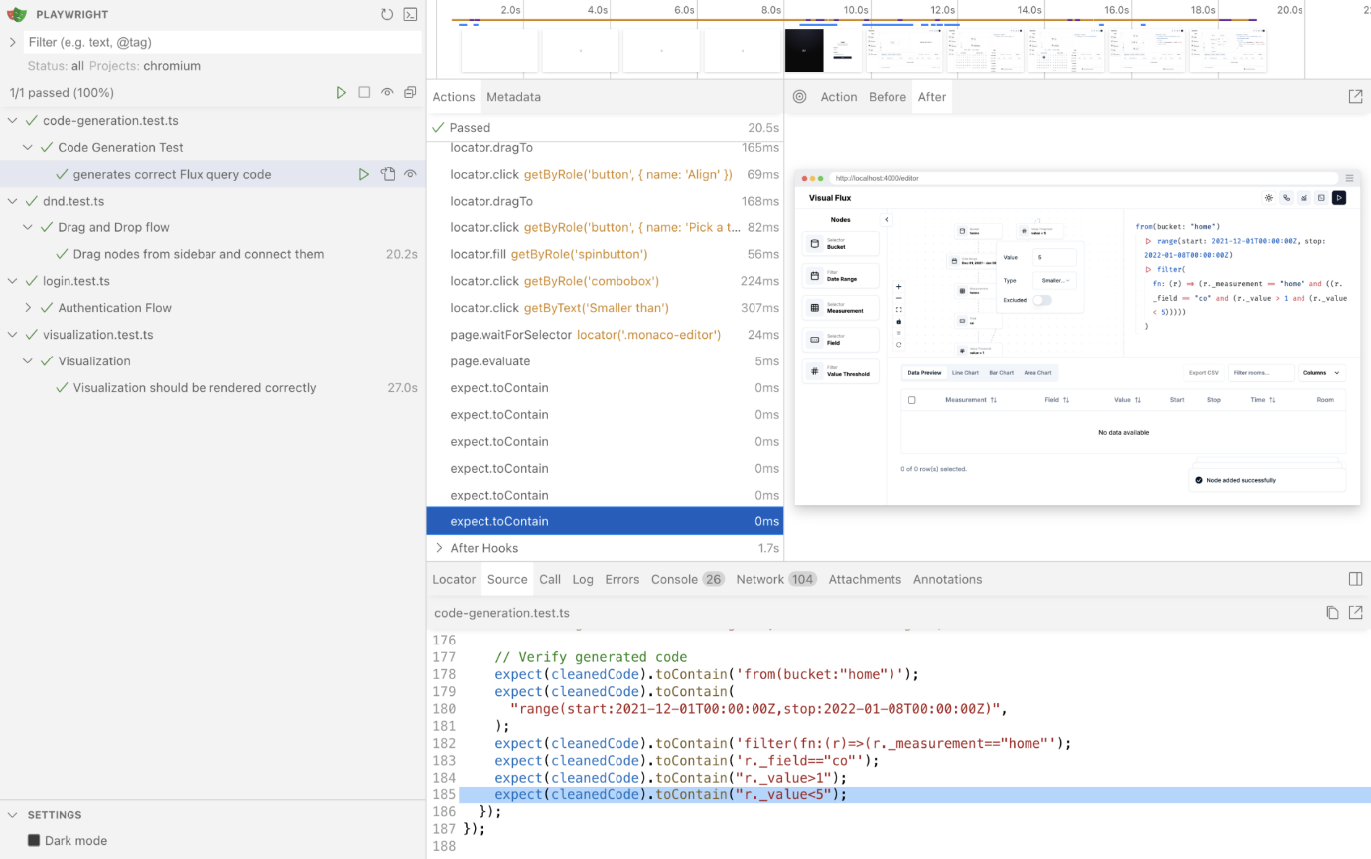

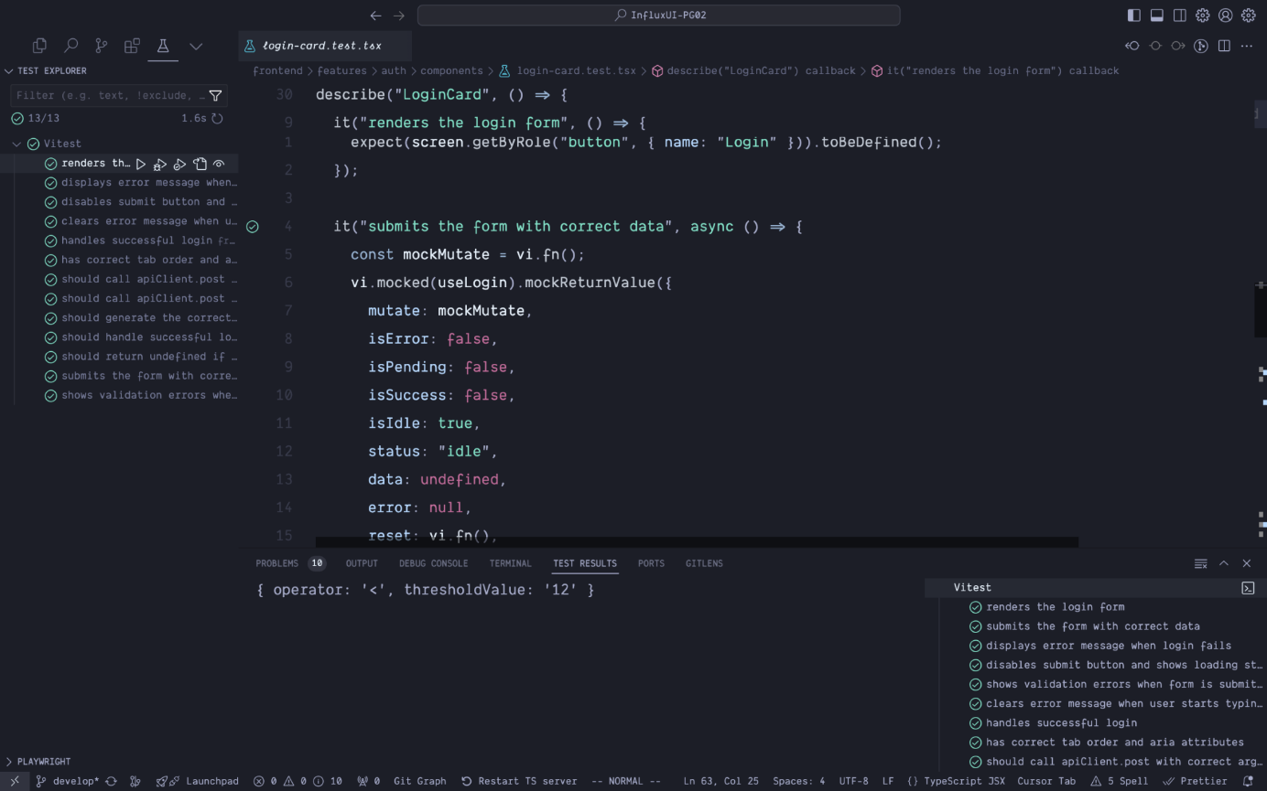

Our team successfully completed multiple-selection of drag-and-drop node in the main user interface with a selection of light and dark mode for user experience. Meanwhile, we also added an additional accessibility mode for visually impaired users.

**Definition of Done**

* Testing plans are thoroughly followed to ensure the workflow is seamless without critical bugs
* Addition of accessibility function to take different users’ experiences into consideration

**Summary of Changes**

* Additional accessibility mode for visually impaired users
* Possibility of integration of Grafana for more seamless visualisation experience
* Code editing function for more advanced user dynamically interacting with generated code
* Disable selection for data-absent date range to ensure accuracy and performance