Murrey Math Trading Rules:

- What was the total range of today’s Trading action?

Today’s High – Today’s Low

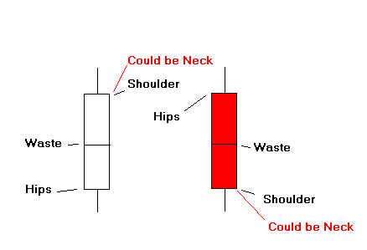
If close is Higher than the open then a Positive Trading range.

If close is Lower than the open then a Negative Trading range.

"Waist" = the open - the close / 2

"Waist" = Price Momentum Reversal Pivot Point - memorize for one day

“Neck” = Price Momentum Reversal Pivot Point - If the following occurs -

The difference between one Murrey Math Line i.e. MM 2/8 and the next Murrey Math line i.e. MM 3/8 is a Murrey Math interval.

A candlestick has a NECK if the open and the close (candle body) span more than one interval in one day.

The Neck of the candlestick is ALWAYS the CLOSE and is not related to the previous days trading action in any way.

A Neck-candlestick may be separated from the previous candlestick by a gap in either direction.

If your stock or index has already run up past the targets set by Rule 3 & 5 and a gap occurs that terminates on a MM line, the odds are very, very high that this is an exhaustion gap and the market will reverse. You must trade the neck.

2. Today’s Volume versus Yesterday’s Volume?

If the difference is more than 25 % at any low or high range this could signal direction reversal

3. How far has this market run (up or down) currently in 1/8ths: (Horizontal Lines)

If the days trading has moved into the next 1/8th at least 1/2 of the way or more then it is considered to have traveled all the way thru to the next 1/8th, if not then it is considered to have only gone to the 1/8th it has just crossed.

% Chance of a Reverse

Run up: Reverse
1/8th 50%
2/8th 75%
3/8th 87.5%
5/8th 93.75%
7/8th 96%
9/8ths 97.5%
11/8ths 98%
% Chance of a Reverse

Run down: Reverse
2/8th 50%
4/8th 75%
6/8th 93.75%
8/8th 96%
10/8ths 97.5%
12/8ths 98%

4. Is this market reversing off a MMSLine? (Speed Angle)

Markets reverse fastest off: 33, 45, or 78 degree angled speed Lines.

Speed Angles are
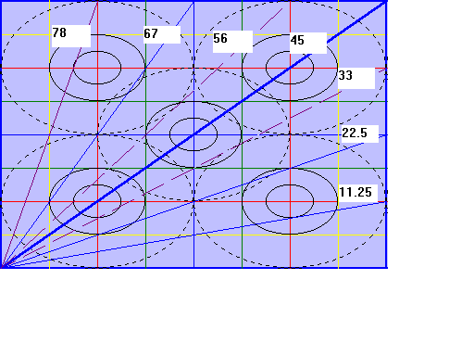

5. Where does this market enter the Trading Frame?

Where any market comes into the trading frame determines how much it will in 1/8ths make from a reversal up or down !

Profit Potential for markets reversing Profit Potential for markets reversing
and moving up off last Low: and moving up off last High:

Point at which it Amount of Point at which it Amount of
entered Trading possible movement entered Trading possible movement
Frame in 1/8ths Frame in 1/8ths

+ 2/8ths May go either way + 2/8ths = 9,10,11
wait for reverse(rare) Upside Potential

+ 1/8ths = 1, + 1/8ths = 8,9,10

Top 8/8ths = 1,2 Top 8/8ths = 7,8,9

7/8ths = 1,2,3 7/8ths = 6,7,8

6/8ths = 2,3,4 6/8ths = 5,6,7

5/8ths = 2,3,4 5/8ths = 4,5,6

4/8ths = 3,4,5 4/8ths = 3,4,5

3/8ths = 4,5,6 3/8ths = 2,3,4

2/8ths = 5,6,7 2/8ths = 2,3,4

1/8ths = 6,7,8 1/8ths = 1,2,3

Zero/8ths = 7,8,9 Zero/8ths = 1,2

- 1/8ths = 8,9,10 - 1/8ths = 1

- 2/8ths = 9,10,11 - 2/8ths = May go either way
Upside Potential wait for reverse(rare)

Any market that goes to +2/8ths or -2/8ths must hold at this price for four days in a row or move past these MMTLines by an additional 30 cents to move to a new trading octive.

Measure the Range of the last run, at 37.5%, 50%, or 62.5% of the new run expect either resistance or the market wanting to stall-out and stop against these ratios especially if they also match up on MMTLine! (MMTLines are more predictable).

MMTL (H) Market condition

+ 2/8ths = This market is too high and needs monitoring closely.

+ 1/8ths = OverBought (Too high on enthusiasm)

Top 8/8ths = Upper end of the Octave (wants to stay in here)

7/8ths = Weak Fast Reverse Line

6/8ths = Pivot Reverse Line

5/8ths = Upper Trading Range (Comfortable trading in here)

4/8ths = 50% = hardest to break thru (up or down) the 1st Time

3/8ths = Lower Trading Range (Comfortable trading in here)

2/8ths = Pivot Reverse Line

1/8ths = Weak Fast Reverse Line

Zero/8ths = Lower End of Octave (wants to stay in here)

- 1/8ths = Oversold (Too Low on enthusiasm)

- 2/8ths = This market is too Low and needs monitoring closely.

All markets will want to trade inside its Trading Range 3/8ths to 5/8ths 43.75% of the time. If the market goes up too far and moves up past its +2/8ths, (above 8/8ths) then the software will set it to the next Octave to the next higher set of numbers.

But, if a market gets above 45º angle and above 8/8ths line and can’t breakout into the next Octave, it will come back down inside its Trading Range and try and balance out the advance over time.

The normal speed angle of an up market through a square of 32 or 64 is a 22.5º through the trading frame. Indexes are the exception and want to run up 45º‘s.

We should expect markets to run up along a 11.25 degree angled line in Trading Frames of 16.

If any market comes into its trading frame at a rate of speed greater than 22.5º of angle, it is said to be moving up too fast and it will have to come back down or explode into the next higher trading octave.

The reverse is not always true of falling markets: bad markets will not always come back up more than +1/8th or +2/8ths off their lows the 1st time they reverse after falling more than 5/8ths off its highs.

Horizontal MMTLine:

We are looking to trade a market Long when it is reversing off its:

A Best odds potential = 1/8ths MMTLine

B 2nd Best odds potential = 0/8ths or 2/8ths MMTLines

C 3rd Best odds potential = -1/8ths MMTLine

D 4th Best odds potential = -2/8ths MMTLine

We are looking to trade a market Short when it is reversing off its:

A Best odds potential = 7/8ths MMTLine

B 2nd Best odds potential = 8/8ths or 6/8ths MMTLines

C 3rd Best odds potential = +1/8ths MMTLine

D 4th Best odds potential = +2/8ths MMTLine

Whip-Lash trading occurs most often when a trader wants to enter trades when a market is trading inside its Trading Range 3/8ths and 5/8ths.

Expect only 1/8th or 2/8th profits reversal of the above range until it finally rises above or below by more than 2/8ths.

6. Is this market running up or down along a parallel momentum line?

All Momentum Lines are longer term trend lines set up as price appreciation or falling prices along 45º angled lines started on either:

A. Lower Left Hand Corner to upper right hand corner.

B. Upper Left Hand Corner to lower right hand corner.

We should expect any market that starts moving along any of these parallel lines to memorize these lines and to step up, or step down, or reverse against 90º angles, off the initial parallel price movement.

The initial Parallel price movement is the low or high that was made just before entering the present Harmonic Trading Frame. To be ahead of the game you need to know where these parallel lines are into the future set to 25, 50, 75, or 100 %, into the next trading frame.

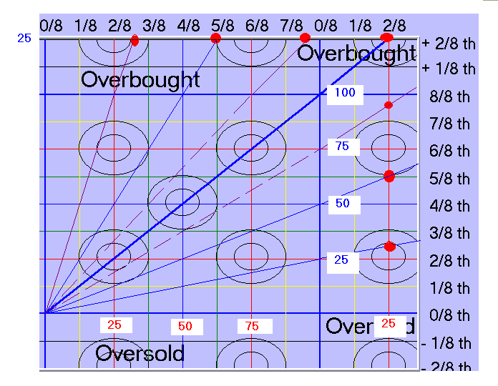

We should not expect however this same parallel trading action to last much past three reverses off the same set of lines.

We usually trade parallel lines set off:

1 0/8ths, greater support,

2 2/8ths,

3 4/8ths, greatest resistance or support,

4 6/8ths,

5 8/8ths, greater resistance.

We usually don’t use the angled lines: 1/8ths, 3/8ths, 5/8ths, 7/8ths, but when we do we shall get faster reverses, which are minor 50% reversal signals.

There are two other angled parallel price momentum lines, which are very rare and are therefore not in the software.

1) 22.5º angled lines, too slow, and

2) 56.25º angled lines are too steep and won’t repeat more than once.

7. Where is the price in relation to the Circles of Conflict?

A Is it rolling over it,

B Is it curling under it,

C Will it move inside it,

The Circles of Conflict are electrical and will change polarization at its own will, so trying to figure it out is only as simple as going with the direction it reverses off its center horizontal MMTLines (+ or - baby 1/8ths).

8. Which Trading Frame Line is it reversing off:

A MMTLine (Horizontal Price),

B MMSLine (Speed Line) every 11.25 degrees,

C MMTLine (Time),

D MMMLine (Momentum),

Please go back to the Rule 3 and ask yourself how far this market has run up or down and then look at which line it reverses on (A, B, C, or D) to see how fast or slow it will reverse.

9 Look at the 3 Time Trading Frames: 64 days, 32 days, or 16 days.

Which Time Frame lets you set your Trading Frame to include the last trading range of high - low as it fits inside the smallest 8/8ths.

10. Setting our Murrey Math Trading Lines:

A zero to 100: 1/8th = 12.50 = 1.5625 = .1953125

B 250 to 1,000: 1/8th = 125. = 15.25 = 1.953125

C 2,500 to 10,000: 1/8th = 1250 = 156.25 = 19.53125

D 25,000 to 100,000 1/8th = 12,500 = 1562.50 = 195.32

Special Situations:

A Gap over - this is where a market price gaps over a MMTLine (horizontal), which would signal that this market ignored the MMTLine, so we must expect it to run toward the next MMTLine, but count how far any run has run to predict its continuation or reversal in direction.

B Drive-through - is a term that describes any market that pushes through any MMTLine on an intra-day trading basis. If it drives through more than 40 cents past (or 2/8ths plus 2 cents) the MMTLine, it should move on toward the next MMTLine.

C S - Move is an intra-day move where a market forms an S laid on its side and it undulates either:

- on a MMTLine, or
- just below a MMTLine, or
- it moves on either side of a major MMTLine, which could form a double S before it breaks out in its own mind’s direction.

D When a market moves sideways and closes 4 out of 7 days above a certain price then it has earned the right to be at or above that mark and will almost certainly move above that mark. The only exception to this is if it has tried three times and failed to get above a certain price.

