Lesson 1 - Introduction

This Trading Octave system differs from any other trading system for our software automatically figures where the software should set the 0/8ths and 8/8ths, set inside one of three squares set of base ten, which is really moving inside a cube, you will see it soon.

This kind of octave is referred to in the future as the Murrey Math Harmonic Octave.

Please notice how many times the daily trading action of this stock knew where our pre-set MMTLines were, and reacted by reversing off them.

As you grow in your knowledge of Murrey Math, you will amaze yourself that you shall be able to memorize all 49 of the internal, internal octaves inside the 1st Trading Square.

Please learn to basic 64 Japanese Candlestick formations.

Horizontal lines are called Murrey Math Trading Lines (MMTL)

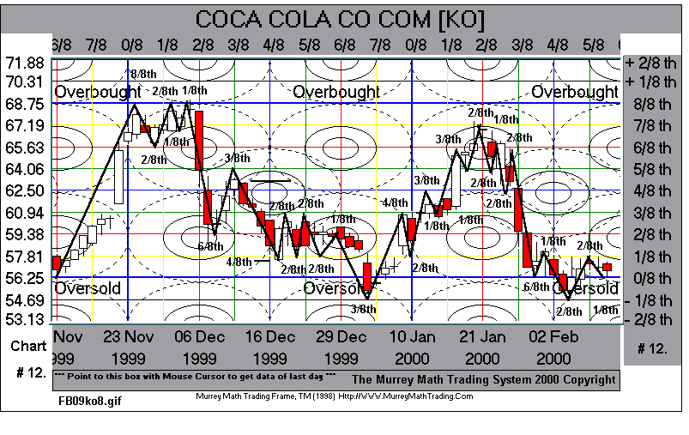

Lesson 2 - Time Lines

Every fall, right on the frost, our software resets our Trading Frame.

Now, as any market runs into its Trading Frame:

1 4 Day
2 8 Day
3 16 Day (normal trading frame)
4 32 Day
5 64 Day Time Frame,

We may expect the greatest reverses to occur on 0/8ths, 2/8ths, 4/8ths, 6/8ths, and finally starting over on 0/8ths.

The most critical reversal day is 6/8ths inside the Trading Frame.

Format 16 is normal for stocks, Bonds, and Indexes, and 32 is more normal for Commodities, but we must switch back and forth between more than one Time frame to get the closest Trading Frame that gives us the best feel for our projected profits.

There are two reasons why markets want to reverse off a multiple of four days:

1 The Earth is set to three days of magnetism and one day of neutrality set off the 1st Frost each fall, please don't ask me where for I never disclose it!

2 The S.E.C. requires all trading brokerage houses to return monies after three days when a sale Long or Short Position is executed, so,

we see that the S.E.C. is setting its own Harmonic Rhythm inside our Trading Frame, which at extreme highs or lows, will run out of liquidity for a few days, so we would expect reverses.

Reversal Days inside Trading Frame 16 and 32 predict stronger reactions when a market trades into a certain zone of time.

Please don't discard the other 9 trading rules and rely too heavily upon Time Reversals as the Ultimate Predictor.

Time is not as important as you were led to believe.

Last July 9th, 1998, I told everyone to close out their Long Positions because it was situated in a three-way negative (positive) sell signal:

1 Market up + 7/8ths inside its Trading Frame,
2 Market moved up too steeply the last 3 months,
- Old highs were exactly 6 months ago. (2 trading Frames)
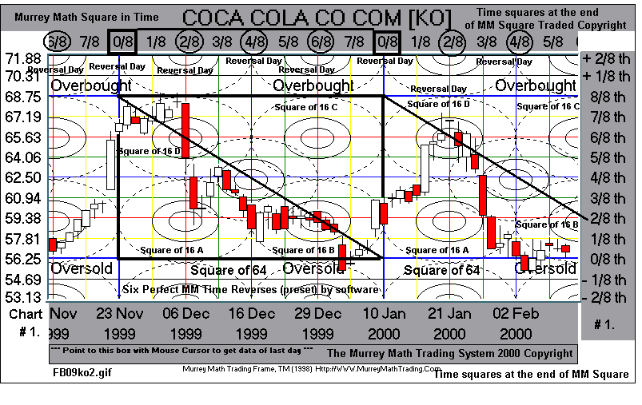

Lesson 3 – Reverse Lines

Reverse Lines Pivot Reversals: 0/8th, 2/8ths, 4/8th, 6/8th, an/or 8/8ths: Vertical Lines

All markets want to move no more than + or - 2/8ths inside its Harmonic
Octave 75% of the time, then it wants to reverse.

And if it moves 3/8ths up or down the odds are 93% that it will reverse directions for at least one trading day even if it reverses and continues its current trend.

Too many traders will wait till confirmation and it is already up or down (2/8ths) then enter and wonder why they are always missing most of the move or getting whip-lashed by having it reverse and come back against you too often.

Even lines predict pivot reverses more often than any set of lines for one simple reason Fibonacci Ratio 1.125%.

The more accurate Ratio is the Murrey Math Rate Percent Movement, set inside or Square.

There are only four squares any market in this world has ever traded inside and they are 100, 1,000, 10,000 and 100,000.

All we want to do is see any market move up or down to one of our even lines and close the day right on the line, or within 19 or 39 cents from the line, then get ready for it to reverse the next day. (experienced traders follow another route - later).

The 0/8th, 4/8th, and 8/8th lines are harder to penetrate, so we would expect to see reverses occur off these lines.

Common sense rules our logic, so, the distance traveled, the longer the better, will also predict our best odds for a reversal. Rule 3.

The 0/8th and 8/8th MMTL are the top and bottom of the Harmonic Octave, so we would expect these lines to hold (stall or reverse) any market the 1st time it approaches either one.

These horizontal MMTLines are always pre-set by the software as soon as the high - low daily trading range extremes fall into one of our Harmonic Internal Octaves.

Please remember these lines as pivot lines that reverse after 2/8ths runs more often than other lines, so we would look for markets that stallout (close) on these lines.

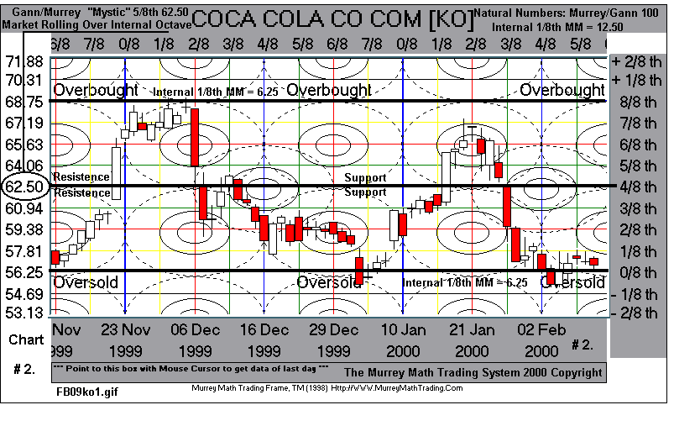

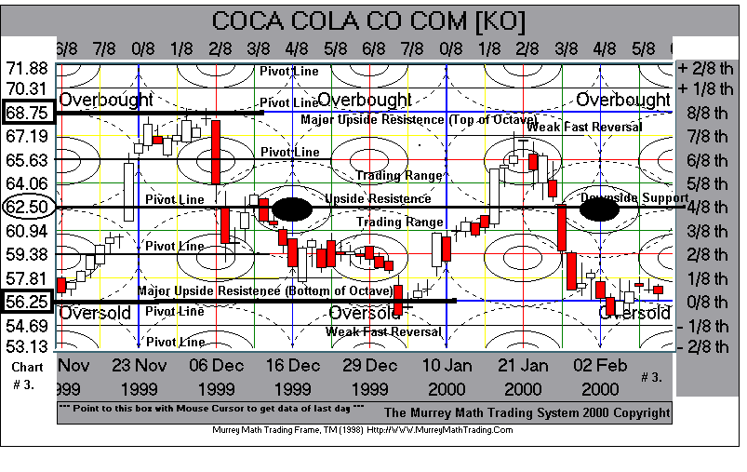

Lesson 4 - Weak Lines 1/8th, 7/8th

1/8ths and 7/8ths are a weakness for the Market.

This means these lines will fail to hold and reverse markets 50% of the time. But, if a market closes on these lines, and reverses, then you get a sharp, steep reverse.

I place a reverse order opposite the current direction, just below its waist or neck and stand back and watch.

Most experts just see 0/8ths and 8/8ths nothing else.

We have two trading situations moving UP and Down.

You may call these Undershoots and Overshoots.

The simplest way to see what these words mean is to imagine that you are a Top Gun pilot and you are trying to land your plane on a carrier.

There is an updraft wind bouncing off the decks.

If you can imagine any plane coming in for a landing has enough problems, but this updraft creates the term Overshoot.

This market tried to fall down to the deck at 0/8ths but couldn't fight off the upforce at 1/8ths so it reversed back up.

A Market moving up has two lines that could weaken its progress: 7/8th and +1/8th (above 8/8ths).

Logic shows us two knowns:

1 How far has this market currently run up off its last reversal?

2 All markets don't want to break-thru the 8/8ths MMTLine the 1st time in the trading frame.

What are the odds of the market reversing according to the current range in 1/8ths, near one of our weak lines. (1/8th & 7/8th) Rule 3 odds.

The extreme limits are 0/8ths and 8/8ths, Therefore taking a profit at least +2/8ths would be selling into a winner, in either direction rather than waiting and letting it hit its hardest lines to get thru. (2/8ths & 6/8ths)

Once any market trades above or below its Major Harmonic Trading Octave (8/8ths or 0/8ths) it really doesn't know whether or not it wants to get free of its last Trading Harmonic Octave. But it still remembers all the trading action that occurred off the last high or low reversal.

Markets may move up into the 7/8ths range and stay there for months before breaking out toward the 8/8ths or even up to its +1/8ths into the next octave.

Logic allows us to test this thesis by just thinking about what the DOW 30 Stocks have done the past three months.

If the DOW 30 Stocks hit 10,000 then we would expect that this market is trading inside the cube of 10,000, 8,750 is the 7/8th MMTLine inside 10,000.

8,750 now becomes 0/8ths of the Harmonic trading octave.

7/8ths is equal in the scale of Music to the Key of B which has 5 sharps and no flats inside its octave, so we would expect wide swings inside this trading range from 8,750 up to 10,000.

Please divide 1,250 by 8 and you get 7 internal harmonic pitch changes inside the larger trading MMTL. (The whole DOW)

You will see each 1/8th equals 156.25.

If you look closely at 10,000 - 156.25 = 9,843.75, you would have seen that the DOW couldn't move up thru its 7/8ths the 1st time to reach 10,000 before it sold off and got support down at 9,843.75.

Conversely, when this market reached 10,000, we would have expected this market to get strong resistance up at + 1/8th above 10,000, which translates in MMTLine = 10,156.25.

The DOW 30 Stocks reversed off 10,156.25 last Friday morning (Options Expiration Day) then fell down to its current area near 6/8th MMTLine.

Markets get above their 8/8ths MMTLine on enthusiasm by believing that numbers are just numbers.

Did you remember the 1st time you made $10,000 per year; $25,000, $50,000, then $75,000, then $100,000? Numbers do matter and are major.

Markets fall below their 0/8th and usually fall an additional -1/8th below the baseline off panic selling off lows by the rookies that Buy and Hold.

One must realize that any market may get Overbought (+1/8th) or Oversold (-1/8th) and stay inside these walls for as long as several months before it moves either way on the other side of its 0/8th or 8/8ths MMTLine.

The critical question as to how long any market shall trade inside this narrow band on either side of its major MMTLine is directly proportional to Rule 3 of how long a market has run up or down in its last range.

Reverses off the 1/8th going back up and reverses off 7/8th going back down will reward you more often with more than the average +2/8ths inside our Harmonic Trading Octave.

Drops in the market make 50% more profit and in 50% shorter time periods.

If you want to be a real trader you must learn to make the fast profits off panic off 7/8ths or +1/8th (above 8/8ths) MMTL.

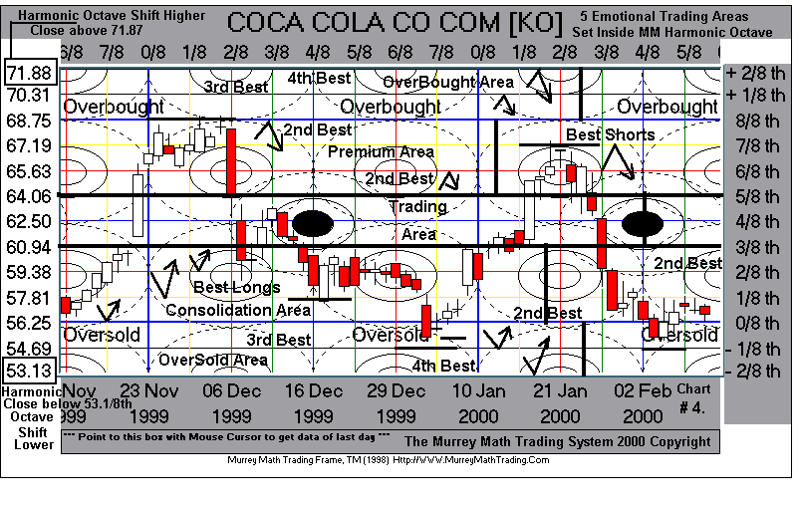

Lesson 5 - Momentum - Trend Lines

Euclid was invited to visit a friend's garden to admire his plants, flora, and his crystal formations.

As they sat and enjoyed green tea, the servant brought over a large prism crystal of quartz. As he approached Euclid his slipped and fell to his knees and finally dropped the crystals and the owner watched his prize light refractor shatter into 64 parallel symmetrical pieces, proportional to the original.

Euclid jumped for joy. He had seen a law of math expressed in divisions of parallels.

Nature does as it should, it finally tries to equalize every equation, the Center point in the parallelogram.

Parallelogram Lines are set automatically for you by simply touching Control M. 45 degree lines

Momentum Lines are set off the parallel momentum row off the 1st low and the 1st high and the 2nd low and simply extend these lines out to the right into the future.

The Center Spine of any run is always visually set off common sense.

If you look at this chart attached you shall see the circled barrel of the Center Spine.

If you ever record a snake's forward progress as it traverses thru sand, you would imagine a center spine dashed line down the middle between its wavy lines high in low that form a parallel wave consistent with where they intend to go.

Any market does the same thing, it won't move, very often in a straight line, up or down without coming back and testing previous highs or lows set off its original intent to move through its current traversing frame.

Markets will move to the right in only one of three patterns

1 Irregular 2 Straight 3 Parallel

If you look down to the last low before this daily trading action entered this current trading frame, it signaled to us where the Center Spine was located.

The Center Spine may be set at only one of 3 starting points: 0/8th, 4/8th, or 8/8th.

You should expect any fluid movement to extend no further than 2 parallel lines above or below its Center Spine.

Gann discovered that all markets want to reverse at least 1/8ths inside its extreme high and low range, and we also found, thru observation, that all markets will be affected by moves along its 50% lines inside its normal band width also at 45 degree angles.

Markets reverse after running up, as far as they decide to run, so we simply touch the down arrow on the keypad to look at the reverse angles.

But, mathematically, most markets want to run up no more than + 2 lines above the Center Spine and they want to fall no more than 2 lines below its top Center Spine set off its 1st nearest touch reverse coming into the Trading Frame.

The Reverse, into the future shall be predicted ahead of time off our simple down arrow keypad touch.

Major reverse angles always begin off the Time Lines: 0/8th, 2/8th, 4/8th, 6/8th or 8/8th.

The minor time reverses automatically come in on the odd lines.

Momentum Lines are Trend Lines. Trends are daily trading action closes that follow the same direction no longer than 16 trading days and no more than 4 to 7 weeks in either direction.

Markets will trend down longer than they will trend up.

Any trend is broken if the daily close is either above or below the line it is paralleling currently.

It must close on the opposite side of the line for four days in a row to have escaped the affect of the line it just paralleled.

Check the following set of lines to see which ones are most important for the present Harmonic Trading Octive :

Horizontal MMTLines
Vertical MMTLines
Sharp angles MMSLines
Momentum trends MMMLines

Markets do not always run in parallel lines. So we forget them until we see a trend developing along our parallel lines, then we simply turn on our momentum lines.

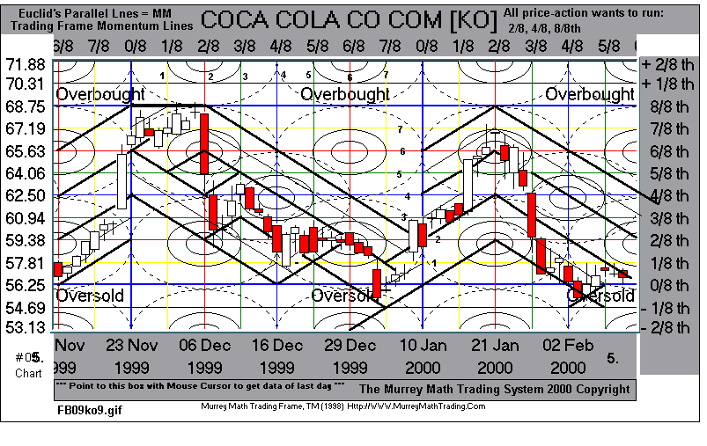

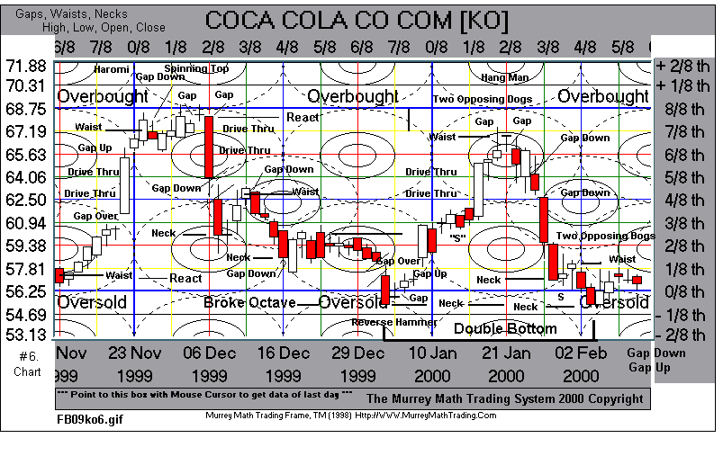

Lesson 6 Trading Range 3/8th - 5/8th

The Trading Range is the range between 3/8th and 5/8th, inside the Harmonic Trading Frame Octave set to Music inside its cube.

The Harmonic Octave is automatically setting itself into three parts:

1 Lower Trading Range = 0/8th to 3/8th
2 Trading Range = 3/8th to 5/8th
3 Premium Trading Range = 5/8th up to 8/8th

Market prices trade differently inside these three price ranges:

1 Trading Range, markets want to stay inside 3/8th and 5/8 - 43.3/4% of time,

2 Lower Trading Range, markets must prove they can break into its trading range, below the 3/8th line, traders are more slowly apt to invest and will stand aside and watch the market go up until it gets into its Tranding Range 3/8ths – 5/8ths. (opportunity knocks)

3 Premium Trading Range, is the price area in which all markets are the most volatile and where traders are most willing to pay any higher price just to own it.

Once a market breaks out above its Trading Range, it enters its Premium Trading Range where all the confirmation rookie traders will enter any market.

A feather will not want to touch the floor the 1st time it falls toward the floor and it will bend back up just as it will not want to move up to the top of the room because the air is hotter and thinner, so the simple fact that it will accelerate as it falls and it has also run out of steam or upthrust from its last run-up.

Every market will have to prove itself inside its Harmonic Octave first, then it must prove that it is worthy of trading inside its Trading Range, then is will accelerate inside its Premium Trading Range above its.

Gann discovered that markets want to move in price lengths of:

A 38.2%
B No more than 61.8% of its last range.

Rule 3 shows us different runs up or down in 1/8ths and the likelyhood of reverses in %. This will determine how far you might expect any market to move before you sell into your profitable position. At least 50% of the last range.

The Lower Trading Range below 3/8ths and the Premium Trading Range above 6/8ths form hard barriers of resistance or support the 1st time any market approaches and tries to break thru.

Always go back to Rule 3 and count how far any market has moved up or down and then see how close our daily trading action is to either our 3/8th or 5/8th
MMTLine.

Now count the days it has stayed above, below, or inside its Trading Range and then you will expect market reversals of a market's desire to fulfill the Percentages of its 3 ranges in the octave in relationship to what trading area it currently occupies.

Lesson 7 - Speed Lines

Speed Lines are Automatically inserted correctly inside the Murrey Math Trading Frame as soon as you click on Control S.

To insert the down Speed Lines simply touch the down arrow.

To take off unused Speed Lines, click on the number that matches up please see the chart.

There are 7 Speed Lines and we have assigned a number to each going from least to most fastest = No 7 - 87º.

The Up Angles always appear 1st because the US markets move up 70% of the time, so we should think Long but we should also be ready to Short runs up that move more than + 2/8th or + 3/8th or take at least a 50% profit of the last range.

50% profits are 50% of our trading strategy.

We have a speed line every 2/8ths in Price and Time now watch daily price action inside the Trading Frame and start trading.

We don't need to add minor 1/8th Speed Lines it just clutters up your mind.

The Speed Line is set into our trading strategy for one reason, to let you see
reversals faster.

If you wait until the end of the trading day to get a signal off one of these lines you will always be getting in a little late.

You must always remember Rule 3 and think of the waist and the neck to help you decide when to go opposite any market's current direction.

Please look at our chart and we will see 5 reverses that bounced off our up Speed Lines and one that signaled a buy when the daily trading action drove thru the Speed Line.

The bounce is our best entry position and the drive thru just confirms that the move will want to continue up to the next horizontal MMTL. The same is true for down markets.

The second chart shows 12 reversals off down angles.

Please notice the three failures to break-thru the 78º angled line.

Speed Lines compensate for price moving to the right and missing reversing on the even days.

The Speed Lines rules are the same for up and down markets:

1 11º = slowest reverse angle
2 22º = normal speed
3 33º = faster reversals
4 45º = Best support/resistance, Normal for Indexes, faster reversals
5 56º = faster reversals
6 67º = fast reversals
7 78º = fastest reverse angle

Insert your near-future Speed Lines out in front of your current trading action, so you may see how to learn to predict market reversals before they occur. overlays

Once any market reverses off any of the Speed Lines, you may expect it to want to
reverse into the future off this same line if it breaks it, it will be reversing its current trend.

The number of reversals to hit or bounce or reverse off should not exceed 3. See the 78º down angle failure in chart 2. After a second bounce expect on the third time a fast reverse of a bounce or it to break thru and aggressively move in that direction.

Speed Lines Reversal rules are as follows:

Intra-Day traders use the wick touch reverse off an intra-day reversal signal.

Intra-day traders are going in earlier off the wick reversal off the horizontal MMTL and are able to capture an extra +1/8th pure profit off being there while it is reversing.

End of day traders simply use the closing price signal.

The closing price signal means simply that the closing price must be on or slightly above one of the Speed Lines for it to have higher odds of working. Opposite for down reversals.

We must always place our entry in the opposite direction just above the waist or neck the next morning or late afternoon before the close to insure a better fill into the reversal position traders.

These Speed Lines are simply confirmation of Rule 3, which is how far has this market has run up or down so far.

Reversal entry must always be decided by Rule 3 and our exact price to enter is dependent upon whether or not the previous day's trading action created a neck or a waist.

The quickest reversals, to make faster short-term profits are always the 78º angles, up or down.

To determine how much the reversal will be worth use Rule 3 and Rule 5.

1 How far has this market already run up or down? Rule 3

- On what MMTL did it reverse on? Rule 5

3 On what MMTL did it enter the Harmonic trading octave? Rule 5

Please look at the two charts attached and you will discover a simple help confirmation of what Rule 3 is setting up for you presently.

There are 7 Up and Down Speed Lines, in every 64 square Trading Frame. Every square of 64 is also made up of 4 squares of 16, so we may apply the same rules to the current smaller square of 16 for faster reverses.

Please use these lines as secondary reversal help signals that were already predicted off Rule 3.

Please remember that our goal is to mesh the 10 rules into one way of trading that allows you to look at any market and within 5 seconds determine what to do.

1 Go Long or Short,
2 Where to set your entry limit order,
3 Where to set your 1st exit 50% profit amount?
4 Place a stop loss order to accept your small loss per trade.

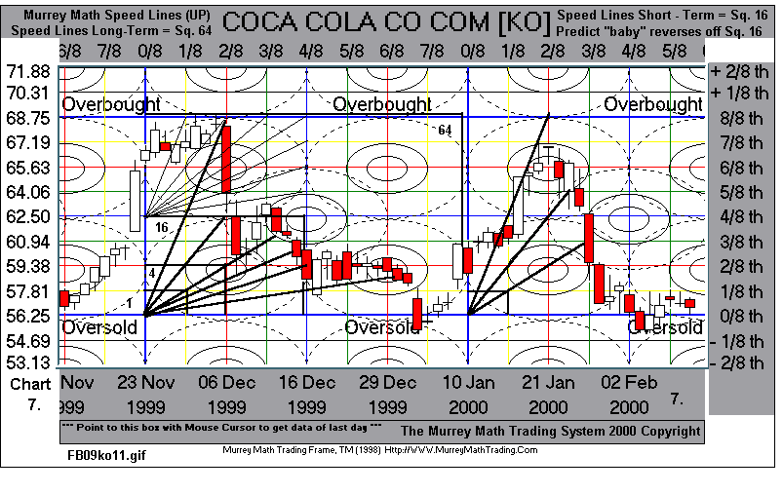

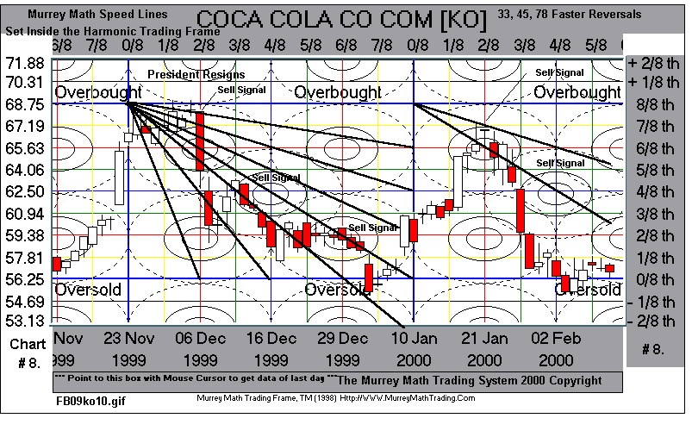

Lessons 8 - Square of 64 - 32 - 16

Square of 64 = 4 Squares of 16 Trading inside the Harmonic Trading Frame:

Please look at these two charts, where are the 4/8ths lines.

Do you notice that these two different markets are trading at 1/4th or 4 times, Corn Prices to Soybean Prices, 225 to 500 Pure Math Base of Ten.

These two different markets are moving up or down set to 1/8ths that are set to a proportion of 1/8th set inside a Cube of 1,000.

Gann established that all markets want to trade inside its extremes low and high and reverse on 1/8ths with most extreme runs to be either 3/8ths or 5/8ths set inside any current 8/8ths.

The Murrey Math Trading System proclaims that all markets are trading with or against pre-set prices, numbers that are automatically established as soon as the daily trading action moves into any pure math Internal Trading Octave.

The 1st Square in the Base of Ten = 100: Base Ten 10 x 10 = 100.

1,000 is the 2nd Square out in the Base of Ten.

1/8th of 1,000 = 125
1/8th of 125 = 15.625
1/2 of 15.625 = 7.80 per 1/8th

Please look at Soybeans, May 99 Futures, 8/8ths. Each 1/8th for Soybeans = 7.80.

Murrey Math students let pure-math predict where markets will reverse, off horizontal lines, not trying to predict where to set the extremes.

Corn Futures, May 99, are trading inside the Square of 100.

Corn is trading at 1/2 the running price of Soybeans, so we would expect each 1/8th to = 3.125 points.

These two markets are trading at the same speed, but one is trading at 1/2 the price speed of the other, so we let our Murrey Math Trading System automatically tell us where we might expect to see reversals.

We have adjusted Gann’s 2nd Rule to set all trading frame Squares off two extremes the high and the low and just start our Trading Frame Square in Time off the 1st Frost each Fall, when these two markets are harvested.

Every live commodity dies when the Frost touches it.

There are only 10 rules and we should let the Murrey Math Trading System automatically set the following trading parameters for you:

1 Automatically set the Trading Octave (8/8ths) for you,
2 Automatically set the Vertical Time Lines (8/8ths) for you,
3 Automatically set the 5 Circles of Conflict for you,
4 Automatically set the 45º Parallel Lines for you,
5 Automatically set the Gann Speed Lines for you,
6 Automatically set the OverBought and OverSold for you,

So all you need to do is find your best entry or exit price and close out 50% of your current position.

Please look how similar the daily trading action of these two markets run.

These two markets are running through a larger square of 64, but, our Trading Frame is able to predict Longer term or Short term runs set inside either a Square of 16 for short term and the Square of 64 for longer term runs.

Please look at The Square of 64 Trading Frame Feb 19 thru Apr 07, 1999.

This Square in Time Trading Frame Feb 19 thru Apr 07 set inside 0/8th to 8/8th set to its own Internal Octave.

We should think in terms trading inside each Square of 16, whichever trading frame 16 it trades inside, and use our trading rules inside this trading frame until the daily trading action moves out and then set our trading frame to the next current trading frame.

Now, after any market trades through its 1st Square of 16 we shall shift our Trading Rules to include the Square of 16 and the Square of 64.

Please look how many times these markets reversed off:

1 Price Horizontal lines 13 reverses
2 Time Time lines 11 reverses
3 Momentum Parallel lines 14 reverses
4 Speed Lines Fast reverses 2 speed reverses
5 5 Circles of Conflict Spheres to avoid Price went in only once

Please look at reverses off Time Lines:

1 Jan 27
2 Feb 08
3 Feb 19
1 March 01
2 March 15
3 March 25
4 March 29
5 April 07

Please see and understand that we trade the rules, all of them, inside the Square of 16, then we immediately shift to the Square of 64 and the same trading rules that apply to the same angles but on a longer term basis.

If you reverse with the market, you are trading a winner.

There is a market 64 inside any market's Square in Time 64.

The two long term charts of Soybeans and Corn are more profitable when we close all short-term losers, as fast as possible.
