**HTTP/2 ServerPush**

1. TLS/X.509



1. OpenSSL







1. Tomcat/conf/server.xml

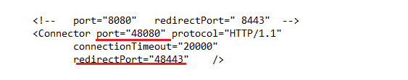

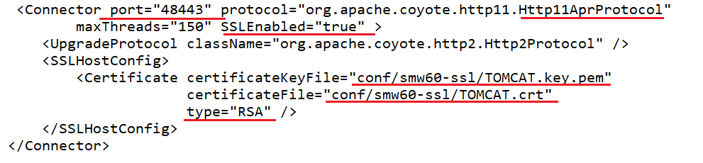

1. Tomcat/conf/smw60-ssl

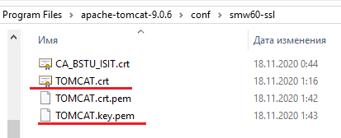

1. Tomcat/bin

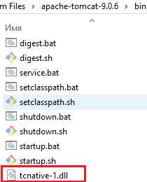

1. mmc

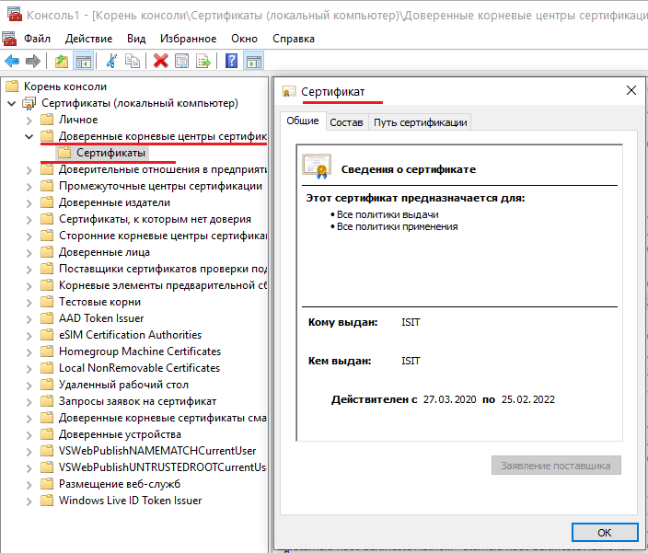

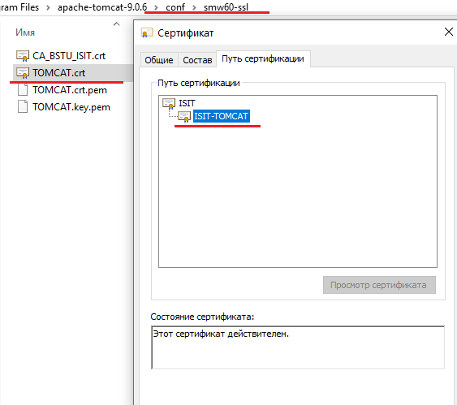

1. Tomcat/logs

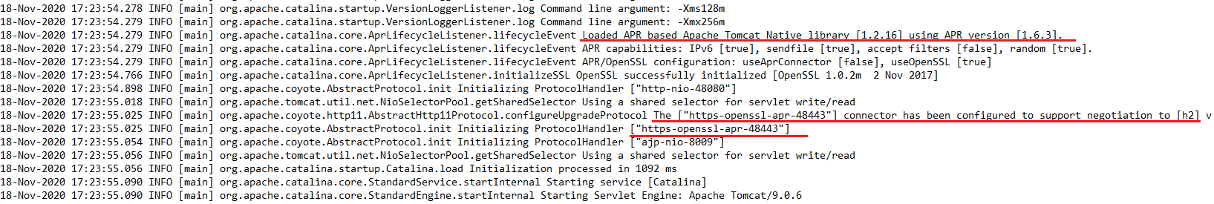

1. Tomcat

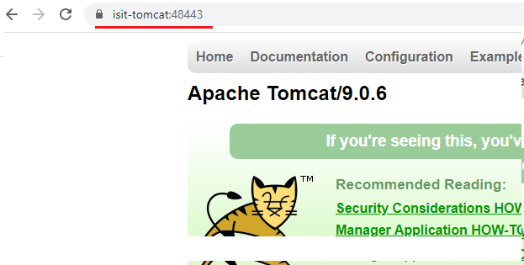

1. 1.
2. 2.
3. 3.