LET’S PLAY SOME WATER (NOT SO) FUN GAME!

Problem:
We study a simple game consisting in a grid of tiles, separated or not by walls, forming different groups of tiles. Numbers figure on the end of some lines/columns. They correspond to a number of flood tiles in this column/line. The goal of the game is to find a solution, consisting of a combination of tiles flooded satisfying the number on each end of line/column and natural rules of physic.
-Each line/column must contain the exact number of flooded tiles indicated on the end of the said line/column.
-Water must follow the following rules:
A tile without water cannot be under a tile of water if there is no wall to stop said water.
A tile without water cannot be next to a tile of water if there is no wall to stop it.
In the same group of tiles, if the group contains water, the level must be the same in all the group even if it is U shaped (or n shaped, for “simplicity”).

Modelling:
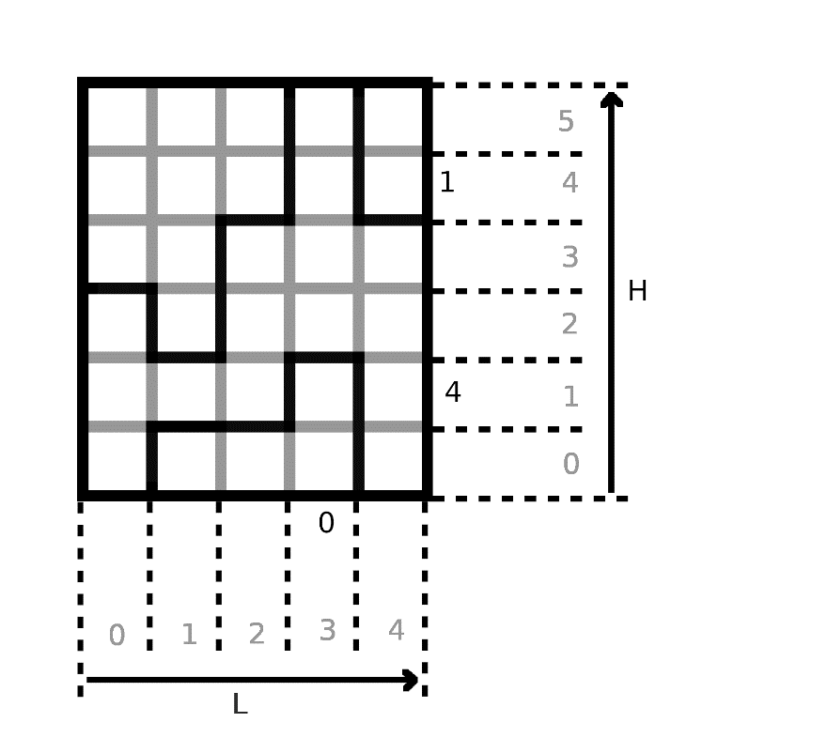
Ih0.3
Iv1.1
a1.3

Definitions:
Let L being the horizontal size of the grid.
Let H being the vertical size of the grid.

∀0≤i<L,0≤j<H we name ai,j the tile of coordinates i,j
∀0<i<L,0≤j<H we name Ivi,j the (vertical) intersection of the tiles ai,j and ai-1,j
∀0≤i<L,0<j<H we name Ihi,j the (horizontal) intersection of the tiles ai,j and ai,j-1
∀0≤i<L we name Zci the number aside to the column i.
∀0<j<H we name Zlj the number aside to the line j.

∀i,j, Wi,j = 1 if and only if there is water in ai,j.
∀i,j, Bhi,j = 1 if and only if there is a horizontal barrier at Ihi,j
∀i,j, Bvi,j = 1 if and only if there is a vertical barrier at Ivi,j

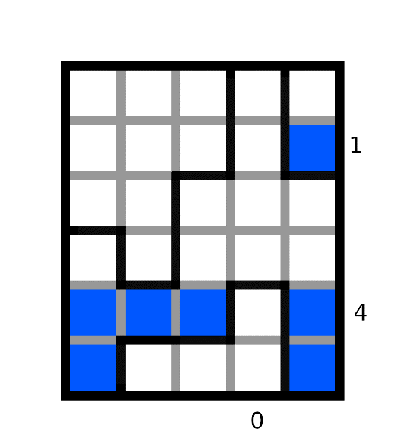
Bv1.5=0
Bv2.3=1
Bh1.3=1
W0.2=0
W0.0=1
Bh1.3=1

Modelling the “water’s physics”:
[schema]

We attribute a number to each tile such that each tile inside a same group of tiles have the same value, in order to be able to say if two tiles are in the same group (i.e. if there’s a path between these tiles). For each tile ai,j, we can access this number at ai,j.val.

To attribute such values, a way to proceed is to initialize the values as the following:
∀i,j ai,j.val=j*h+i
And then use the following rule to get the same values in each group:
∀i,j ¬Bhi,j => ai,j.val = min( ai,j.val ; ai,j-1.val )
∀i,j ¬Bvi,j => ai,j.val = min( ai,j.val ; ai-1,j.val )
0
0
0
0
0
0
0
0
0
0
0
0
0
0
0
1
1
1
1
11
11
11
11
11
11
11
11
11
24
24

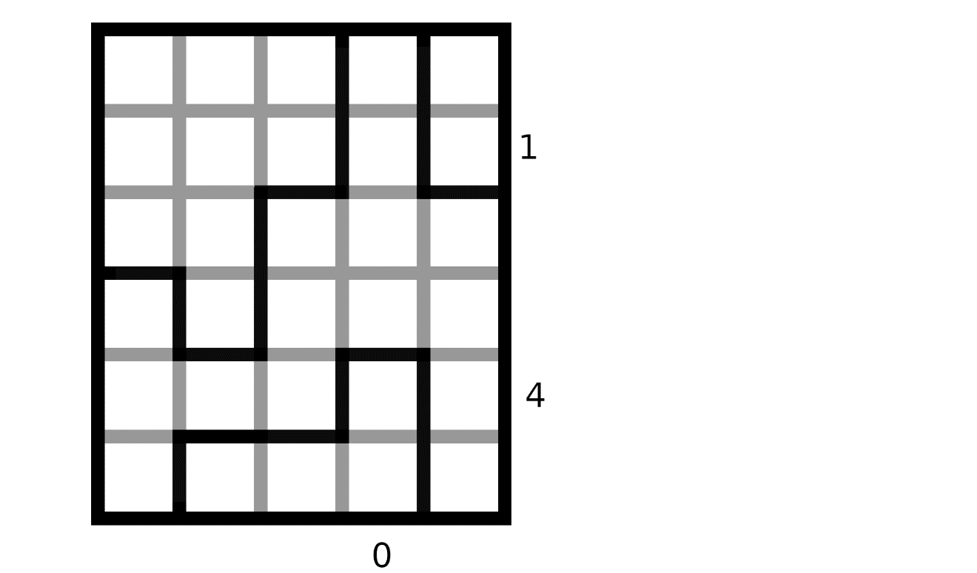

Once ai,j.val is defined, the following rules model the fact that water must follow the rules of physics:

Rule 1:
∀i in {0,…,L-1},j in {0,…,H-1}:

Rule 2:
∀i1,i2 in {0,…,L-1},j in {0,…,H-1}:

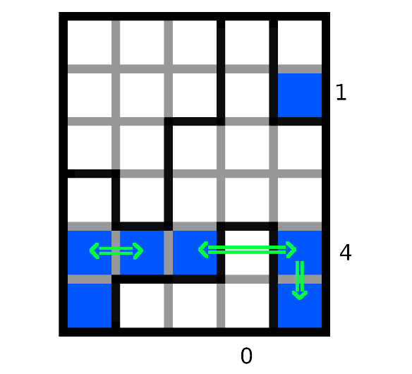

Modelling the fact that Zci and Zlj represents the number of tiles of water on the line or column (rule 3):
Since there happens the same thing on each line with Zli and each column with Zcj, let’s say that S is either L or H, and N is the other.

We will then define Z and Wzi as follows:
if S = H:
for any 0≤i<S, Z is Zci
for any 0≤j<N, Wzj is Wi,j (representing the fact of water being on the tiles of the same column as Z)
if S = L:
for any 0≤i<S, Z is Zli
for any 0≤j<N, Wzj is Wj,i (representing the fact of water being on the tiles of the same line as Z)

Since we want exactly Z tiles to be filled of water, a way to model it is by making a disjunction of each model, but transforming it to a conjunction normal form by developing is long and grindy. Instead, we can model the fact that any assignment with at least Z+1 tiles filled of water should be unsatisfiable, and that any assignment with at most Z-1 tiles filled of water should be unsatisfiable.

To model the fact that any assignment with at most Z-1 tiles filled of water should be unsatisfiable, we do a conjunction of all possible clauses containing exactly N-(Z-1) elements of the form Wzi. (like this, any assignment of at most Z-1 elements that are true have a clause that they can’t validate).
If Z = 0, no need to add a formula for this rule. Otherwise, the formula is the following:

(The product symbolizes a succession of conjunctions and the sum, a succession of disjunctions.)

To model the fact that any assignment with at least Z+1 tiles filled of water should be unsatisfiable, it is the same reasoning, but with a conjunction of all possible clauses containing exactly Z+1 elements of the form ¬Wzi (note the negation, and so it is the same as verifying that at most N-Z elements of the form Wzi are false, which is directly equivalent to saying that there is at most Z tiles filled)
If Z = N, no need to add a formula for this rule. Otherwise, the formula is the following:

And so, the conjunction of these two formulas models the fact that exactly Z of the Wzi are true, and the other false.

Example:
Here we take the following grid:
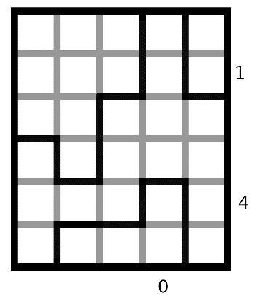
In this example we need a model satisfying all the above-mentioned rules:
Rule 1:
(¬W0.5 V W0.4)Ʌ(¬W0.4 V W0.3)Ʌ(¬W0.2 V W0.1)Ʌ(¬W0.1 V W0.0)
Ʌ(¬W1.5 V W1.4)Ʌ(¬W1.4 V W1.3)Ʌ(¬W1.3 V W1.2)
Ʌ(¬W2.5 V W2.4)Ʌ(¬W2.3 V W2.2)Ʌ(¬W2.2 V W2.1)
Ʌ(¬W3.5 V W3.4)Ʌ(¬W3.4 V W3.3)Ʌ(¬W3.3 V W3.2)Ʌ(¬W3.1 V W3.0)
Ʌ(¬W4.5 V W4.4)Ʌ(¬W4.3 V W4.2)Ʌ(¬W4.2 V W4.1)Ʌ(¬W4.1 V W4.0)

Rule 2:
( ¬W0.5 V W1.5)Ʌ(W0.5 V ¬W1.5)Ʌ( ¬W1.5 V W2.5)Ʌ(W1.5 V ¬W2.5)
Ʌ( ¬W0.4 V W1.4)Ʌ(W0.4 V ¬W1.4)Ʌ( ¬W1.4 V W2.4)Ʌ(W1.4 V ¬W2.4)
Ʌ( ¬W0.3 V W1.3)Ʌ(W0.3 V ¬W1.3)Ʌ( ¬W2.3 V W3.3)Ʌ(W2.3 V ¬W3.3)Ʌ( ¬W3.3 V W4.3)Ʌ(W3.3 V ¬W4.3)
Ʌ( ¬W2.2 V W3.2)Ʌ(W2.2 V ¬W3.2)Ʌ( ¬W3.2 V W4.2)Ʌ(W3.2 V ¬W4.2)
Ʌ( ¬W0.1 V W1.1)Ʌ(W0.1 V ¬W1.1)Ʌ( ¬W1.1 V W2.1)Ʌ(W1.1 V ¬W2.1)
Ʌ( ¬W1.0 V W2.0)Ʌ(W1.0 V ¬W2.0)Ʌ( ¬W2.0 V W3.0)Ʌ(W2.0 V ¬W3.0)

Rule 3:
For the line 1 (Zl1 = 4) :
S = 6, Z = Zl1= 4, N = 5
N-Z = 1
(W0,1 V W1,1)Ʌ(W0,1 V W2,1)Ʌ(W0,1 V W3,1)Ʌ(W0,1 V W4,1)
Ʌ(W1,1 V W2,1)Ʌ(W1,1 V W3,1)Ʌ(W1,1V W4,1)
Ʌ(W2,1 V W3,1)Ʌ(W2,1V W4,1)
Ʌ(W3,1V W4,1)

Ʌ (¬W0,1 V ¬W1,1 V ¬W2,1V ¬W3,1V ¬W4,1)

For the line 4 (Zl4 = 1):
S = 6, Z = Zl4= 1, N = 5
N-Z = 4
(W0,4 V W1,4 V W2,4 W3,4V W4,4)

Ʌ(¬W0,4 V ¬W1,4)Ʌ(¬W0,1 V ¬W2,4) Ʌ(¬W0,1 V ¬W3,4) Ʌ(¬W0,1 V ¬W4,4)
Ʌ(¬W1,4 V ¬W2,4) Ʌ(¬W1,1 V ¬W3,4) Ʌ(¬W1,1 V ¬W4,4)
Ʌ(¬W2,4 V ¬W3,4) Ʌ(¬W2,1 V ¬W4,4)
Ʌ(¬W3,4 V ¬W4,4)

For the column 3 (Zc3 = 0):
S = 5, Z = Zc3= 0, N = 6
N-Z = 6
¬W3,0 Ʌ ¬W3,1 Ʌ ¬W3,2 Ʌ ¬W3,3 Ʌ ¬W3,4 Ʌ ¬W3,5

