UPES
University of Tomorrow
ARES
Adaptive Red-teaming & Enforcement System
Minor Project — Detailed Project Report
7th Semester, B.Tech Computer Science Engineering
Presented by:
Aikagra
Dhruv Aggarwal
Neo Gonsalves
Vansh Malik
Guided by:
Faculty Mentor

Table of Contents
1. Abstract 3
2. Introduction 3
3. Literature Review 4
4. Problem Statement 4
5. Objectives 5
6. Methodology 5
7. PERT Chart 8
8. Conclusion 9
9. References 9

1. Abstract
As enterprises rapidly deploy Large Language Model (LLM) and Retrieval-Augmented Generation (RAG) based applications, prompt injection has emerged as the most critical unaddressed vulnerability in production AI systems. ARES (Adaptive Red-teaming & Enforcement System) addresses this gap through a closed-loop architecture that automatically red-teams and hardens prompts against adversarial attack before deployment, and enforces that hardening in real time once the prompt is live.
Attack results generated during red-teaming are embedded into a vector database. When a new prompt is submitted for optimisation, relevant historical attack context is retrieved via Retrieval-Augmented Generation and used to harden the prompt for maximum robustness and efficiency, rather than relying on a static rule set. Hardened prompts are deployed behind a dedicated enforcement gateway that performs real-time injection classification on every incoming request; attacks caught in production are logged and fed back into the red-teaming engine, allowing the system to continuously improve without manual intervention.
The project additionally includes ARES Arena, an applied prompt-engineering assessment platform built on the same underlying engine. Arena allows a recruiter to issue a practical LLM task to a candidate, who submits a reusable prompt template; ARES then evaluates that submission against hidden test cases and adversarial variations, producing an evidence-backed scorecard rather than a subjective judgement of the candidate's prompt-engineering skill.

2. Introduction
Organisations across every sector are integrating LLM and RAG-based applications into their products and internal tooling — customer-facing chatbots, internal knowledge assistants, coding copilots, and increasingly autonomous agentic tools that can take real actions on a user's behalf. This adoption is happening at a pace that has outstripped the security maturity such applications require. Where web applications took roughly two decades to develop a mature discipline of penetration testing, static analysis, and runtime protection, LLM-based applications are being shipped today largely without an equivalent testing regime.
Within this landscape, prompt injection — the manipulation of an LLM's behaviour through maliciously crafted input, whether typed directly by a user or hidden inside a retrieved document — is ranked the number one risk facing LLM applications by the OWASP Foundation's LLM Top 10. The MITRE ATLAS framework further catalogues the broader landscape of adversarial tactics and techniques specific to machine learning systems, providing a structured vocabulary for classifying such attacks.
Existing mitigations, such as Llama Guard or NeMo Guardrails, are largely static: they apply a fixed set of rules or a pre-trained classifier that does not adapt when a novel attack technique is discovered against a specific deployed application. ARES is designed to close this gap by combining automated adversarial testing, retrieval-augmented prompt hardening, and adaptive runtime enforcement into a single closed-loop system that becomes more resilient over time.
This report presents the background, problem statement, objectives, and proposed methodology for ARES, along with its planned system architecture, technology stack, team structure, and project timeline.

3. Literature Review
- OWASP LLM Top 10: Ranks prompt injection as the foremost security risk facing LLM-integrated applications, ahead of insecure output handling, training data poisoning, and other categories specific to generative AI systems.
- MITRE ATLAS: Provides a structured, publicly maintained framework of adversarial tactics and techniques against machine learning systems, modelled on the established MITRE ATT&CK framework for traditional cybersecurity. ARES's attack categorisation is designed to map onto ATLAS technique identifiers for interpretability.
- Llama Guard and NeMo Guardrails: Widely used open-source guardrail tools that rely on static rule sets or a fixed classifier trained ahead of time. Neither adapts its behaviour based on attacks actually encountered by a specific deployed application, and neither closes the loop back into the systems generating or optimising the prompts they protect.
- Automated red-teaming research: A growing body of research explores automated adversarial prompt discovery, including genetic-algorithm-based and LLM-driven attacker approaches. This research largely stops at vulnerability discovery and does not extend into an integrated hardening or enforcement pipeline.
- Identified gap: No existing system, to the authors' knowledge, combines automated red-teaming, retrieval-augmented prompt hardening, and adaptive runtime enforcement within a single closed feedback loop. ARES is positioned to address this gap directly.

4. Problem Statement
- Prompts deployed to production LLM and RAG applications are rarely tested systematically against adversarial input before release, leaving a direct path for data exfiltration, unauthorised actions, and manipulated outputs.
- Existing defensive tools are static rule sets or fixed classifiers that do not improve from real-world attacks they actually encounter, meaning a novel technique that succeeds once can succeed indefinitely.
- There is no standardised, evidence-based way to evaluate a prompt engineer's ability to design prompts that are simultaneously effective and safe under adversarial conditions, leaving hiring and internal skill assessment reliant on subjective or purely theoretical evaluation.

5. Objectives

5.1 Primary Objective
To design and implement a self-improving system that automatically discovers, defends against, and adapts to prompt injection attacks across the full lifecycle of an LLM or RAG application — from design-time hardening through runtime enforcement.

5.2 Sub-objectives
- Automate adversarial red-teaming of a target LLM and use the resulting attack corpus, via retrieval-augmented generation, to harden new prompts for robustness and efficiency.
- Enforce hardened prompts in real time through a continuously learning enforcement gateway that classifies and blocks injection attempts as they occur.
- Demonstrate the engine's applied and commercial value through ARES Arena, a prompt-engineering assessment platform built on the same underlying attack and evaluation engine.

6. Methodology

6.1 Core Pipeline
The core ARES pipeline follows the sequence below, forming the project's main technical flow:
- Red-team the target LLM using cloud-hosted models (Groq, Google Gemini, and NVIDIA NIM/Nemotron) to systematically probe it with injection, jailbreak, and role-override attack techniques.
- Embed the resulting attack results — successful and unsuccessful attempts, categorised by technique — into a vector database (Qdrant) as a growing, queryable attack corpus.
- When a new prompt is submitted, retrieve the most relevant historical attack patterns from the vector database via retrieval-augmented generation.
- Use the retrieved context to optimise and harden the prompt, scoring each candidate on both task accuracy and adversarial robustness.
- Deploy the hardened prompt behind an enforcement gateway that performs real-time injection classification on every incoming request before it reaches the underlying model.
- Log every blocked attack and feed it back into the red-team corpus, so that future optimisation runs are tested against attacks genuinely encountered in production — closing the loop.

6.2 ARES Arena — Applied Evaluation Layer
ARES Arena is a parallel, non-blocking module that applies the same underlying red-team and scoring engine to a recruiter-facing prompt-engineering assessment workflow. It does not sit on the project's critical path and can be developed alongside the core pipeline once the attack engine and vector database are in place. Arena consists of the following components:
- Candidate portal: A candidate receives a practical LLM task, writes a reusable prompt template, and may test it against a limited number of visible examples before submission.
- Recruiter portal: A recruiter selects or creates an assessment, reviews evidence-backed scorecards for each candidate, and configures scoring weights per role.
- Challenge-pack library: Structured extraction, classification, constrained summarisation, and a Secure RAG challenge in which the candidate's prompt must answer correctly from supplied documents while ignoring malicious instructions hidden within them. The Secure RAG challenge directly reuses ARES's core prompt-injection and resilience engine, so no separate RAG application is required for the MVP.
- Hidden-test infrastructure: On submission, the candidate's prompt is run against hidden test cases and adversarial variations the candidate never sees, ensuring the score reflects genuine performance rather than optimisation against visible examples alone.
- Weighted scoring: Each submission is scored on task correctness (40%), robustness under injection and noisy input (25%), constraint adherence such as schema and format (15%), consistency across repeated runs (10%), and efficiency in tokens, latency, and cost (10%). Recruiters may adjust these weights per role. ARES produces a STRONG, MIXED, or NEEDS REVIEW recommendation; it never automatically accepts or rejects a candidate — a human reviewer always makes the final decision.

6.3 System Architecture
The system is organised into two layers that mirror the project's team structure. The AI and machine-learning services — the prompt optimiser, the red-team attack engine, the injection classifier, and the vector database integration — are implemented in Python, since this is where the mature ecosystem for LLM orchestration, embeddings, and retrieval currently resides. The enforcement gateway and Arena's backend, covering authentication, role-based access control, the prompt registry, and audit logging, are also implemented in Python for consistency across the team, exposed through a well-defined REST API. The dashboard and Arena's candidate and recruiter portals are built with Blazor (C#), consuming these APIs and providing live, real-time views of optimisation runs, the prompt registry, and the attack feed.
Architecturally, ARES Arena is a consumer of the red-team attack engine rather than a dependency of it: the core optimisation-enforcement loop functions identically whether or not Arena is present, and a fault in Arena does not affect the core system's operation.

6.4 Technology Stack
Layer | Technology | Purpose
AI / ML services | Python, FastAPI | Prompt optimisation, red-teaming, injection classification
LLM providers | Groq, Google Gemini, NVIDIA NIM (Nemotron) | Cloud-hosted inference, no local/offline dependency, high free-tier throughput
Vector database | Qdrant Cloud | Storage and retrieval of the embedded attack corpus
Relational database | Supabase (PostgreSQL) | Users, prompt registry, audit logs, Arena data
Backend / gateway | Python (FastAPI) | Authentication, RBAC, enforcement gateway, Arena backend
Frontend | Blazor (C#) | Dashboard, candidate portal, recruiter portal
Deployment | Docker, Render, Vercel | Cloud-hosted, deployable across all team members' systems
CI/CD | GitHub Actions | Automated testing and red-team regression on every change

6.5 Team and Role Distribution
Role | Primary Responsibility
Role 1 | Prompt optimisation engine, ARES Arena (candidate portal, recruiter portal, challenge packs, hidden-test infrastructure, weighted scoring), and shared contribution to the red-team attack engine
Role 2 | Enforcement gateway backend, and shared contribution to the red-team attack engine
Role 3 | Dashboard: optimisation run views, prompt registry, live attack feed
Role 4 | Dataset curation, evaluation methodology, and reporting

7. PERT Chart
The project's main flow follows the core red-teaming and optimisation pipeline described in Section 6.1, forming the critical path shown in amber below. ARES Arena, shown in grey, branches off in parallel once the vector database and attack corpus are available, and rejoins the main flow only at final integration — giving it several weeks of schedule slack relative to the core system.
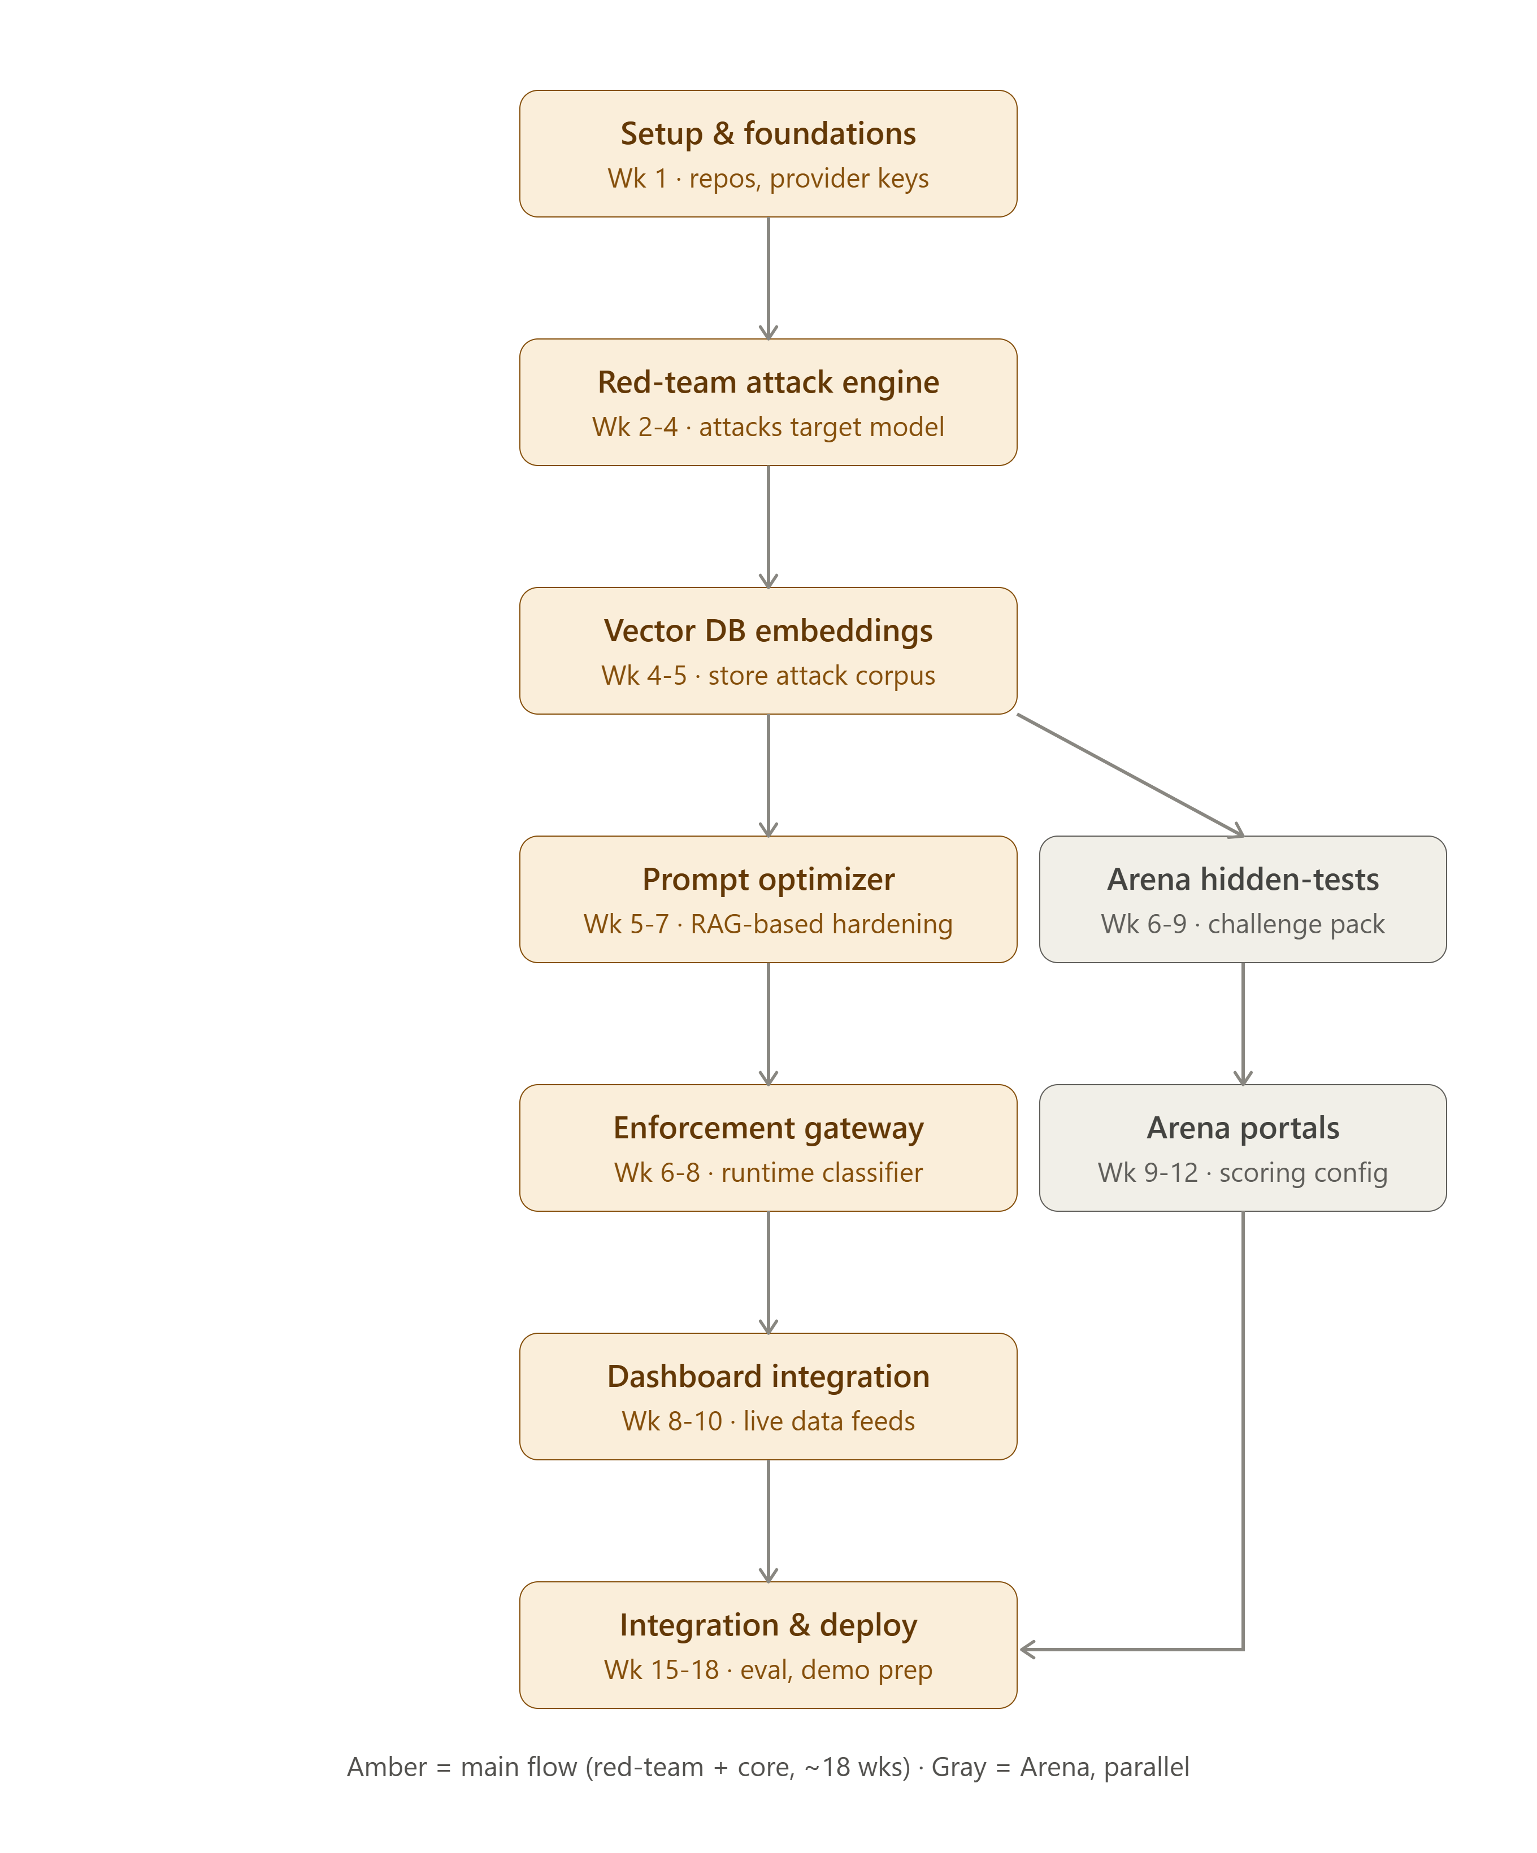
Critical path (main flow): Setup & Foundations → Red-team Attack Engine → Vector DB Embeddings → Prompt Optimiser → Enforcement Gateway → Dashboard Integration → Integration & Deployment, spanning approximately eighteen weeks. The parallel ARES Arena track (hidden-test infrastructure, then portals) begins around week six and completes by week twelve, comfortably ahead of the week-fifteen point at which it is required for final integration.

8. Conclusion
ARES delivers a working closed-loop system that automatically hardens and enforces LLM and RAG prompts against adversarial attack, continuously improving from real-world attempts rather than relying on a static defence. ARES Arena demonstrates the same engine's applied, commercial value through an evidence-based prompt-engineering assessment workflow, positioned as a parallel module that does not compromise the delivery of the core system. Together, they offer both a genuine security-research contribution — mapped explicitly to the OWASP LLM Top 10 and MITRE ATLAS frameworks — and a concrete, understandable use case for non-technical audiences.
Future work beyond the scope of this project includes additional Arena challenge packs beyond the Secure RAG challenge, a multilingual and vernacular attack corpus covering code-mixed and regional-language injection attempts, and extended compliance-oriented reporting suitable for audit and regulatory contexts.

9. References
OWASP Foundation, “OWASP Top 10 for Large Language Model Applications.”
MITRE Corporation, “MITRE ATLAS: Adversarial Threat Landscape for Artificial-Intelligence Systems.”
Meta AI, “Llama Guard: LLM-based Input-Output Safeguard for Human-AI Conversations.”
NVIDIA, “NeMo Guardrails Documentation.”

