ENGN/COMP8535 Homework 2

Yuyang Han u7434576

Q1

1. P is

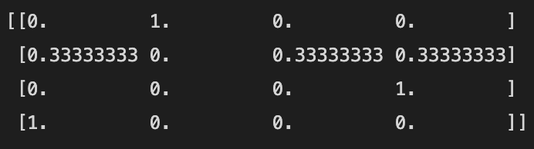

1. G is

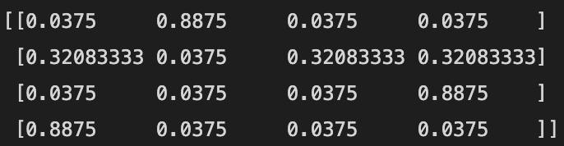

1. Use G and α, rank the webpages with fullrank algorithm. Using the power method to compute an approximation of with 5 iterations from gets the following rank results.

where the first page has the highest rank.

Q2

1. Working out the svd of X by hand

Here is the result of find the svd of X using python numpy library

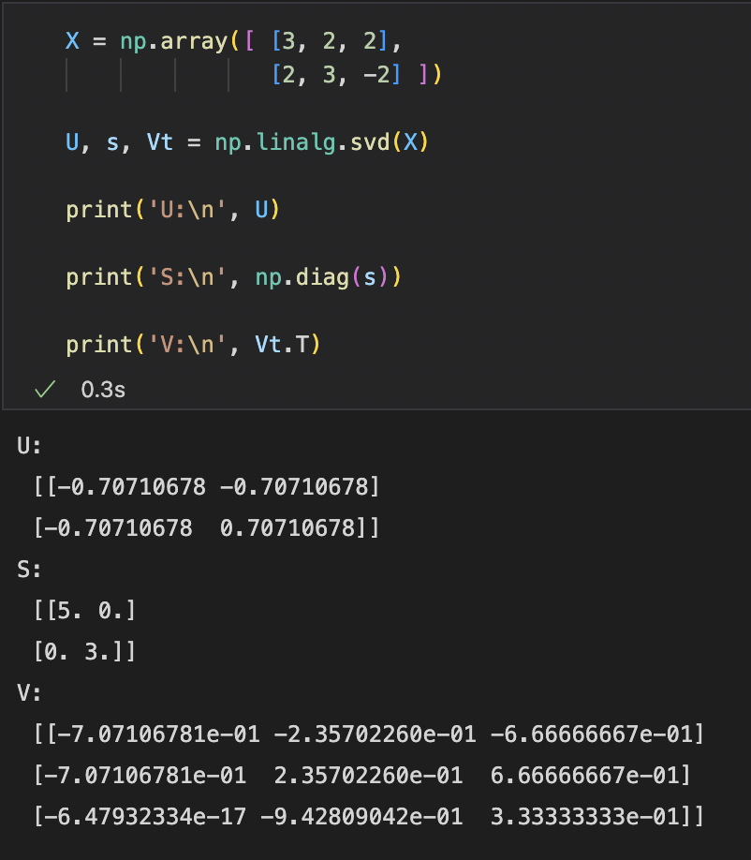

1. The best rank-one approximation to *X* is where is the first singular value, is the first left singular vector, and is the first right singular vector of *X*. Below is the reconstructed *X.*

Q3



