Assignment 1 Report
Question no 1

1 a) Image Shrinking : Every dth column of the image matrix is deleted and then every dth row is deleted. This results in a shrinked image.
Image for d=2
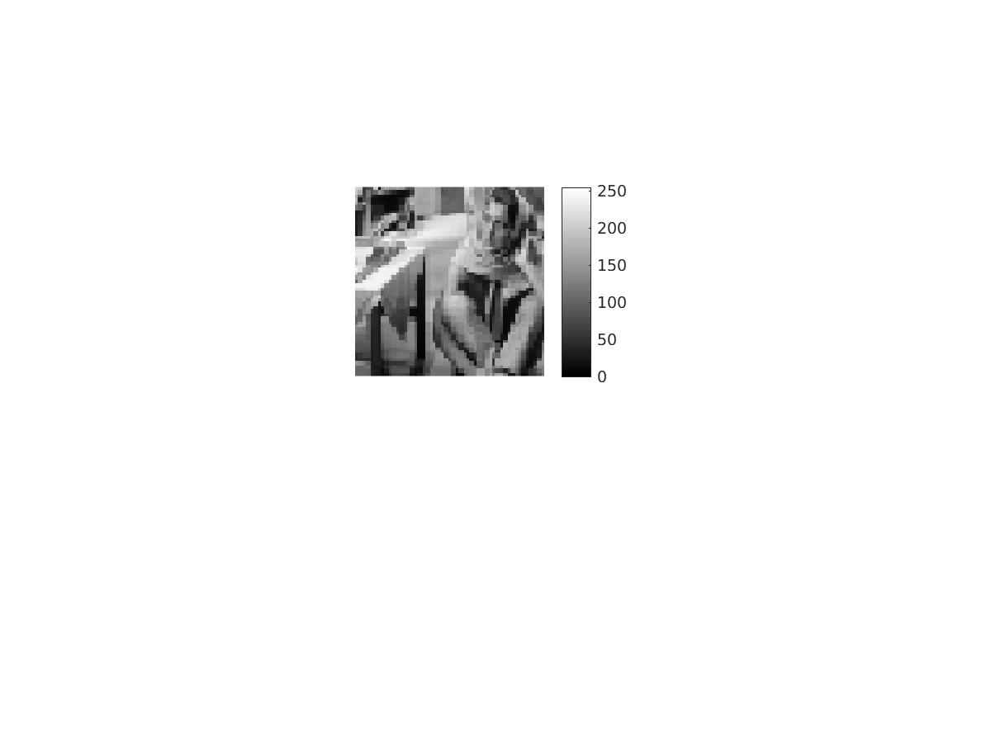

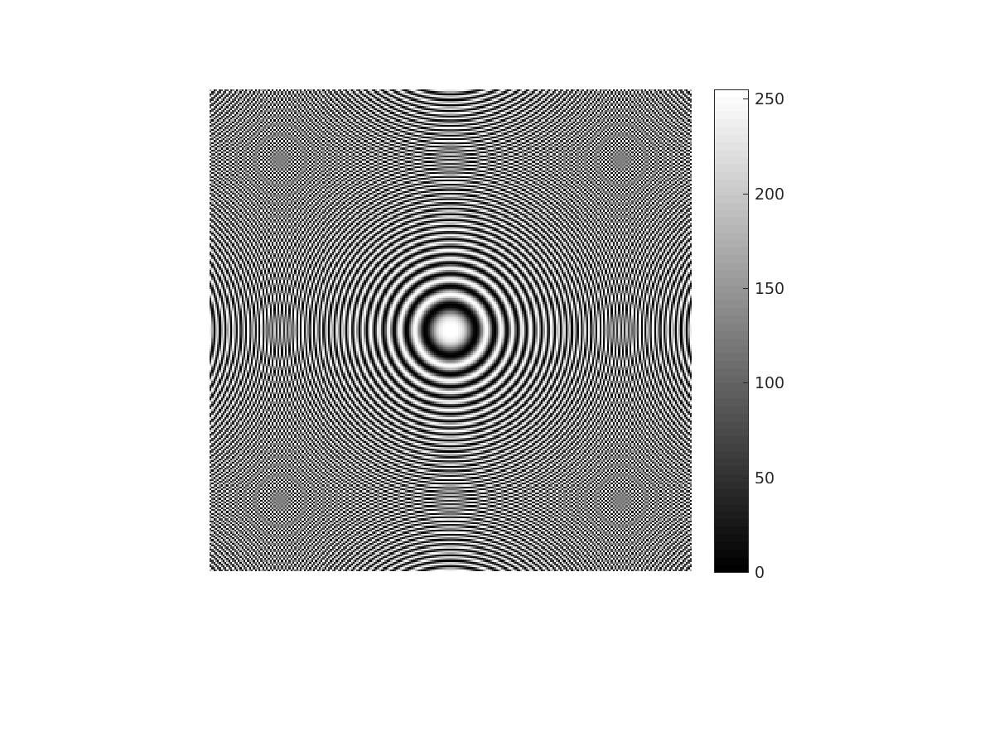

Image for d=3
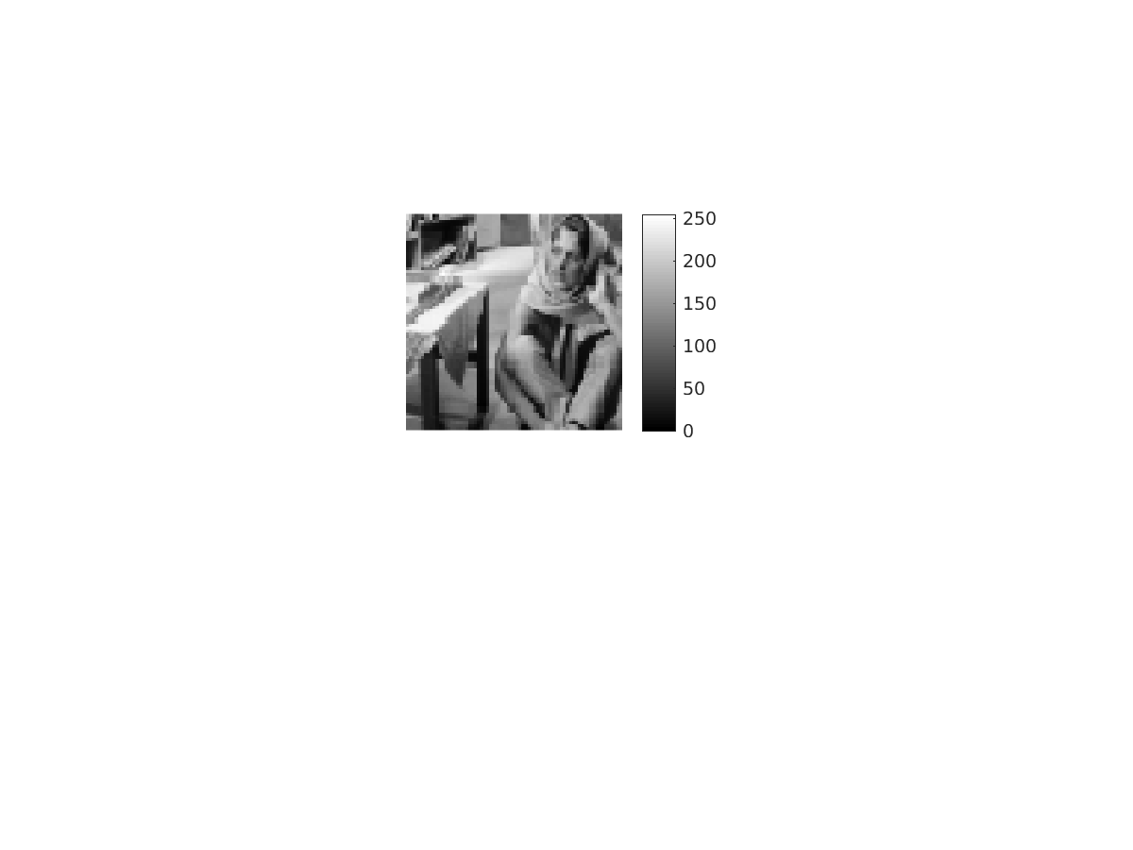
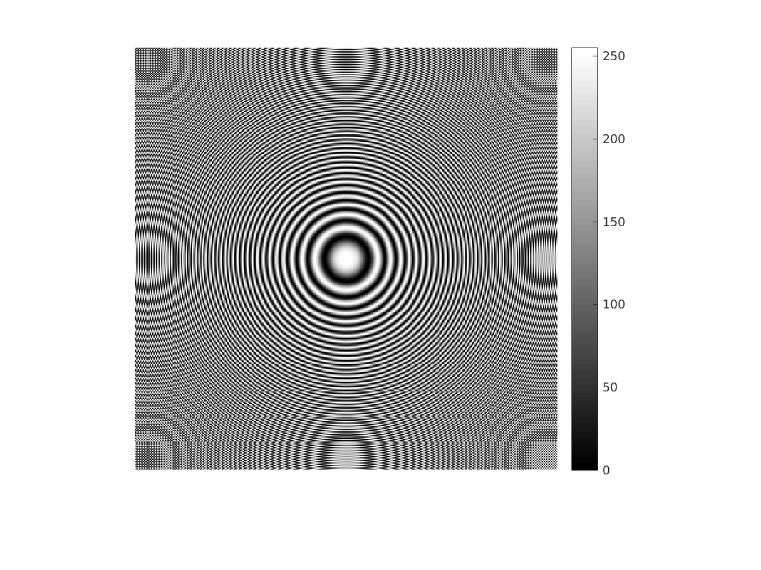

1 b) Image Enlargement using Bilinear Interpolation : A matrix (say M) of double the number of rows of image matrix is created. For each row of image matrix, two rows from the matrix M is inserted into the matrix image. Now size of the resultant matrix (M’) becomes three times the size of the image matrix in terms of number of rows. Now for each column of M’ one column of zeros is inserted. Hence resultant matrix will have two extra rows and one extra column of zeros at the end. Delete these extra rows and columns. Now our resultant matrix size becomes (3M-2)X(2N-1). Odd numbered columns are filled with the average of the next and previous column’s intensities as both are equidistant from the odd number column. Further, First row filled with zeros is filled with the sum of two-third of intensity in previous row and one-third of intensity in next to next row. Similarly, 2nd row filled with zeros is filled with the sum of one-third of intensity in previous to previous row and two-third of intensity next row.
Image generated by this algorithm:
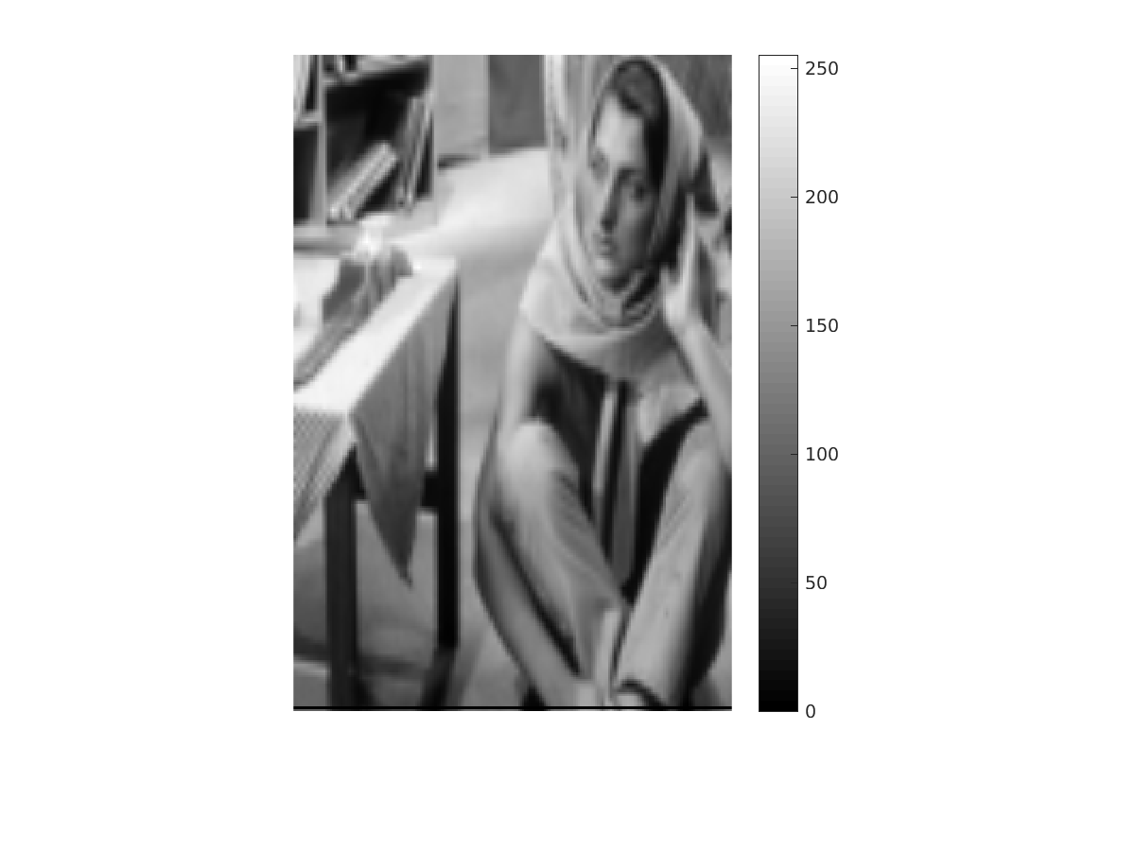

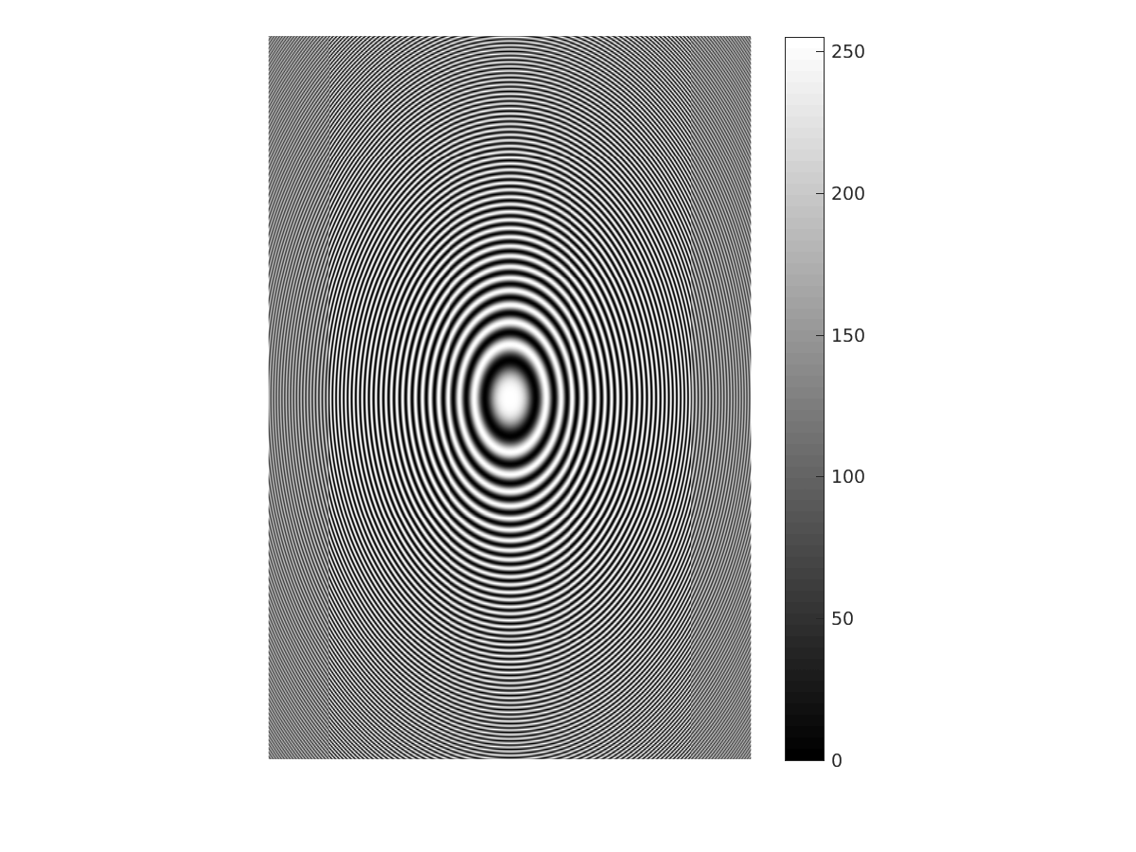

1 c) Image Enlargement using Nearest-Neighbor Interpolation : For this particular question where image size is tripled in row wise and dubled in column wise, if each pixel of original image present in the resultant matrix copy its intesnity to all of its eight neighbours, it becomes exhaustive.

Image generated by this algorithm:
