Assignment 1 Report
Question no 2

2 a) Linear Contrast Stretching :
Pseudocode:
min_val=27.0 #This intensity is after 5% of the intensity from bottom of the intesity range
max_val=235.0 #This intensity is after 5% of the intensity from top of the intesity range
#This top 10% from bottom and top of the range s taken because minimum and maximum intesity #value might be an outlier.

temp_image = deepcopy(original_image)

for i in range(512):
for j in range(512):
if original_image[i][j]<min_val:
temp_image[i][j]=0
elif original_image[i][j]>max_val:
temp_image[i][j]=255
else:
temp_image[i][j] = (original_image[i][j] – min_val)*((255.0)/(max_val- min_val))
cv2.imshow(‘image’, temp_image)

Result of the algorithm:

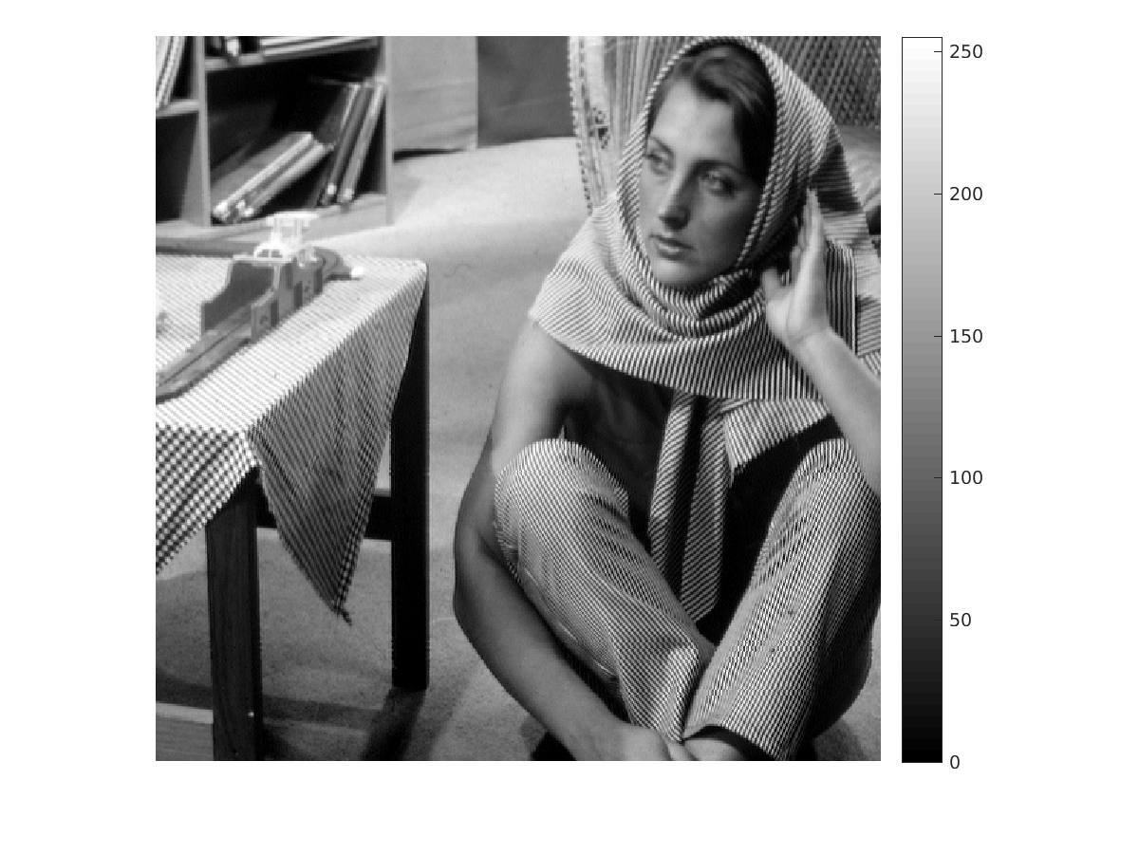

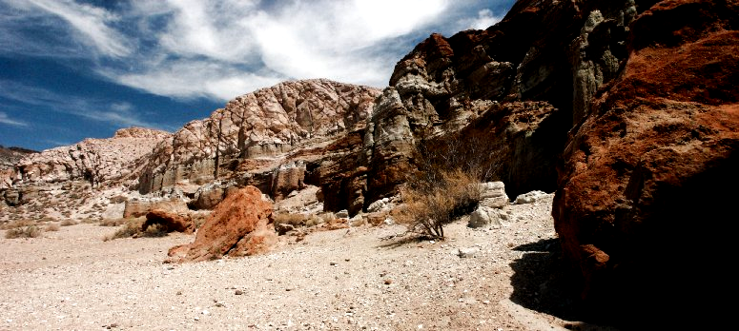
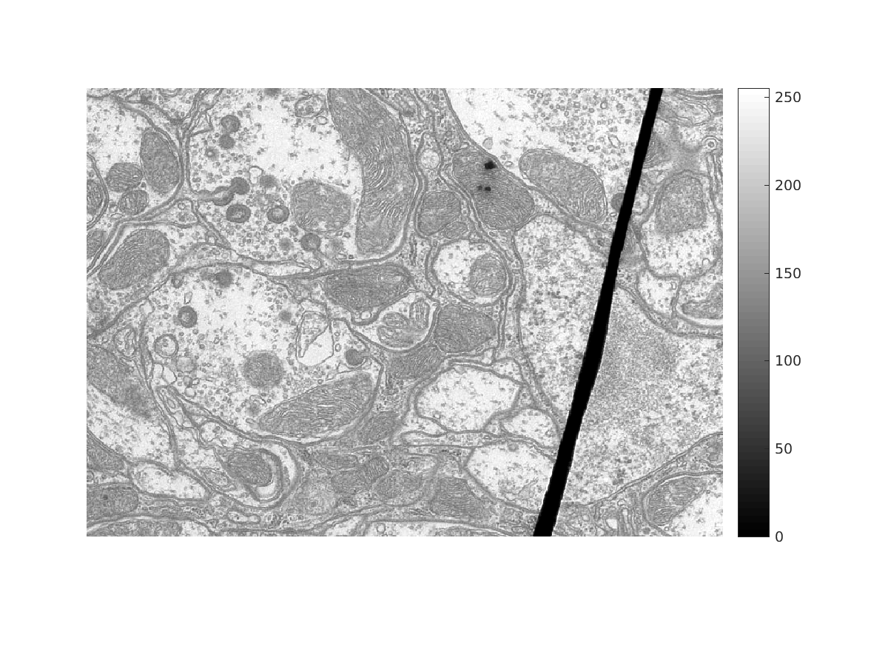

2 b) Histogram Equalization (HE) :
Steps : 1.) Histogram is calculated 2.) CDF is calculated 3.) Values nearby 0 in CDF is marked as invalid i.e. ignore while doing calculation as of now. 4.) As CDF might go beyond range of 0-255, so normalization is done. To avoid 0 being the minimum value (as this might be an outlier) while doing the min-max normalization, step 3 is performed. 5.) Now after normalization, fill 0 for intensities marked as invalid. 6.) CDF now gives the output image intensity value for an input image.

Result of the algorithm:
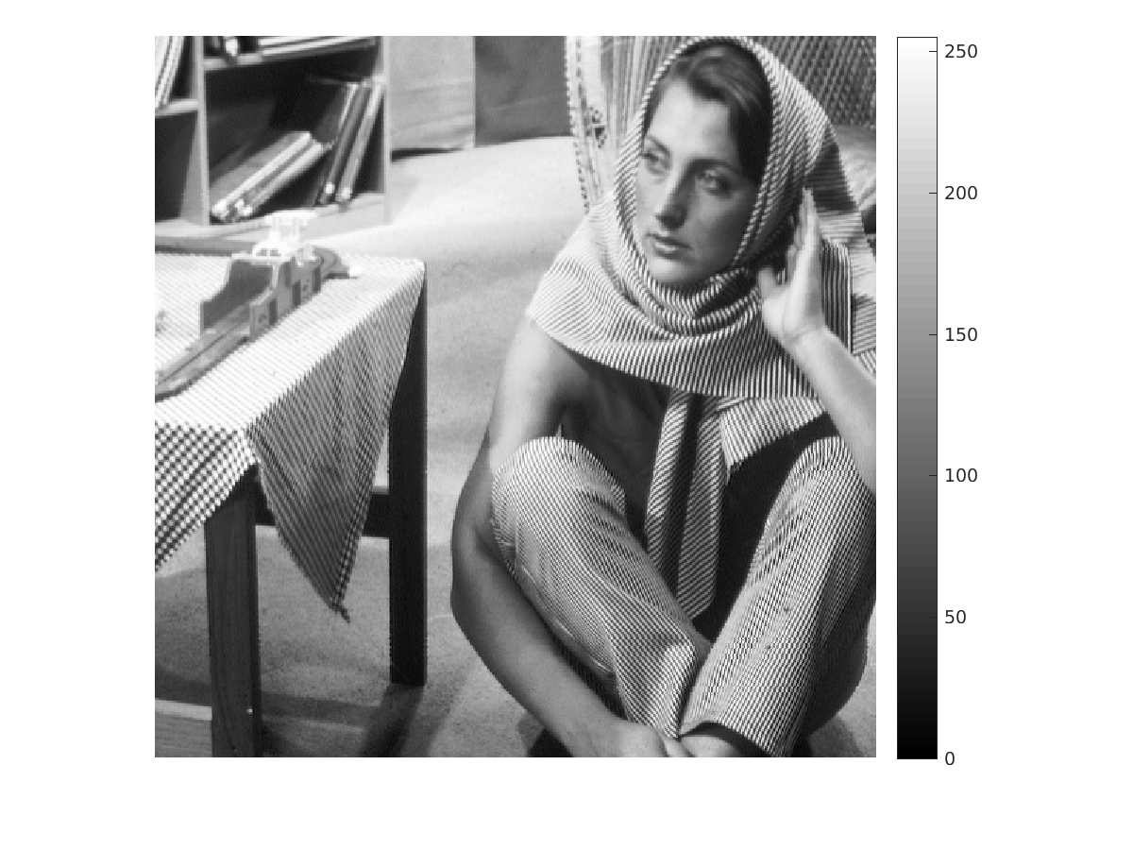
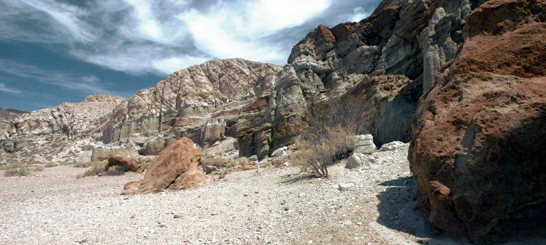

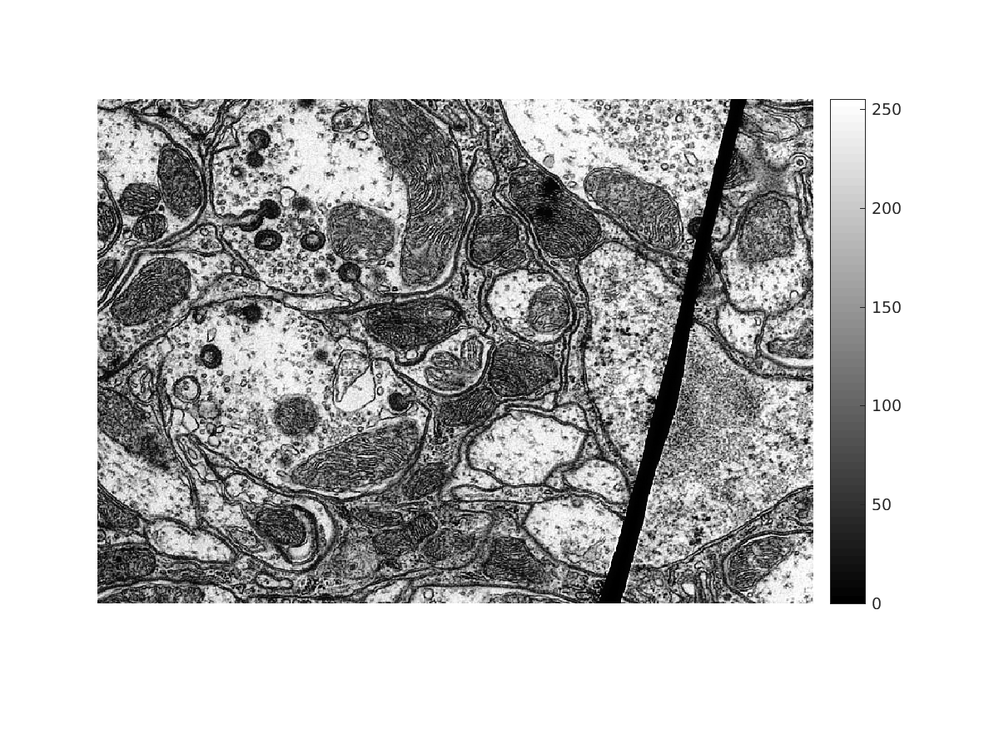

2 c) Adaptive Histogram Equalization (AHE) : Same thing as of Histogram Equalization is performed but not for the entire image at once but for smaller window size. Each pixel is surrounded by a window with pixel being in the center of the window. Now HE is calculated for this window and resulting intensity for the central pixel is stored. Similarly, for all pixels this is done.
This algorithm takes more than 5 minutes to complete its execution. So, a counter is diplayed after every 1000 iterations to show the progress.
Result of the algorithm:
Window Size 25 : Excessive noise amplification.
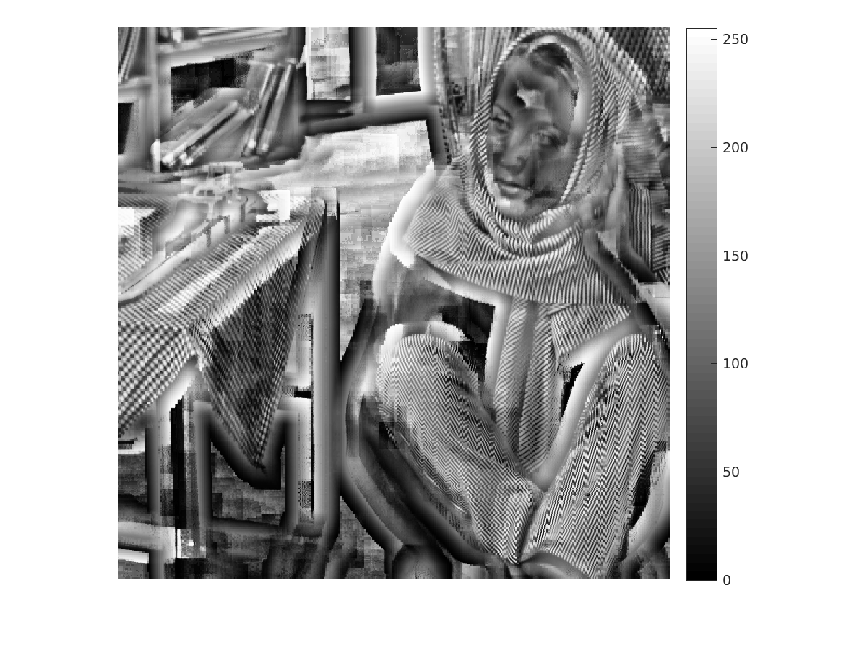

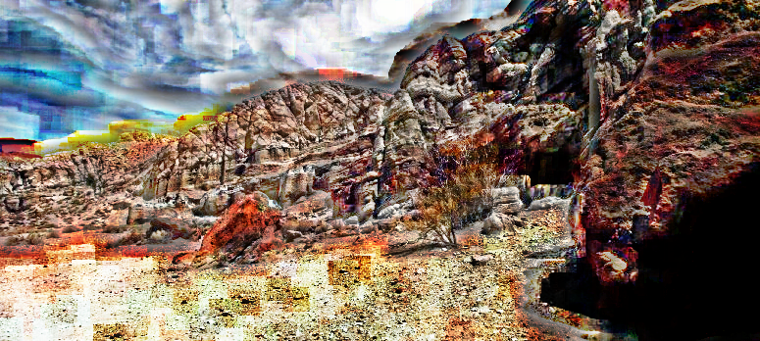

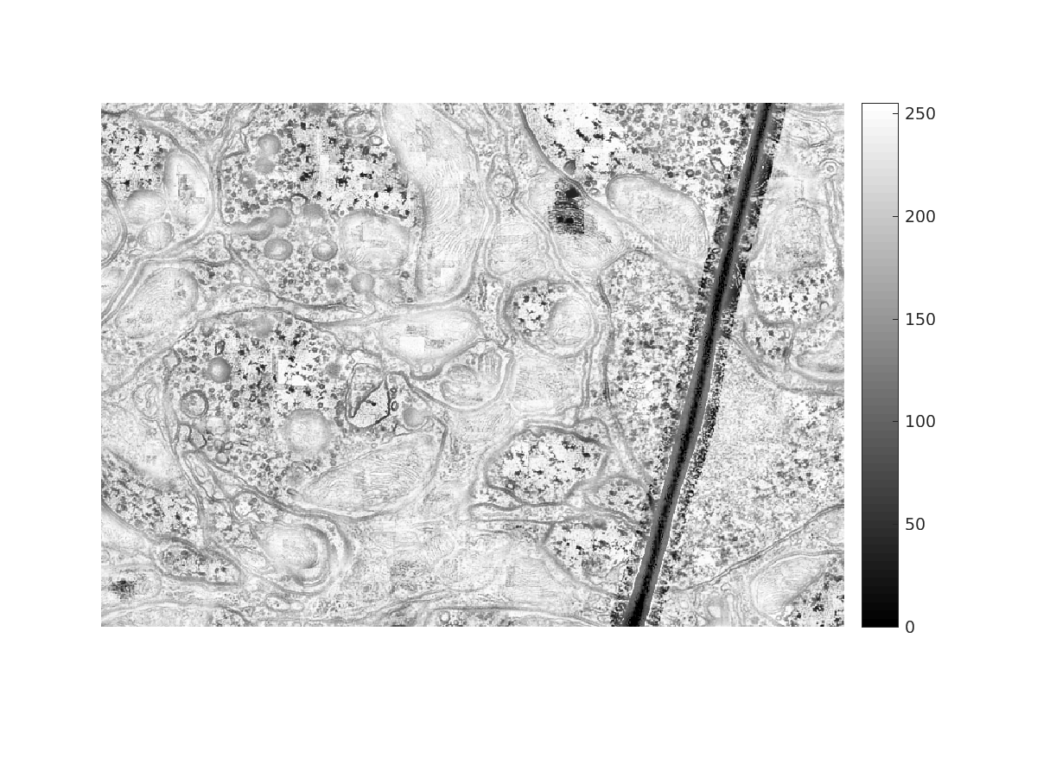

Window size = 301

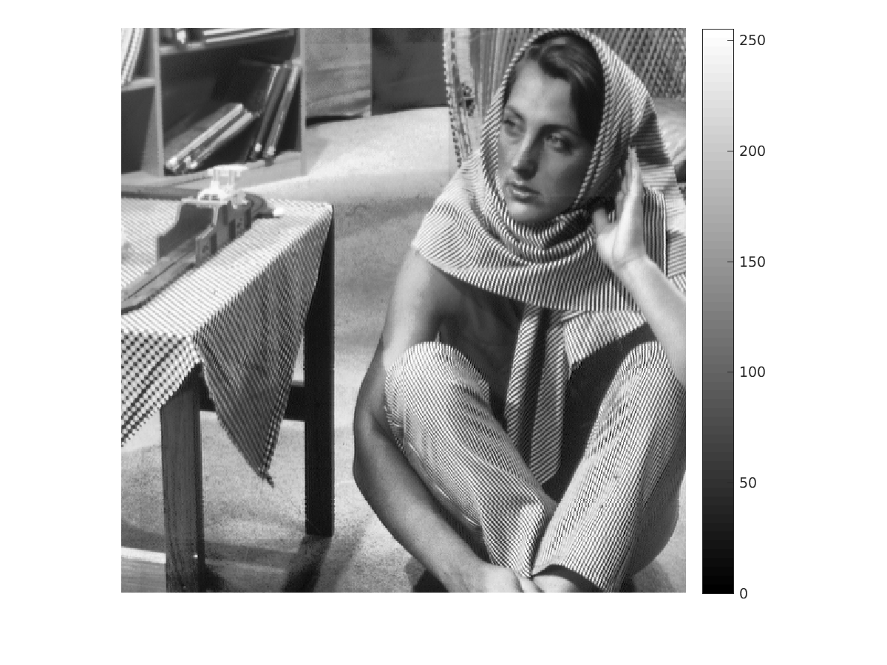
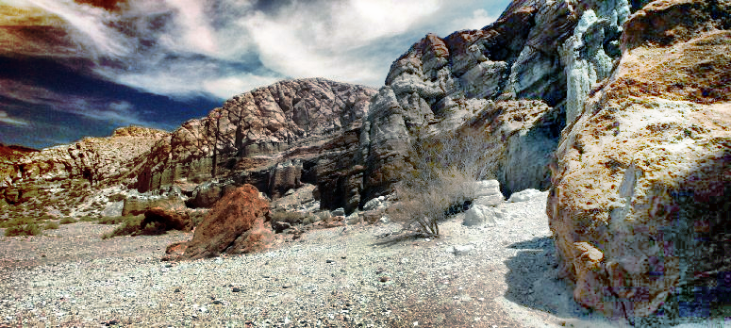

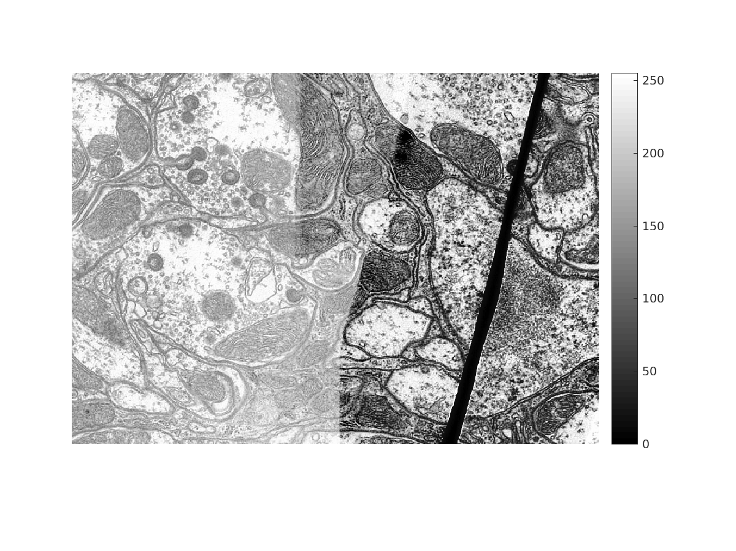

2 d) Contrast-Limited Adaptive Histogram Equalization (CLAHE) :
It is similar to AHE but a threshold is determined by the user for frequency of intensities before calculating the CDF. All intensity frequency crossing the threshold is clipped to the threshold value. And leftover is distributed uniformly over all intensity values. Then, CDF is calculated and rest is similar to AHE.

This algorithm takes more than 5 minutes to complete its execution. So, a counter is diplayed after every 1000 iterations to show the progress.

Result of the algorithm:

Window Size : 25, Threshold = mean
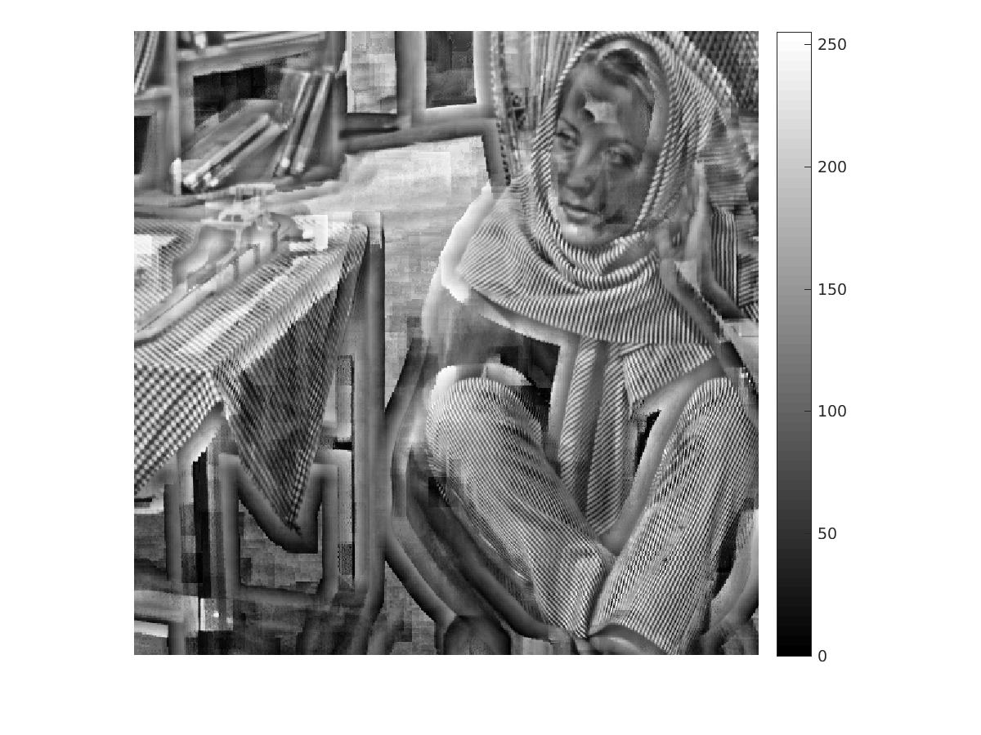
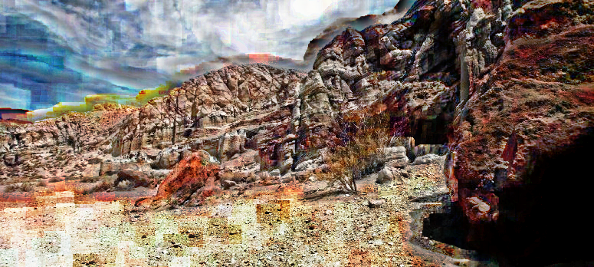

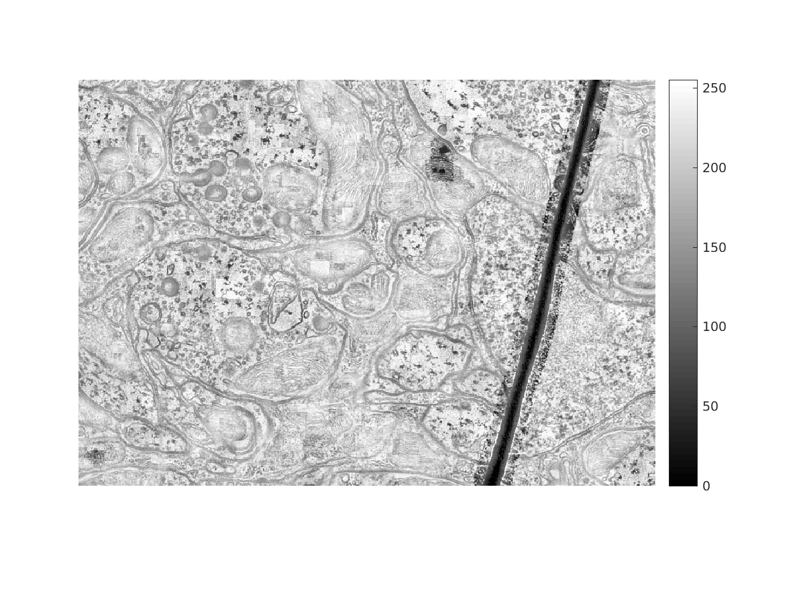

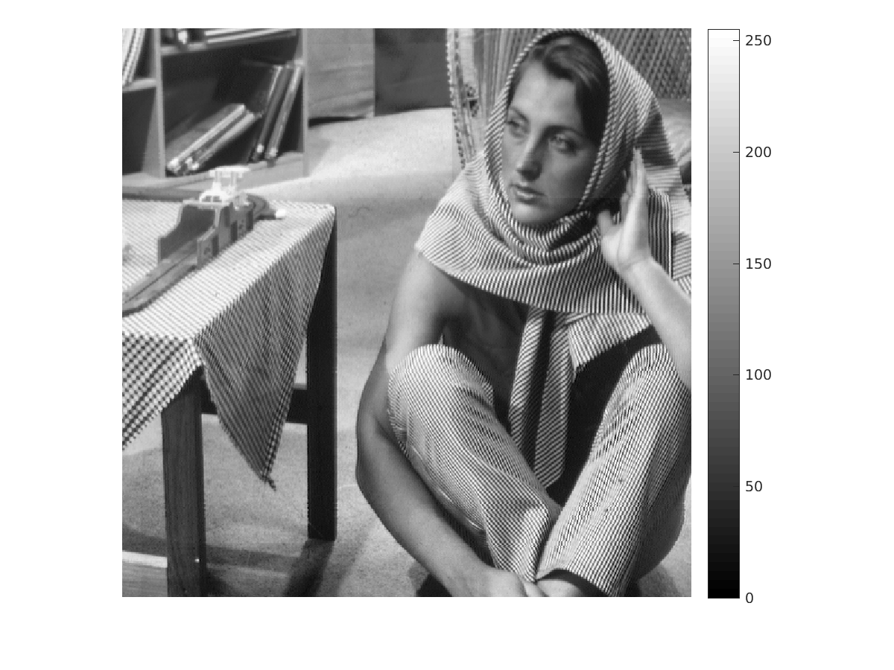
Window Size : 301, Threshold = mean



