Report for Harris Corner Detection

Derivative Image along horizontal direction :
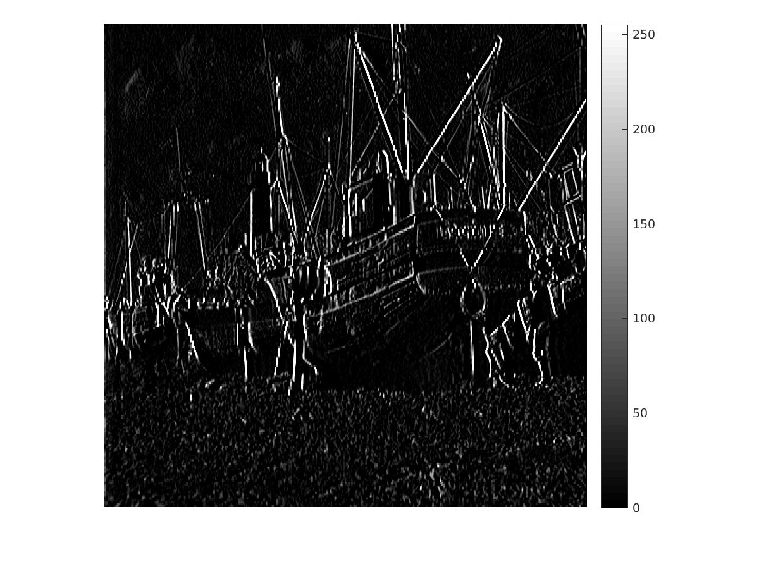
Derivative Image along vertical direction :
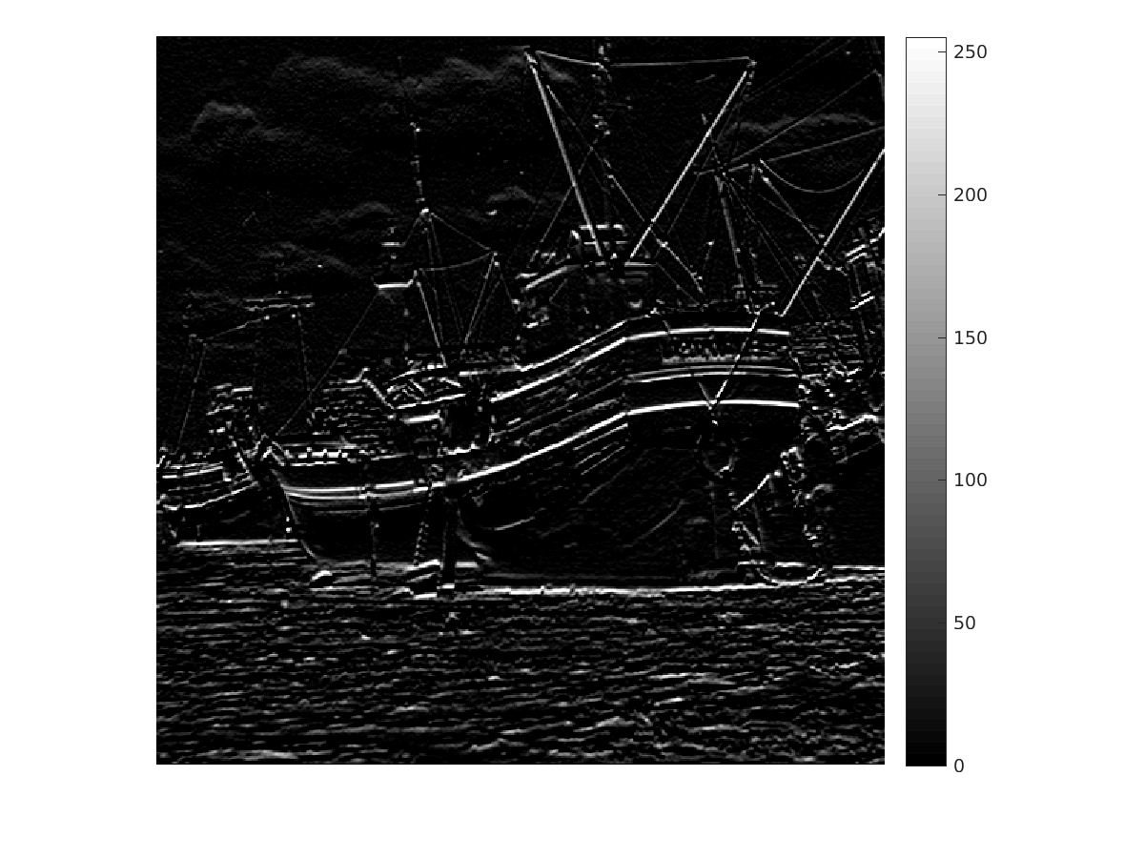

Image of Min eigen value:
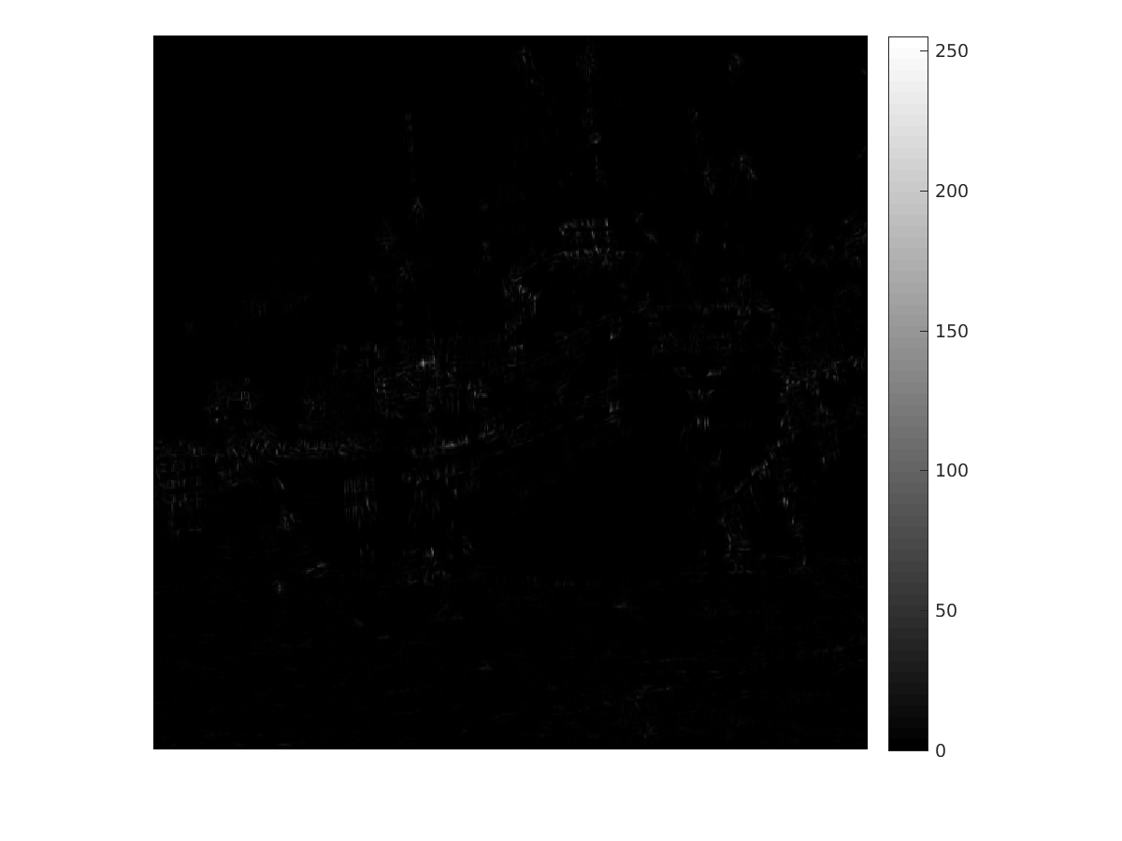
Image of Max eigen Value:
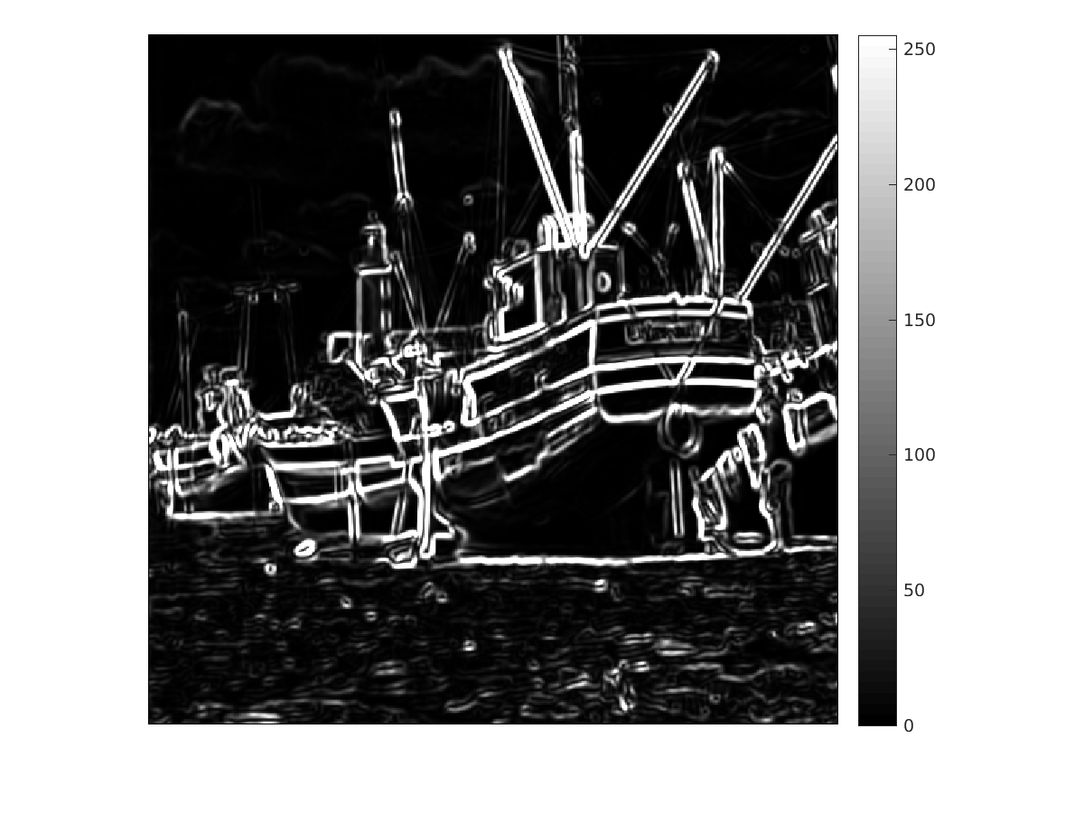

Corner Image
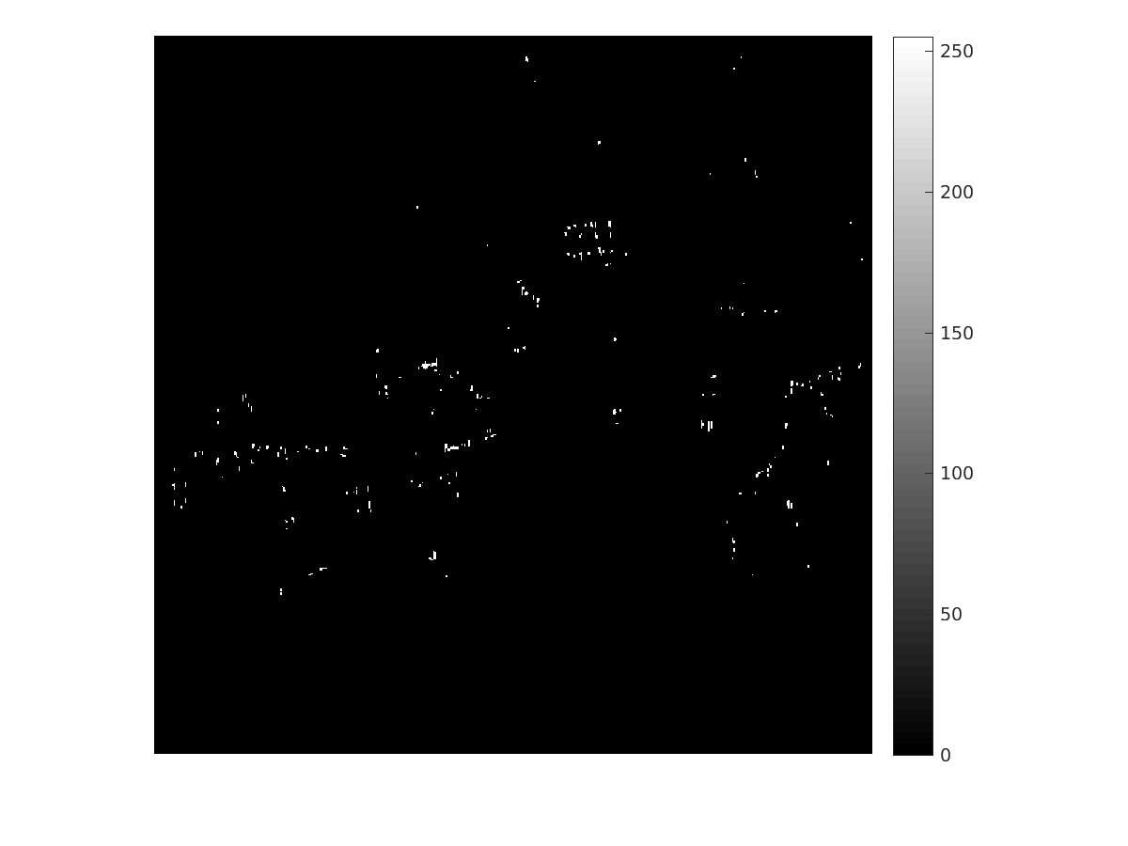
Corner Image Superimposed with Original Image:
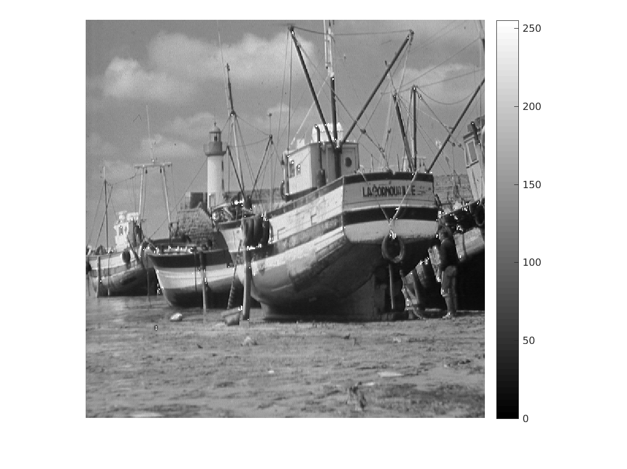
TUNED PARAMETERS:
Sigma x = 10
Sigma y = 3
kappa (k) = 0.05

Original Image
