Report for Image Segmentation using Mean-Shift

Original Image
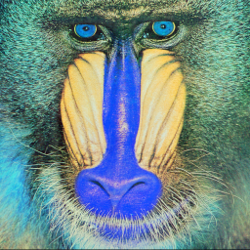

Segmented Image
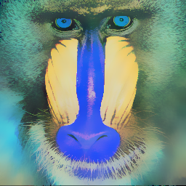

Parameters Tuned
Gaussian kernel bandwidth for the color feature : 0.1
Gaussian kernel bandwidth for the spatial feature : 11
Number of iterations : 20

