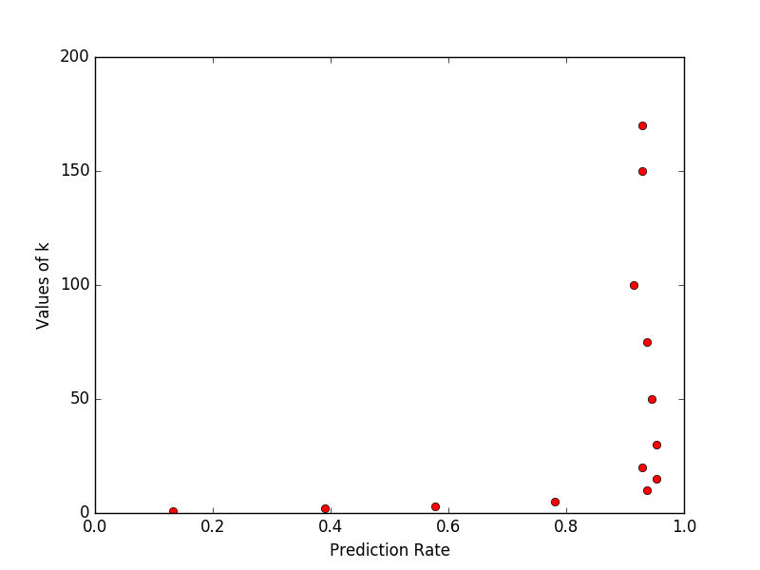
1)

Face recognition on ORL face database using Eigen Value Decompostion.

Face recognition on ORL face database using Singular Value Decompostion.

Face recognition on Yale Face database using Singular Value Decompostion.
(all eigencoefficients are included.)

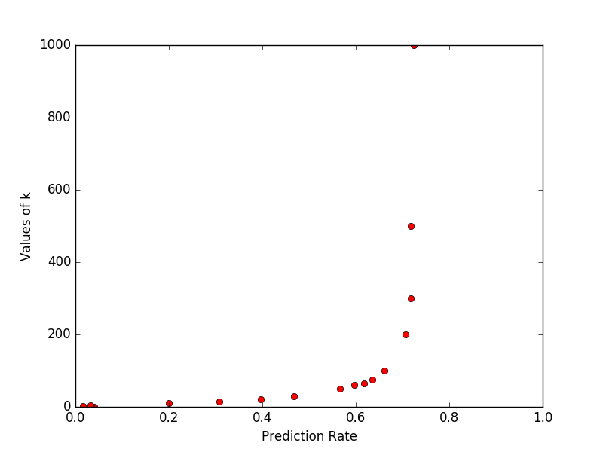
Face recognition on Yale Face database using Singular Value Decompostion. (all except the three eigencoefficients corresponding to the eigenvectors with the three largest eigenvalues)
