6. a.) MSE of noise and original image = 233
MSE of denoised and original image = 402
MSE of denoised and original image < MSE of noise and original image
Denoised Image:

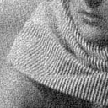

b.) MSE of noise and original image = 146
MSE of denoised and original image = 407
MSE of denoised and original image < MSE of noise and original image
Denoised Image:
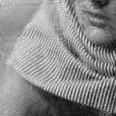

c.) Bilateral Filter Denoised Image :
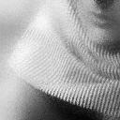

MSE of part a = 233
MSE of part b = 146
MSE of Bilateral Filter = 315

(MSE of part b = 146) < (MSE of part a = 233) < (MSE of Blateral Filter = 315) < (MSE of noisy image = 400)

PCA is a method of dimensionality reduction. We can imagine the reduction of a n-dimensional space to a k-dimensional space, where k<n. PCA finds the plane on which all datapoints are projected so that the amount they get projected is as small as possible i.e. error is as low as possible.
Bilateral filtering on the other hand does not reduce dimensionality. It just removes noise by "smoothing" the image.

