Human Tracking Fan

Himanshu Singh (16305R005), IIT Bombay, Prof. Krithi Ramamritham, IIT bombay

Abstract
This project aims at creating a table fan that can track human i.e. it changes the direction of flow depending on the user’s location from the fan using face detection algorithm.

Introduction
In current scenario, normal table fan generally operates in two modes :
1.) Fan is static and it makes air flow in a particular direction. To change the direction of air flow, one has to manually rotate the fan.
2.) Fan rotates clockwise and anticlockwise continuously at around 180 degree in order to direct airflow to multiple people.
In first mode, when user changes his location in the room, he has to go to the fan and manually rotate the fan to point it in the direction where user is going to stand. It is inconvenient because it needs multiple attempts to properly fix the correct direction of the fan. It becomes extrememly inconvenient if user is continuously moving back and forth in the room for some work. In second mode, fan is facing the empty space most of the time while rotating thus wasting the airflow.

Related Work
Here [1] they have proposed a solution to the above problem using two PIR sensors directed in the same direction as that of the fan. When right sensor detects proper amount of infrared light then fan starts rotating in the right direction till right sensor does not detect proper infrared light. Similarly, if left sensor detects proper amount of infrared light then fan starts rotating in the left direction till the left sensor does not detect proper infrared light. If both sensors do not detect proper amount of infrared light then fan remains static. The probelm with this solution is that it gives absolutely crap result in the presence of more than one person. When many persons are moving, it is not possible to know which user is responsible for the change in infrared light detected by the sensor. Hence, fan will get confused as in which direction to move.

Current Work
In this project, instead of using PIR sensors, image processing algorithms like haarcascade classifier for face detection is used to detect human. Current algorithm follows “detect-rotate-detect-rotate” method i.e. camera captures a frame and depending on the face position in the frame, motor rotates by some predefind degree and then again camera captures a frame and depending on the face position in the frame, motor rotates by this predefined degree. Fan rotates in similar way to bring the face in the center of the frame. Algorithm goes this way:
Step 1 : Camera captures a frame. Divide the frame captured by the camera into three regions : left, central and right regions.
Step 2 : Run the haarcascade classifier on the captured frame. If face detected is in the left region of the frame, change the direction of the stepper motor to move it in the left direction. If face detected is in the right region of the frame, change the direction of the stepper motor to move it in the right direction. If face lies in the central region of the frame then do nothing.
Step 3 : Rotate the stepper motor in the chosen direction by 4.5 degree*.
Step 4 : Repeat steps 1, 2, 3 till current frame has face in it’s central region.

This algorithm works good for single user. For multiple user i.e. if number of faces detected is more than one, I have defined a separate algorithm for that:
Step 1 : Camera captures a frame. Divide the frame captured by the camera into three regions : left, central and right regions.
Step 2 : Classifier detects number of faces present in the frame.
Step 3 : If number of faces is equal to one then run the previous algorithm else get the x-coordinates of the two farthest faces.
Step 4 : Follow previous algorithm to bring the face with the smallest x-coordinate in the central region of the frame and while doing so maintain the count of number of steps moved in this direction. Once face with the smallest x-coordinate is in the central region, change the direction of the stepper motor. Move in the changed direction equal to the number of steps maintained in the count. Now follow the previous algorithm to bring the face with the largest x-coordinate in the central region of the frame.
There is one extra advantage of this algorithm i.e. it can cover those faces also which are not in current frame. This can be understood from below illustration.
Let there are five persons i.e. A, B, C, D, E and currently camera can cover only B, C, D.
fig1.
B C D
A E

Now when motor rotates by 4.5 degree in anticlockwise direction,
fig2.
B C
A D E

Camera captures new frame and found that B is still not in the center of the frame, so motor rotates by 4.5 degree again.
fig3.
A B
C D E

While bringing B in the center of the frame, camera detects one more person left to B i.e. A. So, now motor tries to bring A in the center of the frame. After bringing A in the center, motor changes the direction and first move same number of steps that it took to come from 1st figure to 3rd figure to come back to 1st fig and then start bringing D in the center of the frame. While doing so, camera detects E and then it tries to bring E in the center of the frame. Two consecutive persons will have to be so near that they can come in a single frame for above to happen. Otherwise, fan will move back and forth between those who are so near that they come in a sinle frame.

Apart from “detect-rotate-detect-rotate” method, I found another method in which camera once detect where two farthesr persons are and it directly move back and forth between these two person.
Top View of the fan. Camera is mounted on the fan.

P’s face
W/2
p1

α
β
camera
γ
d
p2

Q’s face

W/2

Here if we know β and γ, then motor can rotate by β degree in anticlockwise direction to bring P in the center and then in clockwise direction by (β+γ) to bring Q in the center of the frame. An we can know these angle values approximately by *. One disadvantage of this method is that it’ll move back and forth between only those person who can be captured in a single frame unlike the previous algorithm where A and E are covered even if they were not able to come in a single frame.

Automatic speed control feature has been added to make this fan smarter i.e. when a user comes near the fan it rotates slower to circulate less air and when a user goes far from it, it rotates faster to circulate more air. This follows following algorithm:
Step 0 : Camera captures a fan.
Step 1 : Face is detected by the haarcascade classifier.
Step 2 : If face size > threshold => face is closer to the fan hence speed up the fan
else => face is farther from the fan hence slow down the rotation of the fan.

Automatic switching on/off of the fan has been implemented as follows: Camera captures a frame and found no face. This happened for say n number of frames then it switches offthe fan. When it finds a face, it again start the fan.

*4.5 degree is obtained by hit and trial. Each time camera detects a face not in the center of the frame, motor rotates by 4.5 degree. To get an accurate angle by which motor should move in order to bring the human face in the center of the frame in one shot, we can follow the below derivation:
Top View of the fan. Camera is mounted on the fan.

person’s face
p2
p1

α
β
camera
d

Since field of view of the camera is 75 degree. So, α = 37.5 degree
and tanα = p2/d and tanβ = p1/d
=> p2/ tanα = p1/ tanβ
=> β = tan⁻¹ ((p1/p2)*tanα) degree
So number of steps motor has to take so that person’s face comes in the center =
β/(1.5), here 1.5 is the minimum possible degree by which stepper motor (Nema 17) can move.
Note : Here p1 and p2 are unknown but it’s ratio is approximately given by

p1 / p2 ≈ (position of the center of the detected face from the center of the frame) / ( half of the width of the frame )

Hence, this expression can be used to bring human face directly in center of the frame unlike previous method where motor takes a step of 4.5 degree and then check if user is in the center of the frame and repeat till face comes in the center of the frame.

Hardware Design
Connection of Nema 17 motor with L298N driver chip to RPI3
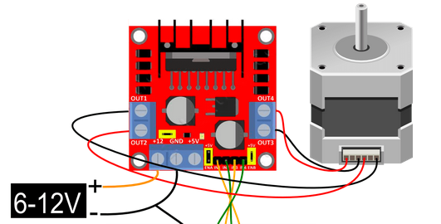

Four inputs of L298N is connected to 4 GPIO pins of Raspberri Pi 3.
Switch for speeding up/down the fan and switching off/on the fan is autoamtically controlled using a relay switch. Images of the fan from different angles.
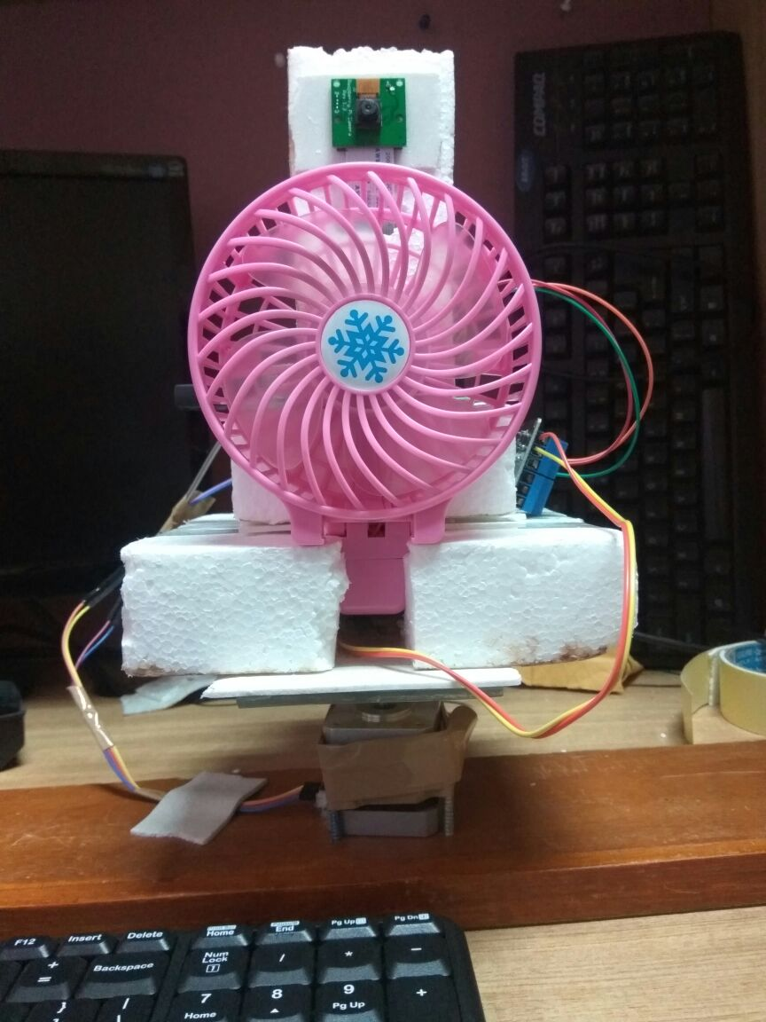
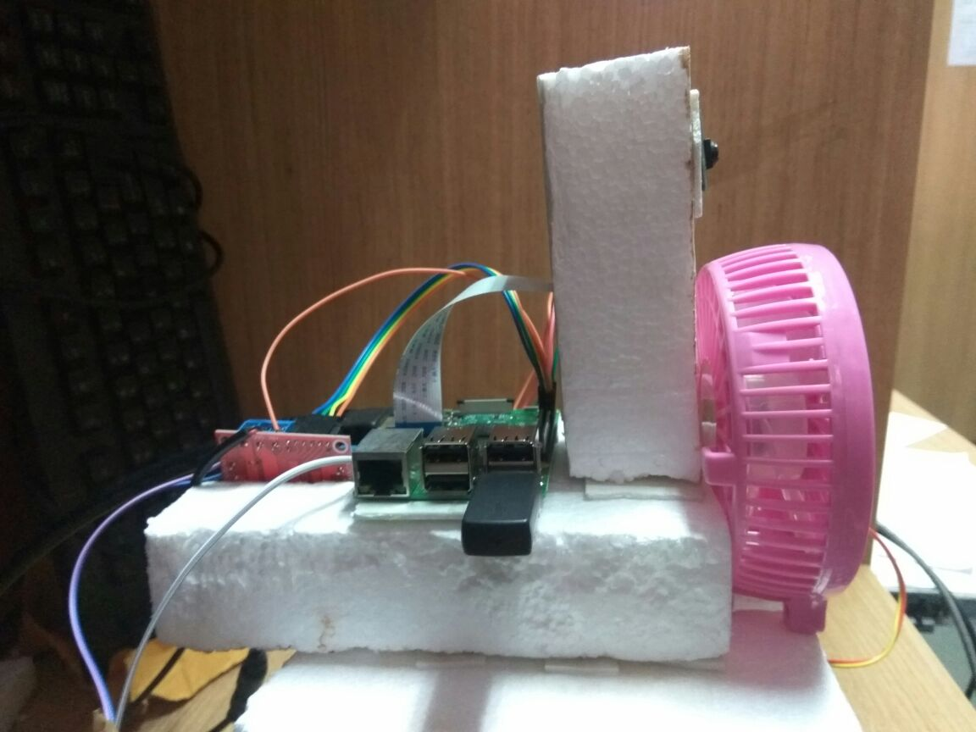

References
[1]https://people.ece.cornell.edu/land/courses/ece4760/FinalProjects/s2011/esp57_jmf293/esp57_jmf293/index.html.html [Last accessed on 27 Nov, 2017]

