Splox Racers
  - By Kate Sarah Boehner

Motivation
Splox Racers is a 3D sandbox racer. The tracks will be generated on splines. Those splines can be created by the developer or a random generator and can be saved to the disk to load at a different time. The AI uses the splines as a guideline to figure out, how to drive along the track. Different points on the spline have different attributes to make different areas, like boosters or obstacles, on the track available.
The players can build their own cars via a sandbox editor. There will be different block shapes available to make the chassis in any form. Blocks can be coloured to further improve the look of the car. Special blocks will be needed to change the cars behaviour, like speed, handling and so forth.
The editor makes sure, that the car has all necessary parts, like a seat, wheels and an engine.
Players can test their cars in a special track or a chosen/generated track to help fine-tune the cars behaviour.
If there are happy with the car, they can name it, save it and choose it to drive in races.
As of my research, no one ever made a random spline track generator or a vehicle builder for a racing game.

Challenges
There will be quite a lot of challenges to overcome.
The mesh of the track has to be generated, so there are no holes in it and all the textures line up without any seems.
The random generator has to generate valid tracks by making sure the spline does not overlap itself and keeps enough distance, so that cars will not be blocked by the track. Loops have to be placed in a way that the players can build up enough speed to be able to make it through the loop. Obstacles have to be placed in a way that makes them fun i.e. make sure the distance between obstacles is not too low, as that will make the track boring, and not too high, as that will make the track too frustrating.
The car editor has to be easy to use and make sure the build cars are valid. Therefore, it has to check for disconnected blocks and indicate them to the player. It has to make sure the player places all the mandatory parts.
Another challenge will be for the AI to drive along the spline in an intelligent way. Cars controlled by the AI have to be able to avoid obstacles.
They also need to be able to drive cars created by users without knowing how the car behaves in terms of acceleration, max speed and handling.

What have other people done
The YouTuber DokipenTech created a unreal engine 4 tool to create a road from a spline as shown in figure 1. He made four video tutorials about how he has done it using blueprints.
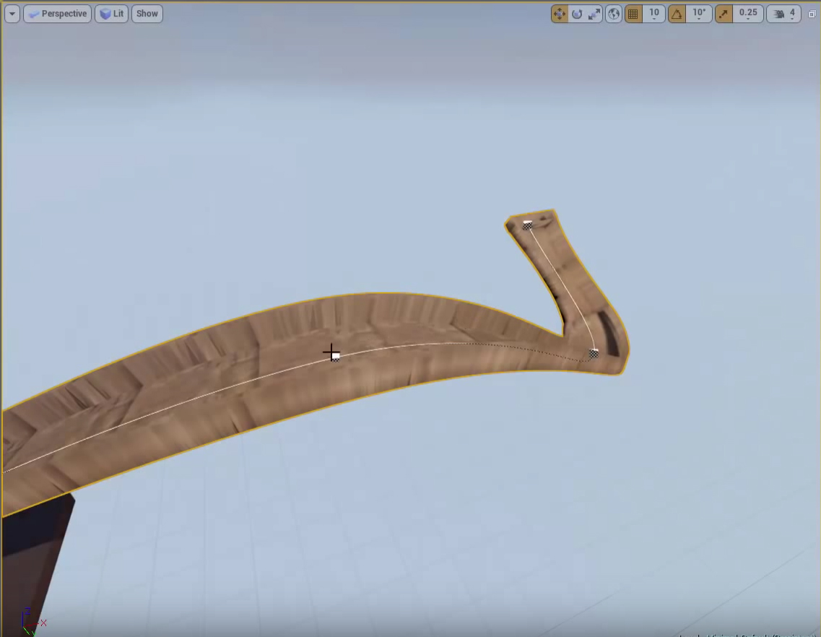
Figure 1: Road created on a spline with the unreal engine 4.

A sandbox vehicle editor has been done by several developers. It is used by the game Robocraft by Freejam LTD seen in figure 2. Other games like Autocraft developed by Alientrap Games also have the ability to create vehicles in a sandbox mode (see figure3), though Autocraft does not use an external editor, just a mode switch in the current loaded level.
Another game that allows the player to create vehicles using blocks is Space Engineers by KEEN SWH LTD. Space Engineers also does not switch into a separate editor and does not switch to a different mode to build as seen in figure 4.
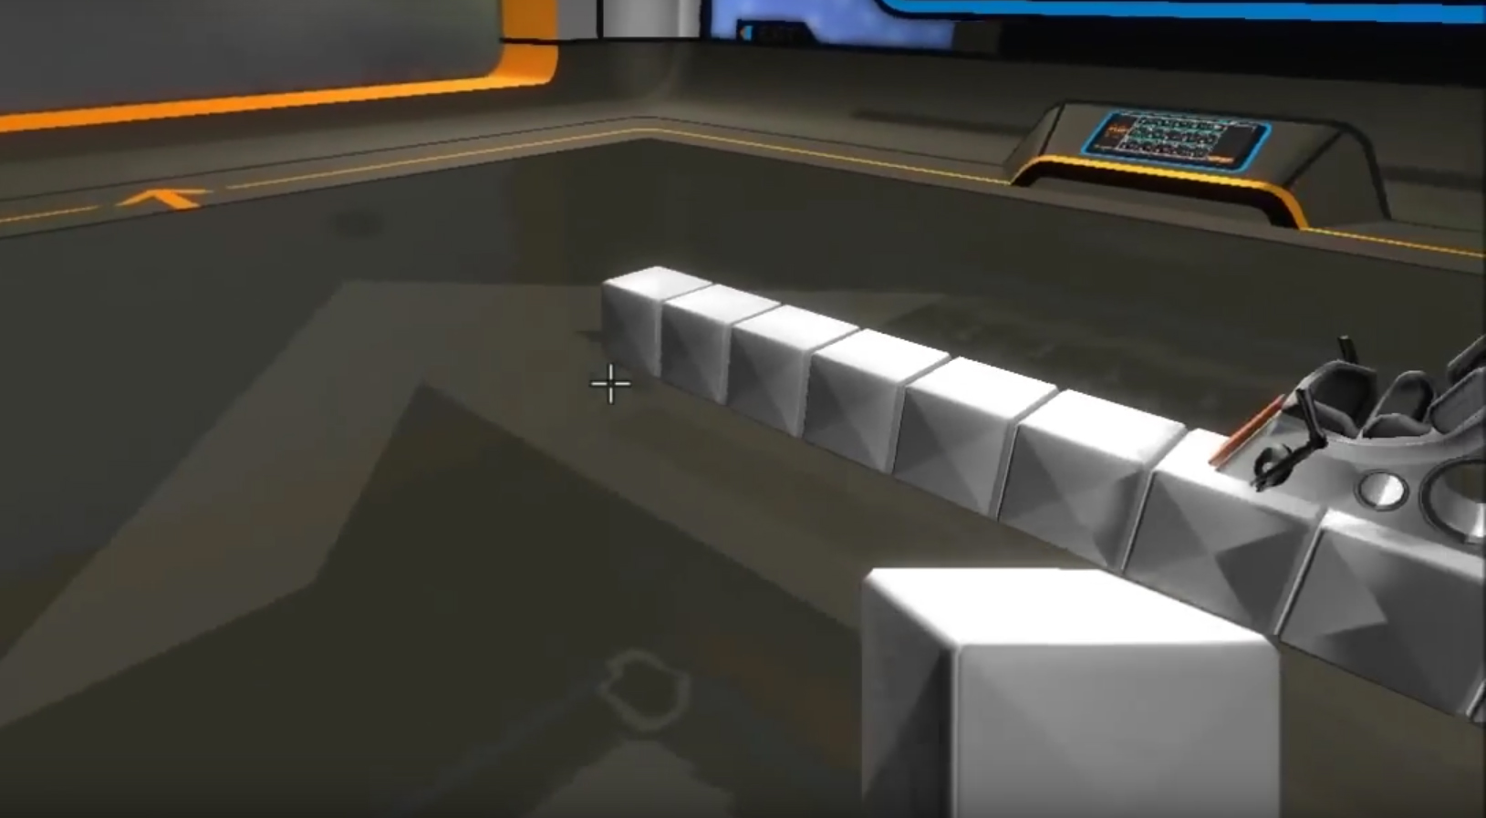
Figure 2: Robot builder used in the game Robocraft.
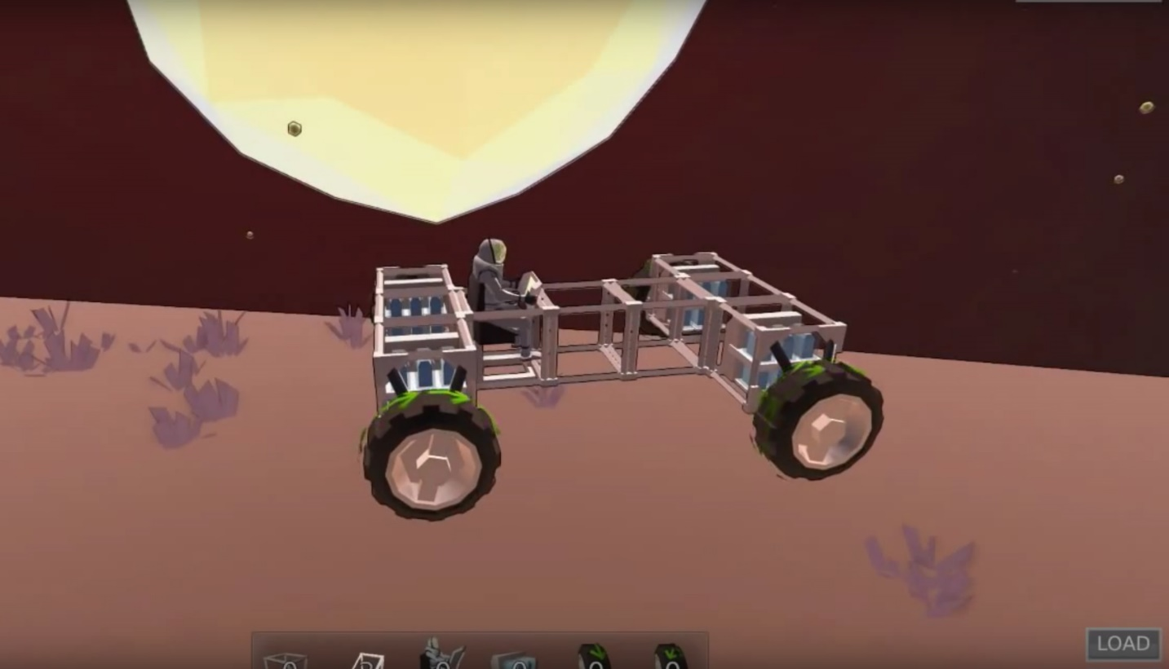
Figure 3: Building mode in the game Autocraft.
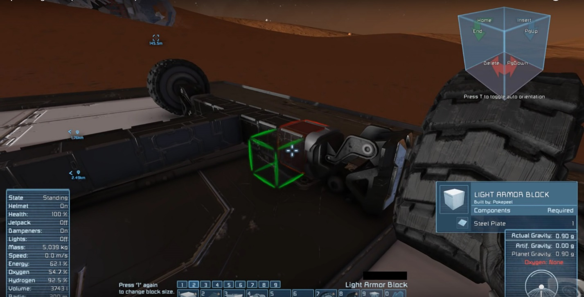
Figure 4: Building a car in Space Engineers.

My approach
To give players the ability to create their own cars, I will provide them with a separate editor mode as it is done in Robocraft. This allows me to constraint the cars size and make sure it is valid before it will be used to race. A separate editor makes also makes it easier to come back later and edit previously created cars.
I will create a virtual 3D-grid to place the blocks on and the editor will provide the player with a starting block. The player will only be able to place blocks attached on any other block and not free floating in the air.
For the spline roads, I will follow the tutorial mentioned before and extend upon it. The tutorial only shows the basics to make it work, but there is more work needed to make it look “good” and make to make sure that curves can’t be too steep.
The AI will at first just use the spline as a path to drive on and will calculate the optimal speed by the steepness of curved, which it will detect through the angle of the tangent of a spline node point.
Later in the development I plan to improve the AI so that it calculates a better path and better detect the optimal speeds also taking into consideration the cars specs.

