LUMEN-STELLAR

  - Neo Lebea-ST10507528

Web Development
WEDE5020
Neo Trinity Lebea
ST10507528

Proposal 1: An information website about space, the galaxy and all NASA related information about the universe.
Name of the organization: Lumen-Stellar.
History
Lumen-Stellar was founded in early 2026 by a small group of astronomers who wanted to create a digital platform where people could learn and explore more about the universe and its vastness.
Mission
The mission of Lumen-Stellar is to make space science accessible for everyone by providing educational and interactive content about the universe.
Vision
The vision of Lumen-Stellar is to inspire the next generation of astronomers, astrophysicists, space scientists, cosmologists and innovators to pursue more knowledge about space.
Target audience
- Teens and adults who are interested in astronomy and space.
- Space nerds
- Fans of sci-fi and NASA content
- Curious minds who wonder how the universe works
- Future astronauts, astronomers and scientists.
Website goals
The goal of the website is to provide valuable information and engages with users, through quizzes and polls. To inspire STEM careers for future scientists, astronomers, astrophysicists, and astronauts. To build a community of space enthusiasts, things like the comment section, forums or even social links. Showcasing space events like The Apollo, like “On this day…”
- People to visit my site
- People to engage with content
- People to explore the topics
- People to like the site enough to visit it again
- People to enjoy the site and its content.
KPI-Key performance indicator.
What we can measure.
- Number of people who visit the site: 400-850 visitors
- How many pages are viewed:
- How many quizzes are completed: 30%
- Time spent on the web or pages:3-5minutes
- Number of returning people:45%

Current analysis
- NASA has a live countdown for certain events, for example “NASA’s Artemis ll crew launches to the moon.”
- There are even live mission updates
- They have their own streaming service and partnered with other popular streaming services.

Proposed Website Features and Functionality:
Homepage
Introduces Lumen-Stellar and its mission and a quick overview of what users can explore. The it will have the search functionality, quizzes, Aeronautics section, Astrophysics, astronomy and cosmology sections, as well as planets and our solar system. News and events will be there, for updates.
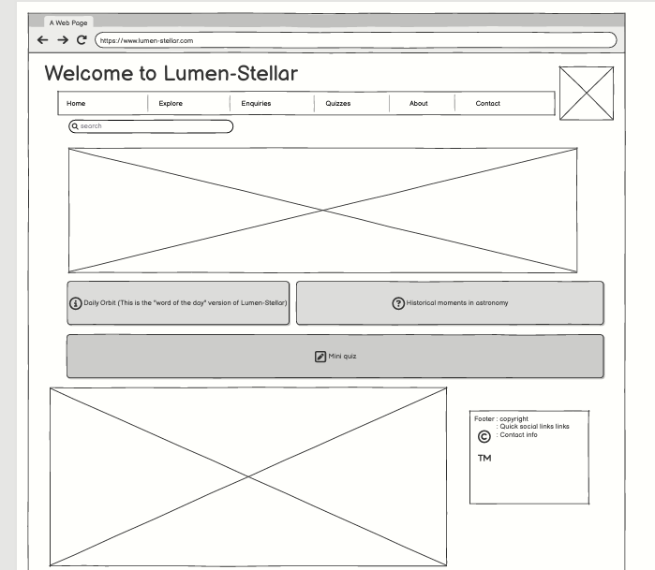

Home
- Introduction to lumen-stellar
- Hero section
- News and updates
- Info-science
- Quiz section
- About page
- Contact page
News and updates
- News, events and updates
Explore
This section will contain the…
- Aeronautics information
- Astrophysics
- Cosmology
- Astronomy
- Space science
Quiz section
- This will contain all the quizzes based on the information science page.
About page
- Company information.
- It contains contact information about the website. Social media links.

For the design and the user experience, I’d like to have three thick vertical gradient stripes on the left-hand side of the website.
Stripe 1: Deep purple
Stripe 2: Electric blue
Stripe 3: Midnight blue.
I will have accent colours for buttons; background would be either black or white to fit the whitespace concept. Headings; Bold and in sans Sarif for impact. Body text, clean and readable and in font such as Arial or Open Sans. Hierarchy; Large – medium headings – standard body font to ensure a smooth scanning.
Will be using HTML for structuring the website’s content and sections. CSS will be used for its styling, including the gradient stripes mentioned earlier. To add interactive elements like quizzes, and clickable star maps I’ll use JavaScript. The website will be GitHub, custom domain lumen-stellar.com

Timeline:
Part1 will be done right before the 20 April 2026, which is the proposal and the html for the website. The Part 2, this is the CSS will be done before the 29 of May 2026. Then the last part of the website, which is the JavaScript, will be done before the 19nth of June 2026.
Hosting and domain registration are expected to cost around R500-R1000per year. And additional cost is estimated to be R200-R500.
References:
(OpenAI, 2026)
OpenAI. (2026) ChatGPT (GPT-5-mini) [AI chatbot]. Available at : https://www.google.com/search?q=chatgpt&oq=&gs_lcrp=EgZjaHJvbWUqCQgCECMYJxjqAjIJCAAQIxgnGOoCMgkIARAjGCcY6gIyCQgCECMYJxjqAjIJCAMQIxgnGOoCMgkIBBAjGCcY6gIyCQgFECMYJxjqAjIJCAYQIxgnGOoCMgkIBxAjGCcY6gLSAQkxNDczajBqMTWoAgiwAgHxBRgvzTs2Oqm8&sourceid=chrome&ie=UTF-8
(Accessed: 14 March 2026)
NASA. (2026) Available at: https://www.nasa.gov/ (Accessed: 18 March 2026)

NASA. (2026) Available at: https://www.nasa.gov/ (Accessed: 18 March 2026)
UCO/Lick Observatory. (2011) Stellar structure and evolution. Available at: https://www.ucolick.org/~woosley/ay112-14/texts/pols11.pdf (Accessed: 18 April 2026)
BBC. (2026). The life cycle of a star – AQA. The formation and life cycle of stars. Available at: https://www.bbc.co.uk/bitesize/guides/zpxv97h/revision/1 (Accessed at:18 April 2026)

