THE DEBUGGERS
Community Service Hub

Table of Contents
Problem Definition 1
System Design and Implementation 1
The Tools and Technologies 2
DATA flow 3
TESTING AND EVALUATION 4
Results and Discussions 5
Conclusion 5

Problem Definition
Many communities, such as Galeshewe, face ongoing challenges with reporting and resolving local issues like broken infrastructure, waste management problems and lack in service delivery. Currently there is no simple and accessible platform for community members to report these issues easily. This results in problems often going unreported or delayed responses, and communication between residents and relevant authorities is weak. This lack of coordination reduces community engagement and slows down the improvement of public services.
Why it matters in ICT?
This is important in ICT because it shows how technology can be used to solve problems like these. A local website will enable the community to have an opportunity to report issues and be helped.

System Design and Implementation

The goal of this website is to make the website easy to navigate

  - THREE MAIN COMPONENTS


USER:
- The community member(user) interacts with the website by loging in and filling a form

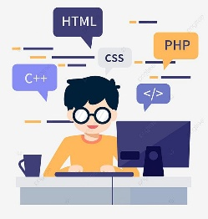
FRONTEND WEBSITE:
Responsible for the implementation and it provides the interface where users enter information

API: 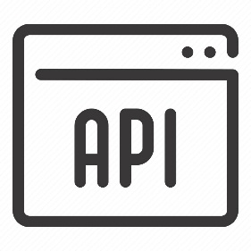
The api is used to locate the users location so we can able to see where users are reporting and also store data

The Tools and Technologies

HTML-
To create the structure of the website. This structure includes :
- A header/ title of the website
- A form for reporting
- Input fields like email
- A submit button

CSS-
For styling and layout the appearance of the website. The designs include:
- Proper space alignment
- Responsive design for mobile and desktop devices
- Styled buttons and form

JAVASCRIPT
For functionality and API interaction. This scripting languages provide the interface where users enter information. It performs task such as:
- Capturing user inputs from the form
- Send data to the API using fetch()
- Displays success or error messages
- Validates input fields

DATA flow
-Home page
>Welcome to Galeshewe Community Hub
>Join us in building a stronger, safer and more connected community. Report local issues, stay informed, and help improve services in real time.
>Get started and learn more
-Login page
>Community login
>Email, password, login and don’t have an account? Sign up
-About page

TESTING AND EVALUATION
1.TEST PLAN
The purpose of testing is to make sure the community website works correctly, is easy to use and can handle many users reporting issues or viewing updates.
Test ID | Feature Tested | Test Description | Expected Result | Status
T1 | User Registration | User creates a new account | Account created successfully | Pass
T2 | Login System | User logs into the website | User is directed to dashboard | Pass
T3 | Report Issue Form | User submits a community problem | Issue is saved and displayed on the website | Pass
T4 | View Community Updates | User opens updates section | Updates and announcements display correctly | Pass
T5 | Events Page | User views community events | Events details appear correctly | Pass
T6 | Navigation Menu | User clicks menu links | Correct page opens | Pass
T7 | Mobile View | Website opened on phone | Layout adjusts correctly | Pass

Responsive Testing
This website was tested on:
- Mobile phone
- Tablets
- Laptop

Results and Discussions
Results:
Screenshots from a tablet
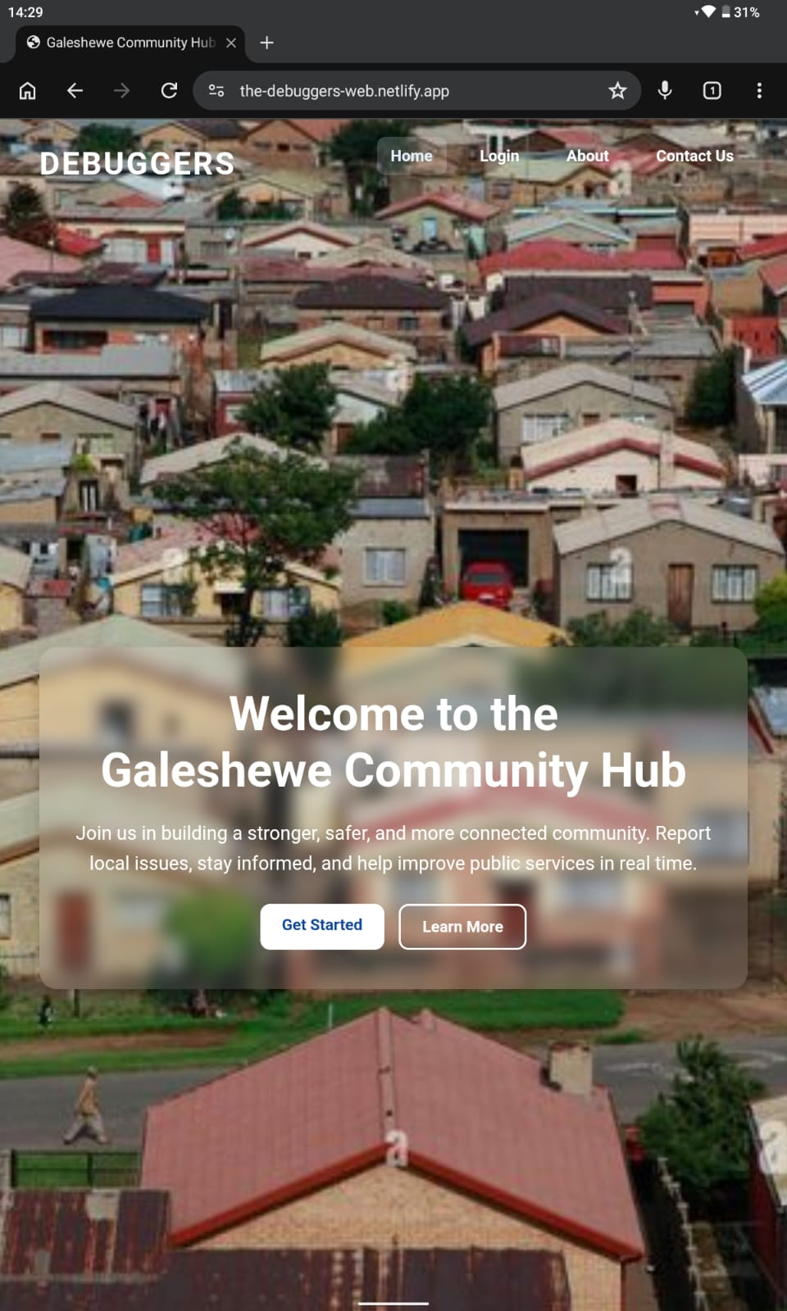
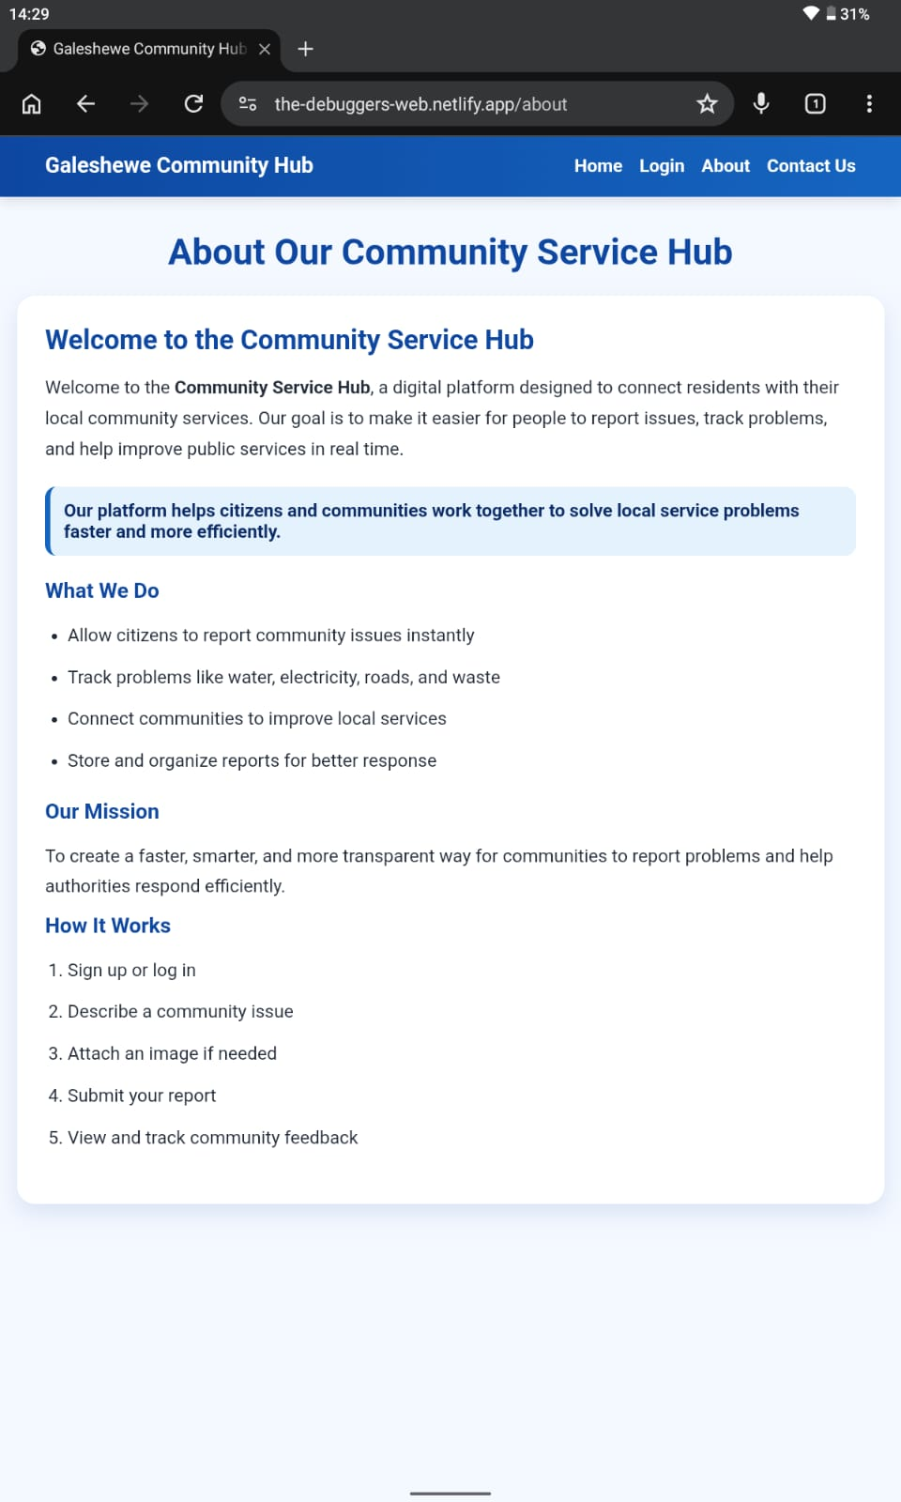
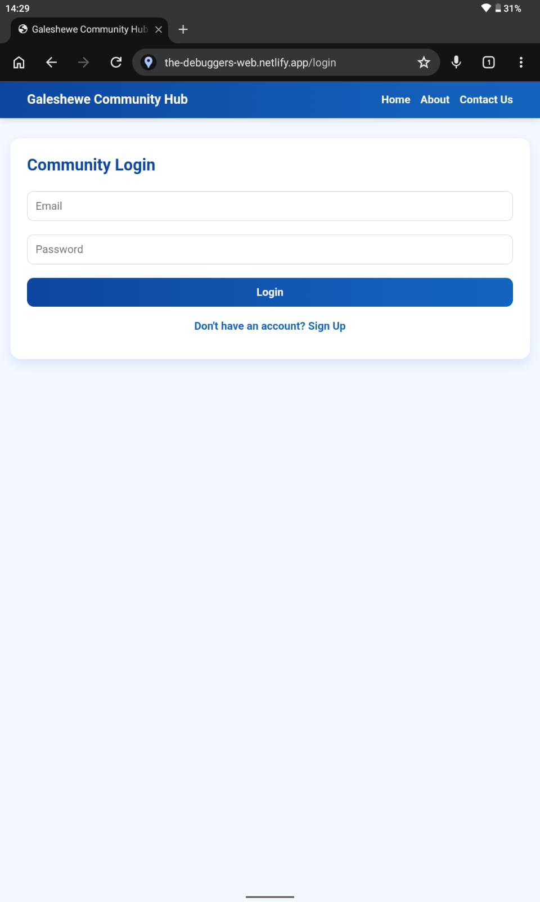
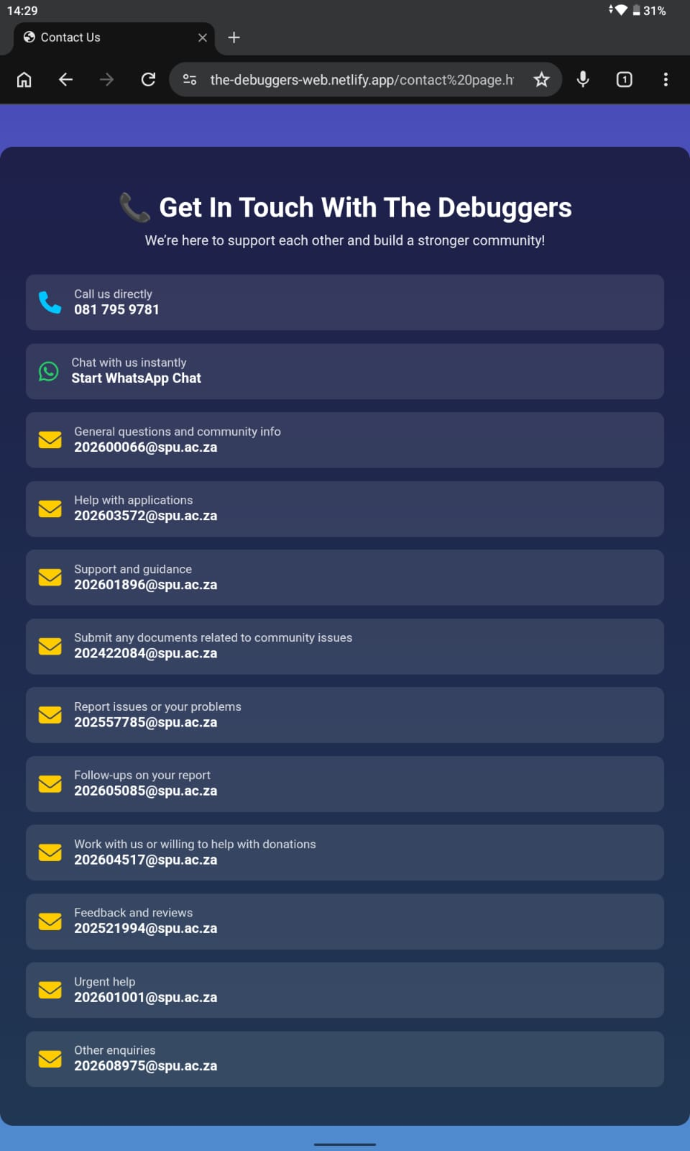

Screenshots from a phone:
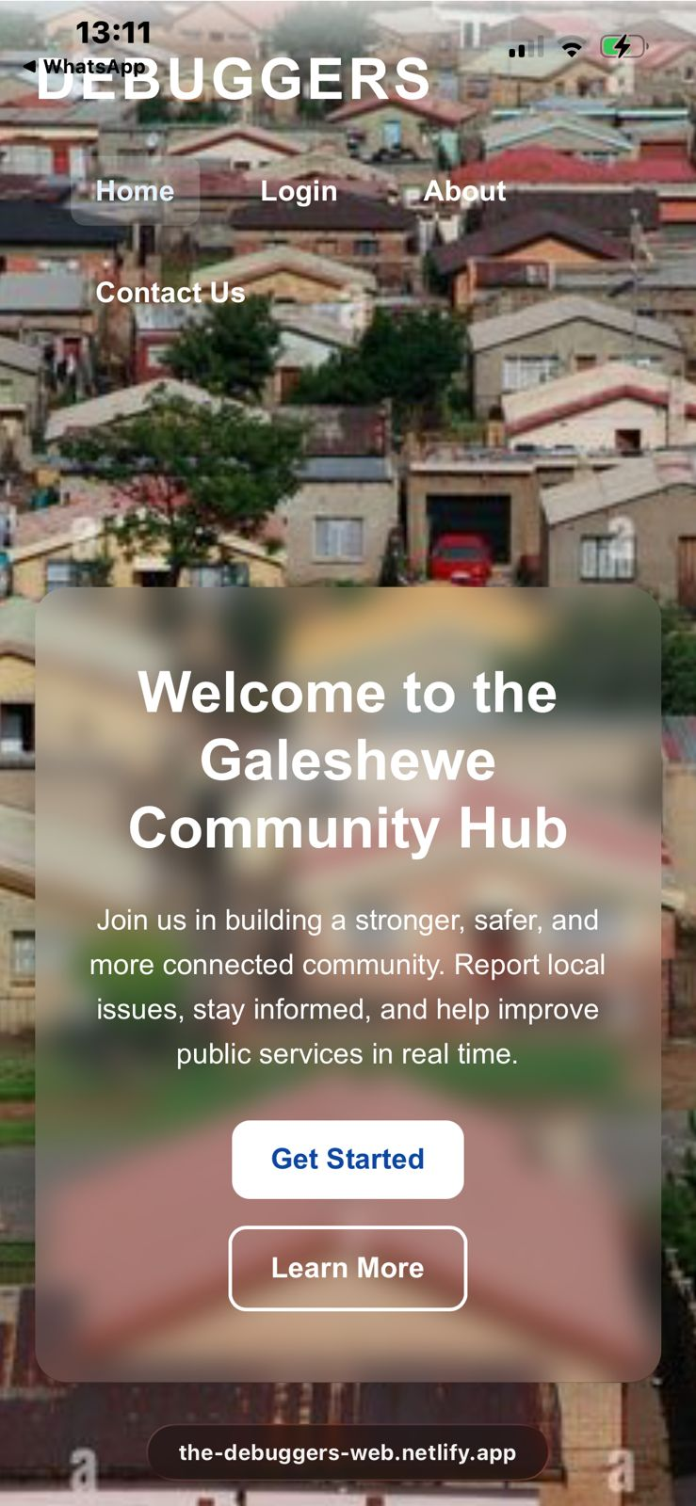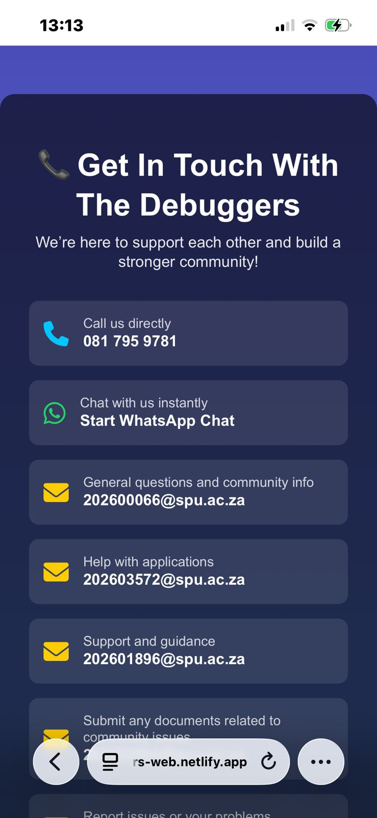

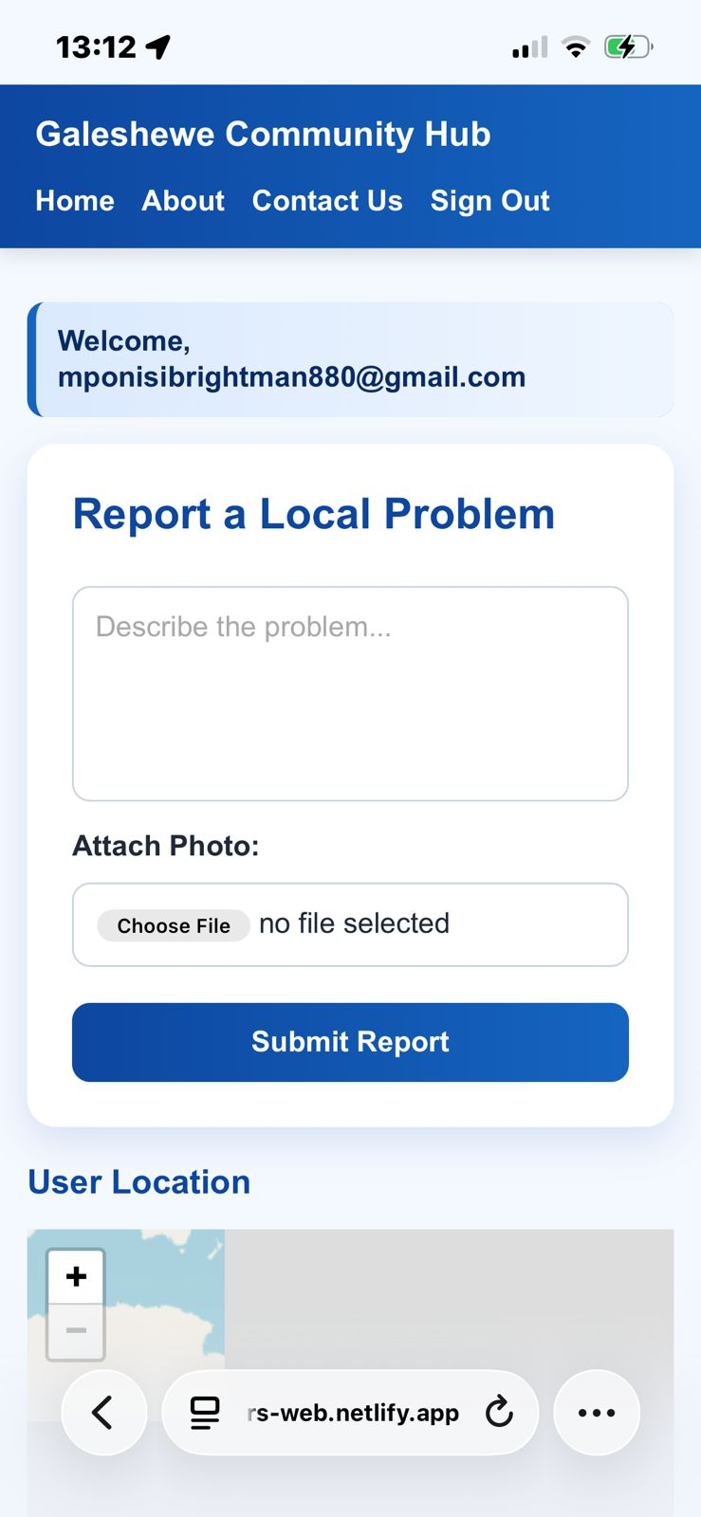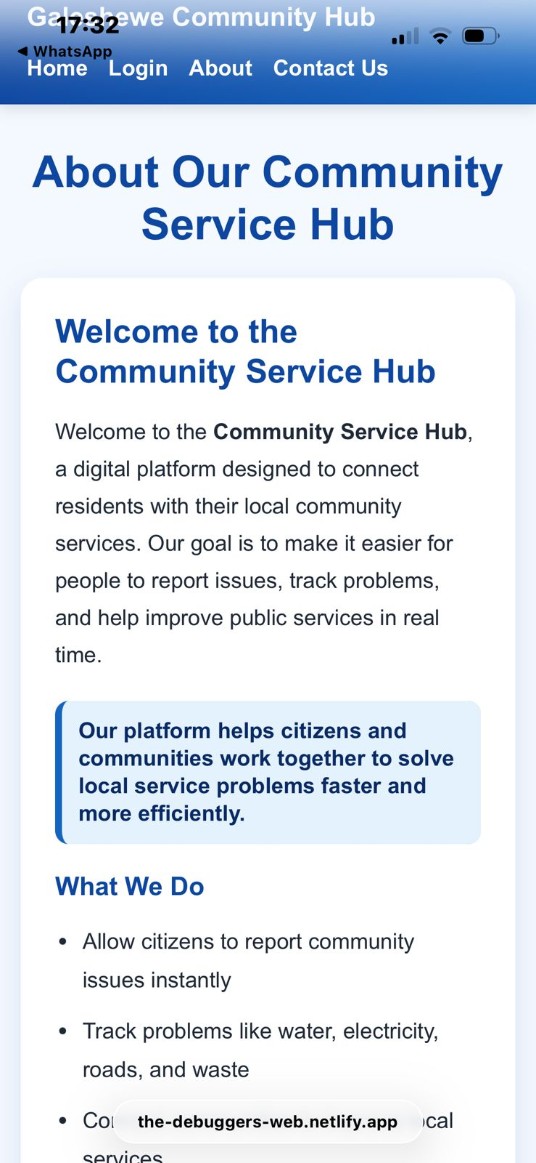

Screenshot from laptop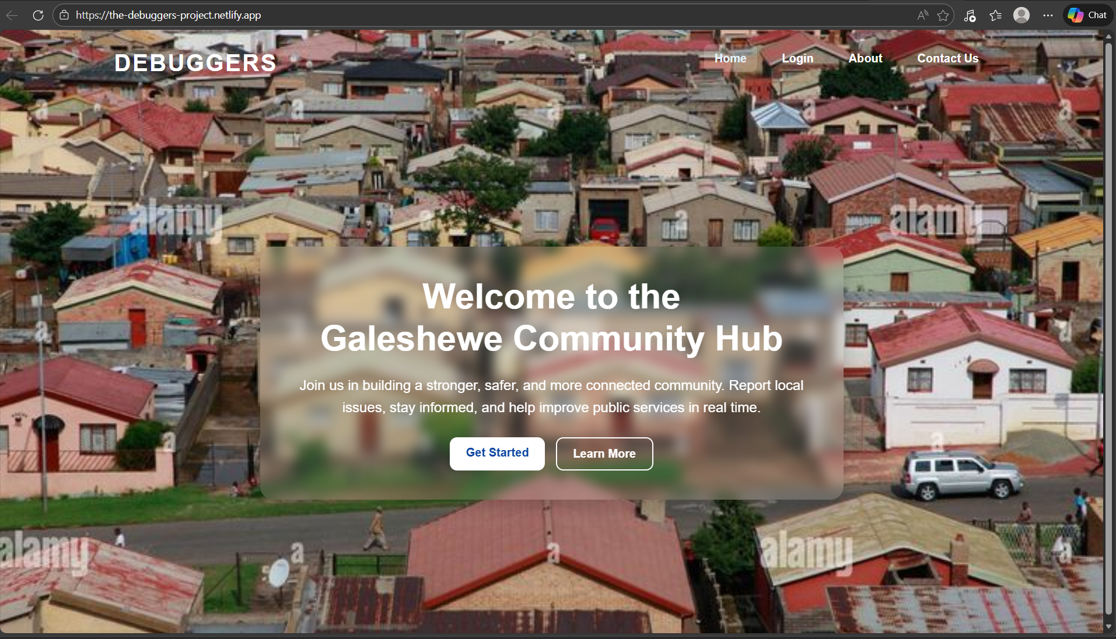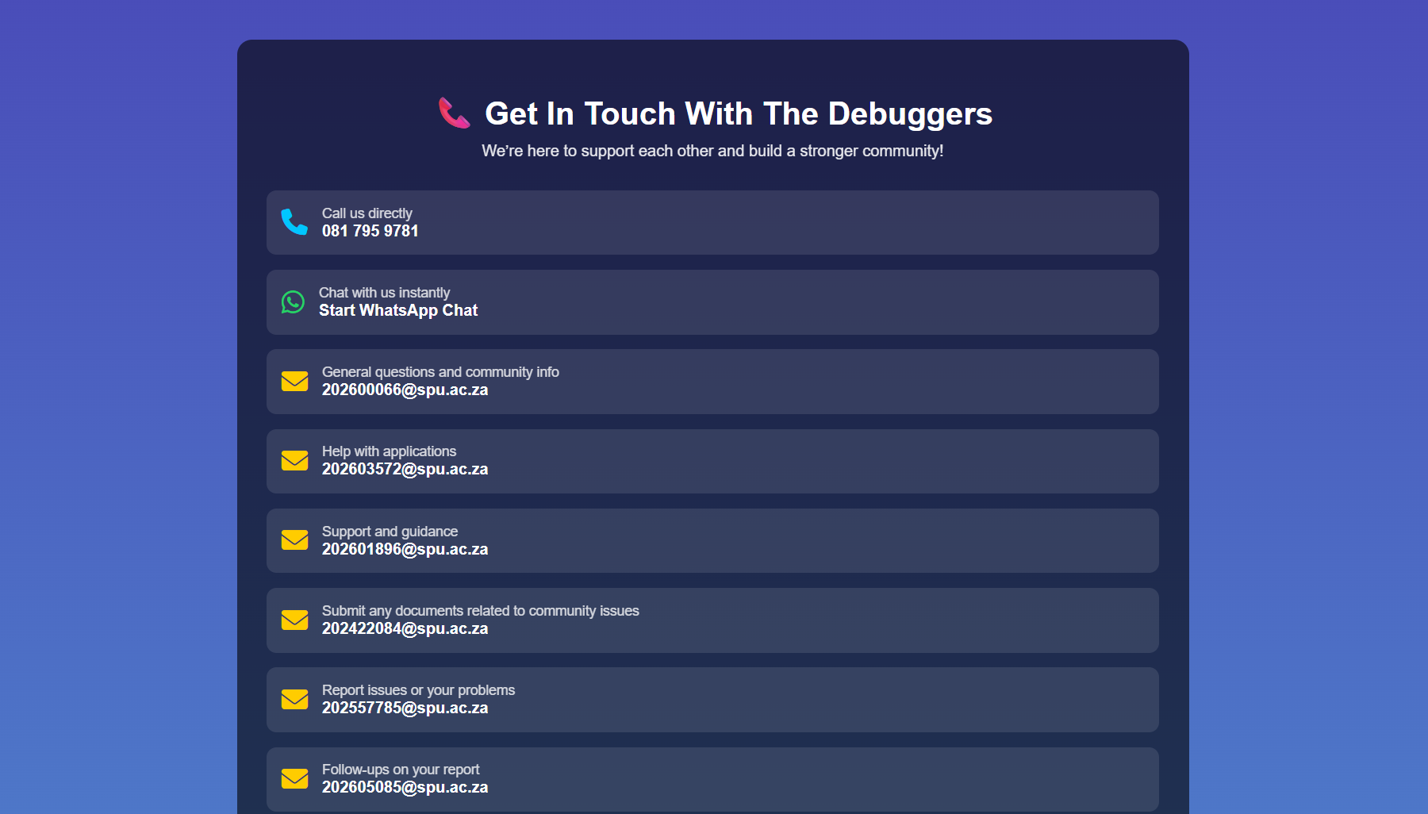
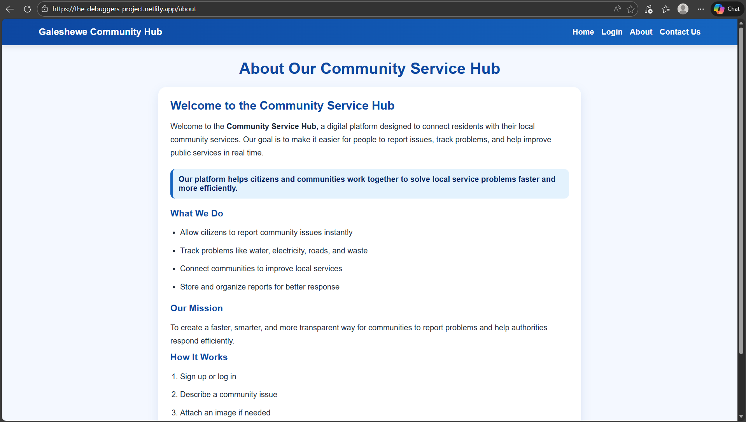

Discussions:
We experienced several challenges during the development of our website, particularly with image uploads, styling, and icon functionality. One issue was that images would appear to load but would not display on the webpage, which was mainly caused by incorrect file paths and minor styling errors. In addition, we faced difficulties when applying background images, as they did not always display correctly due to improper CSS properties. Another challenge involved working with icons from the Font Awesome library, where we struggled to position them correctly and apply appropriate colours using CSS. Furthermore, we encountered problems when trying to link the WhatsApp icon so that it would open a direct chat with our contact, as this required a specific URL format. Overall, these challenges were resolved by carefully correcting file paths, refining our CSS styling, and using the correct linking formats for external communication features.
During the development of our website, we encountered several technical challenges that affected both its functionality and user experience. One major issue involved the map integration, where the markers were visible, but the map itself was not fully displaying; although the functionality of Leaflet was working, the visual rendering of the map was incomplete due to layout and styling problems. At the beginning of the project, we also struggled with adding images to the HTML code, as they were supposed to appear on the homepage but failed to display, and linking the HTML, CSS, and JavaScript files sometimes caused the website to crash during testing. In addition, some buttons did not respond when clicked because the JavaScript file was not properly linked or contained errors, which prevented functions from executing and limited user interaction with features such as logging in, submitting reports, and logging out. Furthermore, we experienced difficulties with the REST API when trying to capture the exact moment an image finished uploading, as it initially returned the time the record was created instead. The timestamps also appeared in UTC rather than local time for our Galeshewe users, which required syncing the server clock and manually converting the time on the front-end. Overall, these challenges were resolved through careful debugging, correct file linking, improved styling, and proper handling of API responses and time conversions.

Conclusion
This project demonstrate how a simple website can be used to solve problems most communitues deal with. The use of the scripting languages made it possible to create a simple, interactive and responsive website.

