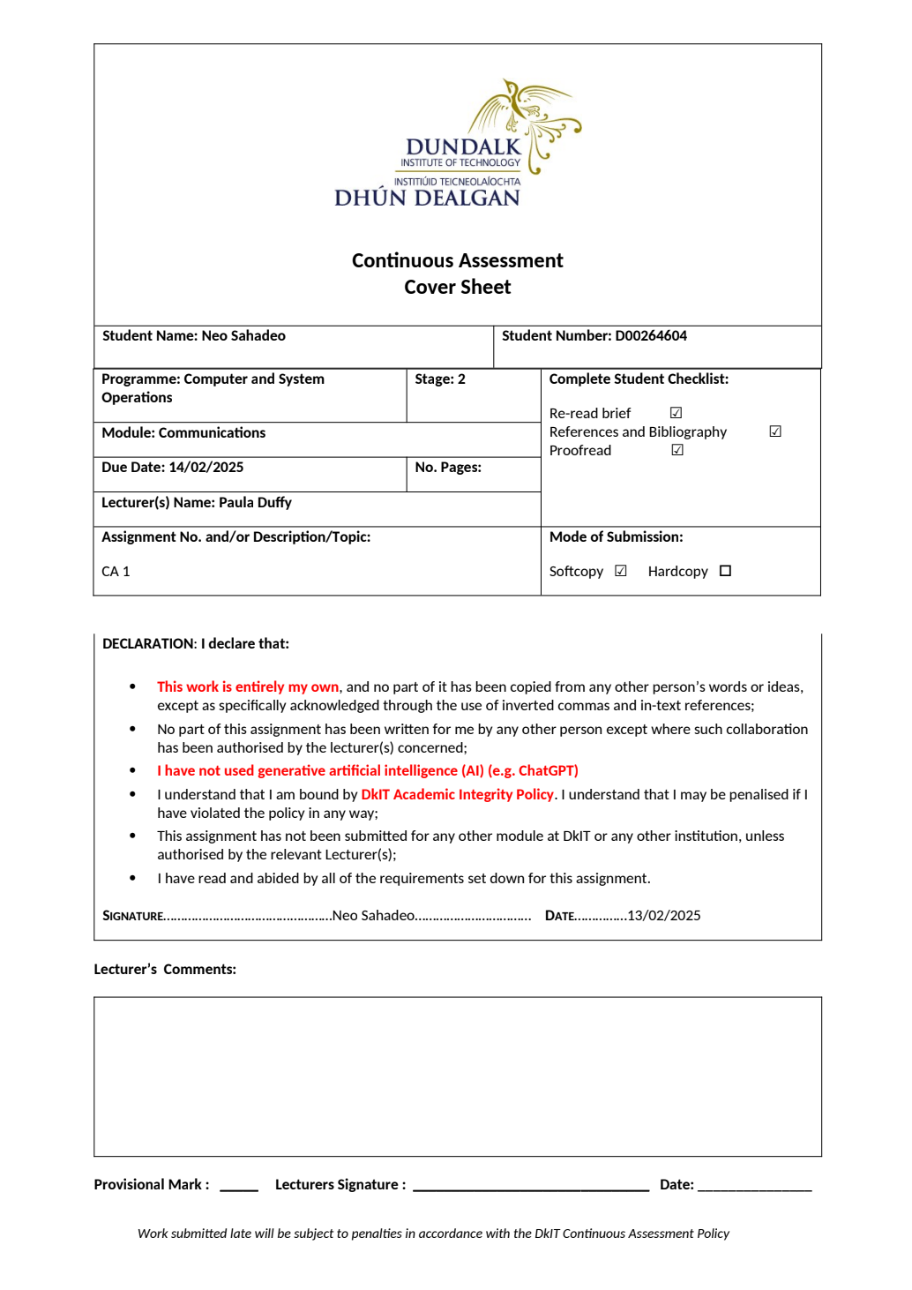

I acknowledge the use of [1] Poe (https://poe.com/) to [2] remove declarations of "I" in my document, used to mark my work, used to formalise my language and summarise content to fit into the word count.
The prompts (generated on 13th Feb 2025) used include [3]
- 'Could your remove the word "I" because I need this to be a report'
- "Based on this context is this paragraph relevevant?"
- "does this make sense"
- "Summarise this and write it in a more formal way"
The prompt outputs were as follows / are included in an appendix [4] [prompt outputs]/[appendix].
The output from the generative artificial intelligence was used to [5] modify and adapt the exisiting text for the final submission.

Signed: Neo Sahadeo
Date: 13/02/2025

CA 1
Neo Sahadeo
Table of Contents
Introduction 1
Reasons for Choosing Program 1
Expectations on Graduation 1
Career Pathways 1
SWOT Analysis 2
Strengths 2
Weaknesses 3
Threats 3
Opportunities 3
Review of the First Semester 3
Conclusion 4
References List 5
Appendix 6
AI Prompts 6
De-personalise my text 6
Mark my work 6
Formalise my text 6
Table of Figures
Figure 1: SWOT Analysis 2
Figure 2: Academic Integrity 7

Introduction
This report covers the reasons for choosing the course, expectations upon graduation, possible career pathways, a personal SWOT analysis, and a review of the first semester.

Reasons for Choosing Program
The primary motivation for selecting this course was the understanding of the necessity to imbue life with a sense of purpose. Understanding how systems operate has always come easily. Therefore, computer science was chosen, as it presents a sufficiently challenging field that will also allow for competitiveness in the current job market.
Modules learnt during this course will provide essential skills needed, such as programming, networking, testing, and deployment (BSc in Computing Systems and Operations (Software Development and DevOps) at DkIT n.d.).
While a degree may not hold significant intrinsic value, it is important to note that if the majority of competitors possess at least a Bachelor of Science degree, it would be challenging to persuade potential employers to consider applications without similar qualifications therefore the Devops degree will be a substantial improvement for influencing potential employers.

Expectations on Graduation
Upon graduation, expectations include a comprehensive understanding of the DevOps lifecycle, as well as the ability to launch and scale applications effectively aligning with practical projects that will be done in year 3 and 4 as prompted by lecturers and other year students.
There is need to be competitive within the future job market and to secure a successful career. Proficiency in various tools, including Docker, Grafana, Python, Java, and GitLab, is also expected to be learnt.
Furthermore, it is expected that a solid foundation in networking, software architecture, virtualisation, operating systems, databases, and the DevOps lifecycle will be taught and learnt. Additionally, there will be an emphasis on the development of teamwork and communication skills (BSc in Computing Systems and Operations (Software Development and DevOps) at DkIT n.d.).

Career Pathways
An exploration of the IT field was conducted with Claire Fallon on Tuesday, February 11th. Guidance was provided to review resources such as GradIreland, CareerConnect, CareerHub, and LinkedIn.
Potential career pathways of interest encompass software development, web development, network engineering, low-level engineering, cybersecurity, and machine learning development (Careers advice: build your skills and get hired | GradIreland, n.d.).
Research conducted on Indeed indicates that the average salary for graduate roles is approximately 43,000 euros per annum. The diverse nature of the DevOps course allows for opportunities to branch into various areas of the tech field. Currently, low-level engineering is personally identified as the most intriguing.

SWOT Analysis
A personal SWOT analysis as described in SlideModel is an “exercise in self-introspection to help you understand yourself and prepare for growth.” (Model and admin 2024)
Below is the personal SWOT analysis that is based on a survey by KYSS (Do the KYSS test | Kickstart - Lemo n.d.).
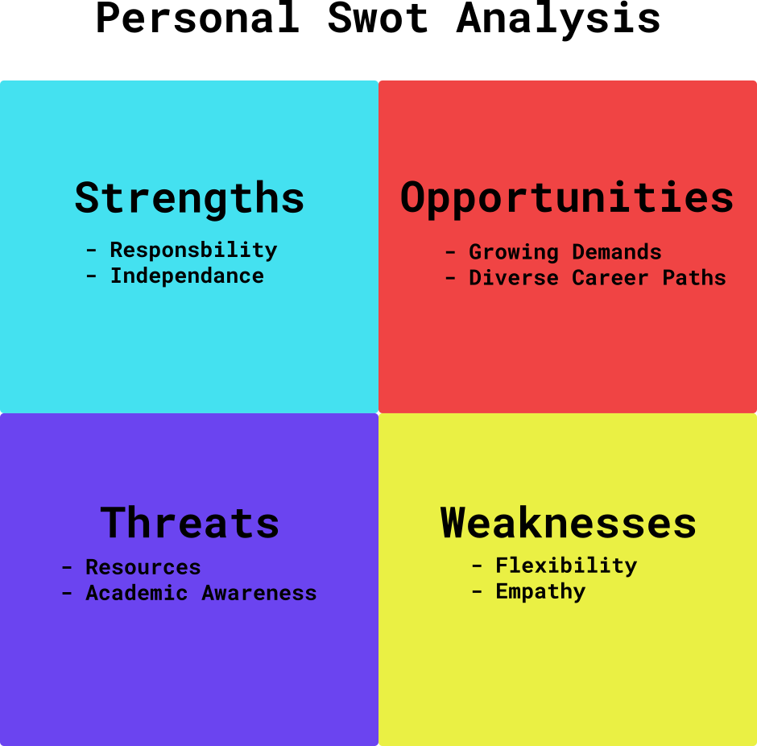Figure 1: SWOT Analysis

Strengths
Responsibility: Consistent initiative was taken to submit assignments early. The added responsibility of class representative was picked up and feedback sessions in-person and the group chat took place to further communicate the concerns of students with lecturers.
Independence: Independence was demonstrated during coursework, particularly in developing the portfolio and managing DevOps GitLab workflows. These tasks required self-direction and problem-solving; which reflected the ability to work autonomously.

Weaknesses
Flexibility: Highlighted by the KYSS test, a tendency toward inflexibility makes it challenging to adapt to new methods. Preference for established routines leads to difficulties when faced with change. For example, this inflexibility negatively impacted work by hindering the ability to follow along with programming during lectures, as prior experience made adapting to a new style difficult.
Empathy: Highlighted by the KYSS test, a tendency toward low empathy regarding classmates' work quality and attendance has been recognized. This area of growth is actively being addressed, as difficulties arise in relating to those who do not share similar moral values such as high-work-ethic and respect for lecturers.

Threats
Resources: As an international student, the annual tuition fee at the university is €11,000. This amount does not encompass expenses related to housing and food. Consequently, this financial consideration, in conjunction with the content of the course, is likely to play a pivotal role in the decision regarding the continuation of studies in this program.
Academic Awareness: Increasing awareness of potential career pathways may influence the decision to continue with this course or to transition to an alternative program.

Opportunities
Growing Demands: The DevOps industry is experiencing significant growth. It is estimated that by 2027, the integration of DevOps within businesses will reach 80% (Essential DevOps Statistics and Trends for Hiring in 2025 n.d.). As the field continues to evolve, numerous career opportunities are becoming increasingly accessible.
Diverse career paths: The DevOps degree encompasses a variety of practices that can serve as pathways into other fields. Given the interrelated nature of technology sectors, transitioning to a different career path in the future is less challenging than it may initially appear.

Review of the First Semester
Performance in semester one was adequate, reflecting a solid understanding of the material and satisfactory grades. Approximately 10% of the coursework was new; however, some aspects felt less valuable, prompting questions about continuing in the degree past year one. Grades were generally strong, but challenges arose in computer hardware due to a learning curve in presenting work. For example, the first lab on logic diagrams suffered from inadequate labelling, resulting in lost marks. Issues also occurred with assembly language and number system conversions, particularly with the 8051 emulator and register management. Tests in this subject often felt random and challenging despite thorough preparation.
In mathematics, topics like Boolean algebra and statistics were somewhat unengaging, except for graph theory, which was fascinating. Consistently scoring above 80 in tests was achieved. Future studies will include calculus, linear algebra, and combinatorics.
The front-end development course felt monotonous due to pre-existing knowledge, though creating a Spotify clone using Svelte5 was enjoyable. The DevOps course was engaging, introducing Docker and Nginx for the first time; there are plans to enhance Docker skills further. Lastly, the introductory programming course was not challenging, prompting plans to explore additional programming paradigms, including work on a C compiler in Python.

Conclusion
Awareness of potential career paths has been enhanced. Key areas for personal development have been identified for improvement, specifically empathy and flexibility. Additionally, a critical analysis of the current course has been conducted to evaluate whether presuppositions align with the realities of graduation.

References List
BSc in Computing Systems and Operations (Software Development and DevOps) at DkIT. DkIT - Dundalk Institute of Technology [online]. Available from: https://www.dkit.ie/courses/school-of-informatics-and-creative-arts/computing-science-and-mathematics/bsc-in-computing-systems-and-operations.html [accessed 11 February 2025].
Careers advice: build your skills and get hired | gradireland. Available from: https://gradireland.com/careers-advice [accessed 13 February 2025].
DevOps Market Size, Share, Growth Trends & Forecast - 2032. Global Market Insights Inc. [online]. Available from: https://www.gminsights.com/industry-analysis/devops-market [accessed 13 February 2025].
Do the KYSS test | Kickstart - Lemo. Available from: https://kickstart.goleweb.be/en/take/3563 [accessed 13 February 2025].
Essential DevOps Statistics and Trends for Hiring in 2025. Brokee [online]. Available from: https://brokee.io/blog/essential-devops-statistics-and-trends-for-hiring-in-2024 [accessed 13 February 2025].
Model, S. and admin. (2024). Personal SWOT Analysis: Quick Guide (with Examples) [online]. SlideModel [online]. Available from: https://slidemodel.com/personal-swot-analysis-quick-guide/ [accessed 11 February 2025].

Appendix

AI Prompts

De-personalise my text
“Could your remove the word "I" because I need this to be a report
The primary motivation for selecting ... and a review of the first semester.”

Mark my work
(1)Reasons for...expectations and course content is made
Based on this context is this paragraph relevevant?
Studying in South Africa... as a result.-”
(2) “does this make sense
They identified suitable options, which I subsequently reviewed and selected this course thusly.”

Formalise my text
“Summarise this and write it in a more formal way
Overall for semester 1 I think I ... paradigms. I covered OOP recently as I was following the OSSU program outline.”
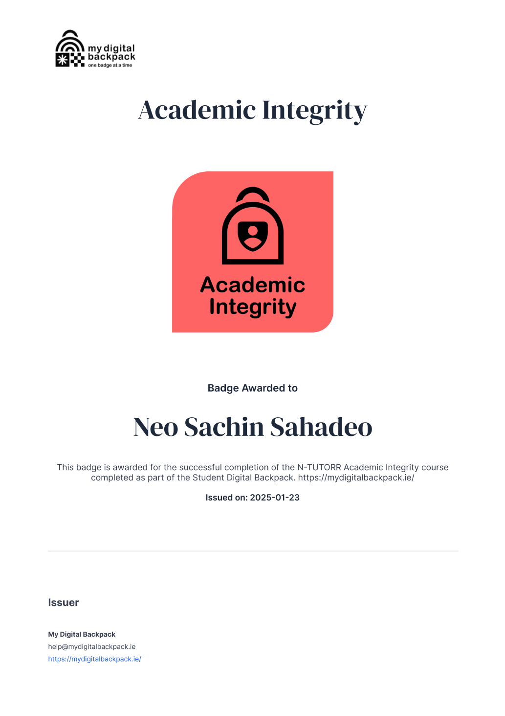Figure 2: Academic Integrity

