Entity Modelling

♦ ENTITY

DEFN: something of significance to the system about which information is to be held.
e.g.

SYSTEM ENTITIES
hospital info. patients, wards, diseases
library books, borrowers, loans, reservations, fines

• SET & OCCURRENCE

An entity set represents a number of entity occurrences. An entity occurrence must be capable of being uniquely identified. This is called the ENTITY IDENTIFIER, e.g.

ENTITY ENTITY ENTITY
SET OCCURRENCE IDENTIFIER
patient J. Jones patient no. 123
S. Smith patient no. 234
D. Measles patient no. 345

What kind of things are to be modelled as entity sets? Commonly distinct physical things in the organisation, such as persons, parts, invoices etc., and others not so clearly visible such as projects, departments, budgets etc.

• REPRESENTATION

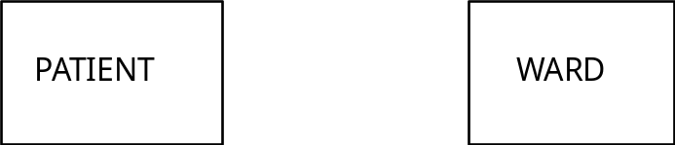

♦ ATTRIBUTES

DEFN: properties of entities (data elements).

The information held about an entity e.g. some of the attributes for J. Jones might be he is MALE, MARRIED, BORN ON 15/1/52.

Some of the Attribute Types that would be associated with the patient entity would be SEX, MARITAL STATUS, DATE OF BIRTH.

e.g.
Employee

Employee-id
date-of-birth
address
(no., street, town)
♦ RELATIONSHIP

DEFN: An association between two entities that is important to the system.

Entities are linked together by concept of a relationship e.g.

J. Jones is treated in ward 10 of the hospital.

Relationships are normally described as verbs (treated, borrowed, has) and entities are nouns (patient, book, ward etc.).

REPRESENTATION

One ward may have many occurrences of patients associated with it e.g.

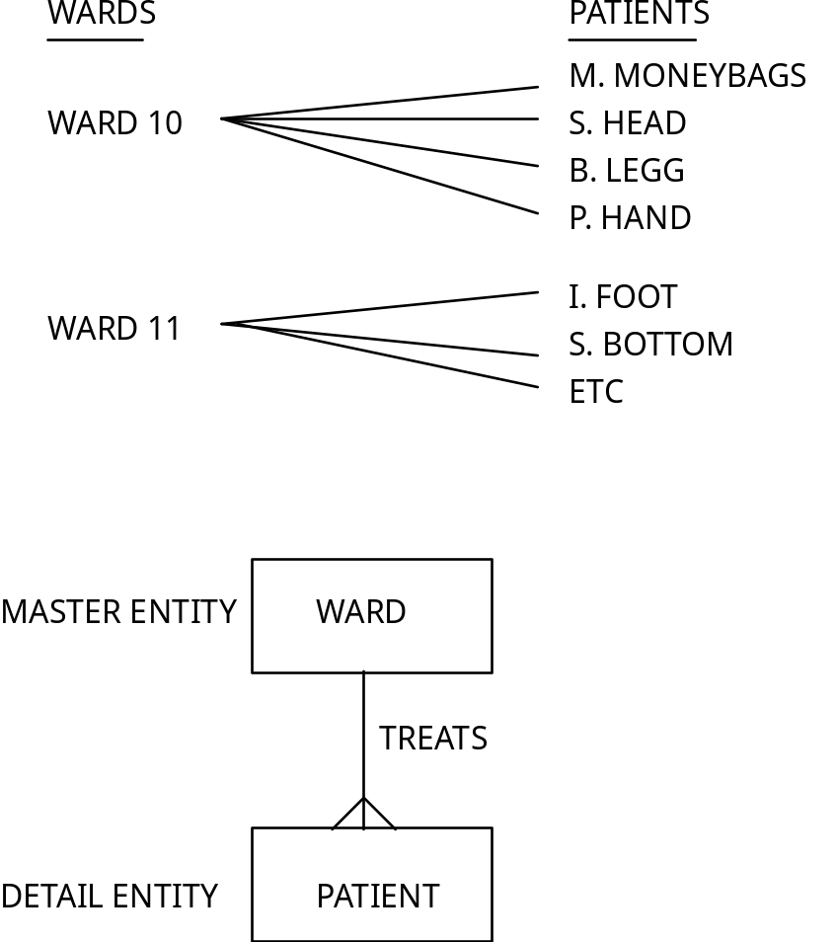

• DEGREE OF A RELATIONSHIP

1 : M
M : 1 These will be the most common (as
per last example).
1 : 1 - rarely exist e.g.

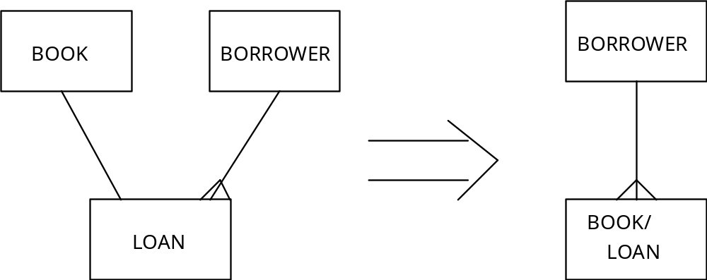

Data items associated with book are combined with those of loan giving title, ISBN, author, date of publication, date borrowed, date due back.

M : N - These are referred to as 'complex' relationships as they cause problems on implementation on some DBMS.

These should be broken down e.g.

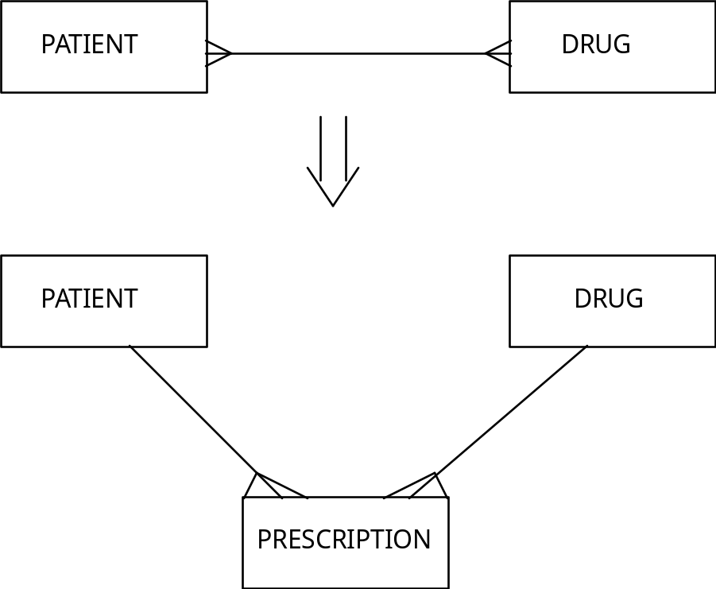

If further analysis does not work as above then use a LINK ENTITY i.e. not a true entity as no information is associated with it.
e.g.

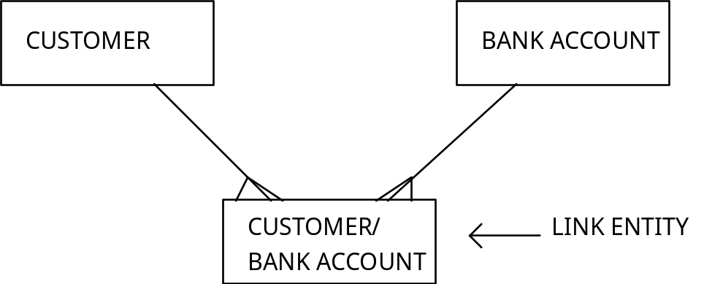

• EXISTENCE OF A RELATIONSHIP

Deciding whether a relationship is optional or mandatory e.g.

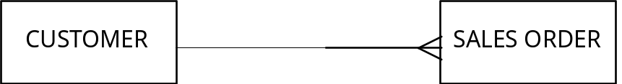

Each sales order must be associated with a customer, but at any point in time there may be no outstanding sales orders for some customers.

• RECURSIVE RELATIONSHIPS

Entity occurrences often have direct relationships with other entity occurrences of the same type e.g.

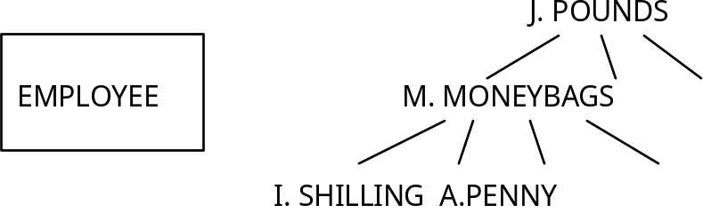

i.e. an employee can manage many employees but is managed by one and only one employee.

• EXAMPLE

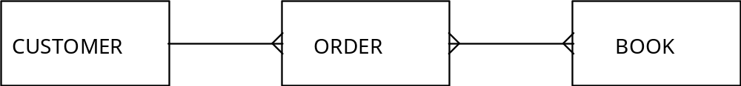

Model building is an iterative process in which the analyst continually reassesses the structure and content of the data model in the light of his understanding of the organisations requirements.

In building the model the analyst must decide which attributes to assign to identified entities. Some attributes need not be included in the E-R model as they may be derived from the values of other attributes.

Attributes for the above example include:

order-value
order-date
quantity-ordered
customer-name
customer-address
order-delivery-address
title
price
publication-date

order-value = sum(quantity-ordered X price)
therefore redundant.

order-date
ORDER ENTITY
order-delivery-address

customer-name
CUSTOMER ENTITY
customer-address

title
price BOOK ENTITY
publication-date

quantity-ordered?

order entity?

No, several values, one for each book on the order. Not clear which book a quantity-ordered refers to.

book entity?

May be several values of quantity ordered for a particular book. Which order is being referred to by any of these values?

customer entity?

It would not always be possible to tell to which order and book a quantity-ordered value should apply.

The solution to this problem of attribute allocation lies in the decomposition of an M:N relationship.

OCCURRENCE DIAGRAM:

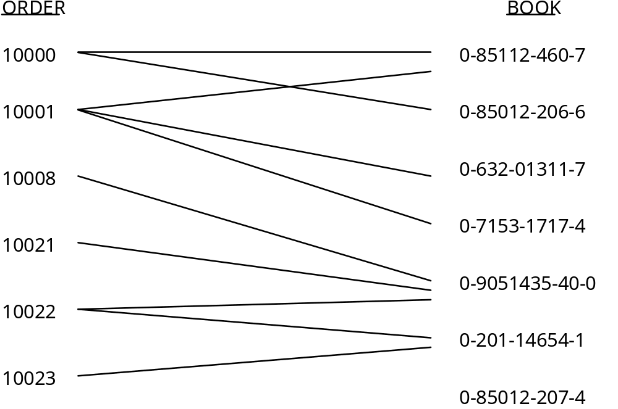

Replacement of the order-book relationship by a new order-line entity.

