Modify the friends database that you have created to maintain details of sports clubs in the area and activities that can be played at each club.

(This poses a similar situation as with friends and hobbies. For each club there may be any number of activities therefore this should be maintained in a separate table and a one to many relationship created with the club table.)

Club Table
Field Name | Data Type
Club_id | Text
Name | Text
Address | Text
Subscription | Text
Membership_Cost | Decimal

Activities Table
Field Name | Data Type
Club_id | Text
Activity | Text

create table club ( club_id varchar(20) NOT NULL,
name varchar(30),
address varchar(30),
subscription varchar(20),
membership_cost decimal(10,2),
PRIMARY KEY (club_id));

create table activities (club_id varchar(20) NOT NULL,
activity varchar (20) NOT NULL,
PRIMARY KEY (club_id, activity),
FOREIGN KEY (club_id) REFERENCES club(club_id));

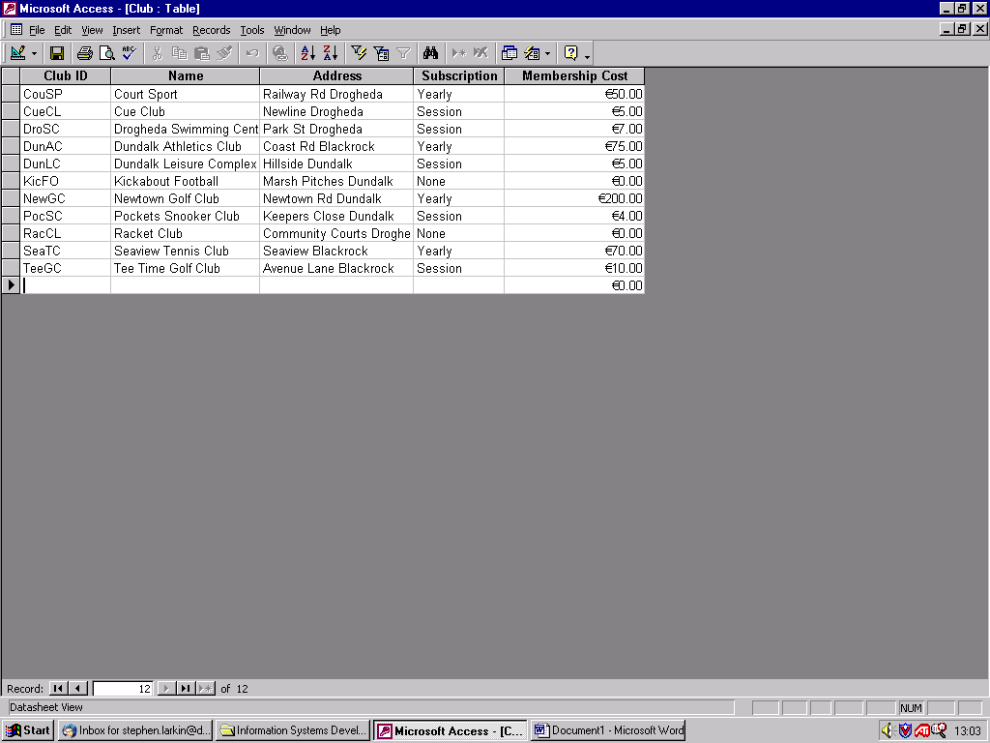

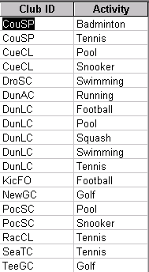

Design queries to retrieve the answers to the following questions.

- Where is Pockets Snooker Club
- What activities are offered at Dundalk Leisure Complex
- What clubs are in Blackrock
- What clubs offer free subscription
- What clubs have an annual membership fee
- Where can I play golf in Dundalk
- What activity can I take part in for free
- What activity in Dundalk can I take part in for less than €5
- Where activities are not free but cost less than €10 subscription to play
- What activities can I play annually for less than €100

