
8

Continuous Assessment
Cover Sheet

Student Name: Neo Sahadeo
Student Number: D00264604
DECLARATION: I declare that:

•

This work is entirely my own, and no part of it has been copied from any other person’s words
or ideas, except as specifically acknowledged through the use of inverted commas and in-text
references;
•

No part of this assignment has been written for me by any other person except where such
collaboration has been authorised by the lecturer(s) concerned;
•

I have not used generative artificial intelligence (AI) (e.g. ChatGPT) unless it has been permitted
by the lecturer(s) concerned;
•

I understand that I am bound by DkIT Academic Integrity Policy. I understand that I may be
penalised if I have violated the policy in any way;
•

This assignment has not been submitted for any other module at DkIT or any other institution,
unless authorised by the relevant Lecturer(s);
•

I have read and abided by all of the requirements set down for this assignment.

S
IGNATURE
………………………………Neo Sahadeo........……………………………………………… D
ATE
…16/10/2024..…………

Lecturer’s Comments:

Provisional Mark : _____ Lecturers Signature : __________________________ Date: _______________

Work submitted late will be subject to penalties in accordance with the DkIT Continuous Assessment Policy

Programme: Computer Systems and
Operations
Stage: 1
Complete Student Checklist:
Re-read brief x
References and Bibliography □
Proofread □

Module: Introduction to Programming
Due Date: 20/10/2024
No. Pages: 4
Lecturer(s) Name: Amanda Clancy
Assignment No. and/or Description/Topic:

CA 1

Mode of Submission:
Softcopy x Hardcopy □

Exercise 1
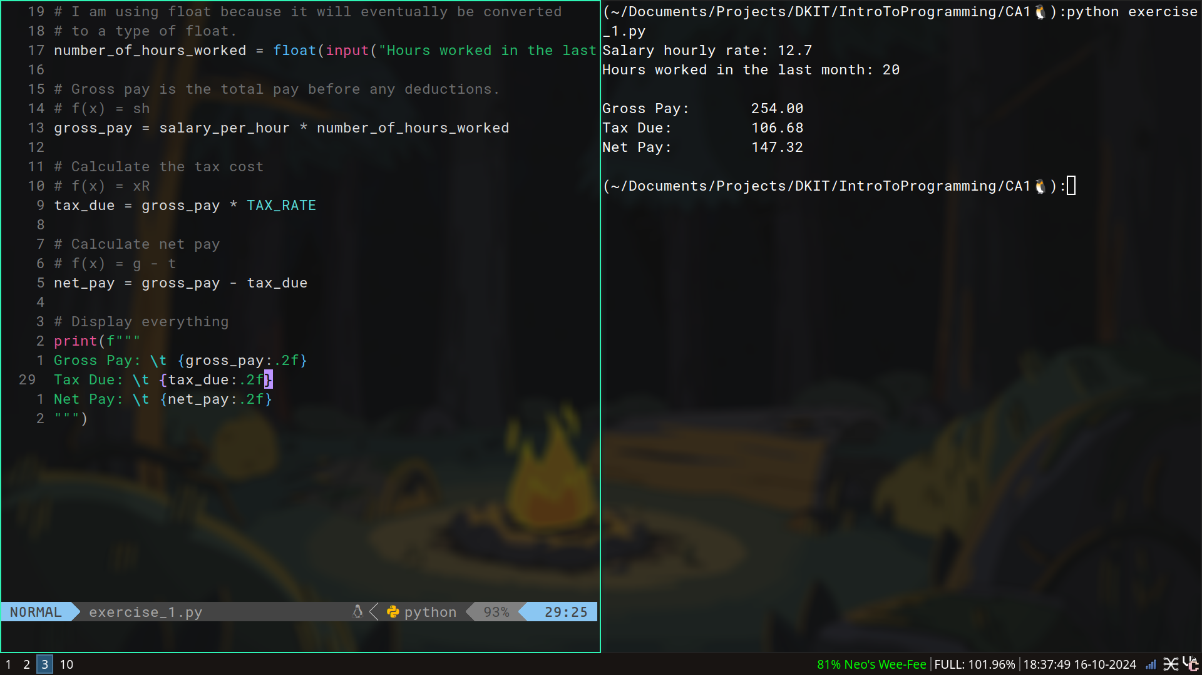

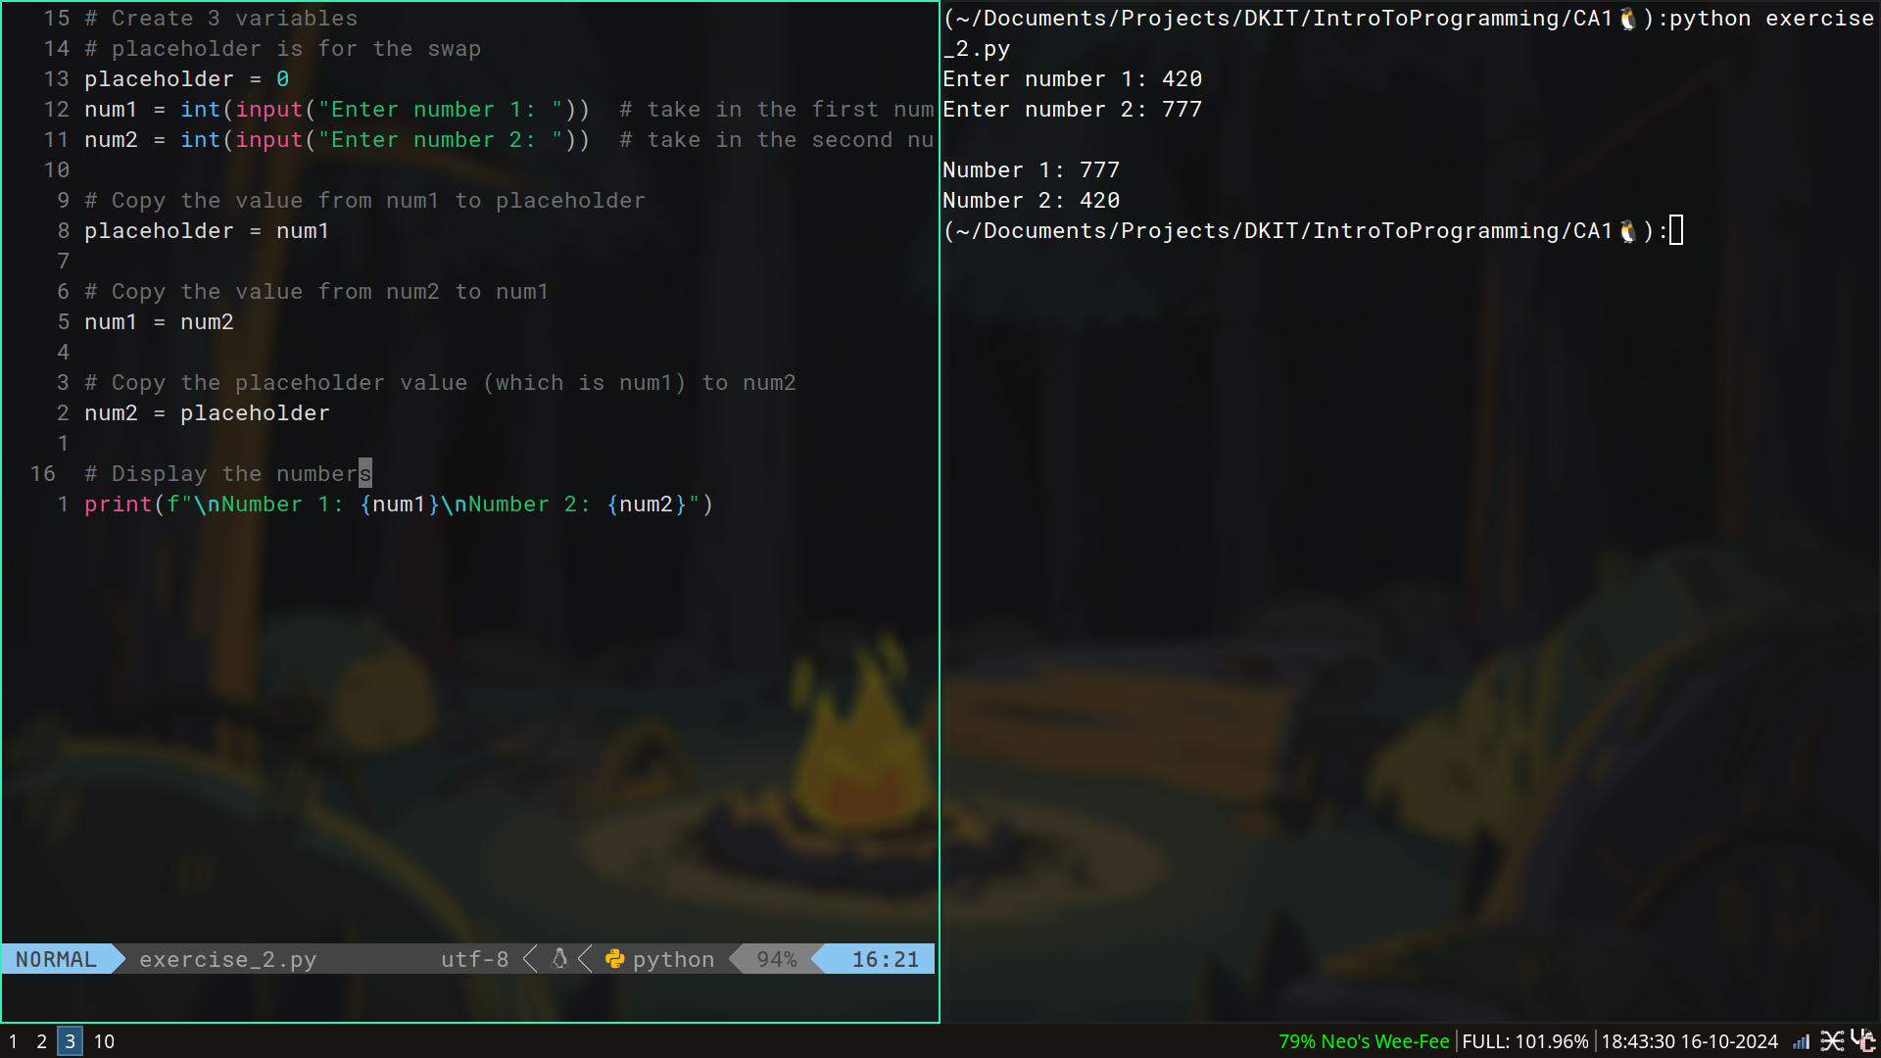
Exercise 2
Exercise 3
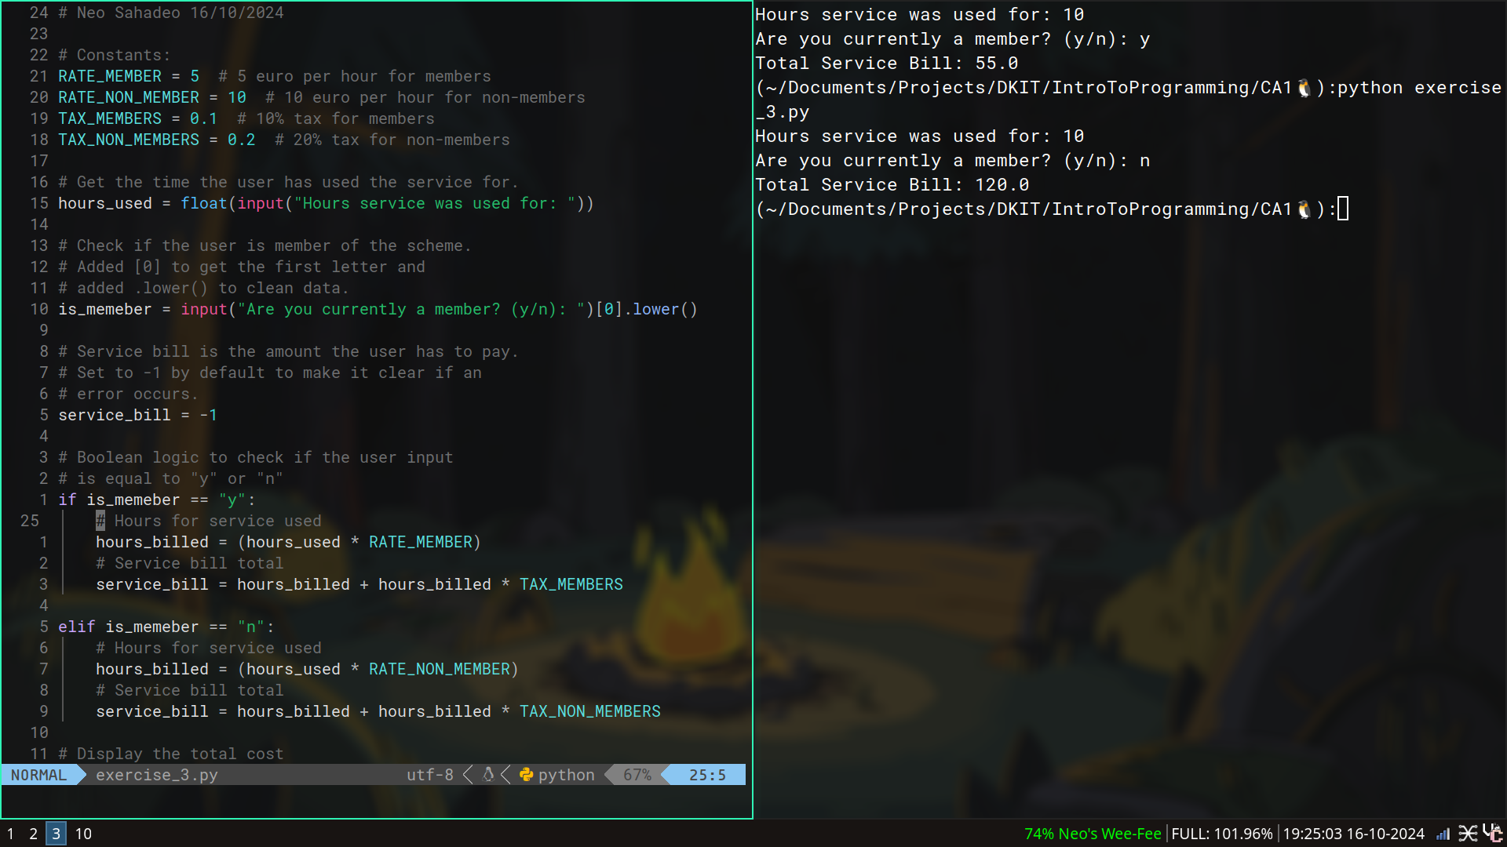

Exercise 4
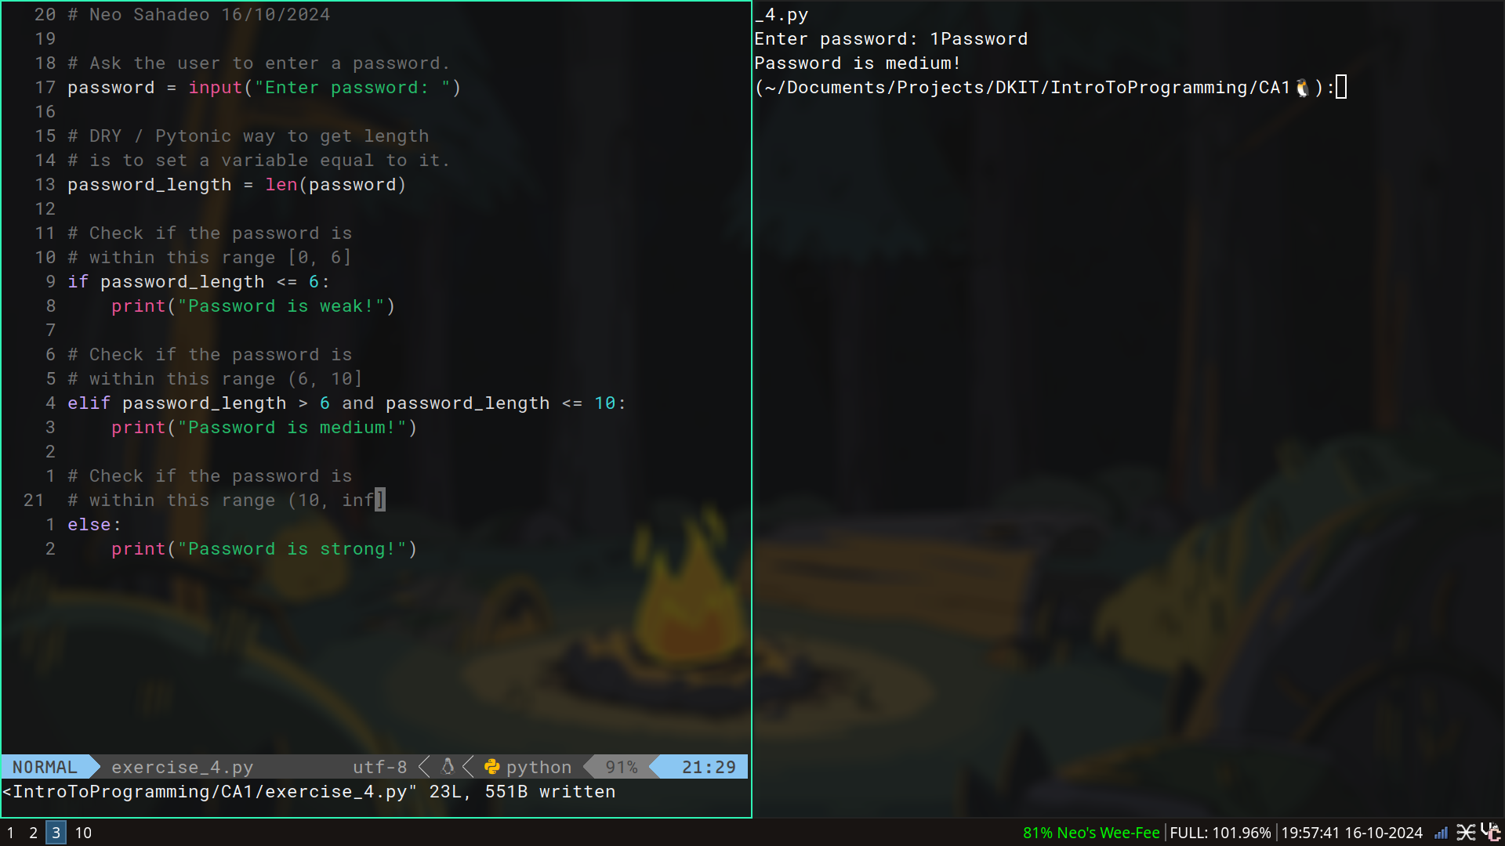
Exercise 5
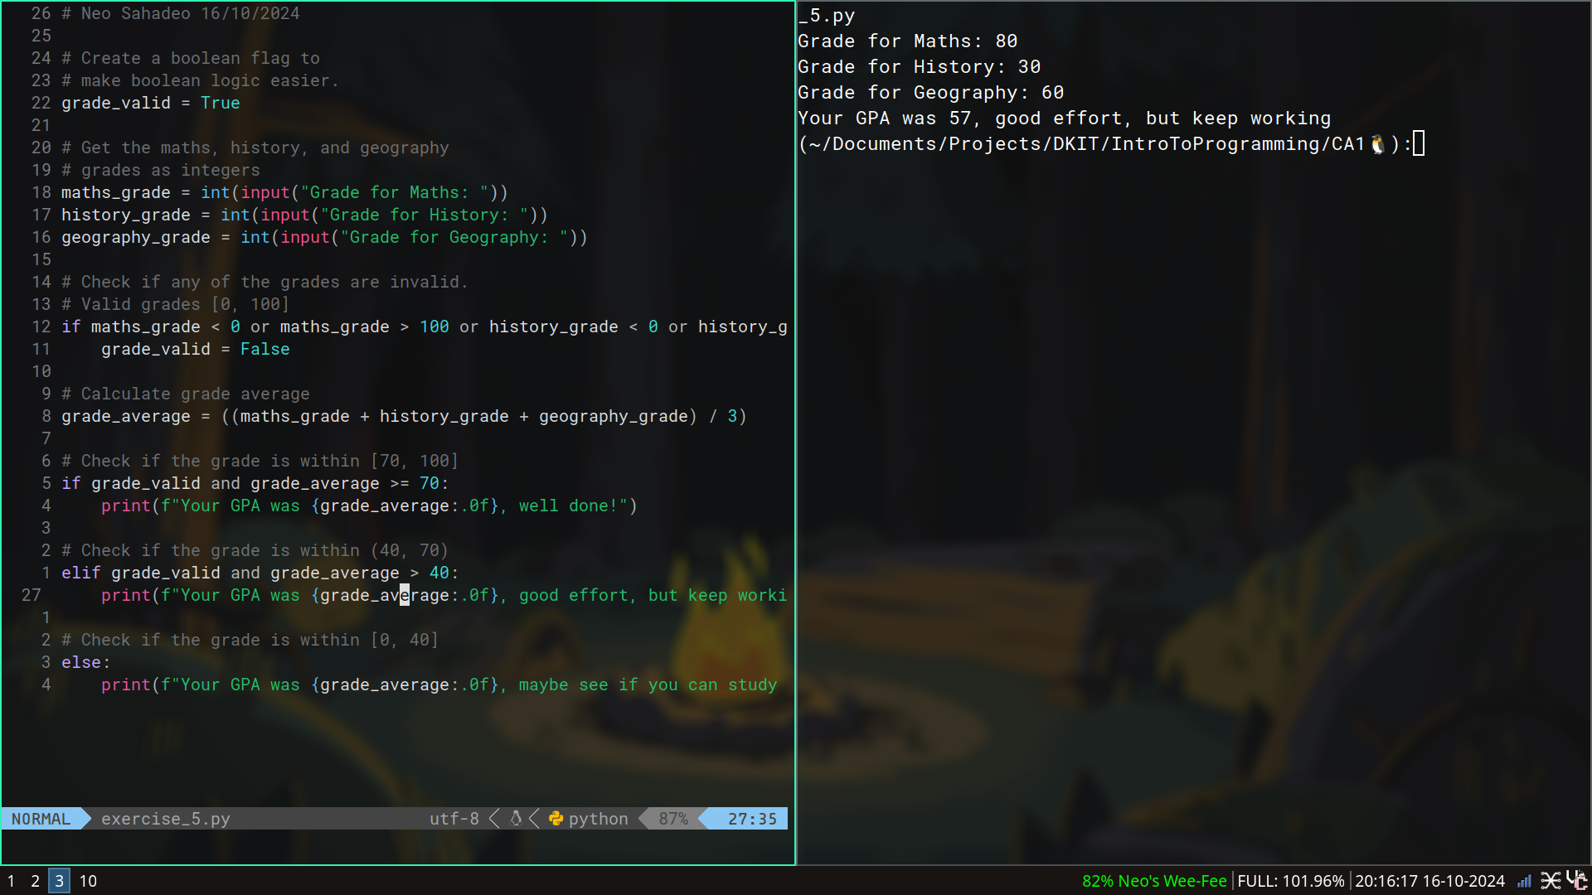

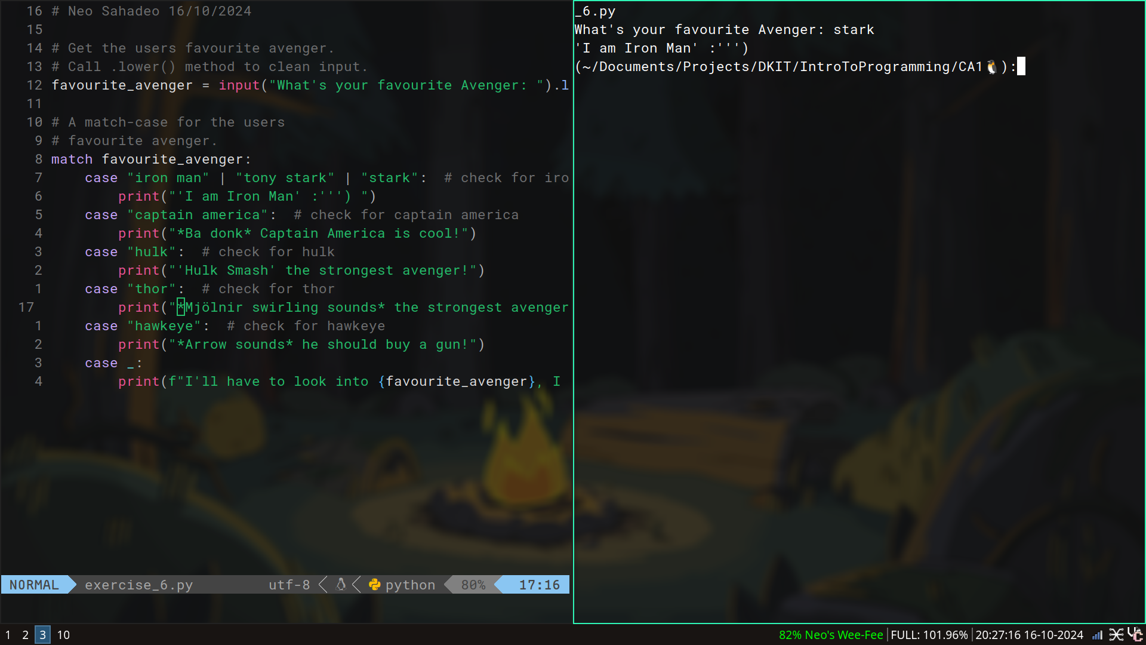
Exercise 6

