

Continuous Assessment
Cover Sheet

Student Name: Neo Sahadeo | Student Number: D00264604
Programme: Computer operations and Systems | Stage: 1 | Complete Student Checklist:  Re-read brief □  References and Bibliography ☑  Proofread ☑
Module: Intro To Programming
Due Date: 10/11/2024 | No. Pages: 2
Lecturer(s) Name: Amanda Clancy
Assignment No. and/or Description/Topic:  CA 2 |  | Mode of Submission:  Softcopy ☑ Hardcopy □
DECLARATION: I declare that:

- This work is entirely my own, and no part of it has been copied from any other person’s words or ideas, except as specifically acknowledged through the use of inverted commas and in-text references;
- No part of this assignment has been written for me by any other person except where such collaboration has been authorised by the lecturer(s) concerned;
- I have not used generative artificial intelligence (AI) (e.g. ChatGPT)
- I understand that I am bound by DkIT Academic Integrity Policy. I understand that I may be penalised if I have violated the policy in any way;
- This assignment has not been submitted for any other module at DkIT or any other institution, unless authorised by the relevant Lecturer(s);
- I have read and abided by all of the requirements set down for this assignment.

Signature……………Neo Sahadeo……………………………………………… Date……08/11/2024…

Lecturer’s Comments:

Provisional Mark : _____ Lecturers Signature : _______________________________ Date: _______________

Work submitted late will be subject to penalties in accordance with the DkIT Continuous Assessment Policy

Exercise 1
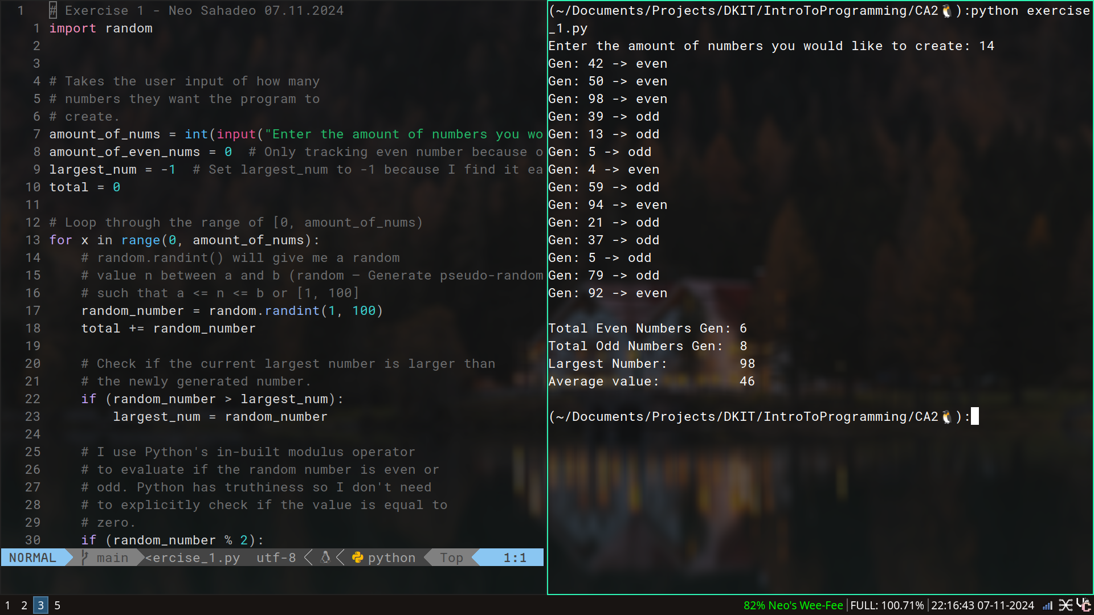

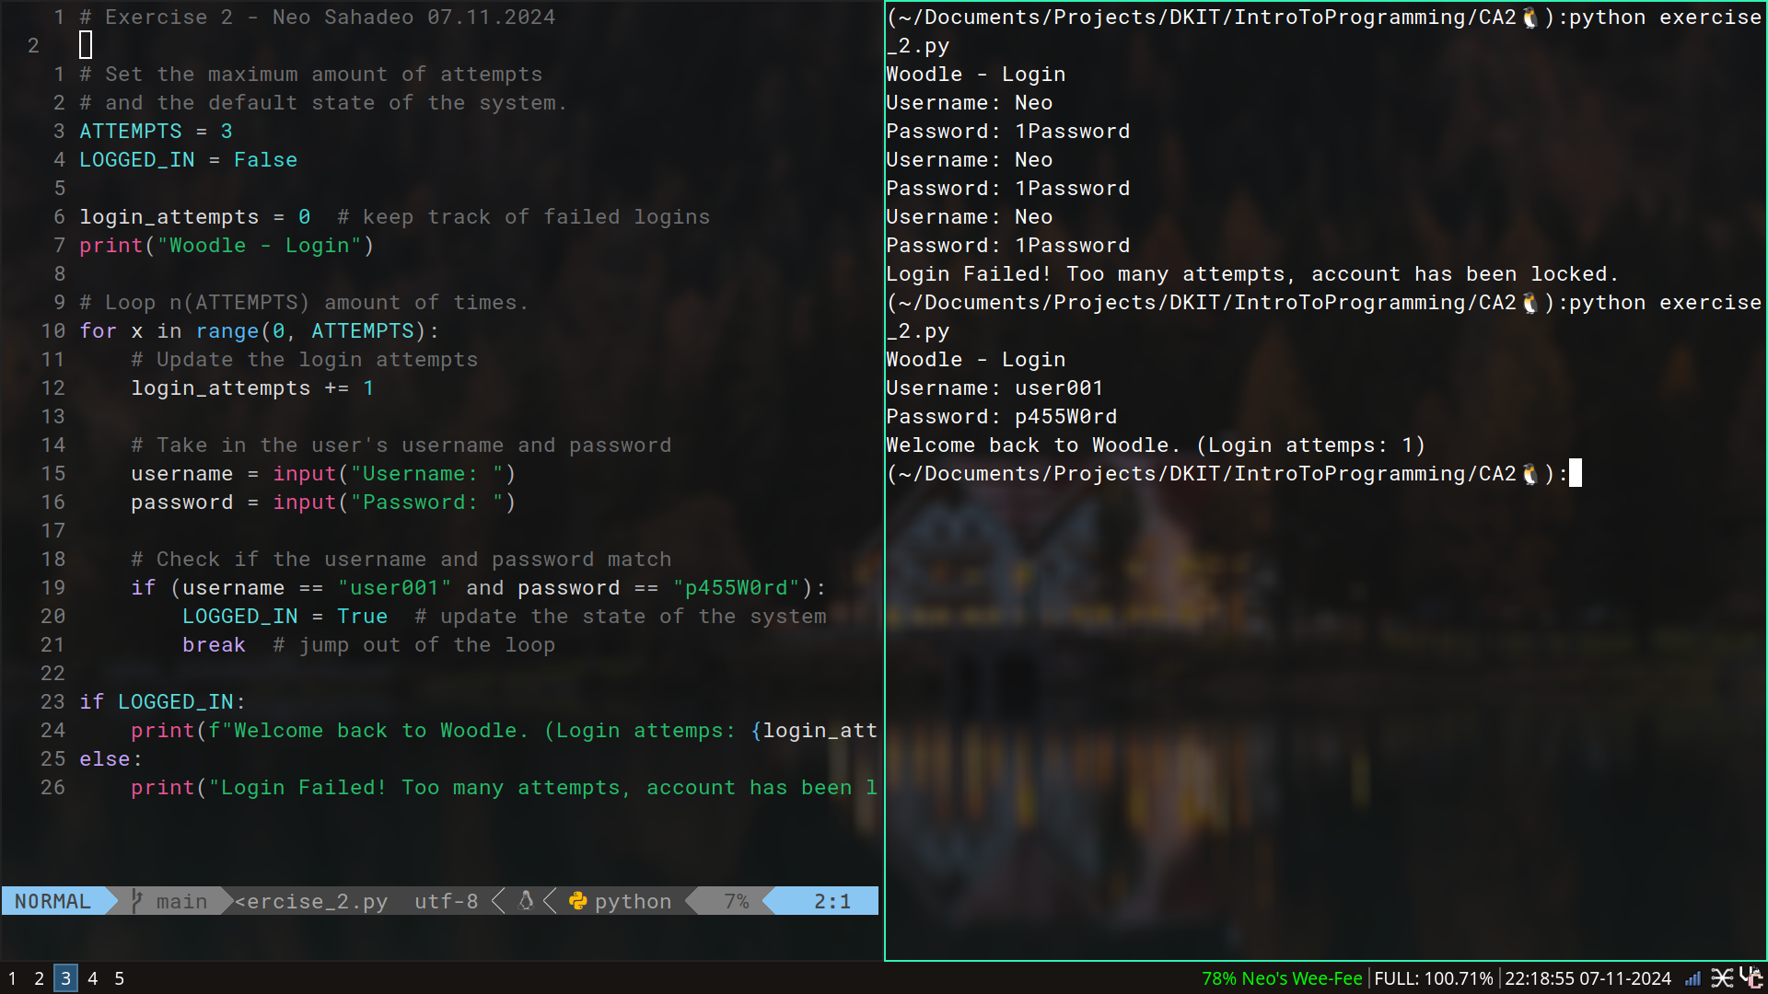
Exercise 2
Exercise 3
