Introduction to Forms:

1: PART 1: INTRODUCTION: 2
2: PART 2: CREATE A WEBPAGE WITH MOST OF THE FORM ELEMENTS: 3
3: PART 3: FORM ELEMENT PROPERTIES: 4
…4: ALIGNING THE FORM ELEMENTS DIRECTLY UNDER EACH OTHER: 4
…5: ACCESSING THE FORM ELEMENTS BY CLICKING ON THE WORDS IN THE LABEL: 5
…6: FORCING THE CURSOR INTO A TEXTBOX WHEN WEBPAGE LOADS: 6
…7: FORCING CONTENT INTO FORM ELEMENTS: 7
…8: TEXTBOX PROPERTIES: 8
…9: TEXTBOX BACKGROUND-COLOUR PROPERTIES & PSEUDOCLASSES: 9
…10: STYLING THE FIELDSET AND LEGEND: 10
11: PART 4: CREATING A BUTTON: 11
12: PART 5: SELECTION LISTS: 12
…13: SELECTION LISTS:PRE-SELECTING A SELECTION LIST OPTION: 12
…14: MULTIPLE-SELECTING SELECTION LIST OPTIONS: 13
15: PART 6: INDEPENDENT LEARNING: 14
…16: PRESELECTING ONE RADIO BUTTON: 14
…17: DEFAULT TEXT IN A TEXTAREA: 14
…18: DEFAULT WIDTH AND HEIGHT OF A TEXTAREA: 14
…19: PASSWORD TEXTBOX: 14
…20: FILE UPLOAD FORM ELEMENT: 14
21: PART 7: APPLYING STYLE TO THE FORM: 15
22: PART 8: MORE INDEPENDENT LEARNING! 16
23: VALIDATE PLEASE! 16
24: EXERCISE: 17

1: PART 1: INTRODUCTION:
Being able to create working forms on a webpage is all-important. It is the usual way for the user to pass information to a webserver (e.g. buying something, logging in to Moodle or email). In order to become familiar with forms you need to be able to create a form and associated form components (“form elements”): e.g. selection list, textbox, submit button, radio button, checkbox, etc.

In this session you will learn how:
- to create a form on a webpage;
- to create the vast majority of form elements, such as:
- textboxes;
- number textboxes;
- email boxes;
- checkboxes;
- radio buttons;
- selection lists;
- buttons;
- reset buttons;
- submit buttons;
- textareas;
- other less widely-used form elements:
- to use important form element properties, such as:
- value;
- type;
- placeholder;
- required;
- autofocus;
- size;
- maxlength.
- to apply styles to form elements;
- to align form elements neatly on the webpage;
- to either go to a new webpage, or generate an email, when the submit button is pressed
- to apply your form knowledge to the Ring Of Gullion website to create a new form (“Contact Us”) webpage.

- You’ll be hearing a lot about form elements: this is an important term that simply means:
  - the tags inside a <form> tag that are specific to the functioning of the form.

2: PART 2: CREATE A WEBPAGE WITH MOST OF THE FORM ELEMENTS:

- Let’s get the basic tags in first, before we worry about either their properties, or styling them (e.g. to align them under each other).
- Chrome has the most up-to-date implementation of HTML5 Form Element standards, so you should view your code in this browser.
- SORRY! There is quite a bit of code needed to become familiar with forms, so there is no shortcut around typing it in ☹ ☹ ☹
- Create a webpage called formIntro.html:
  - The completed webpage should look like the screenshot in BasicFormHTML~Chrome.jpg in your resources.
  - The required code is in BasicFormHTML~Code.jpg.
- We will add the CSS inside the <head> tag (rather than create an external stylesheet) because this is a one-off webpage.

You will find plenty of information on forms and form elements in w3schools: https://www.w3schools.com/html/html_forms.asp .

3: PART 3: FORM ELEMENT PROPERTIES:

…4: ALIGNING THE FORM ELEMENTS DIRECTLY UNDER EACH OTHER:

Add the following style for the <label> tags:
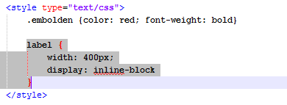
You should notice that the form elements that follow a <label> tag are directly under each other:
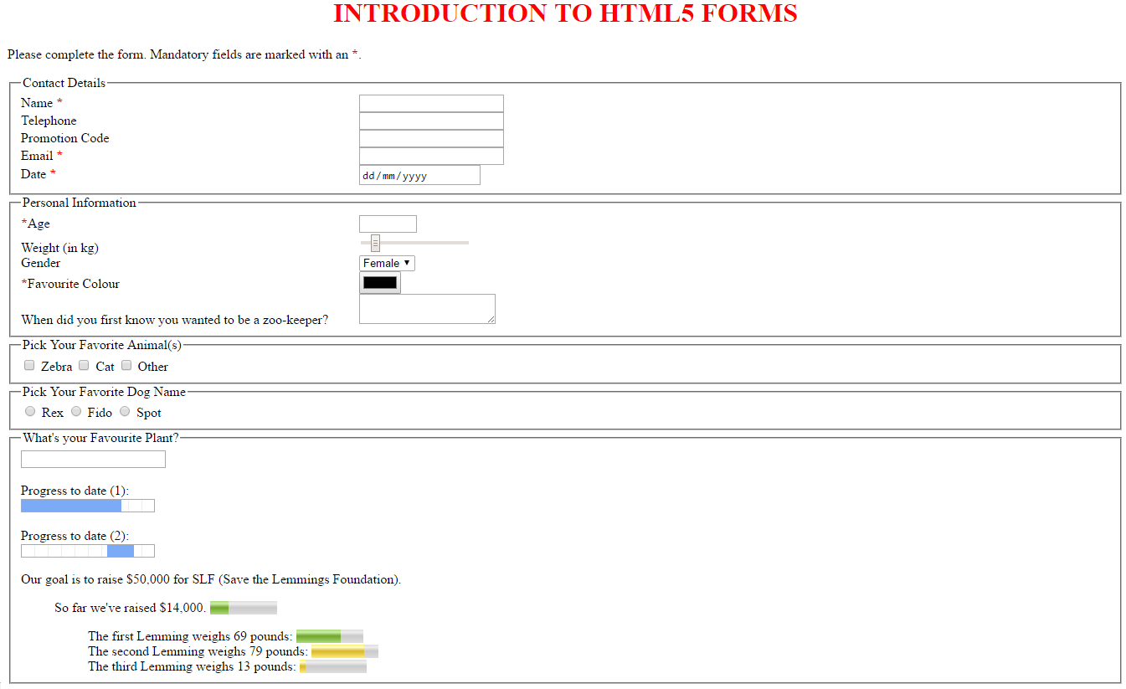

…5: ACCESSING THE FORM ELEMENTS BY CLICKING ON THE WORDS IN THE LABEL:

If you click on the words (in labels) “Name”, “Telephone”, “Promotion Code” and “Email”, nothing happens. Now click on the word “Date”. What happens? Why?

QUESTION: How would you make the same thing happen to the “Name”, “Telephone”, “Promotion Code” and “Email” form elements?

…6: FORCING THE CURSOR INTO A TEXTBOX WHEN WEBPAGE LOADS:

When the webpage loads, the cursor is not blinking anywhere. To force it to blink into the “Name” textbox, add the following word:
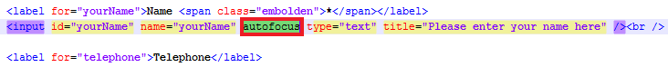
Check that the cursor blinks in the appropriate textbox when the webpage is refreshed.

QUESTIONS:
- What happens if you add autofocus into another textbox?
- Would there be any point in doing this?

…7: FORCING CONTENT INTO FORM ELEMENTS:

If you click the Submit button without entering or selecting any data, the browser goes straight to the RTÉ website. But do you remember the *? We want to force the user to enter data into certain form elements.

Add the following word into the appropriate form elements as follows:
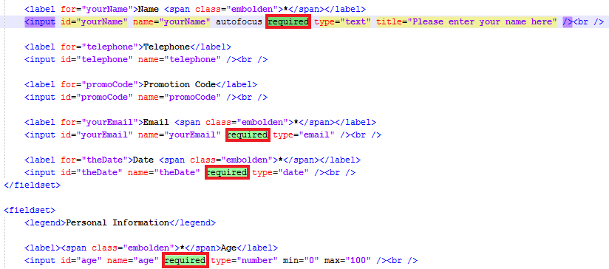
Test this as follows:
- Leaving the four form elements blank, click the submit button. What happens?
- Type an email address without a ‘@’ and click submit. What happens?
- Type alphabetic characters for the “Age” textbox and click submit. What happens?
- Make sure you get to RTÉ when appropriate input has been entered.

…8: TEXTBOX PROPERTIES:

Add the following 3 property-value pair information into the “Telephone” textbox:
Now test this as follows:
- How many characters can you type in?
- What’s the difference between size and maxlength?
- What happens to the placeholder when you start typing?

…9: TEXTBOX BACKGROUND-COLOUR PROPERTIES & PSEUDOCLASSES:

Add the following CSS styles: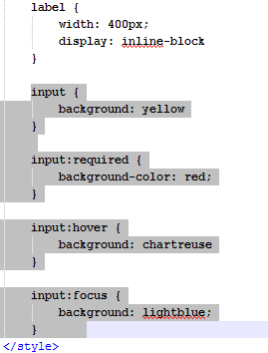.
Your webpage should display as follows: 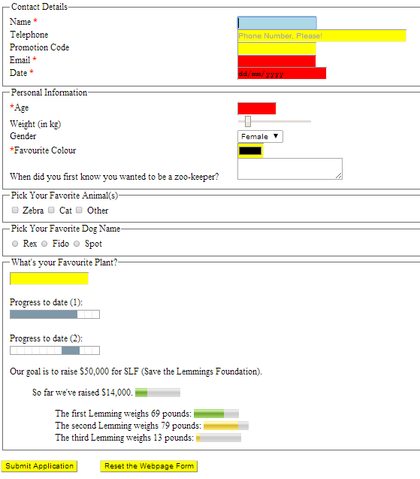.

Does this make sense?

QUESTIONS:
- What happens if you move the mouse over the words “Date”, “Email”, “Promotion Code”, “Telephone” and “Name”? Explain why the “Name” textbox doesn’t turn green.
- Click into the “Telephone” textbox and move the mouse over the word “Telephone”. Does this behaviour make sense?

…10: STYLING THE FIELDSET AND LEGEND:

Add the following style: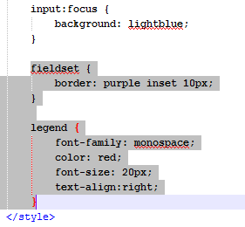

CHECK YOUR WORK:
- Compare the webpage in Chrome, Edge and Firefox.
- Is there any difference in how the different browsers render the webpage?
- Which (if any) of the above form elements and styles do/don’t work in Chrome, Edge and Firefox?
- You can check out the browser support for HTML and CSS at https://caniuse.com/ .

11: PART 4: CREATING A BUTTON:

As you can see from the form html code, there is special code for creating submit and reset buttons. Sometimes you may want to create a button that is not related to a form. So this section shows you how to do this (not a form element).

Do the following:
- Using Paint, create a small .JPG image (30x30pixels) with a red background and one black alphabetic character. Save it as Red.jpg into the same folder as the webpage. (You should see it appear in File Manager once this is done.)
- Add the following code just before the end of the <form> tag:
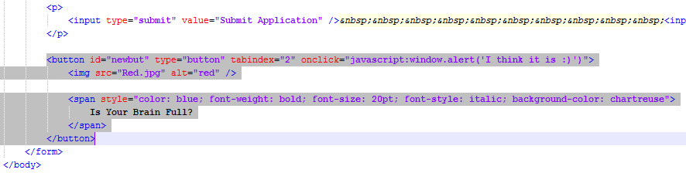

Your webpage should look like this after you click this new button:
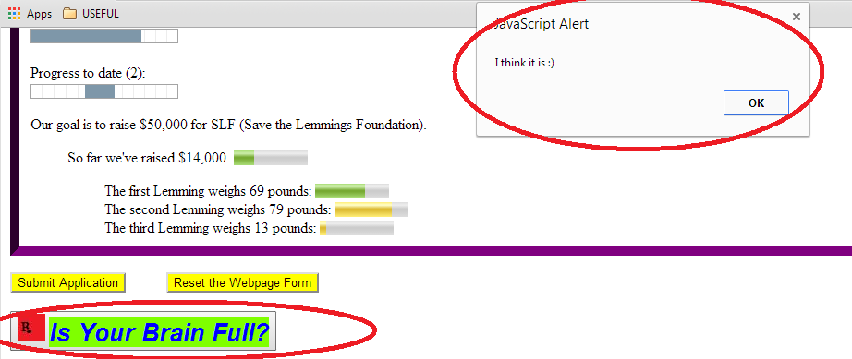
Do both code and browser make sense?

12: PART 5: SELECTION LISTS:

…13: SELECTION LISTS:PRE-SELECTING A SELECTION LIST OPTION:

Q: Which gender option displays?
A: You should notice that the “Female” <option> is the selected one, because the default displaying <option> is the first one.

Changing the default displaying option:
- Add the following property-value pair into the “Male” option:
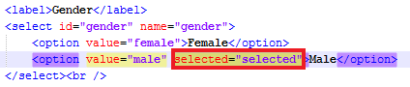
- You should now notice when you refresh the webpage that the second <option> is the selected one.

…14: MULTIPLE-SELECTING SELECTION LIST OPTIONS:
Insert the following code in the appropriate place:
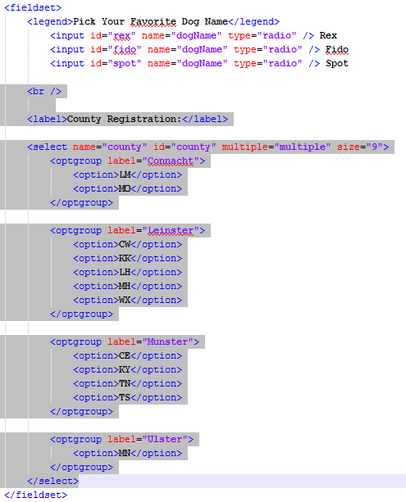
Your webpage should look like this (top heading not shown):
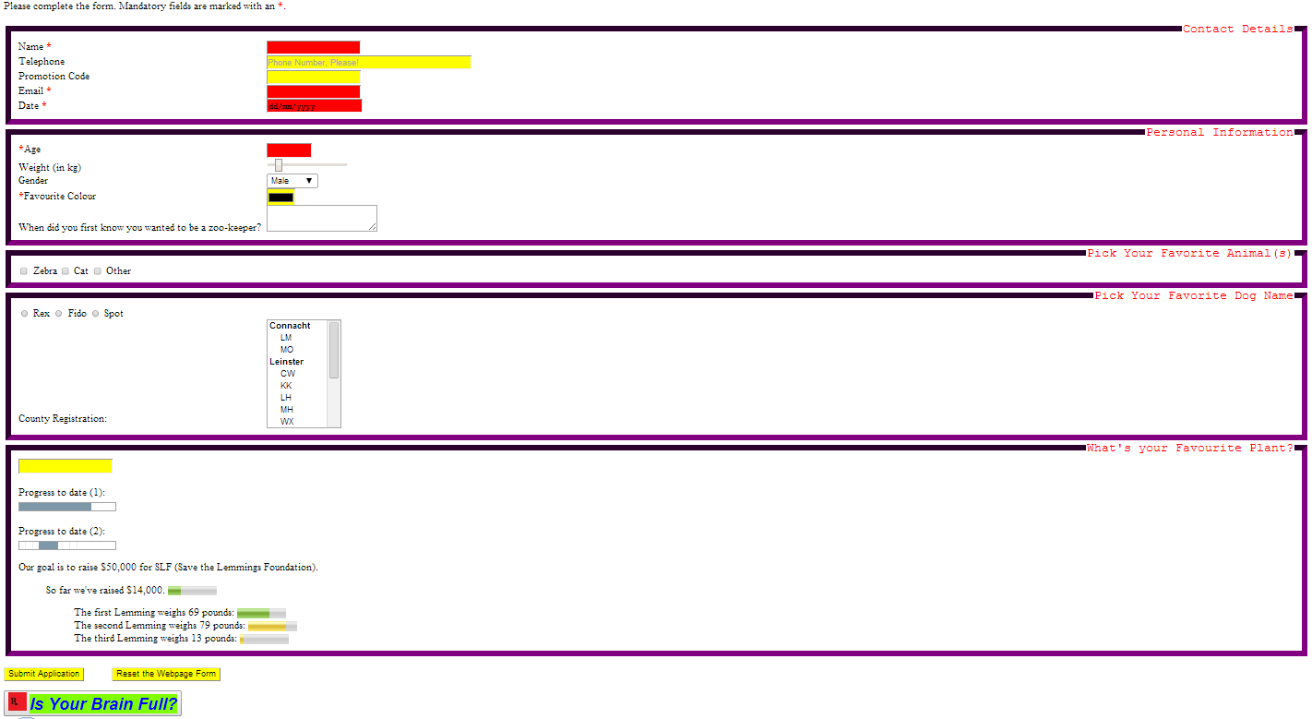
- By holding the Ctrl button and clicking on the ‘County Registration’ selection list you can select or deselect more than one option. Test!
- Can you click to select an <optgroup>?
- What does size=”9” mean? If you change the value to ‘4’, does what is displayed make sense?

15: PART 6: INDEPENDENT LEARNING:
Go to https://www.w3schools.com/html/html_forms.asp for help.
…16: PRESELECTING ONE RADIO BUTTON:
Find out yourself online, please, and test it on your code.

…17: DEFAULT TEXT IN A TEXTAREA:
Find out yourself online, please, and test it on your code.

…18: DEFAULT WIDTH AND HEIGHT OF A TEXTAREA:
Find out yourself online, please, and test it on your code.

…19: PASSWORD TEXTBOX:
Find out yourself online, please, and test it on your code.

…20: FILE UPLOAD FORM ELEMENT:
Find out yourself online, please, and test it on your code.

21: PART 7: APPLYING STYLE TO THE FORM:
Style is often added to the <form> tag. Apply the following style: form {background: cyan; padding: 35px}. Your webpage now looks like this:
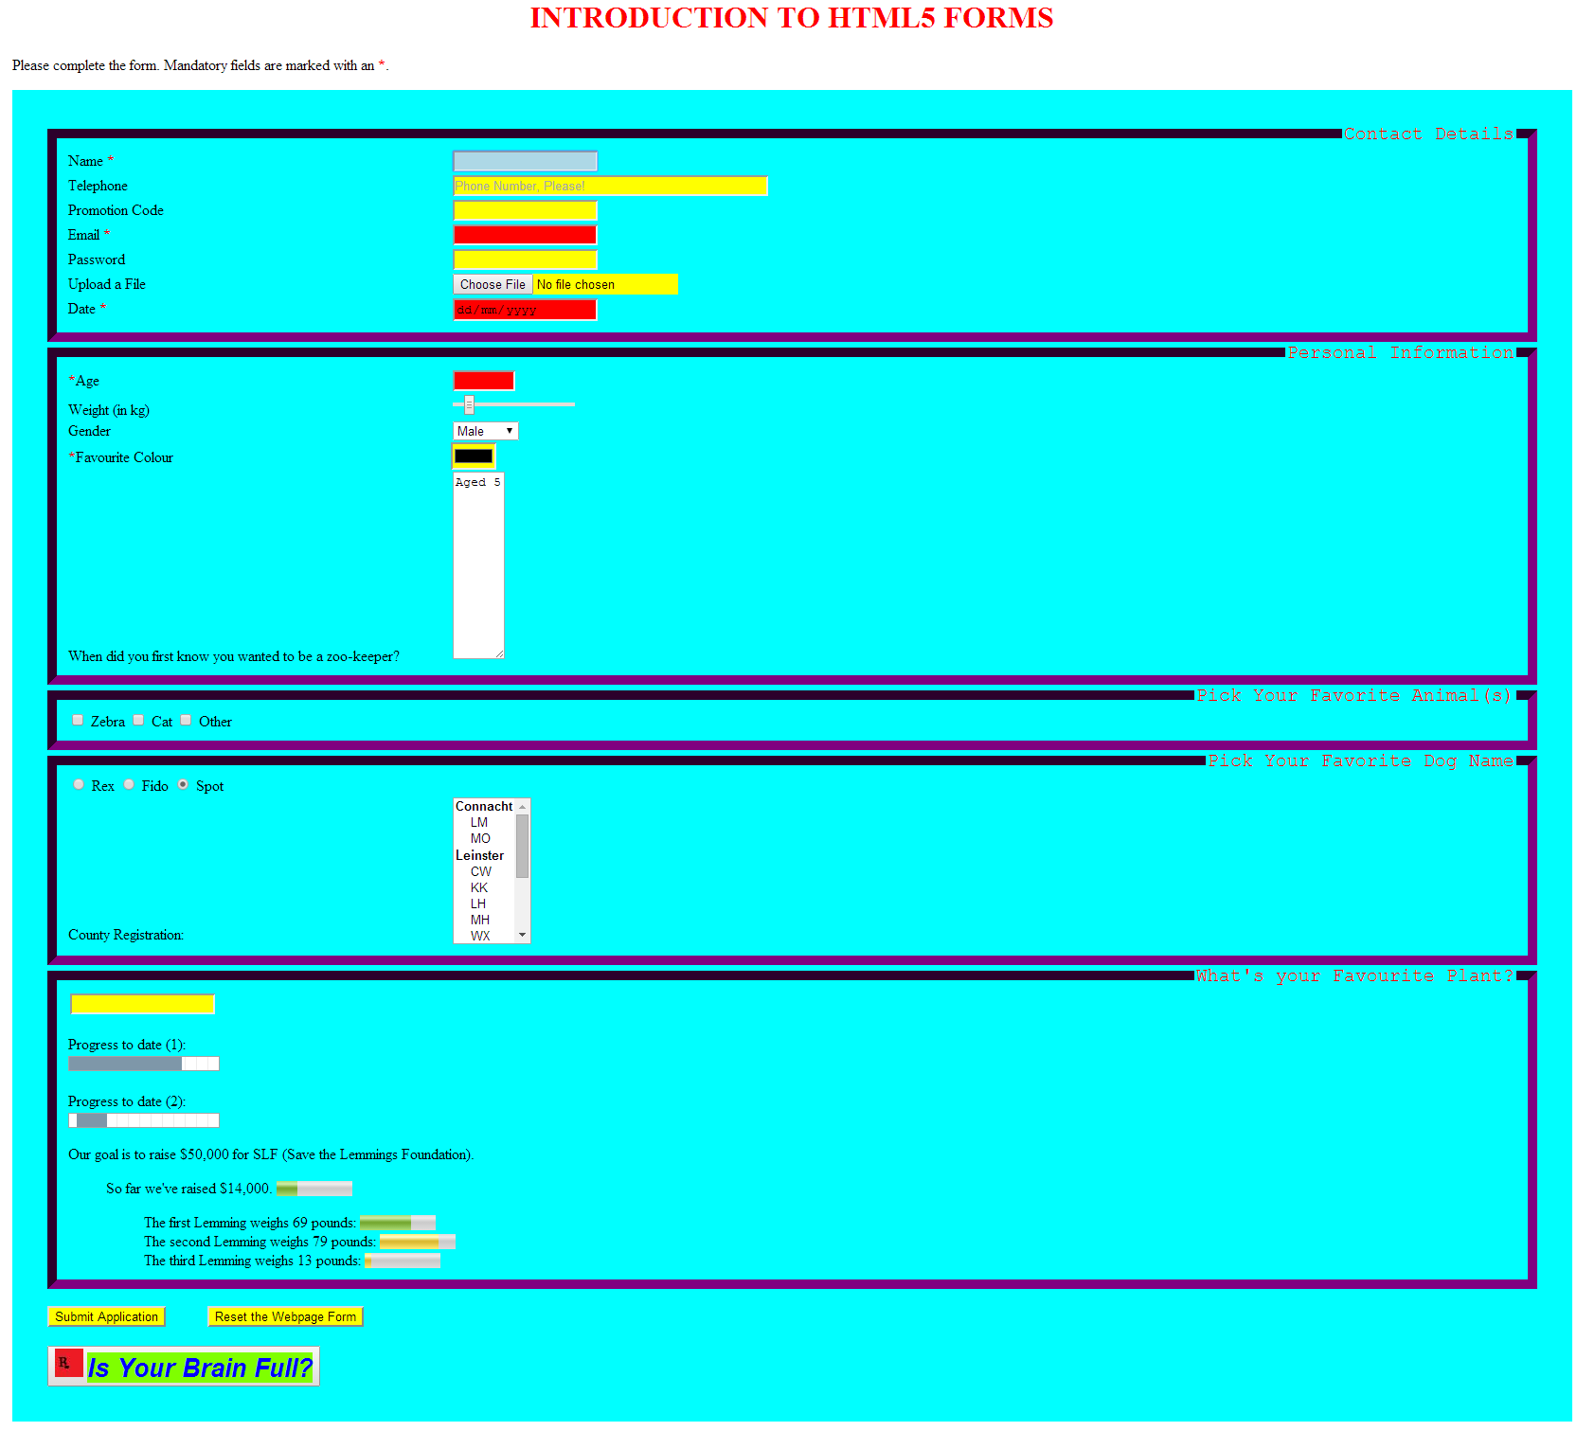
(NOTE: the <textarea> looks that way because of its size. Your textbox may look differently, depending on the size and which browser is used.)

Change the padding value to satisfy yourself that the fieldsets move in response to the new padding value.

Yes, I admit the above colour scheme is not far off disgusting! Come up with a better one!!

22: VALIDATE PLEASE!

23: EXERCISE (part of your Classwork CA mark):

Create a fifth webpage (index/culture/history/rocks so far) for the Ring Of Gullion website, called contact.html. Insert code for selected form elements, so that the webpage looks like this:
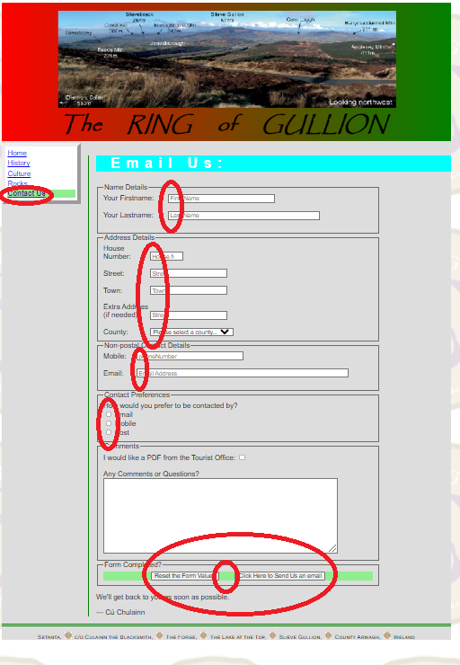

When you are finished, host it in your net2ftp Ring Of Gullion folder, and email me its URL.
Requirements:
- The action for the form should be action=mailto:XXXXXX, where XXXXXX is your email address, so you can test it. In fact, add in the following code for the form tag (use your own email address in the blue area to receive an email):
  - <form name="RoGform" id="RoGform" action="mailto:cuchulainn@microsoft.google" method="post" enctype="text/plain">.
  - (We will look at <form> tag properties in more detail later this semester.)
- Give each form element both a name and an id. Name and id should be identical for any form element, except for radio buttons. When we look at JavaScript and server-side programming (PHP) in Semester 2, you will appreciate why we need both name and id for form elements.
- When you click on any label the relevant form element should become active (there should be 14 labels: by fieldset: 2/5/2/1/2/2);
- Firstname should have cursor in it when webpage loads;
- Something has to be entered into firstname, lastname, street, town, county, email.
- The house number textbox should be type=”number”, with a range 1-999.
- The selection list should have an option for each county.
  - Counties should be grouped according to Province (which should be displayed), and sorted alphabetically within Province.
  - There should be a first option with the text “Please select a county…” . This option should be the default.
- There should be a set of three radio buttons (working correctly) to indicate the user’s preference for being contacted. No need to indent these.
- Reset and submit button should be centered in the last fieldset.
- You will need a separate stylesheet (call it contact.css) (make sure it’s linked to the webpage). You will need styles for:
  - h2,
  - h3,
  - fieldset width,
  - label widths (notice there is a different width used in each of the first three fieldsets),
  - last fieldset:
    - centering, and
    - background colouring.
- Add an extra link for this webpage in all 4 RingOfGullion webpages.

