Commands and ScreenShots

```
pytest tests/pytest_pract1_test.py::test_question1
```

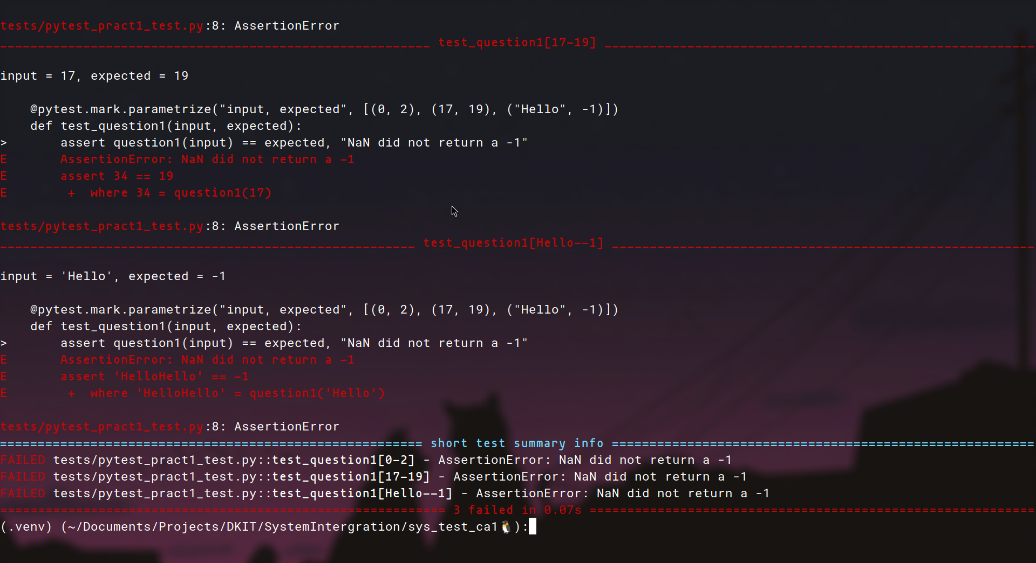
```
pytest tests/pytest_pract1_test.py::test_question2
```

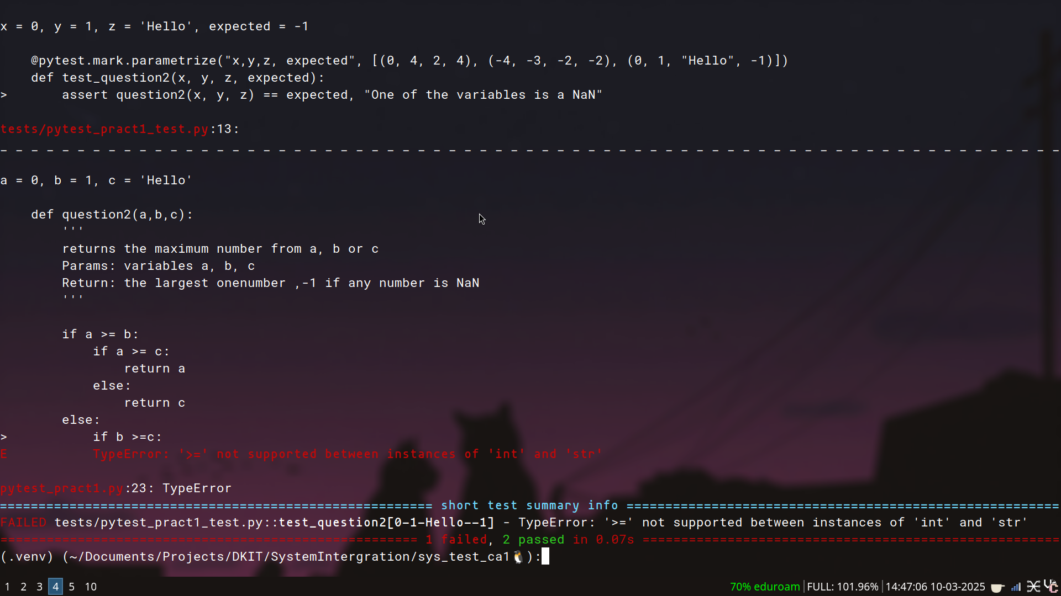

```
pytest tests/pytest_pract1_test.py::test_question3
```

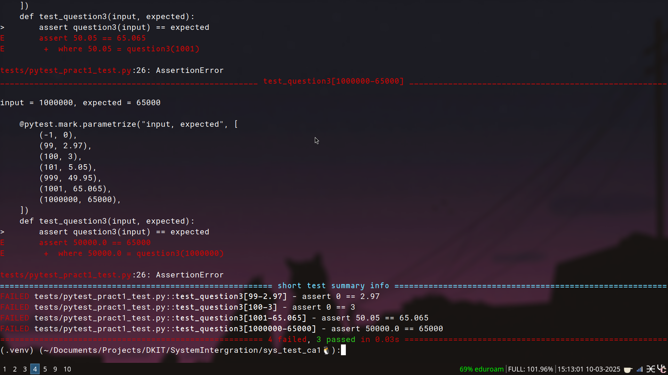
```
pytest tests/pytest_pract1_test.py::test_question4
```

