1. Stubbed out the functions

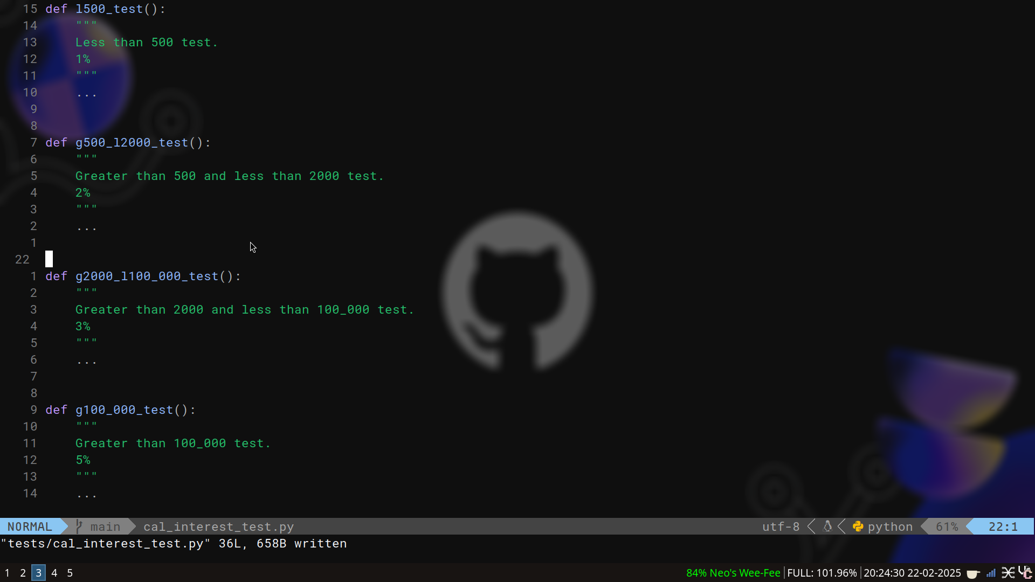
2. Added in a raise exception for non positive number
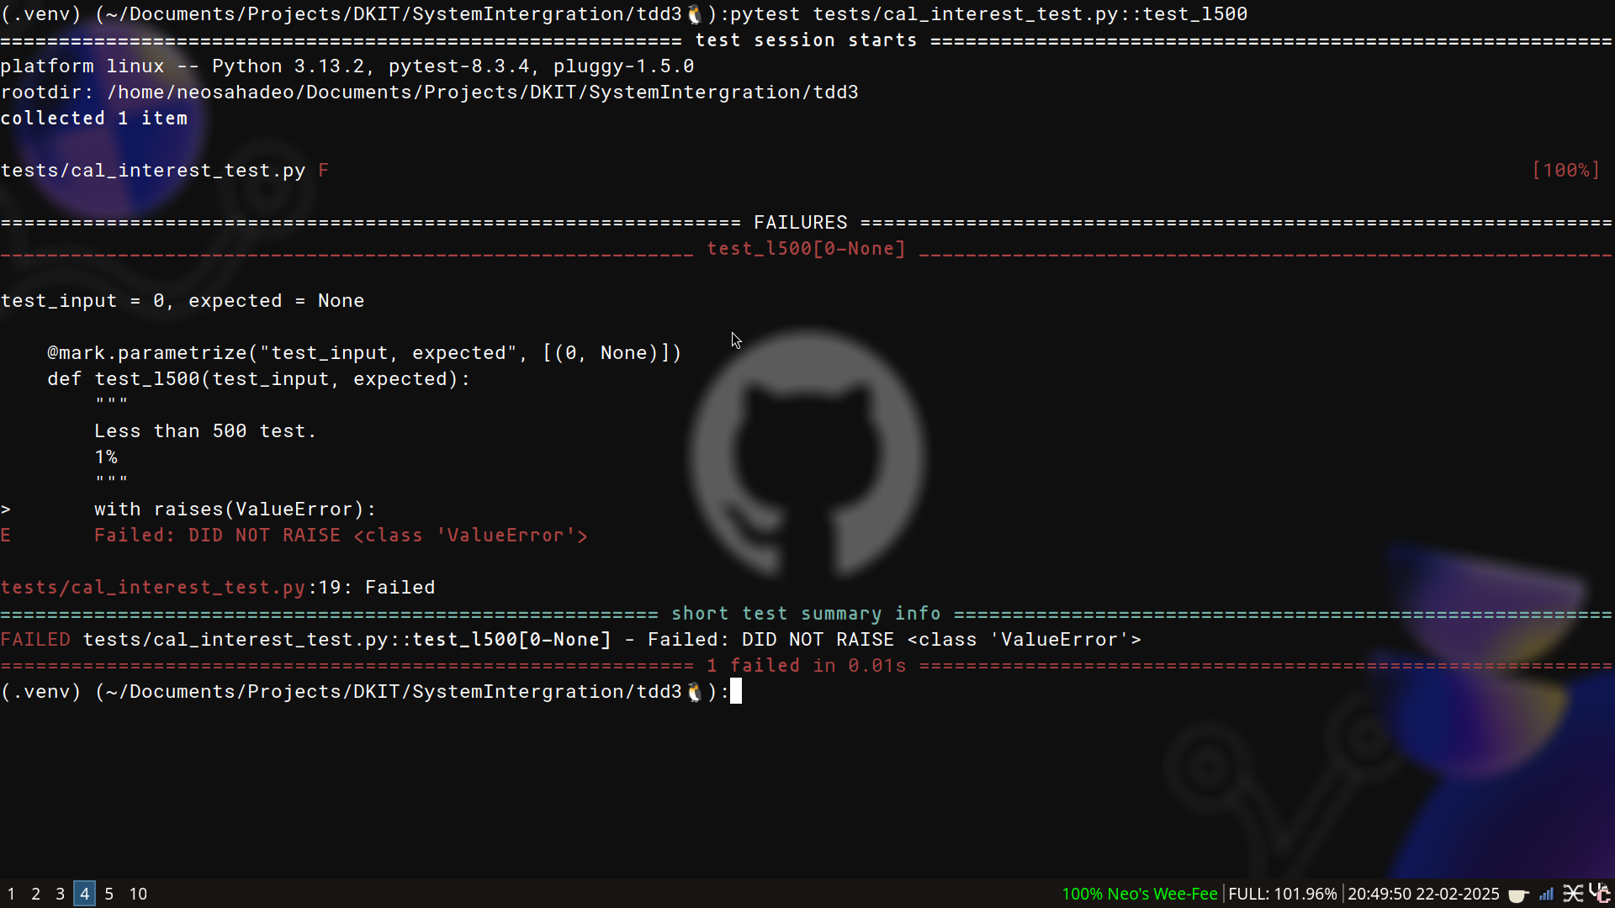

3. Add code to handle the exception

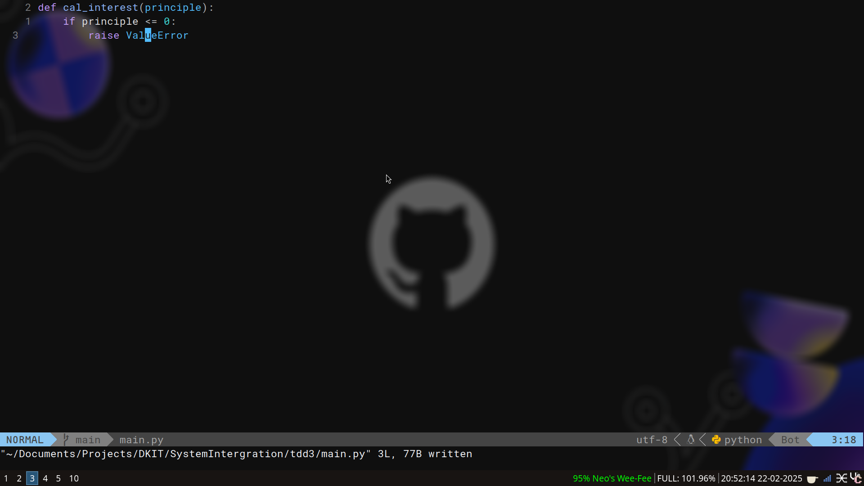
4. Now check if the test passed (“it did, hell yeah brother! [it took me 4 hours]”)

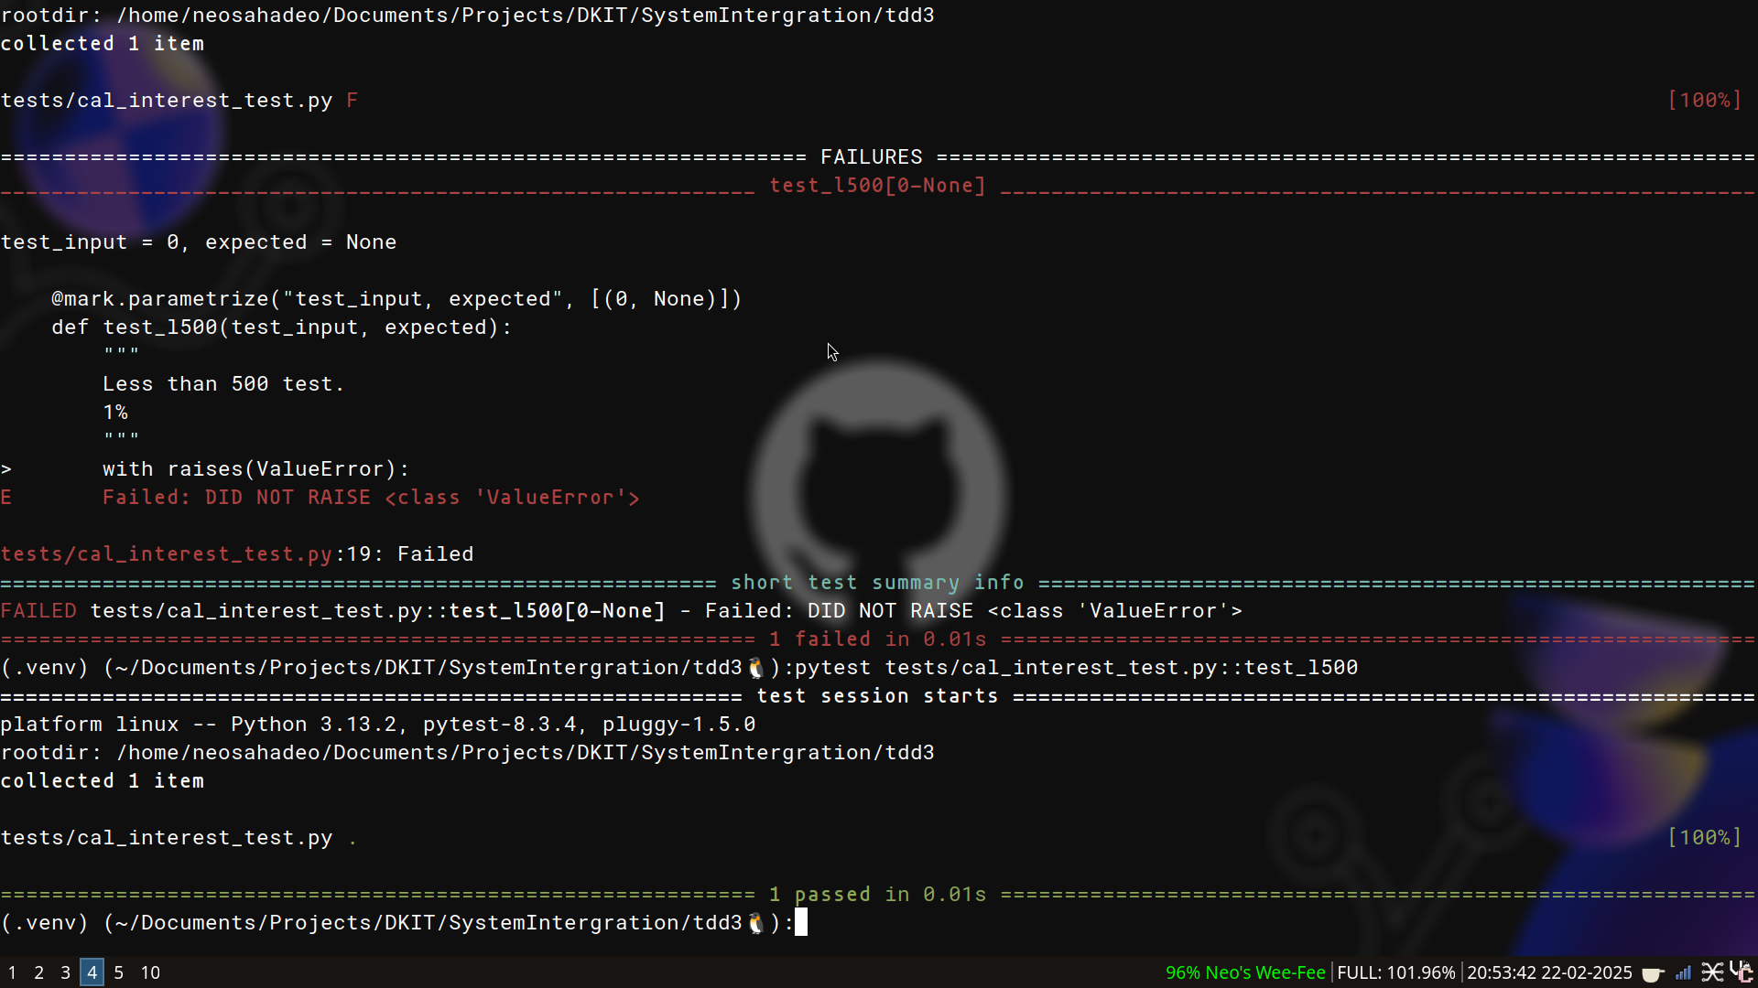

5. I wanted to add another assert and it would get messy with an exception method in the same function so I moved it to its own function.

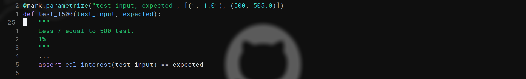
6. Now I check to see if the test failed; which it did
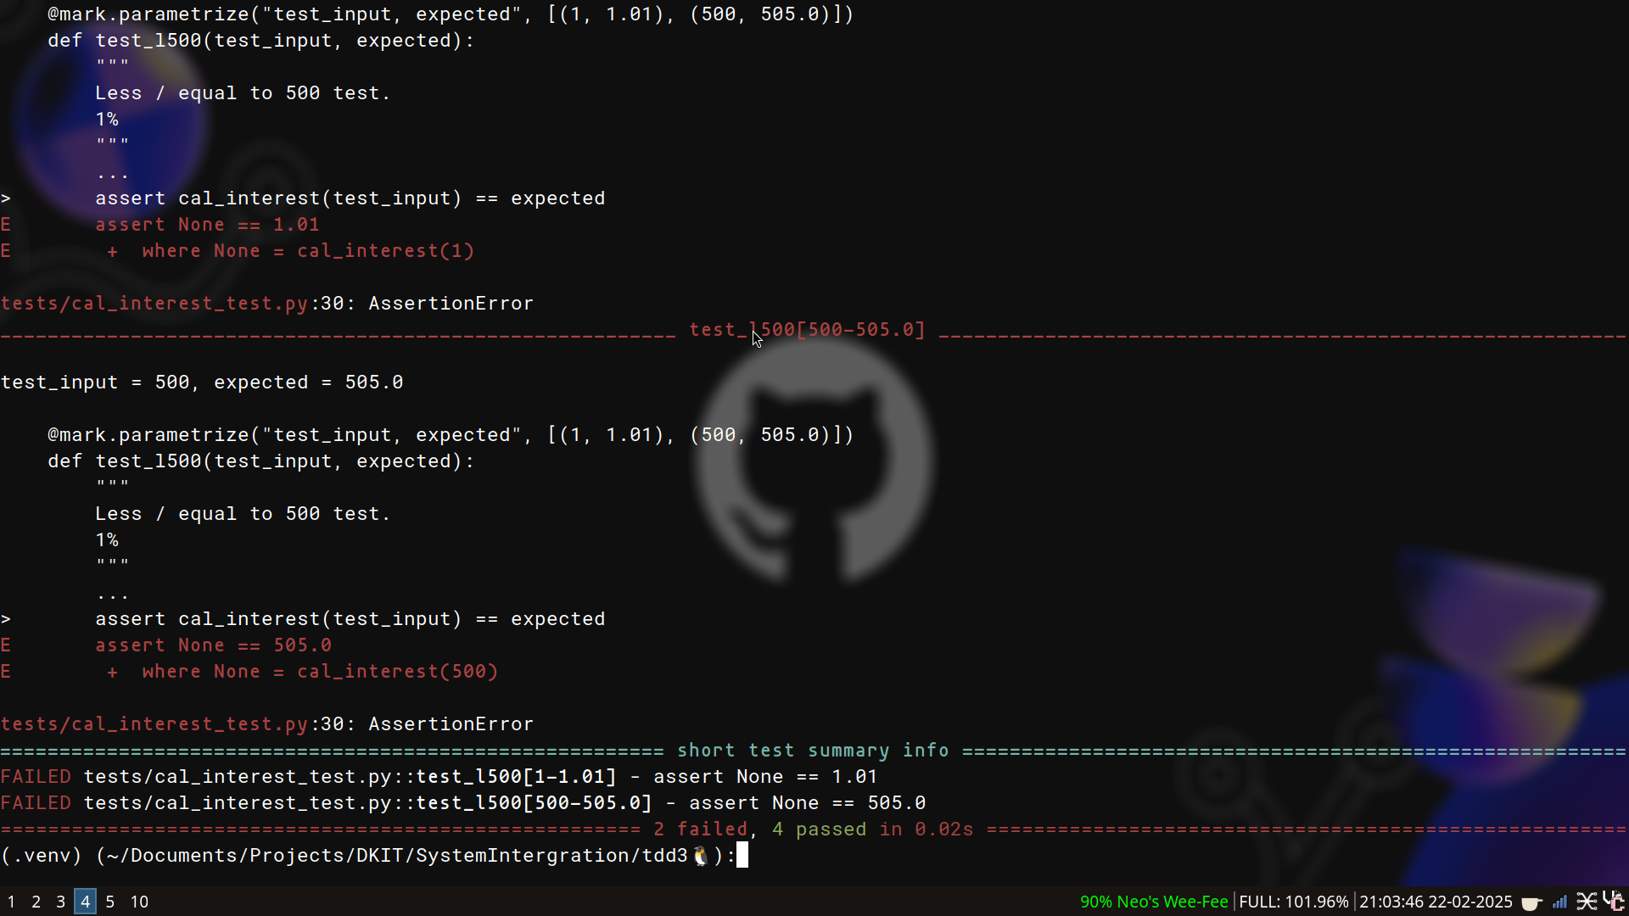

7. I then updated the code to fix it

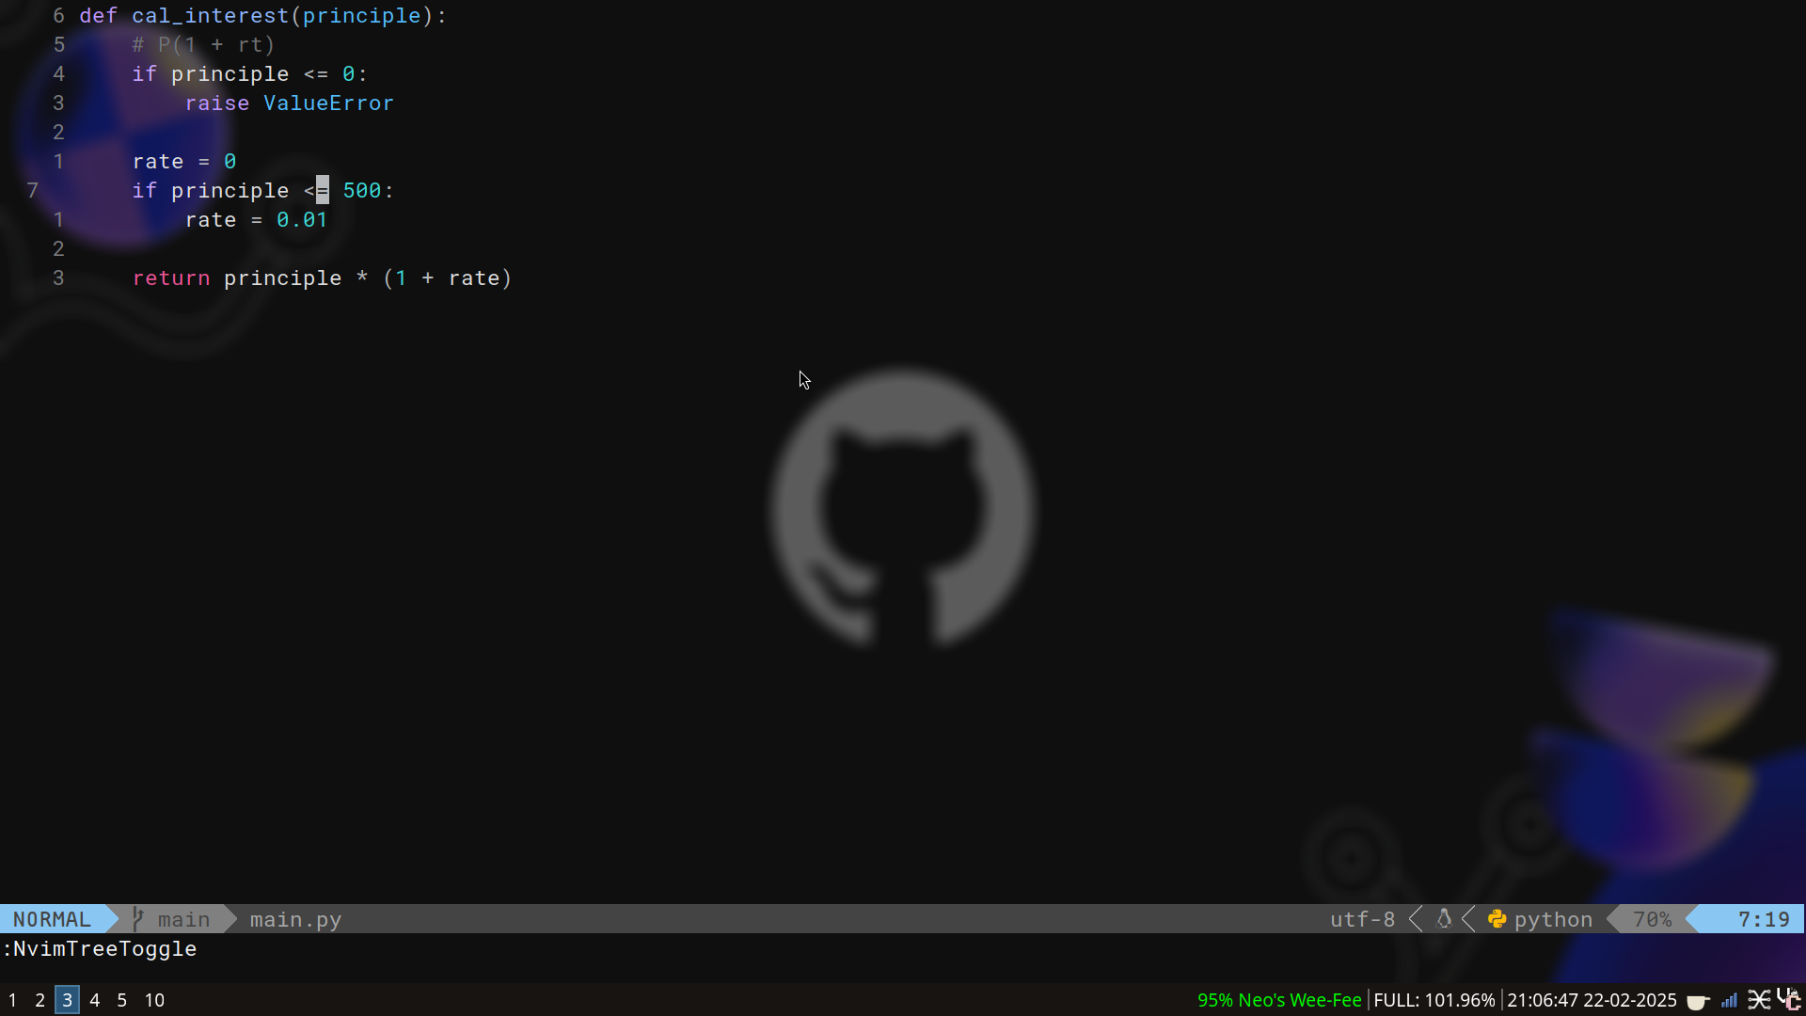
8. I then re-run my tests and see it passes

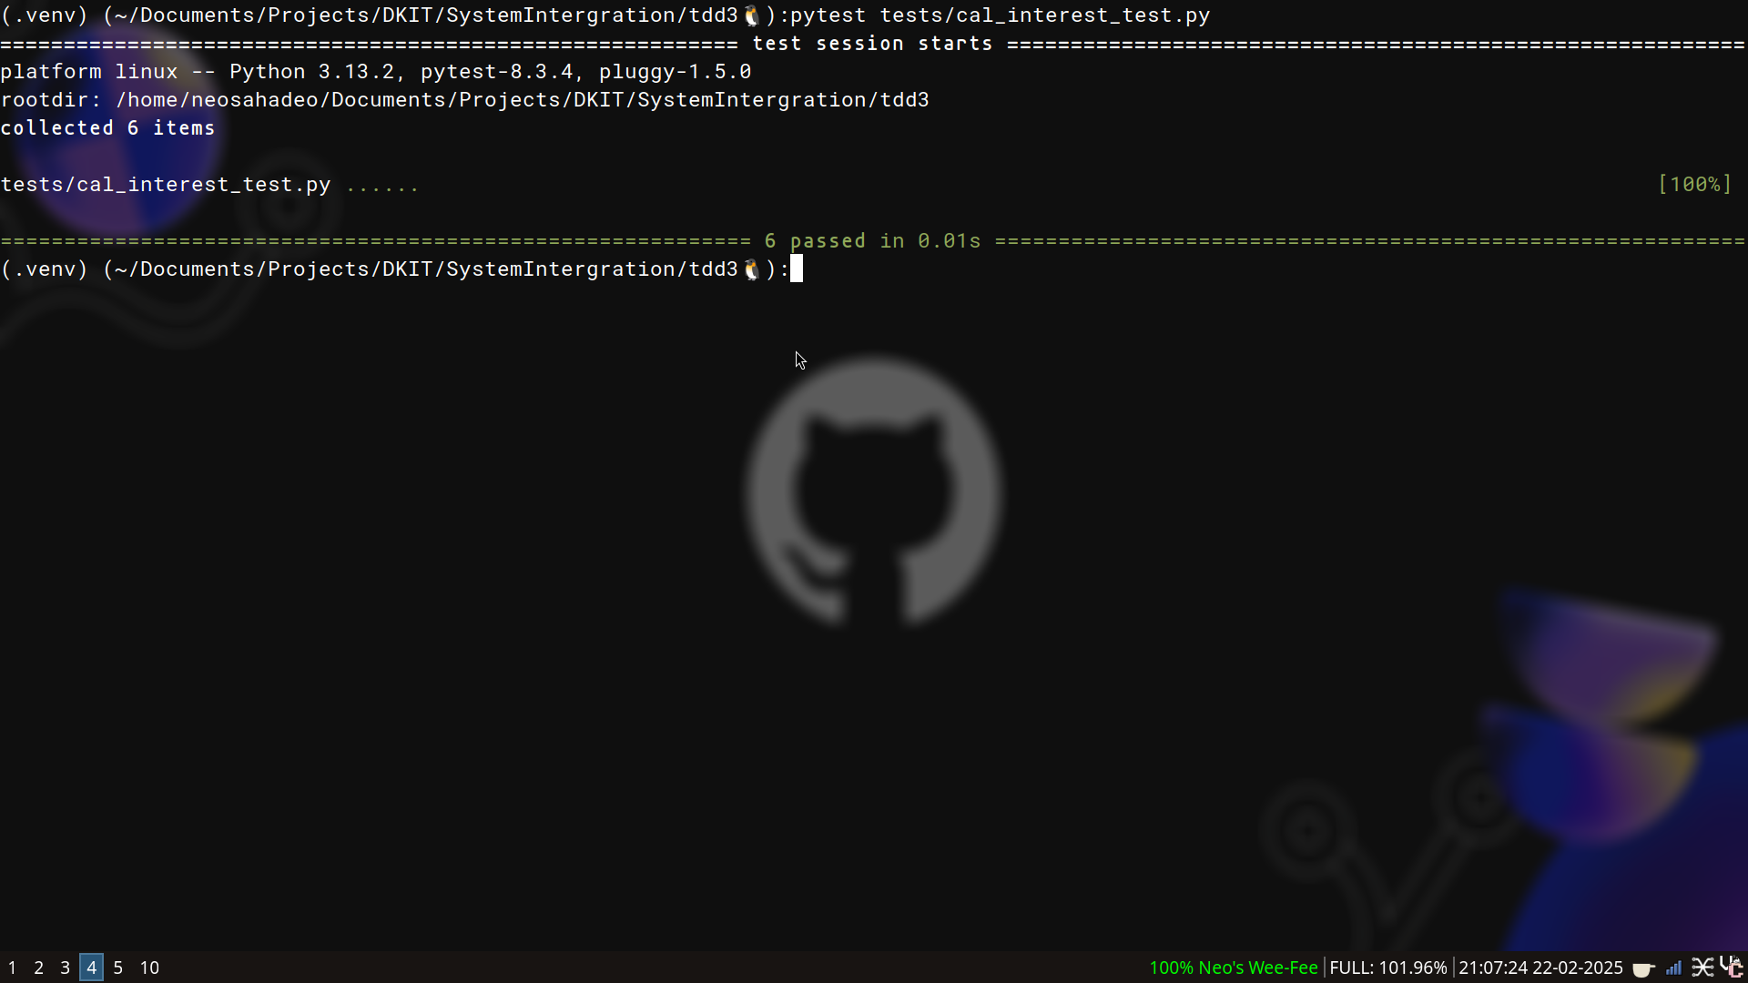

I now repeat this step for every test function.
The finally result looks like this

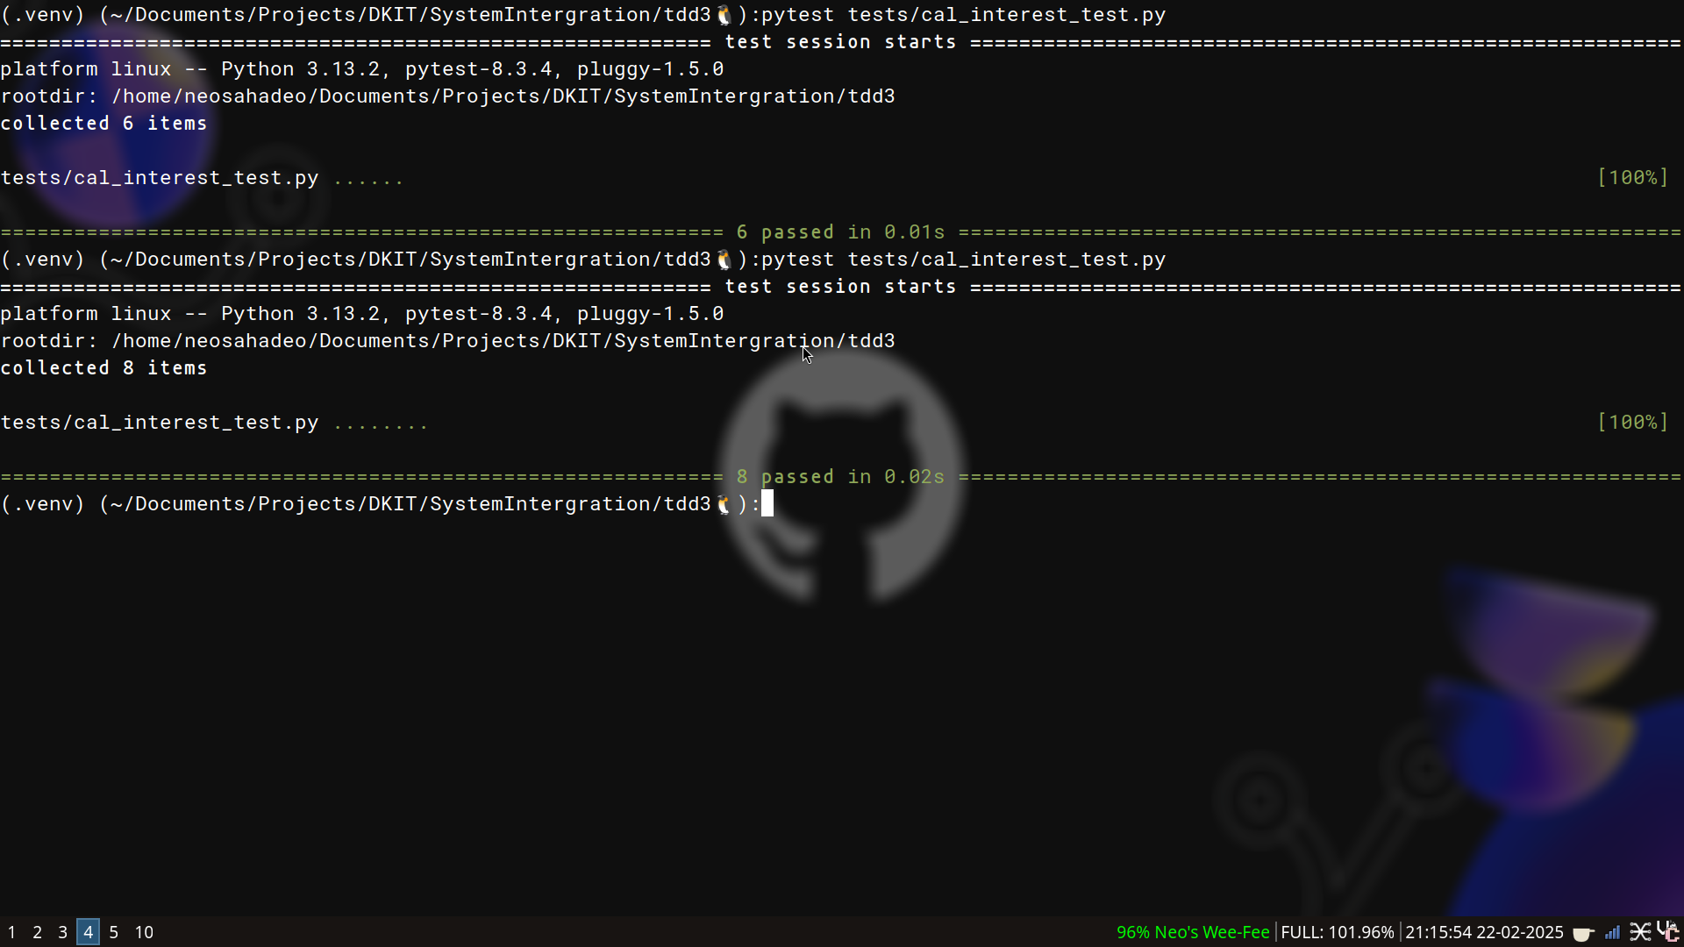

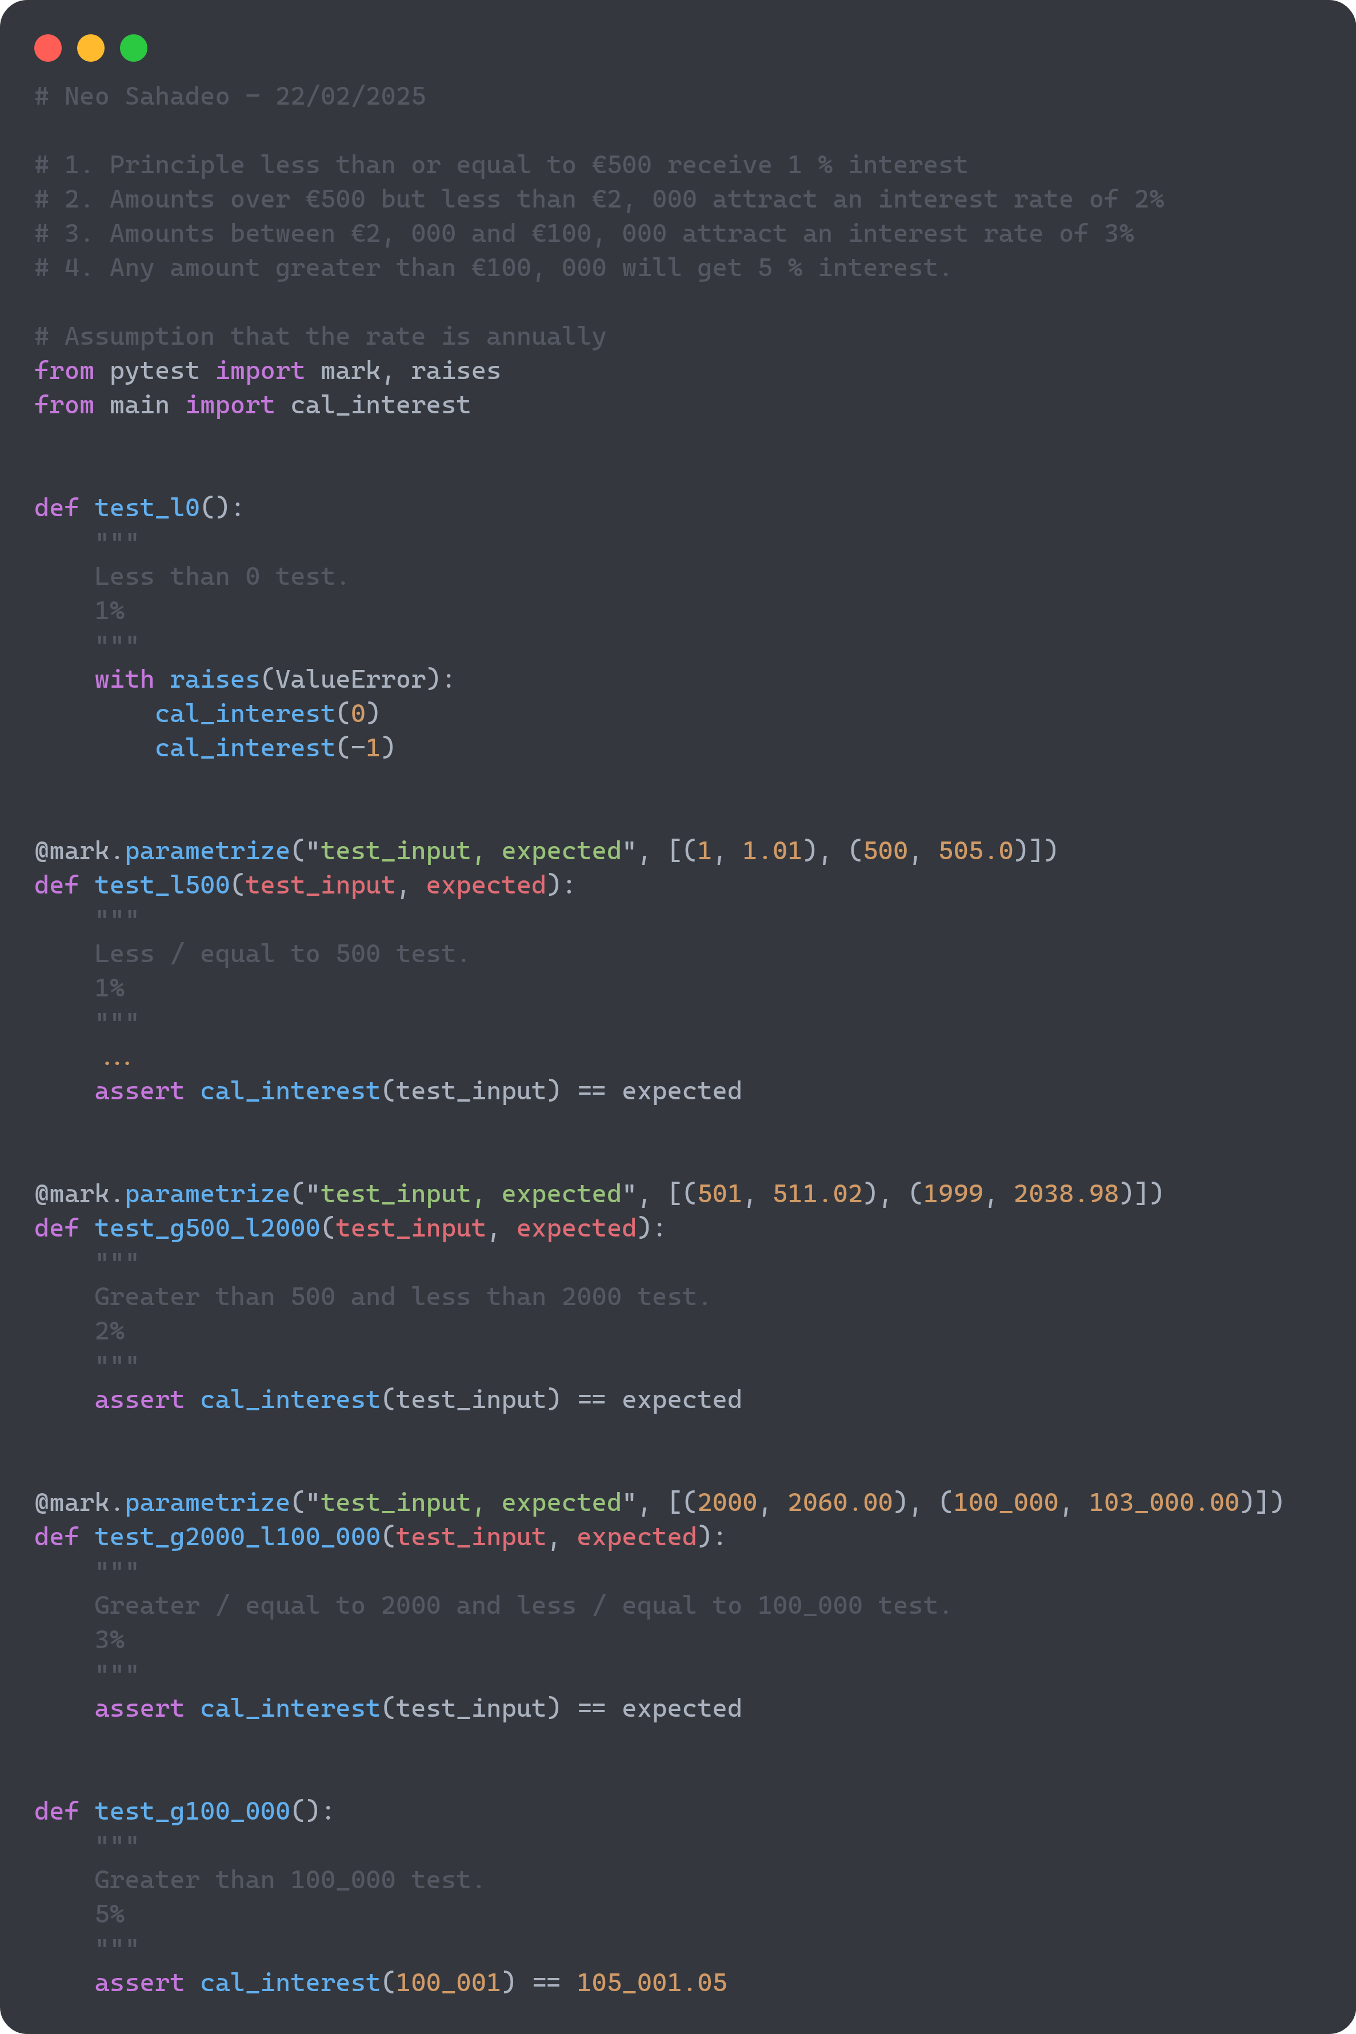
And the code (used codesnap because my screen in small) ->

