**Solution Description**

To run the solution, compile inside the program5 folder using the command:

g++ -std=c++11 *.cpp *.h -o out.o

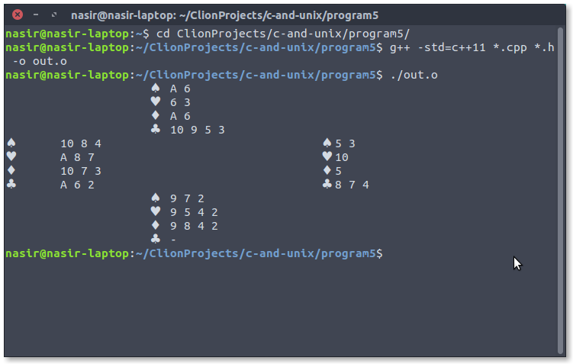

This screenshot demonstrates the project being compiled and the object file being opened.

**Course Learning Objectives (1-5):**

1. Ability to create classes of abstract data consisting of variables and functions

2. Ability to utilize C++ constructors, copy constructors, and destructors

3. Ability to utilize C++ OOP features using static member data and member functions

4. Ability to utilize C++ File and Stream Input/Output Processes

5. Ability to generate reusable code using inheritance.

This project used classes, constructors, static member data, and output processes, which demonstrates the first 4 Learning Outcomes. We created four classes (1st CLO), which contained non-default constructors for the classes (2nd CLO), need static 3rd CLO stuff and the hands were all printed which std::cout (4th CLO). The Spade, Heart, Diamond, and Club class are all derived classes inherited from the Suit base class (5th CLO).