# REPORT (B5)

## D1 – Periodic Table of Elements

The full periodic table provided is the result of numerous iterations (all of which can be found in E1) and as such the one chosen for the final product is representative of the highest degree of accuracy and clearly conveys the largest amount of information of all iterations. The information provided fits into the following categories: elemental numbers, electronic properties, chemical properties, physical properties, and other properties. These categories are explored in more detail below.

### Elemental Numbers

The elemental numbers chosen were the atomic number (), mass number (), and neutron number (). The atomic number of any given element can be obtained experimentally using Moseley’s law, which states that the characteristic x-ray lines emitted by elements are related to the atomic number as seen in the following relationship:

( 1 )

Where is the frequency of the observed x-ray emission line, and are constants: and , and is the atomic number. This relationship can thus be rearranged to find the atomic number, :

( 2 )

This relationship was first described by Henry Moseley in 1913 in the paper *The High-Frequency Spectra of the Elements*. The atomic numbers of the elements are now defined by the International Union of Pure and Applied Chemistry (IUPAC) and are equal to the proton number () of the ordinary nucleus of any given element. In any ordinary uncharged atom, the proton number will also be equal to the number of electrons.

The mass number of an ordinary atom can be obtained by finding the sum of both the atomic () and neutron numbers (), as described in the following equation:

( 3 )

The mass number is always expressed in unified atomic mass units (unit: or ) which can be converted to kilograms (unit: ) by multiplying by the atomic mass constant (). The atomic mass constant was defined by CODATA in 2018 as and is equal to one twelfth of the mass of an unbound neutral atom of carbon-12 in its nuclear and electronic ground state and at rest, as seen in the following equation:

( 4 )

Atomic mass numbers are defined by the Commission on Isotopic Abundances and Atomic Weights (CIAAW) and are rounded to the nearest whole unified atomic mass unit. In the case of elements where the atomic mass number falls closer to the midpoint of two whole number values (such as chlorine - ), the atomic mass number value has been provided rounded to half of a unified atomic mass unit ().

Finally, the neutron number () is the number of neutrons in any given nuclide. For an exact atom of an element according to the periodic table, equation 3 can be rearranged to find the neutron number as follows:

( 5 )

This can be inferred as the difference between the mass and atomic numbers of an element and, as such, is defined by CIAAW and IUPAC due to their affiliation with both elemental numbers. The neutron number is rarely useful outside of nuclear physics and another common property derived from elemental numbers within this field is the neutron excess () which is the difference between the neutron number and the atomic number as seen in the below equation:

( 6 )

A nuclide’s neutron excess is a good indicator of its nuclear stability as stable atoms tend to have more neutrons than protons with increasing atomic numbers and thus increasing neutron excesses. This relationship can be found in the below figure:

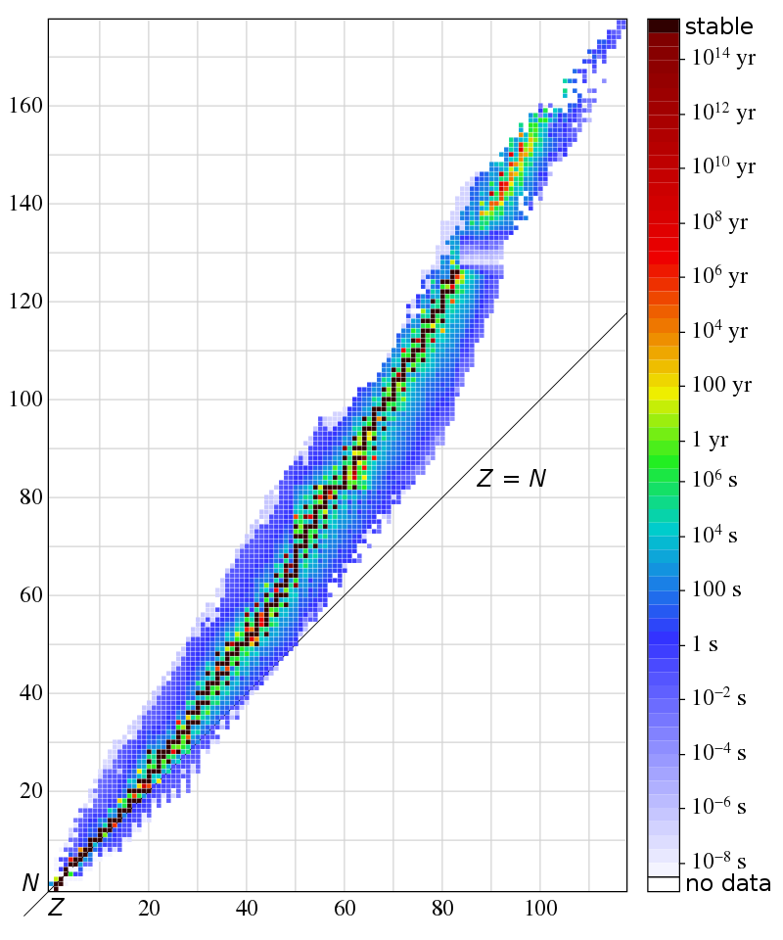

Figure 1: This diagram shows the half-life () of various nuclides related to their atomic number () and their neutron number (). The neutron excess can be calculated by finding the gradient of a tangent to a specific nuclide. Source: User: BenRG (wikimedia.org) – Public Domain.

### Electronic Properties

The chosen electronic properties were the ionic charge, and electronic configuration (represented by coloured blocks on the table). The ionic charge is the range of net electrical charges that an ion of a given element can hold in normal conditions, excluding radioactive decay and synthetic procedures. This net charge is caused by an excess of protons or electrons within an atom and is the result of chemical activities between atoms and, by extension, the loss or gain of electrons. An ion with a net negative charge (electron excess) is called an anion whilst one with a net positive charge (proton excess) is called a cation. An important distinction must be made between ionic charge and oxidation states as the oxidation state is the hypothetical charge of an atom if all of its chemical bonds were ionic – describing the degree of oxidation of an atom in a chemical compound. Oxidation is the process whereby atoms lose electrons and reduction is the opposing process of electron gain. The periodic table merely lists ionic charge and not oxidation states.

Charged states can be denoted with the addition of superscript characters to chemical symbols. The net charge is written as either positive (+) or negative (-) proceeded by the magnitude if higher than one. For example, the ionic state of iron(II) is represented as Fe2+, whilst fluorine can be represented as F-.

It is ionic charges that account for all chemical processes as opposing electric charges act attractively. Furthermore, the process described above whereby an atom gains a net positive or negative charge is known as ionisation.

Within the table, the electronic configuration of an element can be obtained by first identifying the location of the element, then finding which shells and subshells are filled. The electronic shells are colour-coded, with the s-block coloured lilac, the p-block in rose, the d-block coloured light blue, and the f-block in yellow. Finally, count the element’s poition within the final electronic subshell and use this as the final value in the electronic configuration. Each subshell configuration can be written as the shell number (principal quantum number, ) followed by the subshell letter and the number of electrons is then placed in superscript. For example, phosphorus is in the 3p-subshell with 15 electrons, giving it an electronic configuration of 1s2 2s2 2p6 3s2 3p3.

The electronic configuration of the elements are often abbreviated to place the previous noble gas in square brackets before the section of the configuration that is added to the noble gas. For example, phosphorus’ abbreviated electronic configuration (see above) is [Ne] 3s2 3p3 as neon and phosphorus share the 1s2 2s2 2p6 configuration section. The electronic subshell filling order according to Madelung’s rule can be found diagrammatically below:

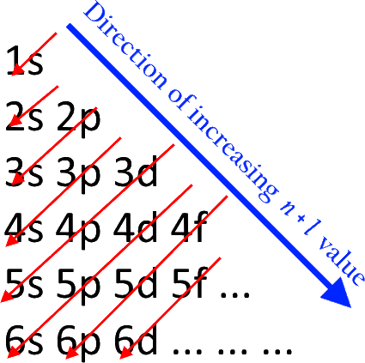

Figure 2: This diagram presents the electronic subshell filling order, first follow the blue arrow downwards, then the red ones. Source: User: Atchemey (wikimedia.org) – CC BY-SA 4.0.

Madelung’s rule states that subshells are filled in the order of increasing and where two subshells have the same value, an order of increasing is preferred. is the principle quantum number and is indicative of the electron shell number that a given electron resides within, values currently range from 1 to 7 and, for any element, the highest electron valency has an value equal to the element’s period in the periodic table. is the azimuthal quantum number and determines the orbital of any given electron, equated to a letter s, p, d or f – where s is assigned a value of 0 and f assigned a value of 3.

Each azimuthal quantum number equivalent letter can hold a set number of electrons, calculated by the below formula: