**Subject/Odd Sem 2023-23/Experiment 2**

|  |  |  |
| --- | --- | --- |
| **Name : Harsh Jain** | **Class/Roll No. :D11AD/25** | **Grade :** |

**Title of Experiment :Personal portfolio.**

**Objective of Experiment : To style and format the website, ensuring visual consistency, responsiveness, and user-friendliness. It aims to make the website visually appealing, easy to navigate, and optimized for various devices while maintaining a professional appearance.**

**Outcome of Experiment : The CSS defines the website's appearance, creating a visually appealing and responsive layout with consistent fonts, colors, and spacing. It ensures user-friendly navigation, engaging animations, and a professional presentation of Harsh's portfolio.**

**Problem Statement : Enhance your personal website that you made in Experiment 01 using CSS.**

**Description / Theory :**

Cascading Style Sheets (CSS) is a fundamental technology used in web development to control the presentation and styling of web pages. It plays a crucial role in separating the content (HTML) of a web page from its visual representation, which significantly enhances the flexibility and maintainability of websites. Here are key aspects of why and where CSS is used:

1. **Separation of Concerns:** One of the primary reasons for using CSS is to separate the structure (HTML) and presentation (CSS) of a web page. HTML defines the content and structure, while CSS defines how that content should be styled and displayed. This separation makes it easier to update and maintain websites because changes to styling can be made without altering the underlying content.
2. **Consistency:** CSS allows web developers to apply consistent styling across an entire website. Styles can be defined in a single CSS file and applied to multiple pages, ensuring a uniform look and feel throughout the site. This consistency is crucial for branding and user experience.
3. **Flexibility:** CSS provides a wide range of styling options, including colors, fonts, margins, padding, borders, and positioning. Developers can create intricate layouts and designs by manipulating these properties, giving them full control over the visual aspects of a webpage.
4. **Responsive Design:** CSS enables responsive web design, which means designing websites that adapt to different screen sizes and devices (e.g., desktops, tablets, smartphones). Media queries in CSS allow developers to apply different styles based on the screen's width, ensuring that content remains accessible and user-friendly on various devices.
5. **Accessibility:** CSS plays a crucial role in making websites accessible to all users, including those with disabilities. By using CSS to control the presentation, developers can create web pages that work well with screen readers and other assistive technologies.

**Subject/Odd Sem 2023-23/Experiment 2**

For example, CSS can be used to adjust font sizes, colors, and spacing to improve readability.

1. **Efficiency:** With CSS, you can apply the same style to multiple elements simultaneously. For instance, you can style all headings or links across a site with a single rule, reducing redundancy and making it easier to update styles globally.
2. **Maintenance:** CSS promotes easier maintenance and updates. When changes are needed, you can modify the CSS file(s) without altering the HTML structure. This separation simplifies the process of making design adjustments or fixing styling issues.
3. **Print and Screen Styles:** CSS can be used to define different styles for printing and screen display. This feature is helpful for creating printer-friendly versions of web pages, ensuring that printed content looks appropriate and legible.
4. **Animations and Transitions:** CSS supports animations and transitions, allowing developers to add interactive and engaging elements to web pages. This enhances the user experience and can be used for subtle visual effects.

**Program :**

|  |
| --- |
| * {  margin: 0; padding: 0;  } body { background-color: rgb(0, 0, 33); color: white; font-family: 'Poppins', sans-serif;  } nav {  display: flex; justify-content: space-around; align-items: center; height: 80px; background-color: rgb(4, 4, 32);  }  nav ul {  display: flex; justify-content: center; list-style: none;  } nav ul li { margin: 0 23px;  } nav ul li a { text-decoration: none; color: white;  } nav ul li a:hover { color: rgb(172, 172, 240); font-size: 1.04rem;  } main hr {  border: 0; |

background: rgb(172, 172, 240); height: 0.5px; margin: 40px 44px;

}

.left { font-size: 1.5rem;

}

.firstSection { padding: 12px; display: flex; justify-content: space-around; align-items: center; margin: 0px 0;

}

.firstSection > div { width: 35%;

}

.leftSection { font-size: 3rem; margin: 70px 0;

}

.leftSection .buttons { padding: 50px 0;

}

.leftSection .btn { padding: 12px; background-color: #1e2167; color: white; border: 2px solid white; border-radius: 6px; font-size: 20px;

}

.rightSection img { width: 80%; margin: 50px 0;

}

.purple {

color: rgb(170, 107, 228);

}

.text-gray { color: gray;

}

#element { color: rgb(170, 107, 228);

}

.secondSection { max-width: 80vw; margin: auto; height: 80vh;

}

.secondSection h1 { font-size: 1.9rem;

}

.secondSection .box { background: white; width: 70vw; height: 2px; margin: 56px 0; display: flex;

}

.secondSection .vertical { height: 140px; width: 1px; background-color: white; margin: 0 6vw;

}

.image-top { width: 50px; position: relative; top: -45px; left: -9px;

}

.vertical-title { position: relative; top: 75px; width: 150px;

}

.vertical-text { position: relative; top: 86px;

color: gray; width: 180px; font-size: 10px;

}

.footer { background-color: #0e0e1a; height: 150px; display: flex; padding: 23px 122px; justify-content: space-evenly;

}

.footer ul { list-style: none;

}

.footer > div { width: 223px;

}

.footer-rights { text-align: center; background-color: #0e0e1a; color: gray; padding: 12px 0;

}

@media screen and (max-width: 1500px) {

.box { flex-direction: column;

}

.secondSection.vertical { height: unset; }

.vertical-title, .vertical-text { top: 0px; left: 45px; }

.secondSection .box { width: 50vw; } nav {

flex-direction: column;

}

.secondSection{

**Subject/Odd Sem 2023-23/Experiment 2**

|  |
| --- |
| height: 160vh;  }  .footer { display: none;  }  .firstSection { flex-direction: column-reverse;  }  .leftSection { width: 100% !important; display: flex;  flex-direction: column; justify-content: center; align-items: center;  }  .rightSection { width: 721px !important; display: flex;  justify-content: center;  }  .rightSection img { width: 45vw; margin-bottom: 73px;  } body {  min-width: fit-content;  }  .image-top{ top: 50px;  }  } |

**Subject/Odd Sem 2023-23/Experiment 2**

**Results and Discussions :**

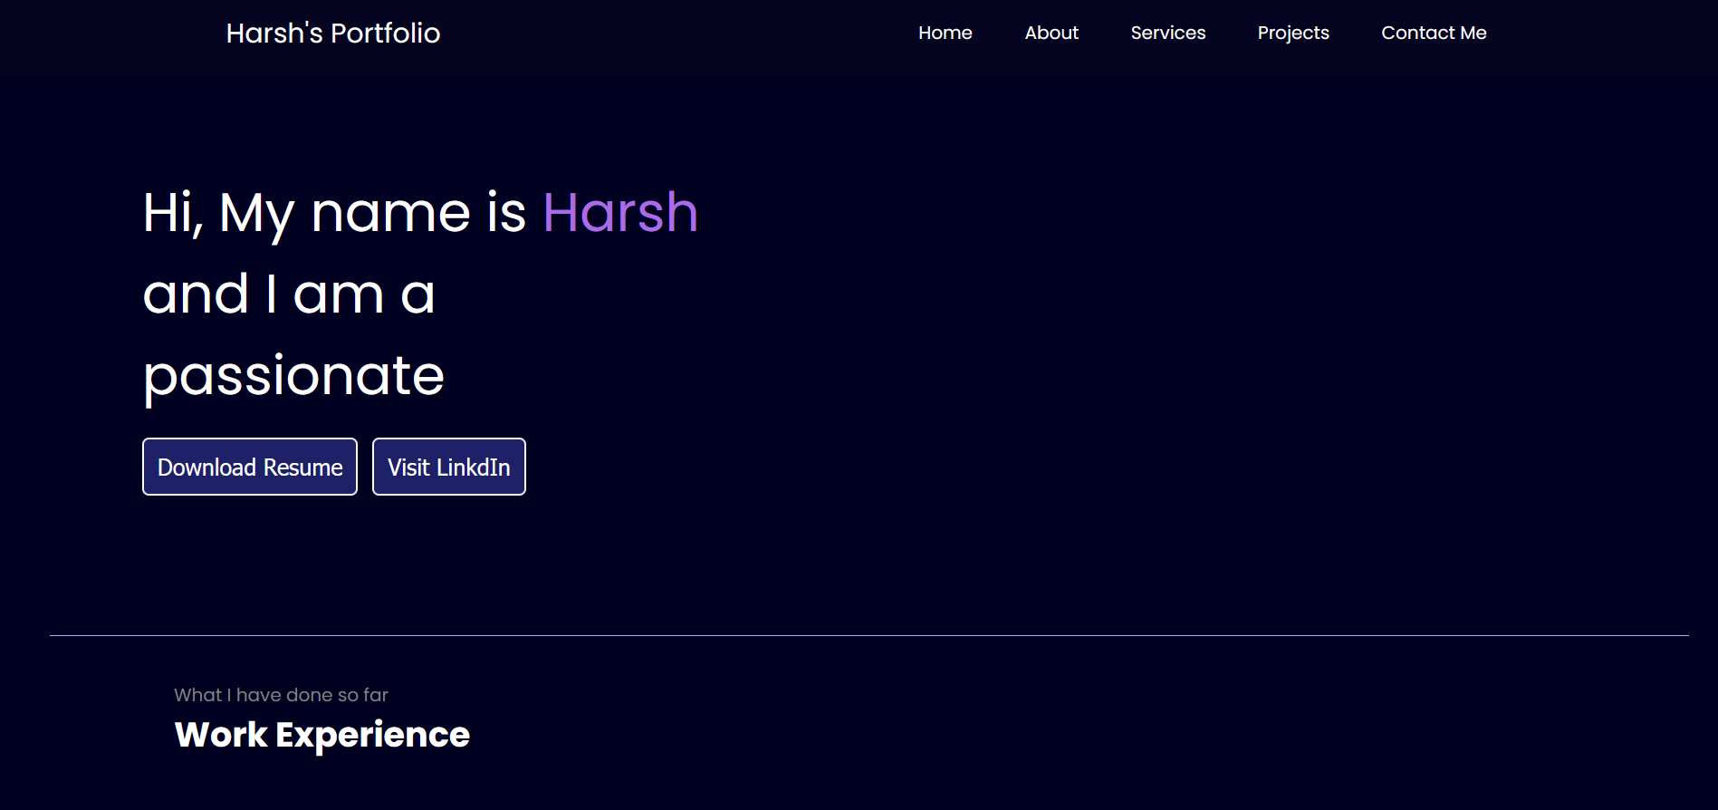

**Subject/Odd Sem 2023-23/Experiment 2**

