**Subject/Odd Sem 2023-23/Experiment 1**

|  |  |  |
| --- | --- | --- |
| **Name : Harsh Jain** | **Class/Roll No. :D11AD/25** | **Grade :** |

**Title of Experiment :Personal Portfolio.**

**Objective of Experiment : Create a personal portfolio website to showcase her skills and work experience.**

**Outcome of Experiment : The HTML code provided represents a structured web page for a personal portfolio. It includes sections for navigation, introduction, work experience, and a footer. The HTML code forms the backbone of the webpage, organizing the content and providing the structure for the visual and interactive elements to be displayed to visitors.**

**Problem Statement : Develop a personal website for yourself using HTML.**

**Description / Theory :**

**1. Document Type Declaration:** `<!DOCTYPE html>`

- This declaration defines the document type and version, indicating that this is an HTML5 document.

**2. HTML Element:** `<html lang="en">`

- The `<html>` element represents the root of the HTML document. The `lang` attribute specifies the language of the document as English.

**3. Head Section:** `<head>`

* The `<head>` section contains meta-information about the document, such as character encoding, viewport settings, and links to external resources like stylesheets and fonts.
* `<meta charset="UTF-8">` specifies the character encoding as UTF-8.
* `<meta name="viewport" content="width=device-width, initial-scale=1.0">` sets the viewport for responsive design.
* `<title>Portfolio</title>` sets the title of the webpage.
* External resources like Google Fonts and a CSS stylesheet are linked using `<link>` elements.

**4. Body Section:** `<body>`

- The `<body>` element contains the main content of the webpage.

**5. Header Section:** `<header>`

* The `<header>` section represents the top of the webpage and typically contains navigation elements and a website title.
* Navigation links are organized within a `<nav>` element.
* The website title "Harsh's Portfolio" is enclosed within `<div>` elements.

**6. Main Content Section:** `<main>`

- The `<main>` element contains the primary content of the webpage.

**7. Introduction Section:** `<section class="firstSection">`

* This `<section>` contains an introduction to Harsh, including her name and a dynamic typing animation created using JavaScript (Typed.js).
* Buttons for downloading her resume and visiting her LinkedIn profile are included.

**8. Image and Text Section:** `<section class="secondSection">` - This `<section>` provides information about Harsh's work experience.

- Work experiences are organized within individual `<div>` elements, each containing an image, job title, and description.

**9. Footer Section:** `<footer>`

* The `<footer>` section typically contains information about the website, contact details, and copyright information.
* The footer is divided into columns using `<div>` elements.
* Links to different sections of the website are provided.
* A copyright notice is included at the bottom.

**10.JavaScript Inclusion:** `<script>`

* JavaScript libraries, like Typed.js, are included using `<script>` tags.

**Program :**

|  |
| --- |
| <!DOCTYPE html>  <html lang="en">  <head>  <meta charset="UTF-8">  <meta name="viewport" content="width=device-width, initial-scale=1.0">  <title>Portfolio</title>  <link rel="preconnect" href="https://fonts.googleapis.com">  <link rel="preconnect" href="https://fonts.gstatic.com" crossorigin>  <link href="https://fonts.googleapis.com/css2?family=Poppins:wght@400;600;700&display=swap" rel="stylesheet">  <link rel="stylesheet" type="text/css" href="style1.css">  </head>  <body>  <header>  <nav>  <div class="left">Harsh's Portfolio</div>  <div class="right">  <ul>  <li><a href="/">Home</a></li>  <li><a href="/">About</a></li>  <li><a href="/">Services</a></li>  <li><a href="/">Projects</a></li>  <li><a href="/">Contact Me</a></li> </ul>  </div>  </nav>  </header> |

|  |
| --- |
| <main>  <section class="firstSection">  <div class="leftSection">  <div> Hi, My name is <span class="purple">Harsh</span></div>  <div>and I am a passionate</div>  <span id="element"></span>  <div class="button">  <button class="btn">Download Resume</button>  <button class="btn">Visit LinkdIn</button> </div>  </div>  <div class="rightSection">  <img src="asset/bg.png" alt="">  </div>  </section>  <hr>  <section class="secondSection">  <span class="text-gray">What I have done so far</span>  <h1>Work Experience</h1>  <div class="box">  <div class="vertical">  <img class="image-top" src="asset/developer.png" alt="">  <div class="vertical-title">HTML Developer</div>  <div class="vertical-text">  Lorem, ipsum dolor sit amet consectetur adipisicing elit. Rerum at laboriosam  voluptas porro ducimus harum ullam nostrum? Deserunt assumenda impedit quidem beatae voluptatibus sit possimus quaerat placeat, fuga, dicta perspiciatis. </div>  </div>  <div class="vertical">  <img class="image-top" src="asset/node.png" alt="">  <div class="vertical-title">Node.js Developer</div>  <div class="vertical-text">  Lorem, ipsum dolor sit amet consectetur adipisicing elit. Rerum at laboriosam  voluptas porro ducimus harum ullam nostrum? Deserunt assumenda impedit quidem beatae voluptatibus sit possimus quaerat placeat, fuga, dicta perspiciatis. </div>  </div><div class="vertical">  <img class="image-top" src="asset/da.png" alt="">  <div class="vertical-title">Data Analyst</div>  <div class="vertical-text">  Lorem, ipsum dolor sit amet consectetur adipisicing elit. Rerum at laboriosam  voluptas porro ducimus harum ullam nostrum? Deserunt assumenda impedit quidem beatae voluptatibus sit possimus quaerat placeat, fuga, dicta perspiciatis. |

|  |
| --- |
| </div>  </div><div class="vertical">  <img class="image-top" src="asset/gd.png" alt="">  <div class="vertical-title">Graphic Designer</div>  <div class="vertical-text">  Lorem, ipsum dolor sit amet consectetur adipisicing elit. Rerum at laboriosam  voluptas porro ducimus harum ullam nostrum? Deserunt assumenda impedit quidem beatae voluptatibus sit possimus quaerat placeat, fuga, dicta perspiciatis. </div>  </div><div class="vertical">  <img class="image-top" src="asset/vd.png" alt="">  <div class="vertical-title">Video Editor</div>  <div class="vertical-text">  Lorem, ipsum dolor sit amet consectetur adipisicing elit. Rerum at laboriosam  voluptas porro ducimus harum ullam nostrum? Deserunt assumenda impedit quidem beatae voluptatibus sit possimus quaerat placeat, fuga, dicta perspiciatis. </div>  </div><div class="vertical">  <img class="image-top" src="asset/wd.png" alt="">  <div class="vertical-title">Web Designer</div>  <div class="vertical-text">  Lorem, ipsum dolor sit amet consectetur adipisicing elit. Rerum at laboriosam  voluptas porro ducimus harum ullam nostrum? Deserunt assumenda impedit quidem bea  </div>  </div>  </div>  </section>  </main>  <footer>  <div class="footer">  <div class="footer-first">  <h3>Harsh's Developer</h3>  </div>  <div class="footer-second">  <ul>  <li>Home</li>  <li>About</li>  <li>Services</li>  <li>Contact</li>  </ul>  </div>  <div class="footer-third">  <ul>  <li>Home</li> |

|  |
| --- |
| <li>About</li>  <li>Services</li>  <li>Contact</li>  </ul>  </div>  <div class="footer-fourth">  <ul>  <li>Home</li>  <li>About</li>  <li>Services</li>  <li>Contact</li>  </ul>  </div>  </div>  <div class="footer-rights">  Copyright &#169; Harshsportfolio.com | All rights reserved </div>  </footer>  <script src="https://unpkg.com/typed.js@2.0.16/dist/typed.umd.js" defer></script>  <script>  var typed = new Typed('#element', {  strings:['Web Developer', 'Data Analyst', 'Graphic Designer.'],  typeSpeed: 50,  });  </script>  </body>  </html>  <!DOCTYPE html>  <html lang="en"> <head>  <meta charset="UTF-8">  <meta name="viewport" content="width=device-width, initial-scale=1.0"> <title>Contact Me - Harsh's Portfolio</title>  <link rel="preconnect" href="https://fonts.googleapis.com">  <link rel="preconnect" href="https://fonts.gstatic.com" crossorigin> |

|  |
| --- |
| <link href="https://fonts.googleapis.com/css2?family=Poppins:wght@400;600;700&display=swap" rel="stylesheet">  <link rel="stylesheet" type="text/css" href="style1.css">  <style>  /* Navigation styles (copied from your provided CSS) */ nav {  display: flex;  justify-content: space-around; align-items: center;  height: 80px;  background-color: rgb(4, 4, 32);  }  nav ul {  display: flex;  justify-content: center; list-style: none;  }  nav ul li { margin: 0 23px;  }  nav ul li a { text-decoration: none;  color: white;  }  nav ul li a:hover { color: rgb(172, 172, 240); font-size: 1.04rem; |

|  |
| --- |
| }  /* Contact form styles */  .contactSection { text-align: center;  padding: 20px;  }  .contactSection h1 { font-size: 2rem;  margin-bottom: 20px;  }  .contactSection form { max-width: 400px; margin: 0 auto; text-align: left;  }  .contactSection label { display: block;  margin-bottom: 5px; font-weight: bold;  }  .contactSection input[type="text"],  .contactSection input[type="email"],  .contactSection textarea { width: 100%; padding: 10px;  margin-bottom: 15px; |

|  |
| --- |
| border: 1px solid #ccc;  border-radius: 5px;  }  /* Center the button */  .contactSection button { display: block; margin: 0 auto;  background-color: rgb(4, 4, 32);  color: white;  padding: 10px 20px; border: none; border-radius: 5px;  cursor: pointer;  }  </style>  </head> <body>  <nav>  <div class="left">Harsh's Portfolio</div>  <div class="right"> <ul>  <li><a href="/">Home</a></li>  <li><a href="/">About</a></li>  <li><a href="/">Services</a></li>  <li><a href="/">Projects</a></li>  <li><a href="/">Contact Me</a></li> </ul>  </div>  </nav> |

**Subject/Odd Sem 2023-23/Experiment 1**

|  |
| --- |
| <main>  <section class="contactSection">  <!-- Contact form and content go here -->  <h1>Contact Me</h1>  <form action="submit_form.php" method="POST">  <label for="name">Name:</label>  <input type="text" id="name" name="name" placeholder="Your Name" required>  <label for="email">Email:</label>  <input type="email" id="email" name="email" placeholder="Your Email" required>  <label for="message">Message:</label>  <textarea id="message" name="message" rows="4" placeholder="Your Message"  required></textarea>  <!-- Center the button -->  <button type="submit">Send Message</button> </form>  </section>  </main>  </body>  </html> |

**Subject/Odd Sem 2023-23/Experiment 1 Results and Discussions :**

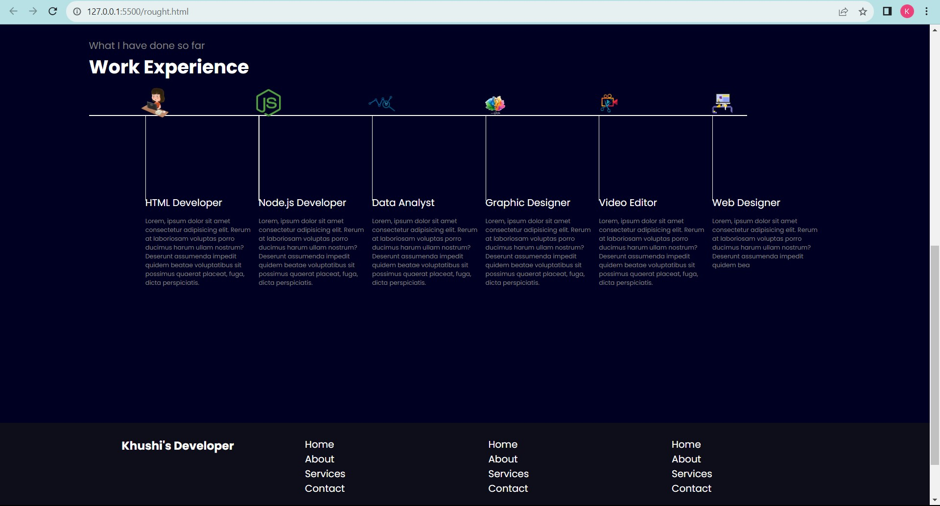

**Subject/Odd Sem 2023-23/Experiment 1**

