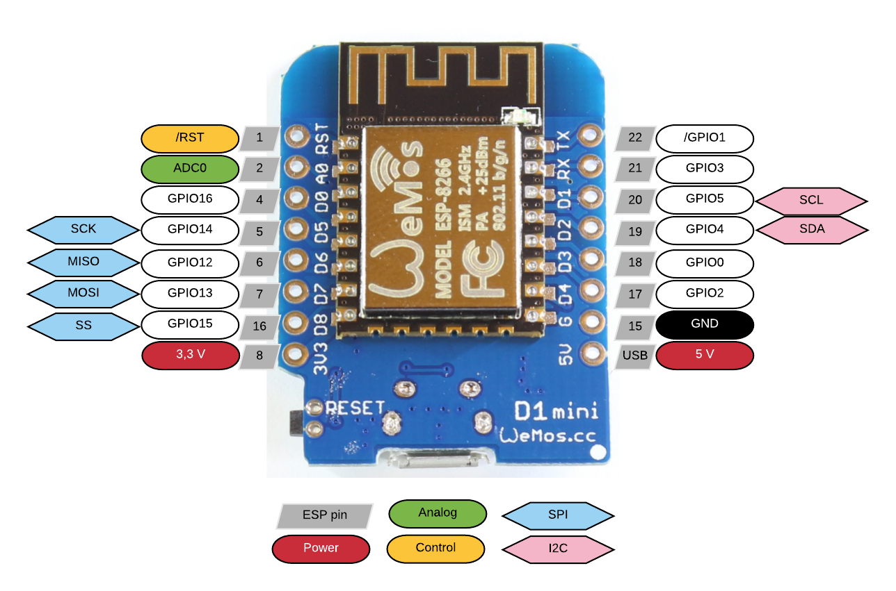

Mod 1023=

- BME280 : temperature, humidity and absolute air pressure sensor

- IAQ : VOCs and C02 measurements

I2C requires the use of pull-up resistors. The board comes with the pull-up resistors enabled. If you are connecting to an existing I2C buss that already has pull-up resistors, or you are using internal pull-ups in your microcontroller, you can disable the pull-up resistors by unsoldering the 10k resistors from theMOD-1023board and making sure the pads are not connected with any residual solder. Having extra pull-ups won’t hurt anything, other than a very marginal increase in power consumption.

The AMS-IAQ takes 5 minutes to settle until first reading is available, duringwhich time it will show an ERROR reading from thestatus register

TEST:

MARCHE PAS :

MOD1023 Humidity 100pourcent sur capteur 1 et capt2 avec temperature en 2eme ?

MARCHE :

Temperature et Pression marche capt1/2 2/1

Pression et pression marche

Temp et temp marche

Temperature et CO2 marche cap1/2 et 2/1

VOC et CO2 capt1/2 2/1

….ect