

技职教育系

**Department of Vocational Education**

**Exercise 1**

|  |  |
| --- | --- |
| 科目 Subject | Mobile Application Development – iOS |
| 科目编号 Subject Code | SEIOT026 |
| 中文姓名 Chinese Name | 李贯昊 |
| 英文姓名 English Name | Lee Guan Hao |
| 学号 Student ID | 2330247-SEIOT-DB |
| 分数 Marks |  |

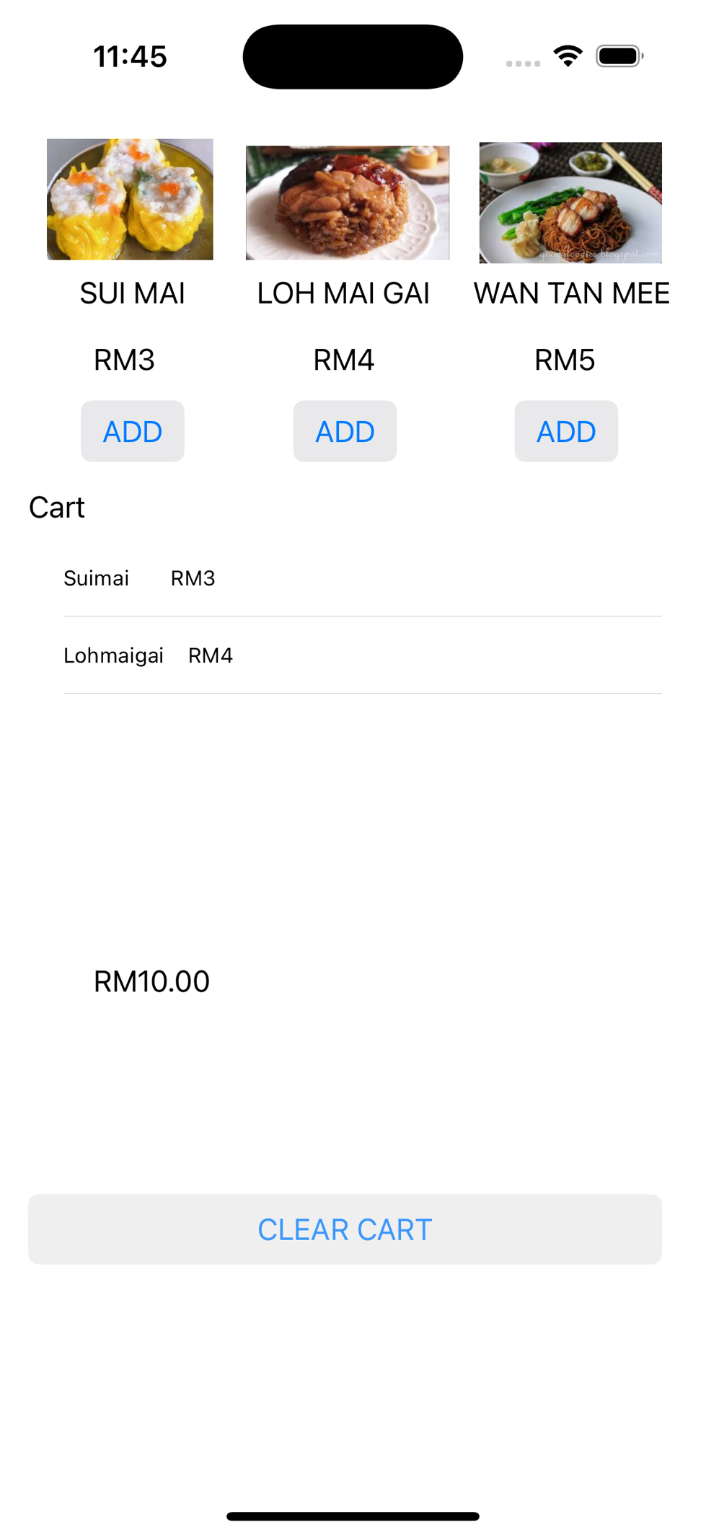

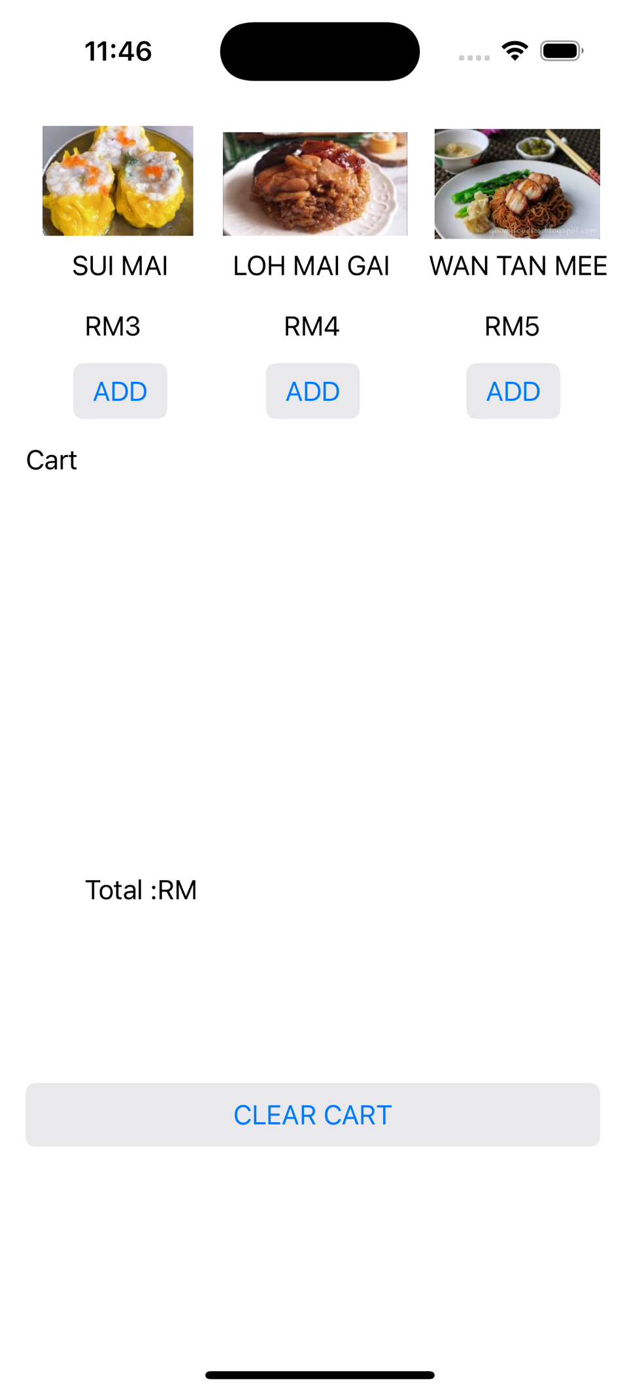

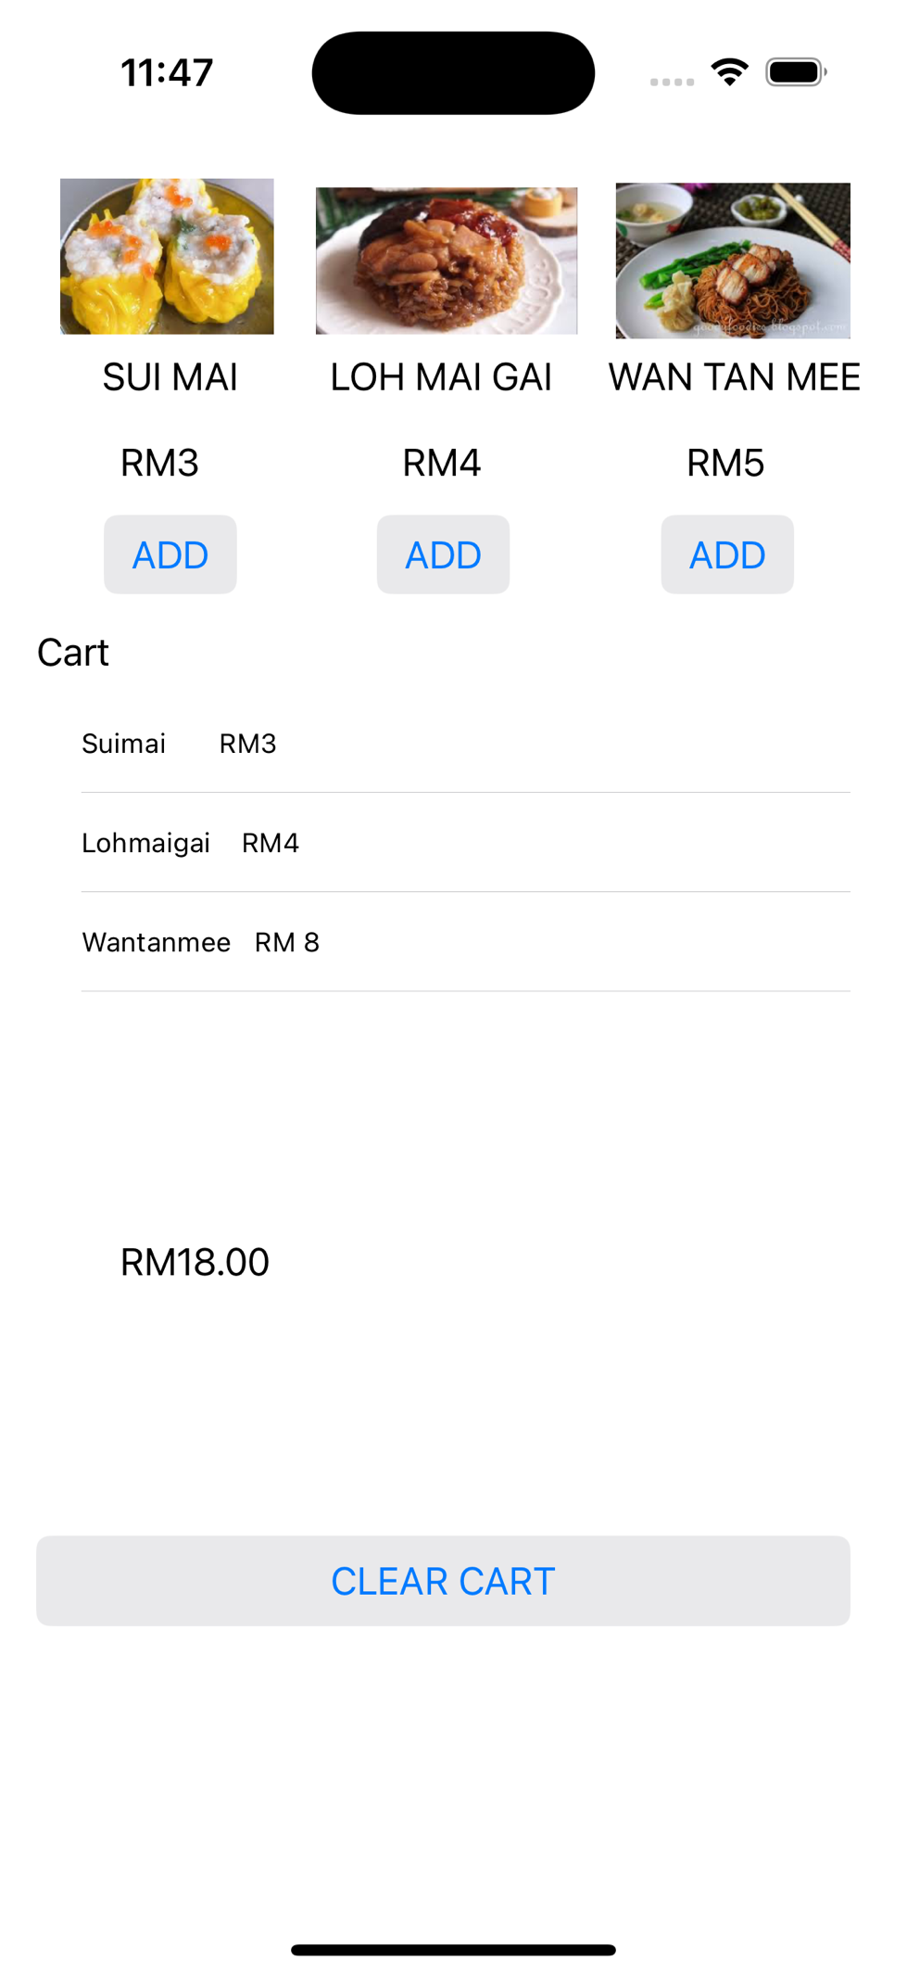

**import** UIKit

**class** ViewController: UIViewController, UITableViewDataSource, UITableViewDelegate {

**@IBOutlet** **weak** **var** TotalPrice: UILabel!

**@IBOutlet** **weak** **var** button_suimai: UIButton!

**@IBOutlet** **weak** **var** button_wantanmee: UIButton!

**@IBOutlet** **weak** **var** CartTableView: UITableView!

**@IBOutlet** **weak** **var** button_lohmaigai: UIButton!

// Model to store cart items

**var** cartItems: [(name: String, price: Double)] = []

**override** **func** viewDidLoad() {

**super**.viewDidLoad()

CartTableView.dataSource = **self**

CartTableView.delegate = **self** // Ensure delegate is set

CartTableView.reloadData() // Reload in case there are items when the view loads

}

// Clear all items from the cart

**@IBAction** **func** clearCartTapped(_ sender: **Any**) {

cartItems.removeAll()

CartTableView.reloadData()

TotalPrice.text = "RM0.00"

}

**@IBAction** **func** suimai_select(_ sender: **Any**) {

**let** name = "Suimai RM3"

**let** price = 6.00 // Example price for Suimai

cartItems.append((name, price))

CartTableView.reloadData()

updateTotalPrice()

}

**@IBAction** **func** lohmaigai_select(_ sender: **Any**) {

**let** name = "Lohmaigai RM4"

**let** price = 4.00 // Example price for Lohmaigai

cartItems.append((name, price))

CartTableView.reloadData()

updateTotalPrice()

}

**@IBAction** **func** wantanmee_select(_ sender: **Any**) {

**let** name = "Wantanmee RM 8"

**let** price = 8.00 // Example price for Wantanmee

cartItems.append((name, price))

CartTableView.reloadData()

updateTotalPrice()

}

// TableView DataSource Methods

**func** tableView(_ tableView: UITableView, numberOfRowsInSection section: Int) -> Int {

**return** cartItems.count

}

**func** tableView(_ tableView: UITableView, cellForRowAt indexPath: IndexPath) -> UITableViewCell {

**let** cell = tableView.dequeueReusableCell(withIdentifier: "Cell", for: indexPath)

// Get the item for this row

**let** item = cartItems[indexPath.row]

// Set the cell's labels to display the item's name and price

cell.textLabel?.text = item.name

cell.detailTextLabel?.text = "$\(item.price)"

**return** cell

}

// Update the total price of items in the cart

**func** updateTotalPrice() {

**let** total = cartItems.reduce(0) { $0 + $1.price }

TotalPrice.text = "RM\(String(format: "%.2f", total))"

}

}