

技职教育系

**Department of Vocational Education**

**Exercise 1**

|  |  |
| --- | --- |
| 科目 Subject | Mobile Application Development – iOS |
| 科目编号 Subject Code | SEIOT026 |
| 中文姓名 Chinese Name | 李贯昊 |
| 英文姓名 English Name | Lee Guan Hao |
| 学号 Student ID | 2330247-SEIOT-DB |
| 分数 Marks |  |

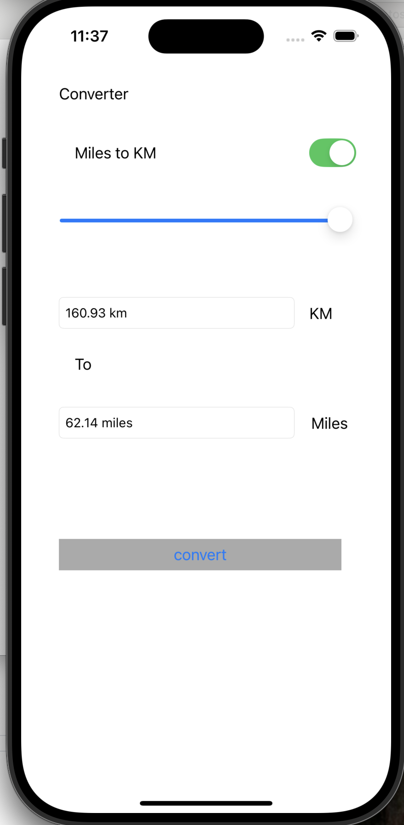

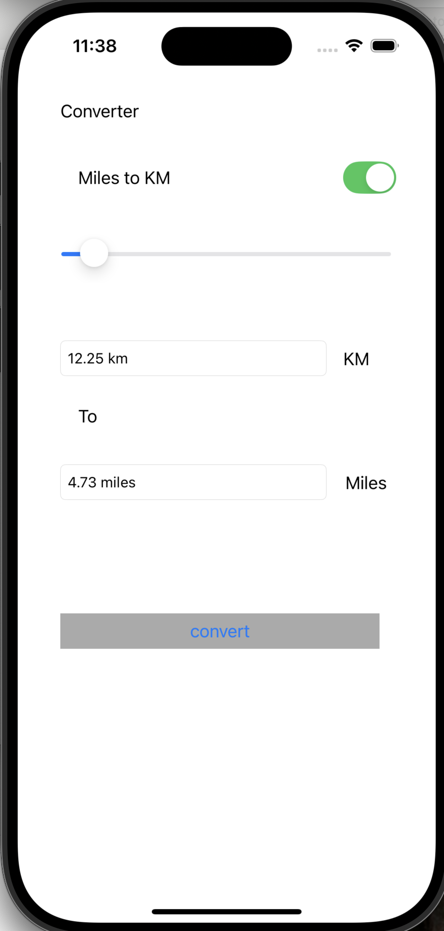

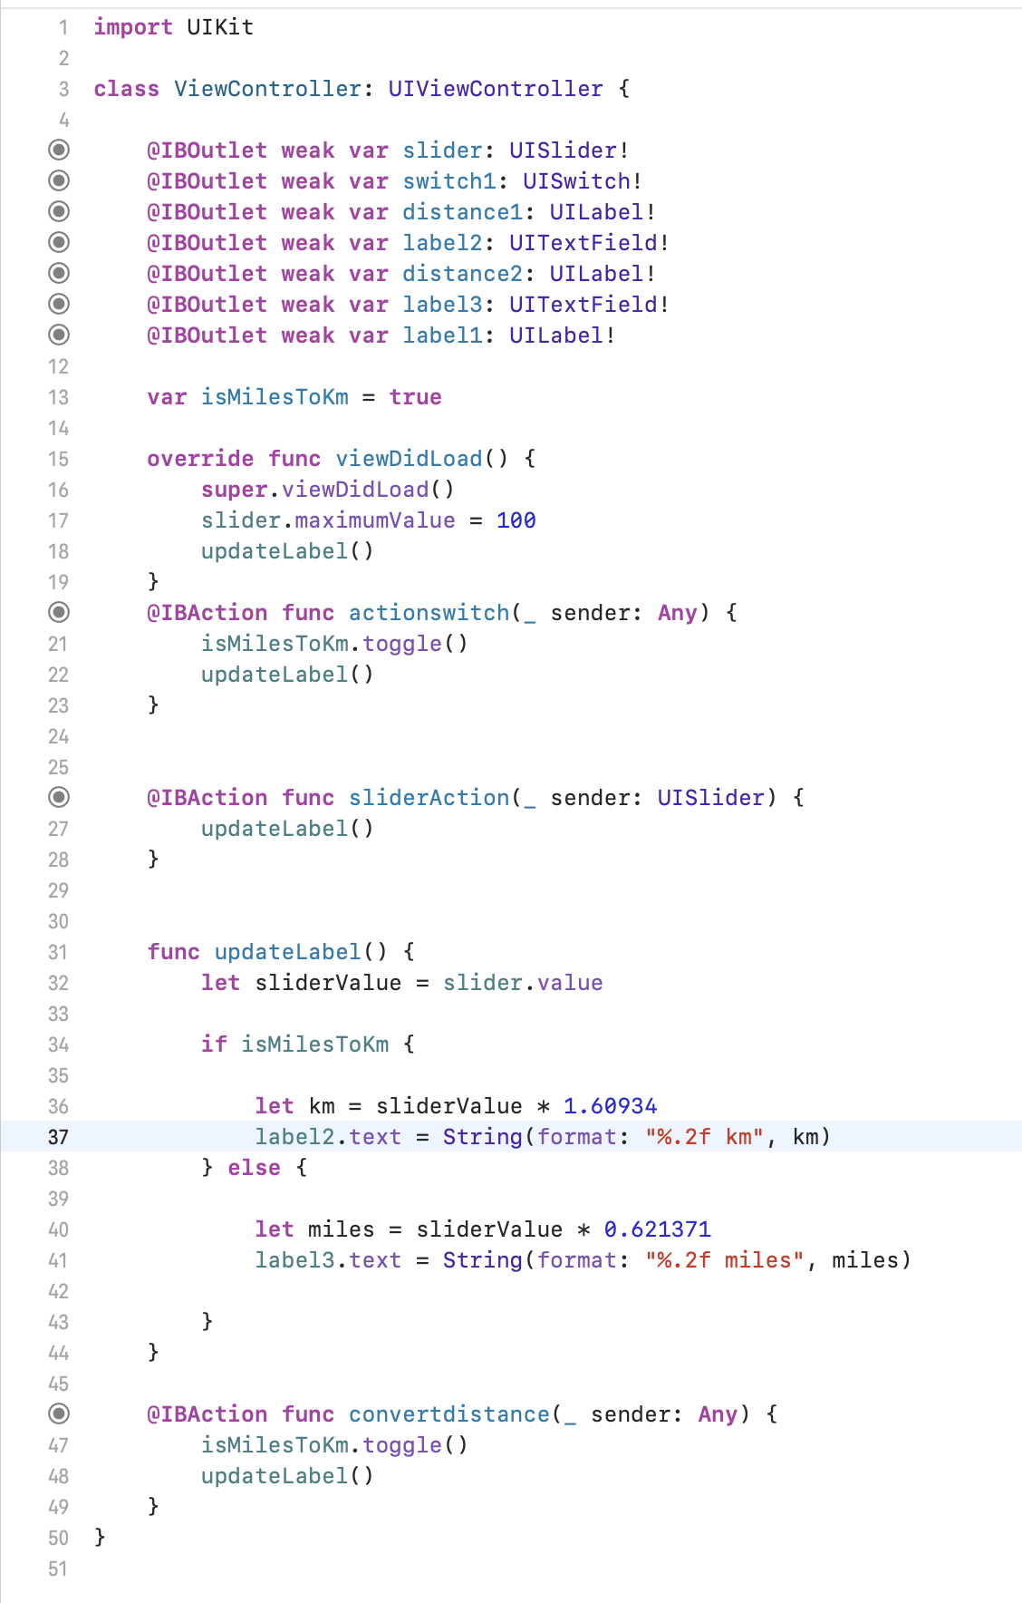

**import** UIKit

**class** ViewController: UIViewController {

**@IBOutlet** **weak** **var** slider: UISlider!

**@IBOutlet** **weak** **var** switch1: UISwitch!

**@IBOutlet** **weak** **var** distance1: UILabel!

**@IBOutlet** **weak** **var** label2: UITextField!

**@IBOutlet** **weak** **var** distance2: UILabel!

**@IBOutlet** **weak** **var** label3: UITextField!

**@IBOutlet** **weak** **var** label1: UILabel!

**var** isMilesToKm = **true**

**override** **func** viewDidLoad() {

**super**.viewDidLoad()

slider.maximumValue = 100

updateLabel()

}

**@IBAction** **func** actionswitch(_ sender: **Any**) {

isMilesToKm.toggle()

updateLabel()

}

**@IBAction** **func** sliderAction(_ sender: UISlider) {

updateLabel()

}

**func** updateLabel() {

**let** sliderValue = slider.value

**if** isMilesToKm {

**let** km = sliderValue * 1.60934

label2.text = String(format: "%.2f km", km)

} **else** {

**let** miles = sliderValue * 0.621371

label3.text = String(format: "%.2f miles", miles)

}

}

**@IBAction** **func** convertdistance(_ sender: **Any**) {

isMilesToKm.toggle()

updateLabel()

}

}