Performance Test Report

Date | May 17, 2021 4:55:24 PM
Project | Neoload_17_05_2021
Scenario | scenario1
Comment
Notes

Summary
Results summary
Name | 16:55 - 17 May 2021 | Project | Neoload_17_05_2021
Description |  | Scenario | scenario1
Description |  | Load Policy | • The population web1 is ramp up from 2 users adding 2 users every 2.0 seconds, to a maximum of 50 users.
Status | Passed | Load Policy
Start date | May 17, 2021 4:55:24 PM | Load Policy
End date | May 17, 2021 4:57:28 PM | Stop Policy | • Population web1: immediate.
Duration | 00:02:04 | Stop Policy | • Population web1: immediate.
Termination reason | Execution policy | Filters | None
LG Hosts | l​o​c​a​l​h​o​s​t​:​7​1​0​0​ | Debug | Disabled
Statistics Summary
Total pages | 9762 |  | Average pages/s | 78.1
Total requests | 12634 |  | Average requests/s | 101.1
Total users launched | 50 |  | Average Request response time | 0.335 s
Total iterations completed | 1581 |  | Average Page response time | 0.43 s
Total throughput | 40.8 MB |  | Average throughput | 2.61 Mb/s
Total request errors | 2 |  | Error rate | 0 %
Total action errors | 0 |  | Alerts total duration | 0 %

= No SLA | = Passed | = Warning | = Failed

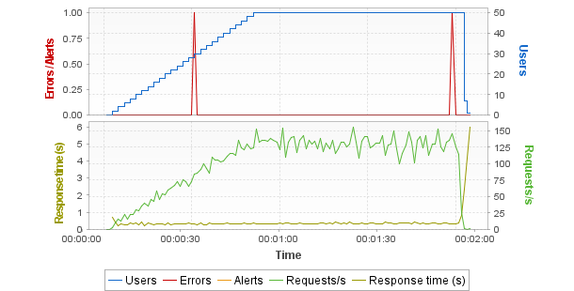
Hot spots
Top 5 errors
User Path | Parent | Page | Count
product_booking_flow | confirm | /actions/Order.action | 2
Top 5 alerts
No alerts
First critical alerts
No alerts
Top 5 average response time (Pages)
User Path | Parent | Page | Duration
checking_order_info | my_orders | /actions/Order.action | 2.4
product_booking_flow | enter_the_store | /actions/Catalog.action | 0.872
checking_product_price | enterthe_store | /actions/Catalog.action | 0.87
searching_the_product | enter_the_store | /actions/Catalog.action | 0.864
checking_order_info | enter_the_store | /actions/Catalog.action | 0.861
Top 5 maximum response time (Pages)
User Path | Parent | Page | Duration
checking_order_info | my_orders | /actions/Order.action | 5.73
product_booking_flow | enter_the_store | /actions/Catalog.action | 1.83
checking_product_price | enterthe_store | /actions/Catalog.action | 1.79
searching_the_product | enter_the_store | /actions/Catalog.action | 1.6
searching_the_product | search | /actions/Catalog.action;jsessio...4C45F68591C5754A0805 | 1.51
Errors
Request errors
Error Type | Count | Description
500 | 2 | Internal Server Error
Total | 2 | Total error count.
Action errors
No errors
Alerts
No alerts
General statistics
Min | Avg | Max | Count | Err | % of Err | SLA Profile
All User Paths
70.7 | 95 | 118.8 | 50 | 2 | 4 | -
All pages
0 | 0.43 | 5.73 | 9,762 | 2 | 0 | -
All requests
0.157 | 0.335 | 6 | 12,634 | 2 | 0 | -
Transaction statistics
Min | Avg | Max | Count | Err | % of Err | Perc 50 | Perc 95 | Perc 99 | Std Dev | Avg-90% | SLA Profile
All Transactions
0 | 0.447 | 5.73 | 9,909 | 2 | 0 | 0.307 | 0.937 | 2.15 | 0.384 | 0.404 | -

Scenario
Summary
Name | 16:55 - 17 May 2021 | Project | Neoload_17_05_2021
Description |  | Scenario | scenario1
Description |  | Load Policy | • The population web1 is ramp up from 2 users adding 2 users every 2.0 seconds, to a maximum of 50 users.
Status | Passed | Load Policy
Start date | May 17, 2021 4:55:24 PM | Load Policy
End date | May 17, 2021 4:57:28 PM | Stop Policy | • Population web1: immediate.
Duration | 00:02:04 | Stop Policy | • Population web1: immediate.
Termination reason | Execution policy | Filters | None
LG Hosts | l​o​c​a​l​h​o​s​t​:​7​1​0​0​ | Debug | Disabled
Populations
web1
User Path | Percentage | WAN Emulation | Signal strength | Bandwidth ↑ | Latency ↑ | Packet loss % ↑ | Bandwidth ↓ | Latency ↓ | Packet loss % ↓ | Browser | Handle cookies | Connections | Handle cache
product_booking_flow | 15.0% | Unlimited |  | Unlimited | 0ms | 0% | Unlimited | 0ms | 0% | Recorded one | Yes | 6 | As recorded
sign_in_out | 15.0% | Unlimited |  | Unlimited | 0ms | 0% | Unlimited | 0ms | 0% | Recorded one | Yes | 6 | As recorded
addto_cart_flow | 15.0% | Unlimited |  | Unlimited | 0ms | 0% | Unlimited | 0ms | 0% | Recorded one | Yes | 6 | As recorded
profile_update | 15.0% | Unlimited |  | Unlimited | 0ms | 0% | Unlimited | 0ms | 0% | Recorded one | Yes | 6 | As recorded
checking_order_info | 15.0% | Unlimited |  | Unlimited | 0ms | 0% | Unlimited | 0ms | 0% | Recorded one | Yes | 6 | As recorded
checking_product_price | 15.0% | Unlimited |  | Unlimited | 0ms | 0% | Unlimited | 0ms | 0% | Recorded one | Yes | 6 | As recorded
searching_the_product | 10.0% | Unlimited |  | Unlimited | 0ms | 0% | Unlimited | 0ms | 0% | Recorded one | Yes | 6 | As recorded
User Paths
Name | Description | On failed assertion | On error | Think time | Thinktime range
product_booking_flow |  | Do nothing | Do nothing | From pages | 0%
sign_in_out |  | Do nothing | Do nothing | From pages | 0%
addto_cart_flow |  | Do nothing | Do nothing | From pages | 0%
profile_update |  | Do nothing | Do nothing | From pages | 0%
checking_order_info |  | Do nothing | Do nothing | From pages | 0%
checking_product_price |  | Do nothing | Do nothing | From pages | 0%
searching_the_product |  | Do nothing | Do nothing | From pages | 0%
Rendezvous
Enabled | Name | Policy | Value | Timeout
Empty list

Execution context
Name | 16:55 - 17 May 2021 |  | Project | Neoload_17_05_2021
Description |  |  | Scenario | scenario1
Description |  |  | Load Policy | • The population web1 is ramp up from 2 users adding 2 users every 2.0 seconds, to a maximum of 50 users.
Status | Passed |  | Load Policy
Start date | May 17, 2021 4:55:24 PM |  | Load Policy
End date | May 17, 2021 4:57:28 PM |  | Stop Policy | • Population web1: immediate.
Duration | 00:02:04 |  | Stop Policy | • Population web1: immediate.
Termination reason | Execution policy |  | Filters | None
LG Hosts | l​o​c​a​l​h​o​s​t​:​7​1​0​0​ |  | Debug | Disabled
NeoLoad version |  | 7.9.1;build=20210423-80
Graphs granularity |  | Standard
Application proxy
Name | Description
NL | Automatically detect settings
Zone application proxies
Zone | Name | Description
Empty list
Constant variables
Name | Value | Description
p_mail | yourname@yourdomain.com
p_phoneNO | 555-555-5555
p_pref_launguage | english
User Paths settings
product_booking_flow
Error policy: | Do nothing
Assertion policy: | Do nothing
Thinktime policy: | defined in pages
Pacing: | No pacing
sign_in_out
Error policy: | Do nothing
Assertion policy: | Do nothing
Thinktime policy: | defined in pages
Pacing: | No pacing
addto_cart_flow
Error policy: | Do nothing
Assertion policy: | Do nothing
Thinktime policy: | defined in pages
Pacing: | No pacing
profile_update
Error policy: | Do nothing
Assertion policy: | Do nothing
Thinktime policy: | defined in pages
Pacing: | No pacing
checking_order_info
Error policy: | Do nothing
Assertion policy: | Do nothing
Thinktime policy: | defined in pages
Pacing: | No pacing
checking_product_price
Error policy: | Do nothing
Assertion policy: | Do nothing
Thinktime policy: | defined in pages
Pacing: | No pacing
searching_the_product
Error policy: | Do nothing
Assertion policy: | Do nothing
Thinktime policy: | defined in pages
Pacing: | No pacing

Servers
Servers
Host | Port | HTTP/2 ready | HTTP/2 used
petstore.octoperf.com | 443 | Yes | Yes

Populations
Graphs
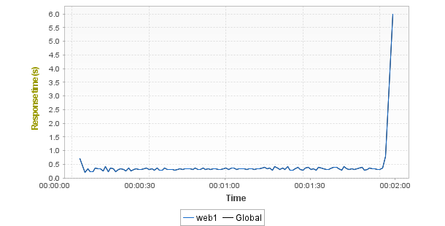
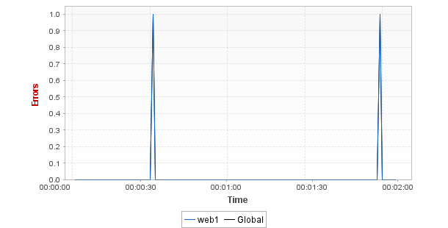
Statistics
Population | Total requests | Average requests/s | Avg. Page res. time | Error rate
web1 | 12634 (100%) | 101.1 | 0.43s (0%) | 0% (0%)
Global | 12634 (100%) | 101.1 | 0.43s | 0%

User Paths
User Paths
Min | Avg | Max | Count | Err | % of Err | SLA Profile
addto_cart_flow
78 | 96.9 | 117.1 | 7 | 0 | 0 | -
checking_order_info
73.4 | 94.3 | 116.1 | 8 | 0 | 0 | -
checking_product_price
79.6 | 96.6 | 115.3 | 7 | 0 | 0 | -
product_booking_flow
77.4 | 96.6 | 118.8 | 7 | 2 | 28.6 | -
profile_update
71.5 | 93.5 | 117.5 | 8 | 0 | 0 | -
searching_the_product
71.2 | 94.2 | 113 | 6 | 0 | 0 | -
sign_in_out
70.7 | 93 | 114.8 | 7 | 0 | 0 | -

Transactions
Shared Containers
Min | Avg | Max | Count | Err | % of Err | Perc 50 | Perc 95 | Perc 99 | Std Dev | Avg-90% | SLA Profile
Empty list
addto_cart_flow
Min | Avg | Max | Count | Err | % of Err | Perc 50 | Perc 95 | Perc 99 | Std Dev | Avg-90% | SLA Profile
addto_cart_flow
78 | 96.9 | 117.1 | 7 | 0 | 0 | - | - | - | - | - | -
Init
0 | 0 | 0.002 | 7 | 0 | 0 | - | - | - | - | - | -
Actions
2.65 | 3.04 | 4.13 | 217 | 0 | 0 | - | - | - | - | - | -
enterthe_store
0.722 | 0.86 | 1.26 | 223 | 0 | 0 | 0.85 | 0.971 | 1.07 | 0.067 | 0.855 | -
signin
0.164 | 0.22 | 0.627 | 223 | 0 | 0 | 0.21 | 0.286 | 0.434 | 0.047 | 0.214 | -
login
0.351 | 0.437 | 0.707 | 223 | 0 | 0 | 0.426 | 0.527 | 0.667 | 0.053 | 0.432 | -
fish
0.169 | 0.222 | 0.847 | 222 | 0 | 0 | 0.212 | 0.277 | 0.33 | 0.054 | 0.216 | -
productID_FISW01
0.169 | 0.22 | 0.432 | 222 | 0 | 0 | 0.212 | 0.278 | 0.315 | 0.032 | 0.217 | -
ITEMID_EST-1
0.173 | 0.217 | 0.415 | 221 | 0 | 0 | 0.211 | 0.276 | 0.297 | 0.031 | 0.214 | -
Addto_cart
0.169 | 0.221 | 0.458 | 221 | 0 | 0 | 0.21 | 0.29 | 0.416 | 0.04 | 0.216 | -
proceedto_checkout
0.177 | 0.219 | 0.41 | 220 | 0 | 0 | 0.212 | 0.282 | 0.36 | 0.033 | 0.215 | -
signout
0.345 | 0.43 | 0.637 | 217 | 0 | 0 | 0.424 | 0.514 | 0.611 | 0.045 | 0.426 | -
End
0 | 0 | 0 | 7 | 0 | 0 | - | - | - | - | - | -
checking_order_info
Min | Avg | Max | Count | Err | % of Err | Perc 50 | Perc 95 | Perc 99 | Std Dev | Avg-90% | SLA Profile
checking_order_info
73.4 | 94.3 | 116.1 | 8 | 0 | 0 | - | - | - | - | - | -
Init
0 | 0 | 0 | 8 | 0 | 0 | - | - | - | - | - | -
Actions
3.85 | 4.79 | 8.26 | 150 | 0 | 0 | - | - | - | - | - | -
enter_the_store
0.745 | 0.861 | 1.07 | 157 | 0 | 0 | 0.853 | 0.979 | 1.05 | 0.062 | 0.858 | -
signin
0.165 | 0.216 | 0.444 | 157 | 0 | 0 | 0.208 | 0.262 | 0.434 | 0.037 | 0.211 | -
login
0.357 | 0.431 | 0.559 | 157 | 0 | 0 | 0.426 | 0.51 | 0.553 | 0.04 | 0.428 | -
my_account
0.17 | 0.222 | 0.797 | 157 | 0 | 0 | 0.21 | 0.294 | 0.487 | 0.06 | 0.214 | -
my_orders
1.69 | 2.4 | 5.73 | 151 | 0 | 0 | 2.22 | 4.64 | 5.18 | 0.698 | 2.28 | -
click_on_orderID
0.178 | 0.221 | 0.425 | 151 | 0 | 0 | 0.209 | 0.278 | 0.419 | 0.043 | 0.215 | -
signout
0.366 | 0.442 | 1.05 | 150 | 0 | 0 | 0.422 | 0.593 | 0.676 | 0.079 | 0.432 | -
End
0 | 0 | 0 | 8 | 0 | 0 | - | - | - | - | - | -
checking_product_price
Min | Avg | Max | Count | Err | % of Err | Perc 50 | Perc 95 | Perc 99 | Std Dev | Avg-90% | SLA Profile
checking_product_price
79.6 | 96.6 | 115.3 | 7 | 0 | 0 | - | - | - | - | - | -
Init
0 | 0 | 0 | 7 | 0 | 0 | - | - | - | - | - | -
Actions
2 | 2.39 | 3.56 | 278 | 0 | 0 | - | - | - | - | - | -
enterthe_store
0.727 | 0.87 | 1.79 | 285 | 0 | 0 | 0.855 | 1.03 | 1.19 | 0.094 | 0.86 | -
signin
0.165 | 0.222 | 0.533 | 284 | 0 | 0 | 0.214 | 0.286 | 0.452 | 0.043 | 0.216 | -
login
0.352 | 0.432 | 0.582 | 281 | 0 | 0 | 0.424 | 0.515 | 0.566 | 0.043 | 0.429 | -
fish
0.166 | 0.22 | 0.457 | 278 | 0 | 0 | 0.207 | 0.29 | 0.44 | 0.04 | 0.215 | -
productID_FISW01
0.171 | 0.218 | 0.975 | 278 | 0 | 0 | 0.209 | 0.273 | 0.311 | 0.054 | 0.213 | -
signout
0.344 | 0.429 | 1.07 | 278 | 0 | 0 | 0.416 | 0.512 | 0.664 | 0.063 | 0.423 | -
End
0 | 0 | 0 | 7 | 0 | 0 | - | - | - | - | - | -
product_booking_flow
Min | Avg | Max | Count | Err | % of Err | Perc 50 | Perc 95 | Perc 99 | Std Dev | Avg-90% | SLA Profile
product_booking_flow
77.4 | 96.6 | 118.8 | 7 | 2 | 28.6 | - | - | - | - | - | -
Init
0 | 0 | 0 | 7 | 0 | 0 | - | - | - | - | - | -
Actions
3.05 | 3.5 | 4.7 | 189 | 2 | 1.1 | - | - | - | - | - | -
enter_the_store
0.722 | 0.872 | 1.83 | 196 | 0 | 0 | 0.855 | 1.02 | 1.22 | 0.101 | 0.862 | -
signin
0.169 | 0.22 | 1.02 | 195 | 0 | 0 | 0.21 | 0.26 | 0.456 | 0.065 | 0.214 | -
login
0.551 | 0.648 | 0.905 | 193 | 0 | 0 | 0.637 | 0.772 | 0.812 | 0.057 | 0.643 | -
fish
0 | 0 | 0 | 193 | 0 | 0 | 0 | 0 | 0 | 0 | 0 | -
productID_FISW01
0.166 | 0.219 | 0.501 | 191 | 0 | 0 | 0.209 | 0.279 | 0.468 | 0.041 | 0.213 | -
ITEMID_EST1
0.175 | 0.218 | 0.441 | 191 | 0 | 0 | 0.208 | 0.284 | 0.347 | 0.035 | 0.214 | -
addto_cart
0.17 | 0.217 | 0.39 | 191 | 0 | 0 | 0.209 | 0.279 | 0.374 | 0.034 | 0.213 | -
proceedto_checkout
0.167 | 0.217 | 0.357 | 190 | 0 | 0 | 0.21 | 0.287 | 0.337 | 0.032 | 0.214 | -
continue
0.181 | 0.223 | 0.354 | 190 | 0 | 0 | 0.216 | 0.289 | 0.352 | 0.032 | 0.22 | -
confirm
0.174 | 0.231 | 0.471 | 190 | 2 | 1.1 | 0.212 | 0.34 | 0.465 | 0.051 | 0.224 | -
signout
0.352 | 0.432 | 0.659 | 189 | 0 | 0 | 0.421 | 0.519 | 0.564 | 0.048 | 0.429 | -
End
0 | 0 | 0 | 7 | 0 | 0 | - | - | - | - | - | -
profile_update
Min | Avg | Max | Count | Err | % of Err | Perc 50 | Perc 95 | Perc 99 | Std Dev | Avg-90% | SLA Profile
profile_update
71.5 | 93.5 | 117.5 | 8 | 0 | 0 | - | - | - | - | - | -
Init
0 | 0 | 0 | 8 | 0 | 0 | - | - | - | - | - | -
Actions
2.05 | 2.4 | 3.06 | 307 | 0 | 0 | - | - | - | - | - | -
enterthe_store
0.73 | 0.86 | 1.1 | 312 | 0 | 0 | 0.854 | 0.971 | 1.05 | 0.062 | 0.857 | -
signin
0.163 | 0.215 | 0.466 | 312 | 0 | 0 | 0.21 | 0.267 | 0.32 | 0.031 | 0.213 | -
login
0.356 | 0.434 | 0.647 | 310 | 0 | 0 | 0.427 | 0.522 | 0.558 | 0.045 | 0.431 | -
my_account
0.171 | 0.219 | 0.459 | 310 | 0 | 0 | 0.212 | 0.276 | 0.389 | 0.037 | 0.215 | -
save_accont_info
0.179 | 0.227 | 0.451 | 309 | 0 | 0 | 0.218 | 0.294 | 0.433 | 0.038 | 0.222 | -
signout
0.339 | 0.437 | 0.993 | 307 | 0 | 0 | 0.427 | 0.525 | 0.589 | 0.059 | 0.432 | -
End
0 | 0 | 0 | 8 | 0 | 0 | - | - | - | - | - | -
searching_the_product
Min | Avg | Max | Count | Err | % of Err | Perc 50 | Perc 95 | Perc 99 | Std Dev | Avg-90% | SLA Profile
searching_the_product
71.2 | 94.2 | 113 | 6 | 0 | 0 | - | - | - | - | - | -
Init
0 | 0 | 0 | 6 | 0 | 0 | - | - | - | - | - | -
Actions
1.25 | 1.5 | 2.54 | 373 | 0 | 0 | - | - | - | - | - | -
enter_the_store
0.736 | 0.864 | 1.6 | 377 | 0 | 0 | 0.856 | 0.997 | 1.12 | 0.086 | 0.857 | -
search
0.439 | 0.634 | 1.51 | 373 | 0 | 0 | 0.618 | 0.741 | 1.04 | 0.09 | 0.624 | -
End
0 | 0 | 0 | 6 | 0 | 0 | - | - | - | - | - | -
sign_in_out
Min | Avg | Max | Count | Err | % of Err | Perc 50 | Perc 95 | Perc 99 | Std Dev | Avg-90% | SLA Profile
sign_in_out
70.7 | 93 | 114.8 | 7 | 0 | 0 | - | - | - | - | - | -
Init
0 | 0 | 0 | 7 | 0 | 0 | - | - | - | - | - | -
Actions
8.98 | 9.19 | 9.51 | 67 | 0 | 0 | - | - | - | - | - | -
launch
0.615 | 0.621 | 0.637 | 74 | 0 | 0 | 0.619 | 0.632 | 0.637 | 0.006 | 0.62 | -
enter
0.323 | 0.329 | 0.369 | 74 | 0 | 0 | 0.325 | 0.343 | 0.369 | 0.009 | 0.327 | -
enter_store
0.699 | 0.852 | 1.09 | 73 | 0 | 0 | 0.851 | 0.986 | 1.09 | 0.07 | 0.847 | -
signin
1.89 | 1.95 | 2.17 | 72 | 0 | 0 | 1.94 | 2.01 | 2.17 | 0.039 | 1.94 | -
enter_str
0.36 | 0.434 | 0.706 | 71 | 0 | 0 | 0.414 | 0.557 | 0.706 | 0.06 | 0.426 | -
signout
0.948 | 1.02 | 1.26 | 70 | 0 | 0 | 1.01 | 1.11 | 1.26 | 0.052 | 1.02 | -
End
0 | 0 | 0 | 7 | 0 | 0 | - | - | - | - | - | -

Push messages
Shared Containers
Min | Avg | Max | Count | Err | % of Err | SLA Profile
Empty list
addto_cart_flow
Min | Avg | Max | Count | Err | % of Err | SLA Profile
Empty list
checking_order_info
Min | Avg | Max | Count | Err | % of Err | SLA Profile
Empty list
checking_product_price
Min | Avg | Max | Count | Err | % of Err | SLA Profile
Empty list
product_booking_flow
Min | Avg | Max | Count | Err | % of Err | SLA Profile
Empty list
profile_update
Min | Avg | Max | Count | Err | % of Err | SLA Profile
Empty list
searching_the_product
Min | Avg | Max | Count | Err | % of Err | SLA Profile
Empty list
sign_in_out
Min | Avg | Max | Count | Err | % of Err | SLA Profile
Empty list

Pages
Shared Containers
Min | Avg | Max | Count | Err | % of Err | SLA Profile
Empty list
addto_cart_flow
Min | Avg | Max | Count | Err | % of Err | SLA Profile
addto_cart_flow
78 | 96.9 | 117.1 | 7 | 0 | 0 | -
Actions
2.65 | 3.04 | 4.13 | 217 | 0 | 0 | -
enterthe_store
0.722 | 0.86 | 1.26 | 223 | 0 | 0 | -
/actions/Catalog.action
0.722 | 0.86 | 1.26 | 223 | 0 | 0 | -
signin
0.164 | 0.22 | 0.627 | 223 | 0 | 0 | -
/actions/Account.action;jsessi...BDF1B512F8BE8E2D50BE
0.164 | 0.22 | 0.627 | 223 | 0 | 0 | -
login
0.351 | 0.437 | 0.707 | 223 | 0 | 0 | -
/actions/Account.action
0.351 | 0.437 | 0.707 | 223 | 0 | 0 | -
fish
0.169 | 0.222 | 0.847 | 222 | 0 | 0 | -
/actions/Catalog.action
0.169 | 0.222 | 0.847 | 222 | 0 | 0 | -
productID_FISW01
0.169 | 0.22 | 0.432 | 222 | 0 | 0 | -
/actions/Catalog.action
0.169 | 0.22 | 0.432 | 222 | 0 | 0 | -
ITEMID_EST-1
0.173 | 0.217 | 0.415 | 221 | 0 | 0 | -
/actions/Catalog.action
0.173 | 0.217 | 0.415 | 221 | 0 | 0 | -
Addto_cart
0.169 | 0.221 | 0.458 | 221 | 0 | 0 | -
/actions/Cart.action
0.169 | 0.221 | 0.458 | 221 | 0 | 0 | -
proceedto_checkout
0.177 | 0.219 | 0.41 | 220 | 0 | 0 | -
/actions/Order.action
0.177 | 0.219 | 0.41 | 220 | 0 | 0 | -
signout
0.345 | 0.43 | 0.637 | 217 | 0 | 0 | -
/actions/Account.action
0.345 | 0.43 | 0.637 | 217 | 0 | 0 | -
checking_order_info
Min | Avg | Max | Count | Err | % of Err | SLA Profile
checking_order_info
73.4 | 94.3 | 116.1 | 8 | 0 | 0 | -
Actions
3.85 | 4.79 | 8.26 | 150 | 0 | 0 | -
enter_the_store
0.745 | 0.861 | 1.07 | 157 | 0 | 0 | -
/actions/Catalog.action
0.745 | 0.861 | 1.07 | 157 | 0 | 0 | -
signin
0.165 | 0.216 | 0.444 | 157 | 0 | 0 | -
/actions/Account.action;jsessi...99EDDF4B453EB501ADF3
0.165 | 0.216 | 0.444 | 157 | 0 | 0 | -
login
0.357 | 0.431 | 0.559 | 157 | 0 | 0 | -
/actions/Account.action
0.357 | 0.431 | 0.559 | 157 | 0 | 0 | -
my_account
0.17 | 0.222 | 0.797 | 157 | 0 | 0 | -
/actions/Account.action
0.17 | 0.222 | 0.797 | 157 | 0 | 0 | -
my_orders
1.69 | 2.4 | 5.73 | 151 | 0 | 0 | -
/actions/Order.action
1.69 | 2.4 | 5.73 | 151 | 0 | 0 | -
click_on_orderID
0.178 | 0.221 | 0.425 | 151 | 0 | 0 | -
/actions/Order.action
0.178 | 0.221 | 0.425 | 151 | 0 | 0 | -
signout
0.366 | 0.442 | 1.05 | 150 | 0 | 0 | -
/actions/Account.action
0.366 | 0.442 | 1.05 | 150 | 0 | 0 | -
checking_product_price
Min | Avg | Max | Count | Err | % of Err | SLA Profile
checking_product_price
79.6 | 96.6 | 115.3 | 7 | 0 | 0 | -
Actions
2 | 2.39 | 3.56 | 278 | 0 | 0 | -
enterthe_store
0.727 | 0.87 | 1.79 | 285 | 0 | 0 | -
/actions/Catalog.action
0.727 | 0.87 | 1.79 | 285 | 0 | 0 | -
signin
0.165 | 0.222 | 0.533 | 284 | 0 | 0 | -
/actions/Account.action;jsessi...F64C90953282A54A6911
0.165 | 0.222 | 0.533 | 284 | 0 | 0 | -
login
0.352 | 0.432 | 0.582 | 281 | 0 | 0 | -
/actions/Account.action
0.352 | 0.432 | 0.582 | 281 | 0 | 0 | -
fish
0.166 | 0.22 | 0.457 | 278 | 0 | 0 | -
/actions/Catalog.action
0.166 | 0.22 | 0.457 | 278 | 0 | 0 | -
productID_FISW01
0.171 | 0.218 | 0.975 | 278 | 0 | 0 | -
/actions/Catalog.action
0.171 | 0.218 | 0.975 | 278 | 0 | 0 | -
signout
0.344 | 0.429 | 1.07 | 278 | 0 | 0 | -
/actions/Account.action
0.344 | 0.429 | 1.07 | 278 | 0 | 0 | -
product_booking_flow
Min | Avg | Max | Count | Err | % of Err | SLA Profile
product_booking_flow
77.4 | 96.6 | 118.8 | 7 | 2 | 28.6 | -
Actions
3.05 | 3.5 | 4.7 | 189 | 2 | 1.1 | -
enter_the_store
0.722 | 0.872 | 1.83 | 196 | 0 | 0 | -
/actions/Catalog.action
0.722 | 0.872 | 1.83 | 196 | 0 | 0 | -
signin
0.169 | 0.22 | 1.02 | 195 | 0 | 0 | -
/actions/Account.action;jsessi...8A0EB5E0FA7B2972D634
0.169 | 0.22 | 1.02 | 195 | 0 | 0 | -
login
0.551 | 0.648 | 0.905 | 193 | 0 | 0 | -
/actions/Account.action
0.551 | 0.648 | 0.905 | 193 | 0 | 0 | -
fish
0 | 0 | 0 | 193 | 0 | 0 | -
/actions/Catalog.action
0 | 0 | 0 | 193 | 0 | 0 | -
productID_FISW01
0.166 | 0.219 | 0.501 | 191 | 0 | 0 | -
/actions/Catalog.action
0.166 | 0.219 | 0.501 | 191 | 0 | 0 | -
ITEMID_EST1
0.175 | 0.218 | 0.441 | 191 | 0 | 0 | -
/actions/Catalog.action
0.175 | 0.218 | 0.441 | 191 | 0 | 0 | -
addto_cart
0.17 | 0.217 | 0.39 | 191 | 0 | 0 | -
/actions/Cart.action
0.17 | 0.217 | 0.39 | 191 | 0 | 0 | -
proceedto_checkout
0.167 | 0.217 | 0.357 | 190 | 0 | 0 | -
/actions/Order.action
0.167 | 0.217 | 0.357 | 190 | 0 | 0 | -
continue
0.181 | 0.223 | 0.354 | 190 | 0 | 0 | -
/actions/Order.action_1
0.181 | 0.223 | 0.354 | 190 | 0 | 0 | -
confirm
0.174 | 0.231 | 0.471 | 190 | 2 | 1.1 | -
/actions/Order.action
0.174 | 0.231 | 0.471 | 190 | 2 | 1.1 | -
signout
0.352 | 0.432 | 0.659 | 189 | 0 | 0 | -
/actions/Account.action
0.352 | 0.432 | 0.659 | 189 | 0 | 0 | -
profile_update
Min | Avg | Max | Count | Err | % of Err | SLA Profile
profile_update
71.5 | 93.5 | 117.5 | 8 | 0 | 0 | -
Actions
2.05 | 2.4 | 3.06 | 307 | 0 | 0 | -
enterthe_store
0.73 | 0.86 | 1.1 | 312 | 0 | 0 | -
/actions/Catalog.action
0.73 | 0.86 | 1.1 | 312 | 0 | 0 | -
signin
0.163 | 0.215 | 0.466 | 312 | 0 | 0 | -
/actions/Account.action;jsessi...A589CA1E32A3455E16DD
0.163 | 0.215 | 0.466 | 312 | 0 | 0 | -
login
0.356 | 0.434 | 0.647 | 310 | 0 | 0 | -
/actions/Account.action
0.356 | 0.434 | 0.647 | 310 | 0 | 0 | -
my_account
0.171 | 0.219 | 0.459 | 310 | 0 | 0 | -
/actions/Account.action
0.171 | 0.219 | 0.459 | 310 | 0 | 0 | -
save_accont_info
0.179 | 0.227 | 0.451 | 309 | 0 | 0 | -
/actions/Account.action
0.179 | 0.227 | 0.451 | 309 | 0 | 0 | -
signout
0.339 | 0.437 | 0.993 | 307 | 0 | 0 | -
/actions/Account.action
0.339 | 0.437 | 0.993 | 307 | 0 | 0 | -
searching_the_product
Min | Avg | Max | Count | Err | % of Err | SLA Profile
searching_the_product
71.2 | 94.2 | 113 | 6 | 0 | 0 | -
Actions
1.25 | 1.5 | 2.54 | 373 | 0 | 0 | -
enter_the_store
0.736 | 0.864 | 1.6 | 377 | 0 | 0 | -
/actions/Catalog.action
0.736 | 0.864 | 1.6 | 377 | 0 | 0 | -
search
0.439 | 0.634 | 1.51 | 373 | 0 | 0 | -
/actions/Catalog.action;jsessi...4C45F68591C5754A0805
0.439 | 0.634 | 1.51 | 373 | 0 | 0 | -
sign_in_out
Min | Avg | Max | Count | Err | % of Err | SLA Profile
sign_in_out
70.7 | 93 | 114.8 | 7 | 0 | 0 | -
Actions
8.98 | 9.19 | 9.51 | 67 | 0 | 0 | -
enter_store
0.699 | 0.852 | 1.09 | 73 | 0 | 0 | -
/actions/Catalog.action
0.699 | 0.852 | 1.09 | 73 | 0 | 0 | -
signin
1.89 | 1.95 | 2.17 | 72 | 0 | 0 | -
/actions/Account.action;jsessi...A4D8FAEB5D6529338C6F
0.167 | 0.218 | 0.43 | 73 | 0 | 0 | -
enter_str
0.36 | 0.434 | 0.706 | 71 | 0 | 0 | -
/actions/Account.action
0.36 | 0.434 | 0.706 | 71 | 0 | 0 | -
signout
0.948 | 1.02 | 1.26 | 70 | 0 | 0 | -
/actions/Account.action
0.349 | 0.417 | 0.515 | 70 | 0 | 0 | -

SLA per User Path
Shared Containers
SLA | Value | Severity
Empty list
addto_cart_flow
SLA | Value | Severity
addto_cart_flow
Actions
enterthe_store
/actions/Catalog.action
signin
/actions/Account.action;jsessi...BDF1B512F8BE8E2D50BE
login
/actions/Account.action
fish
/actions/Catalog.action
productID_FISW01
/actions/Catalog.action
ITEMID_EST-1
/actions/Catalog.action
Addto_cart
/actions/Cart.action
proceedto_checkout
/actions/Order.action
signout
/actions/Account.action
checking_order_info
SLA | Value | Severity
checking_order_info
Actions
enter_the_store
/actions/Catalog.action
signin
/actions/Account.action;jsessi...99EDDF4B453EB501ADF3
login
/actions/Account.action
my_account
/actions/Account.action
my_orders
/actions/Order.action
click_on_orderID
/actions/Order.action
signout
/actions/Account.action
checking_product_price
SLA | Value | Severity
checking_product_price
Actions
enterthe_store
/actions/Catalog.action
signin
/actions/Account.action;jsessi...F64C90953282A54A6911
login
/actions/Account.action
fish
/actions/Catalog.action
productID_FISW01
/actions/Catalog.action
signout
/actions/Account.action
product_booking_flow
SLA | Value | Severity
product_booking_flow
Actions
enter_the_store
/actions/Catalog.action
signin
/actions/Account.action;jsessi...8A0EB5E0FA7B2972D634
login
/actions/Account.action
fish
/actions/Catalog.action
productID_FISW01
/actions/Catalog.action
ITEMID_EST1
/actions/Catalog.action
addto_cart
/actions/Cart.action
proceedto_checkout
/actions/Order.action
continue
/actions/Order.action_1
confirm
/actions/Order.action
signout
/actions/Account.action
profile_update
SLA | Value | Severity
profile_update
Actions
enterthe_store
/actions/Catalog.action
signin
/actions/Account.action;jsessi...A589CA1E32A3455E16DD
login
/actions/Account.action
my_account
/actions/Account.action
save_accont_info
/actions/Account.action
signout
/actions/Account.action
searching_the_product
SLA | Value | Severity
searching_the_product
Actions
enter_the_store
/actions/Catalog.action
search
/actions/Catalog.action;jsessi...4C45F68591C5754A0805
sign_in_out
SLA | Value | Severity
sign_in_out
Actions
enter_store
/actions/Catalog.action
signin
/actions/Account.action;jsessi...A4D8FAEB5D6529338C6F
enter_str
/actions/Account.action
signout
/actions/Account.action

Media Contents
addto_cart_flow
Count | Errors | Bitrate | Played Time | Lag Duration | Lag Ratio | Fill Buffer Duration
Empty list
checking_order_info
Count | Errors | Bitrate | Played Time | Lag Duration | Lag Ratio | Fill Buffer Duration
Empty list
checking_product_price
Count | Errors | Bitrate | Played Time | Lag Duration | Lag Ratio | Fill Buffer Duration
Empty list
product_booking_flow
Count | Errors | Bitrate | Played Time | Lag Duration | Lag Ratio | Fill Buffer Duration
Empty list
profile_update
Count | Errors | Bitrate | Played Time | Lag Duration | Lag Ratio | Fill Buffer Duration
Empty list
searching_the_product
Count | Errors | Bitrate | Played Time | Lag Duration | Lag Ratio | Fill Buffer Duration
Empty list
sign_in_out
Count | Errors | Bitrate | Played Time | Lag Duration | Lag Ratio | Fill Buffer Duration
Empty list

Monitors
Controller
Performance Counters
Min | Avg | Max | Med | Avg-90% | Std Dev
Controller/User Load
0 | 38.5 | 50 | 50 | 39.8 | 16.6
Controller/Throughput
0 | 2.59 | 4.84 | 2.73 | 2.59 | 1.26
Controller/Alerts
0 | 0 | 0 | 0 | 0 | -
Controller/Critical Alerts
0 | 0 | 0 | 0 | 0 | -
Controller/Warning Alerts
0 | 0 | 0 | 0 | 0 | -
Controller/CPU Load
10 | 31.7 | 82 | 28 | 30.1 | 13.3
Controller/Memory Used
17 | 25.4 | 36 | 25 | 25.2 | 5.32
Controller/Thread Count
525 | 551.9 | 558 | 549 | 552 | 5.86
Controller/Connected
1 | 1 | 1 | 1 | 1 | 0
Controller/Total Disconnections
0 | 0 | 0 | 0 | 0 | 0
Controller/Total Reconnections
0 | 0 | 0 | 0 | 0 | 0
Controller/Network/Segments sent/sec.
0 | 693.1 | 8,062 | 0 | 487.2 | 1,302
Controller/Network/Segments retransmitted/sec.
0 | 0 | 0 | 0 | 0 | 0
Controller/Network/wlan0 (Microsoft Wi-Fi Direct Virtual...gabits received/sec.
0 | 0 | 0 | 0 | 0 | -
Controller/Network/wlan0 (Microsoft Wi-Fi Direct Virtual...)/Megabits sent/sec.
0 | 0 | 0 | 0 | 0 | -
Controller/Network/eth1 (Intel(R) Ethernet Connection (4...gabits received/sec.
0 | 0 | 0 | 0 | 0 | -
Controller/Network/eth1 (Intel(R) Ethernet Connection (4...)/Megabits sent/sec.
0 | 0 | 0 | 0 | 0 | -
Controller/Network/wlan2 (Intel(R) Dual Band Wireless-AC...gabits received/sec.
0.001 | 3.51 | 6.28 | 3.87 | 3.54 | 1.61
Controller/Network/wlan2 (Intel(R) Dual Band Wireless-AC...)/Megabits sent/sec.
0 | 0.423 | 0.61 | 0.502 | 0.434 | 0.175
Controller/Default zone/User Load
0 | 38.8 | 50 | 50 | 40.1 | 16.3
Controller/Default zone/web1/User Load
1 | 39.1 | 50 | 50 | 40.4 | 16
Controller/Default zone/web1/product_booking_flow/User Load
0 | 5.54 | 7 | 7 | 5.73 | 2.24
Controller/Default zone/web1/sign_in_out/User Load
0 | 5.53 | 7 | 7 | 5.71 | 2.23
Controller/Default zone/web1/addto_cart_flow/User Load
0 | 5.54 | 7 | 7 | 5.75 | 2.24
Controller/Default zone/web1/profile_update/User Load
0 | 6.13 | 8 | 8 | 6.33 | 2.63
Controller/Default zone/web1/checking_order_info/User Load
0 | 6.19 | 8 | 8 | 6.39 | 2.57
Controller/Default zone/web1/checking_product_price/User Load
0 | 5.53 | 7 | 7 | 5.74 | 2.3
Controller/Default zone/web1/searching_the_product/User Load
0 | 4.63 | 6 | 6 | 4.8 | 1.95
LG localhost:7100
Performance Counters
Min | Avg | Max | Med | Avg-90% | Std Dev
LG localhost:7100/CPU Load
0 | 30.5 | 80 | 28 | 29.4 | 12.9
LG localhost:7100/Memory Used
0 | 20.3 | 40 | 19 | 20 | 9.1
LG localhost:7100/Throughput
0 | 2.61 | 4.84 | 2.77 | 2.61 | 1.24
LG localhost:7100/User Load
0 | 38.8 | 50 | 50 | 40.1 | 16.3
LG localhost:7100/Thread Count
0 | 97.3 | 109 | 109 | 99.1 | 18.3
LG localhost:7100/Http client/Thread Pool used
0 | 0.099 | 0.1 | 0.1 | 0.1 | 0.009
LG localhost:7100/Http client/Task Pool used
0 | 0.001 | 0.033 | 0 | 0 | 0.005
LG localhost:7100/Controller Connection/Disconnections
0 | 0 | 0 | 0 | 0 | -
LG localhost:7100/Controller Connection/Reconnections
0 | 0 | 0 | 0 | 0 | -
LG localhost:7100/Controller Connection/Ping Duration (ms)
2 | 2.7 | 3 | 3 | 2.72 | 0.459
LG localhost:7100/Network/Segments sent/sec.
0 | 307.9 | 4,242 | 0 | 167.3 | 745.3
LG localhost:7100/Network/Segments retransmitted/sec.
0 | 0 | 0 | 0 | 0 | 0
LG localhost:7100/Network/wlan0 (Microsoft Wi-Fi Direct ...gabits received/sec.
0 | 0 | 0 | 0 | 0 | -
LG localhost:7100/Network/wlan0 (Microsoft Wi-Fi Direct ...)/Megabits sent/sec.
0 | 0 | 0 | 0 | 0 | -
LG localhost:7100/Network/eth1 (Intel(R) Ethernet Connec...gabits received/sec.
0 | 0 | 0 | 0 | 0 | -
LG localhost:7100/Network/eth1 (Intel(R) Ethernet Connec...)/Megabits sent/sec.
0 | 0 | 0 | 0 | 0 | -
LG localhost:7100/Network/wlan2 (Intel(R) Dual Band Wire...gabits received/sec.
0 | 3.54 | 6.18 | 3.92 | 3.57 | 1.58
LG localhost:7100/Network/wlan2 (Intel(R) Dual Band Wire...)/Megabits sent/sec.
0.019 | 0.427 | 0.611 | 0.51 | 0.438 | 0.17

Main graphs
Average page response time

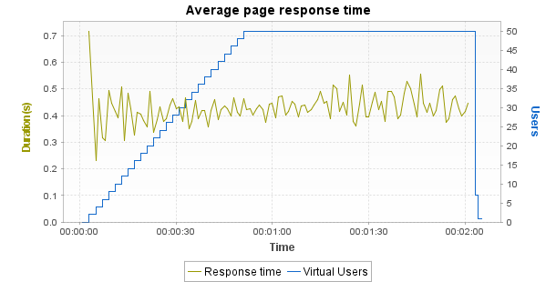

Min | Average | Max
0.231 | 0.43 | 0.717

Notes: Displays the average response time, in seconds, of all pages during the test.
Average request response time

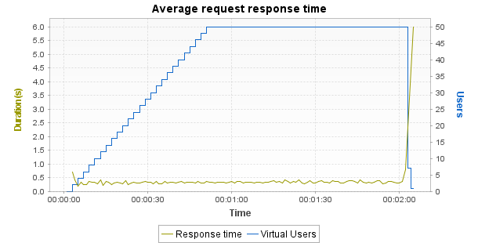

Min | Average | Max
0.199 | 0.335 | 5.997

Notes: Displays the average response time, in seconds, of all requests during the test.
Average response time (Transactions)

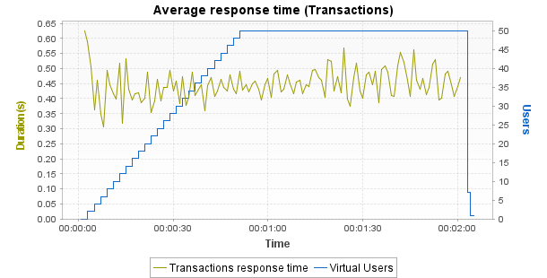

Min | Average | Max | Median | Avg-90% | Std. Dev.
0.306 | 0.448 | 0.626 | 0.445 | 0.447 | 0.044

Notes: Displays the average response time, in seconds, of all Transactions during the test.
Requests per second

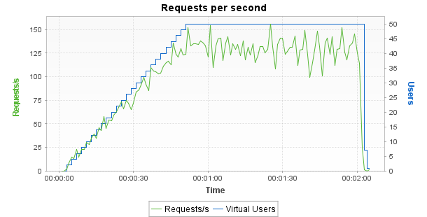

Min | Average | Max
0 | 101.1 | 156

Notes: Displays the number of requests per second.
Errors

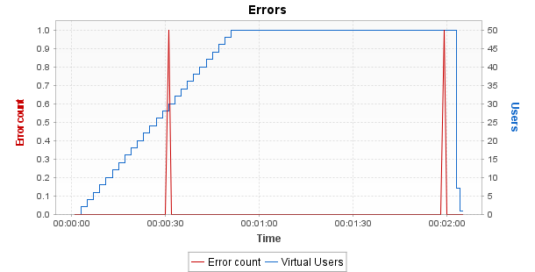

Min | Average | Max
0 | 0 | 1

Notes: Displays the number of errors per sampling interval.
Throughput

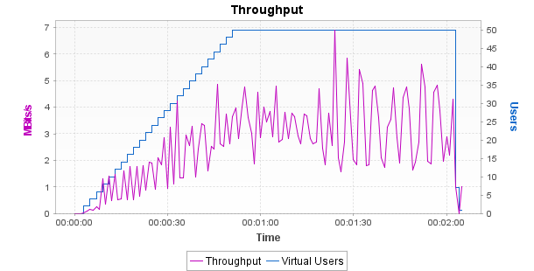

Min | Average | Max
0 | 2.59 | 6.91

Notes: Displays the number of megabits of data per second returned by the server.
Response time against load

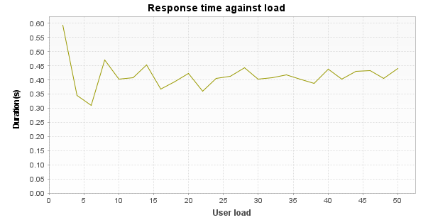

Min | Average | Max
0.311 | 0.415 | 0.594

Notes: Displays the average response time, in seconds, of all pages according to the number of simultaneous Virtual Users.
Distribution of Transaction Durations

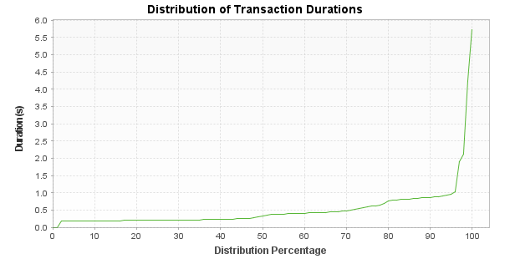
Notes: Displays the percentage of Transactions that were performed within a given time range. This graph helps determine the percentage of Transactions that meet a performance objective. For example, it may show that 90% of the Transactions have a duration under n seconds.
Graph board
User Load and Error Rate

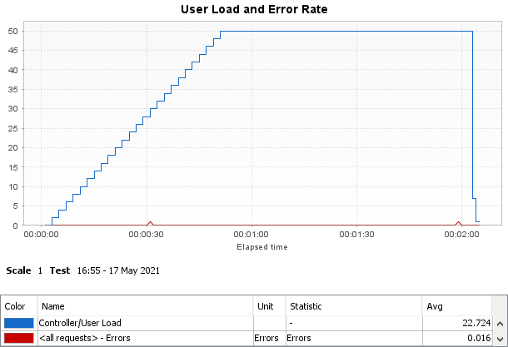

Name | Min | Average | Max
Controller/User Load | 0 | 22.72 | 50
<all requests> - Errors | 0 | 0.02 | 1

Overall Throughput

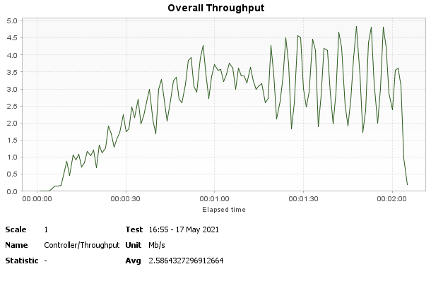

Name | Min | Average | Max
Controller/Throughput | 0 | 2.59 | 4.84

Load Generators CPU usage

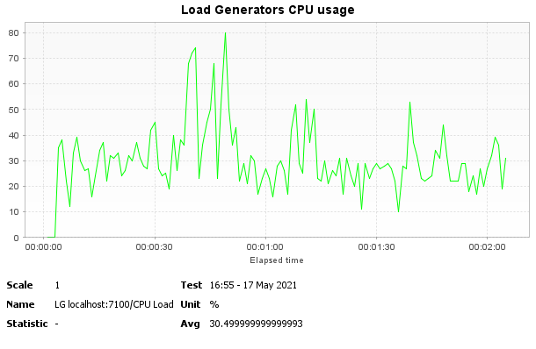

Name | Min | Average | Max
LG localhost:7100/CPU Load | 0 | 30.5 | 80

