Database architecture
- uses a client server model that database is a server and clients may be (GUI , command line , web server )
- uses TCP/IP
- port 5432 is the default port for database connections

Transaction
- transaction’s database’s instructions don’t get send one by one to the database, it is sent as a set of many instructions called transaction.
- If one of them fails , the transaction fails,
- transaction available instructions (UPDATE , DELETE , INSERT )
- you add transactions ’s instructions into transaction then commit your changes to database
- Why ?
  - If any instruction is failed the database won’t fail
  - transactions can happen in parallel without knowing about each other

PostgresSQL
- initial
  - sudo -u <username> -i
  - createdb <dbname>
  - psql dbname
- \l >> list databases
- \dt list database’s tables >> list tables
- \d <table_name> >> show table
- \q quit

Database Adapter (API)
- API for accessing the database via code
- each language has its own API to connect to the database

- psycopg2 is the adapter of python or django or flask
  - connects the database with python
- important : check python files located in the same folder
Indexing
- indexing is for using different data structure to lookup data from database
- CREATE INDEX index_name ON table_name(attribute_name);
- this uses btree for lookup attribute_name instead of linear search
Indexing your (table/document) may increase performance in-case of intensive read operations.
• But when talking about frequently writes to your Indexed (table/document) it cost much.
• Every write to an indexed (table/document)’s (column/field) requires re-indexing all data again.
Recap
https://classroom.udacity.com/nanodegrees/nd0044-ent/parts/2d240500-eecb-45c7-8cb1-e725e8845050/modules/440efd71-b1f4-4afe-b848-f2a38c4849a7/lessons/73c4ae16-eecb-4550-9ba9-29d72f307b33/concepts/7f493ea2-58a5-42eb-9031-1d4071884aa6

SQLAlchemy
- High level Library to access database from python or any framework without directly writing SQL commands into database, SQLAlchemy generates SQL statements
- ORM Object-Relational Mapping library, which provides an interface for using object oriented programmingto interact with a database.
  - It maps the tables, columns into classes and objects so it makes things easier
- Why
  - Avoid writing SQL directly to database for less SQL overhead
  - you can change the database using another SQL without changing the application code
- SQLAlchemy offers several layers of abstraction and convenient tools for interacting with a database.

Layers of SQLAlchemy

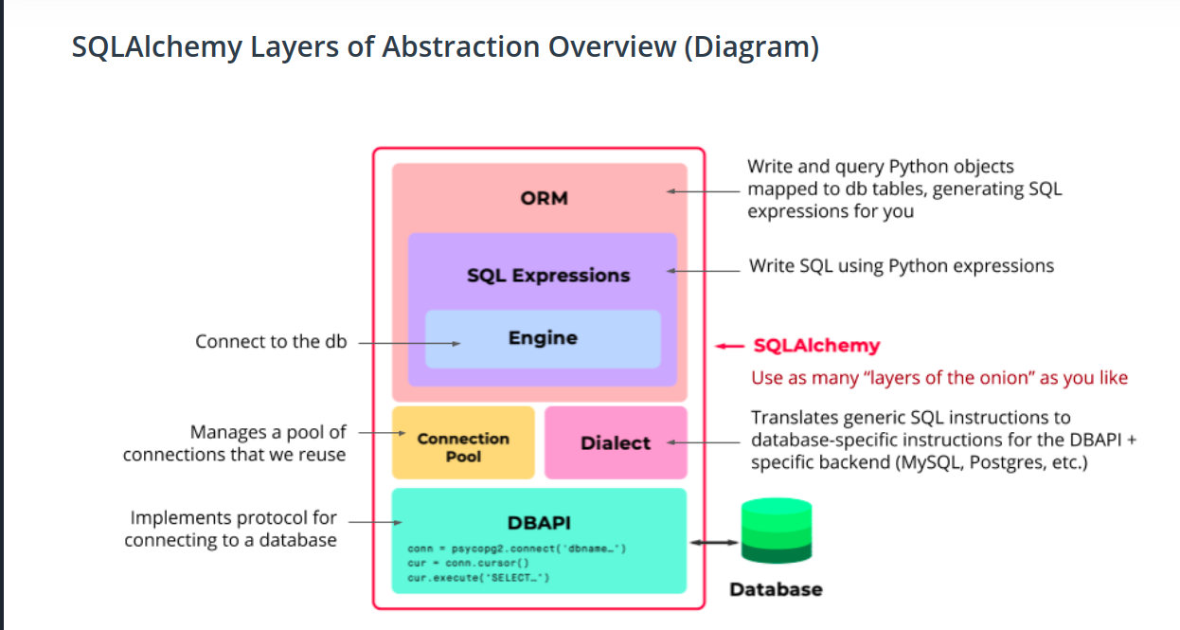
    - DB_API
    - The Dialect
    - Deals with different DBAPIs,abstract the API Handling
    - The Connection Pool
    - abstract opening,closing db, handles connection lost
    - The Engine
    - a way to interact with db just like psycopg2
    - SQL Expressions
    - an expressions to abstract SQL into functions with same name : ex : .select() , .insert() .create()
    - SQLAlchemy ORM (optional)
    - The ORM lets you map from the database schema to the application's Python objects
    - The ORM persists objects into corresponding database tables
https://www.compose.com/articles/using-postgresql-through-sqlalchemy/

SQLAlchemy
- Maps Classes to Tables
- Maps objects to records

Decorator Functions
- decorators wrap a function, modifying its behavior.
- @decorator_function
def function():
# implementation
  - pass the <function> to the <decorator_function> to generate a <new_function that calls the <function> inside it and add some behaviors to it like listening to a socket or something.
  - Also it changes the <function>reference to the <new_function>
- https://realpython.com/primer-on-python-decorators/#decorators-with-arguments
- @app.route(‘/’)
def function() :
  - this is add the listening to URL functionality to the <function>

SQLAlchemy in Flask
- set configurations to the app to connect the database
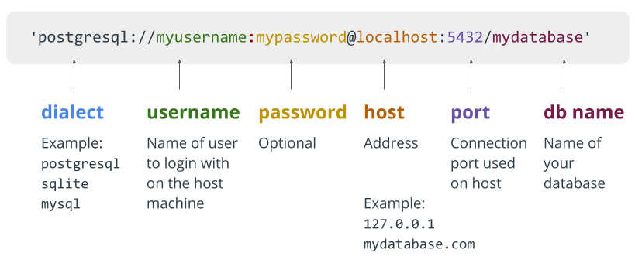
- db.Model lets us create and manipulate data models
- db.session lets us create and manipulate database transactions
- when inheriting from db.Model you create a table or connect to a table with that class

SQLAlchemy Code
- SELECT * FROM <table>
- https://classroom.udacity.com/nanodegrees/nd0044-ent/parts/2d240500-eecb-45c7-8cb1-e725e8845050/modules/440efd71-b1f4-4afe-b848-f2a38c4849a7/lessons/18b19fc8-6007-4479-8461-3a9cadcc2d8b/concepts/4d39ccab-2adb-42fc-9198-30619e9ede5a
  - query generates SELECT statements
    - db. session. query(model) | model. query
    - Chaining Functions
      - supports Chaining (methods return another query to call another filtering)
      - Filter , join ……. Fakes Filter_by
        - Table.query.filter(Table. Attribute == ‘’ )
        - Table.query.filter(Table. Attribute == ‘’, Another_Table. Attribute2 ==’’ )
        - Table.query.filter_by( Attribute_not_Table. Attribute = ‘’ )
        - Table. order_by ( Table. Attribute)
        - Table. query. limit(MAX_Records_Number)
    - Results Functions
      - all , first , get (primary_id) , count , delete
        - all : ( SELECT * )array of elements
        - first : first element
        - count: number of records
        - get : filter and get by primary key
        - delete : delete the record that currently pointed at
- INSERT
  - create new instance from Table
  - db.session.add(Table)
  - db.session.commit()
- Data Types
  - https://flask-sqlalchemy.palletsprojects.com/en/2.x/models/
- Constrains
  - nullable = False
  - unique = True
  - price = db.Column(db. Float, db. CheckConstraint('price>0'))

SEE THE query_sqlalchemy.py

Object Life cycle
- Transit : creation of table object without adding it to a session
- pending : adding into session without commit
  - can be session. rollback() to undo
- flush is an event that transform our code to SQL commands without commit
  - happens when calling query
  - FOR SHORT MAKES THINGS WORK IN CODE BUT NOT IN DATABASE
- Commit to database

SEE THE PYTHON FILES

Parent Child relation , Lists has Items
- relationship
  - define db. relationship in the parent class
- ForeignKey
  - define db. ForeignKey in the child class

we may use both to make it easy to use relationship

- ListClass { items = db. relationship(‘ItemClass’ backref = ‘list’ , lazy = True) }
  - define the relation in the parent class to the child class to make it easy to sqlalchemy
  - backref is the name the parent will be called in the child object , item1. list
  - lazy is for protocol of calling the join , to call it whenever needed
  - lazy = false is eager loading , to call a many join statements in a big one call
- ItemClass { lid = db. Column (Integer , ForeignKey(‘ListClass. Id’) }
  - connect the ForeignKey to the Primary Key of the parent class
- so we can use List_Object. items or Item_Object. list
- if you add a parent to a session or delete it , the childs will have the same action

Lazy loading
Load needed joined data only as needed. Default in SQLAlchemy.
- Pro: no initial wait time. Load only what you need.
- Con: produces a join SQL call every time there is a request for a joined asset. Bad if you do this a lot.

Eager loading
Load all needed joined data objects, all at once.
- Pro: reduces further queries to the database. Subsequent SQL calls read existing data
- Con: loading the joined table has a long upfront initial load time.

For many to many Relationship
- create a Table Object with 2 ForeignKey of the 2 related Classes
- set the db. relationship between the parent and child (the 2 related classes) to access each from the other easily.
- Set the secondary table of the parent class to the table in the first line
- when you use db.session.add() to add Parent or child , the other is added automatically

