Database architecture
- uses a client server model that database is a server and clients may be (GUI , command line , web server )
- uses TCP/IP
- port 5432 is the default port for database connections

Transaction
- transaction’s database’s instructions don’t get send one by one to the database, it is sent as a set of many instructions called transaction.
- If one of them fails , the transaction fails,
- transaction available instructions (UPDATE , DELETE , INSERT )
- you add transactions ’s instructions into transaction then commit your changes to database
- Why ?
  - If any instruction is failed the database won’t fail
  - transactions can happen in parallel without knowing about each other

PostgresSQL
- initial
  - sudo -u <username> -i
  - createdb <dbname>
  - psql dbname
- \l >> list databases
- \dt list database’s tables >> list tables
- \d <table_name> >> show table
- \q quit

Database Adapter (API)
- API for accessing the database via code
- each language has its own API to connect to the database

- psycopg2 is the adapter of python or django or flask
  - connects the database with python
- important : check python files located in the same folder
Indexing
- indexing is for using different data structure to lookup data from database
- CREATE INDEX index_name ON table_name(attribute_name);
- this uses btree for lookup attribute_name instead of linear search
Indexing your (table/document) may increase performance in-case of intensive read operations.
• But when talking about frequently writes to your Indexed (table/document) it cost much.
• Every write to an indexed (table/document)’s (column/field) requires re-indexing all data again.
Recap
https://classroom.udacity.com/nanodegrees/nd0044-ent/parts/2d240500-eecb-45c7-8cb1-e725e8845050/modules/440efd71-b1f4-4afe-b848-f2a38c4849a7/lessons/73c4ae16-eecb-4550-9ba9-29d72f307b33/concepts/7f493ea2-58a5-42eb-9031-1d4071884aa6

SQLAlchemy
- High level Library to access database from python or any framework without directly writing SQL commands into database, SQLAlchemy generates SQL statements
- ORM Object-Relational Mapping library, which provides an interface for using object oriented programmingto interact with a database.
  - It maps the tables, columns into classes and objects so it makes things easier
- Why
  - Avoid writing SQL directly to database for less SQL overhead
  - you can change the database using another SQL without changing the application code
- SQLAlchemy offers several layers of abstraction and convenient tools for interacting with a database.

Layers of SQLAlchemy

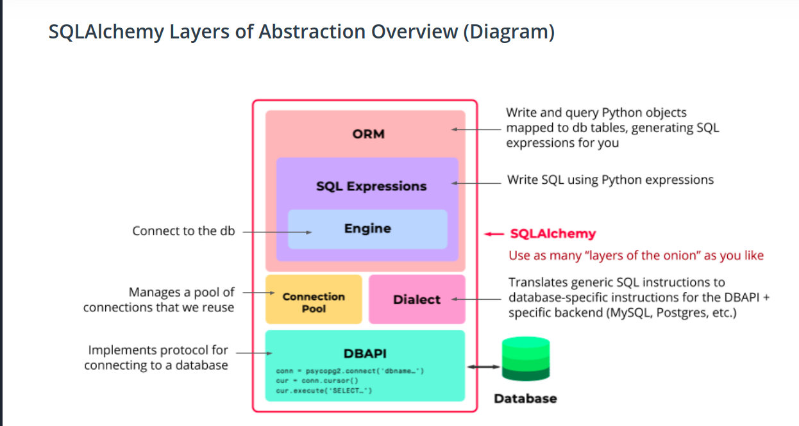
    - DB_API
    - The Dialect
    - Deals with different DBAPIs,abstract the API Handling
    - The Connection Pool
    - abstract opening,closing db, handles connection lost
    - The Engine
    - a way to interact with db just like psycopg2
    - SQL Expressions
    - an expressions to abstract SQL into functions with same name : ex : .select() , .insert() .create()
    - SQLAlchemy ORM (optional)
    - The ORM lets you map from the database schema to the application's Python objects
    - The ORM persists objects into corresponding database tables
SQLAlchemy
- Maps Classes to Tables
- Maps objects to records

Decorator Functions
- decorators wrap a function, modifying its behavior.
- @decorator_function
def function():
# implementation
  - pass the <function> to the <decorator_function> to generate a <new_function that calls the <function> inside it and add some behaviors to it like listening to a socket or something.
  - Also it changes the <function>reference to the <new_function>
- https://realpython.com/primer-on-python-decorators/#decorators-with-arguments
- @app.route(‘/’)
def function() :
  - this is add the listening to URL functionality to the <function>

SQLAlchemy in Flask
- set configurations to the app to connect the database
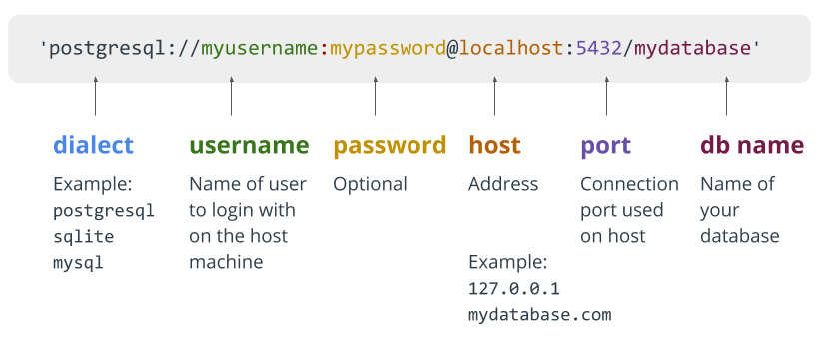
- db.Model lets us create and manipulate data models
- db.session lets us create and manipulate database transactions
- when inheriting from db.Model you create a table or connect to a table with that class

SQLAlchemy Code
- SELECT * FROM <table>
  - Class_Table.query.all()
  - Class_Table.query.filter(attribute == ‘’ )
- INSERT
  - create new instance from Class_Table
  - db.session.add(Class_Table)
  - db.session.commit()
- Data Types
  - https://flask-sqlalchemy.palletsprojects.com/en/2.x/models/

