An Android Application SwiftSlotz: The Smart Way to Slot Your Day

By

**Arnob Bhowmik**

Roll: 1907065

&

**Pantho Haque**

Roll: 1907075



**Supervisor:**

Nazia Jahan Khan Chowdhury

Assistant Professor

Dept. of Computer Science and Engineering Signature

Khulna University of Engineering & Technology (KUET)

**Department of Computer Science and Engineering**

**Khulna University of Engineering & Technology**

**Khulna 9203, Bangladesh**

**December 2023**

**Acknowledgements**

As we reflect on the journey of developing this appointment management application, we are deeply grateful for the unwavering guidance and support provided by my supervisor, Nazia Jahan Khan Chowdhury. Her expertise and insights have been invaluable in shaping both the technical and conceptual aspects of this project. Her ability to challenge conventional thinking and encourage innovative solutions has profoundly influenced the development of this application. Her dedication to academic rigor and practical application has been a source of inspiration and has significantly contributed to my personal and professional growth throughout this endeavor. We are sincerely thankful for her mentorship and for the pivotal role she has played in bringing this project to fruition.

**Arnob & Pantho**

**Abstract**

This report introduces an advanced Android application designed for efficient and intuitive appointment management. The application stands out for its dynamic user status checks, utilizing shared preferences to ascertain the login state of users, thereby offering a seamless and personalized user experience. Its architecture is carefully crafted to enhance user engagement, featuring an easily navigable sidebar, a responsive bottom bar for quick switching, and an app bar leading to a comprehensive profile page. Central to its functionality is the home page, where users can view their daily appointments, categorized, and dynamically updated as upcoming, running, or expired. This real-time update is ingeniously achieved through meticulous comparisons of current time and appointment start times, visually represented through color-coded gradient overlays and progress bars on each appointment card. Additionally, the app includes a range of interconnected pages like the Search User page, Requesting Appointment Page, Mail Page, and others, each thoughtfully designed to streamline the appointment setting and management process. The application also boasts an innovative scheduling feature, presenting a dual-layer pie chart for a bird's-eye view of daily time allocation. The objective of this application is to revolutionize the way appointments are managed, ensuring efficiency, accuracy, and time synchronization across devices. This report delves into the design, implementation, and impact of this sophisticated appointment management system, highlighting its potential to significantly enhance time management and user productivity.

**Contents**

|  |  |  |
| --- | --- | --- |
|  |  | **Page** |
| Acknowledgement |  | ii |
| Abstract |  | iii |
| Contents |  | iv |
| List of Tables |  | vi |
| List of Figures |  | vii |

|  |  |  |
| --- | --- | --- |
| **1** | **Introduction** | 1 |
|  | 1.1 Background / Problem statement | 1 |
|  | 1.2 Objectives | 1 |
|  | 1.3 Scopes | 2 |
|  | 1.4 Unfamiliarity of the problem | 3 |
|  | 1.5 Project planning | 3 |
|  |  |  |
| **2** | **Related Work** | 4 |
|  | 2.1 Related Works Information | 4 |
|  | 2.2 Discussing the Research Gap Solution | 5 |
|  |  |  |
| **3** | **System Design** | 6 |
|  | 3.1 Analysis | 6 |
|  | 3.2 System architecture | 6 |
|  | 3.2.1 Database Schema Description | 7 |
|  | 3.2.2 Supported Pages | 10 |
|  | 3.3 Tools / Platform used | 10 |
|  | 3.3.1 Android Studio | 10 |
|  | 3.3.2 Java | 11 |
|  | 3.3.3 Adobe Illustrator | 11 |
|  | 3.3.4 Git and GitHub | 11 |
|  | 3.3.5 Figma | 12 |
|  | 3.3.6 Blender | 12 |
|  | 3.3.7 Firebase Realtime Database | 12 |
|  | 3.3.8 Firebase Authentication | 13 |
|  | 3.3.9 Firebase Cloud Messaging | 13 |
|  |  |  |
| **4** | **Project Implementation** | 13 |
|  | 4.1 System implementation | 13 |
|  | 4.2 Morality or Ethical | 18 |
|  | 4.3 Socio-economic impact and sustainability | 18 |
|  | 4.4 Financial analyses and budget | 18 |
|  |  |  |
| **5** | **Conclusions** | 19 |
|  | 5.1 Conclusion and challenges faced | 19 |
|  | 5.2 Future work | 20 |
|  |  |  |
|  |  |  |
|  | **References** | 21 |
|  |  |  |

**List of Tables**

|  |  |  |
| --- | --- | --- |
| **Table No.** | **Description** | **Page** |
| 4.4.1 | Development Project Budget | 19 |
|  |  |  |

**List of Figures**

|  |  |  |
| --- | --- | --- |
| **Figure No.** | **Description** | **Page** |
| 3.1 | System Architecture | 7 |
| 3.2 | Database Schema | 9 |
| 4.1 | Appointments Upcoming | 14 |
| 4.2 | Appointments Running | 14 |
| 4.3 | Requesting Appointment | 15 |
| 4.4 | Incoming Requests | 15 |
| 4.5 | User Profile | 16 |
| 4.6 | Appointment Status Notifications | 16 |
| 4.7 | Expired Appointment details | 17 |
| 4.8 | Expired Appointment lists | 17 |

1. Introduction

* 1. Background

In today's fast-paced world, the efficient management of appointments and schedules is more crucial than ever. The current landscape of appointment management solutions is diverse, ranging from basic calendar applications to more complex scheduling systems integrated with various functionalities. Despite the plethora of available options, many users still face challenges in finding a solution that seamlessly integrates flexibility, user-friendliness, and real-time synchronization. This gap in the market led to the conceptualization of our Android-based appointment management application. Our aim was to develop a solution that not only caters to the basic need for scheduling and tracking appointments but also addresses the nuances of user interaction and time management in a digitally interconnected environment.

**1.2 Objectives**

The primary objectives of this application are detailed as follows:

* **Enhanced Efficiency in Appointment Management:** Our goal is to streamline the process of managing appointments. This includes reducing the time and effort required to create, modify, and track appointments, thereby boosting overall productivity for users.
* **Intuitive User Experience:** The application is designed to be user-centric, focusing on ease of use. This involves a clean, navigable interface, ensuring that users can effortlessly find and use the various features available.
* **Real-Time Updates and Notifications:** A key objective is to provide immediate updates on appointment statuses. This includes alerts for upcoming appointments, changes in scheduling, and reminders, ensuring users are always informed and prepared.
* **Comprehensive Daily Schedule Overview:** The application aims to offer users a clear and detailed view of their daily schedules. This is achieved through innovative visual representations, like the dual-layer pie chart, which allow users to quickly grasp their availability and commitments for the day.
* **Seamless Feature Integration:** Another important objective is ensuring that the transition between different features and functionalities within the app is smooth and intuitive. This includes seamless navigation from scheduling to user search, profile management, and historical data review.
* **Adaptive Appointment Tracking:** We aim to make appointment tracking adaptable to various user needs. This includes categorizing appointments based on their status (upcoming, running, expired) and providing different views and filters for better organization.
* **User-Centric Customization:** The application is designed to cater to individual user preferences and needs. This includes customizable notification settings, personalized views, and adjustable appointment details, making the user experience as tailored and relevant as possible.

**1.3 Scope**

The scope of the application encompasses a wide array of functionalities tailored to the modern user's needs. It includes dynamic appointment tracking, where appointments are categorized and updated in real-time based on their status. The application facilitates robust user interaction through features like user profile management, appointment requests, and direct communication options. Time management is another critical aspect, handled through innovative visual representations of daily schedules and timely notifications. The app's design ensures that all these functionalities are interconnected, providing a cohesive and user-friendly experience.

**1.4 Unfamiliarity of the Problem**

While many existing solutions address general appointment management, they often overlook the nuanced challenges faced by users in a multi-device, interconnected environment. Our application specifically targets these challenges, such as ensuring accurate time synchronization across devices, providing visually engaging and intuitive representations of schedules, and implementing a flexible yet robust system for managing various types of appointments. These challenges are unique in the sense that they require a deep understanding of user behavior and technological trends in the digital age.

**1.5 Project Planning**

The development of this application followed a structured project planning approach, beginning with the conception phase, where the initial idea was refined into a viable project plan. This was followed by the design phase, focusing on the application's architecture and user interface. The implementation phase involved rigorous coding, testing, and iterative refinement based on user feedback. Finally, the deployment phase saw the application being made available to users, along with ongoing maintenance and updates based on user engagement and technological advancements. Each stage of development was approached with a focus on quality, user experience, and scalability.

1. Related Works

**2.1 Related Works Information**

The appointment management system domain features a variety of solutions, each with its unique focus and limitations. These are outlined as follows:

* Calendly

**Market Position:** Currently one of the top platforms for appointment scheduling.

**Limitations:** While Calendly offers a mobile version, its core functionalities are primarily web oriented. Users often need to access a browser to manage appointments effectively, which can be inconvenient for mobile-centric users.

* Google Calendar

**Focus:** More of a generalized platform rather than being specifically tailored for intensive appointment management.

**Limitations:** Offers basic solutions for appointment scheduling, lacking advanced controls and features that cater to complex appointment management needs. Its approach is more generic, which may not suit users looking for a more appointment-centric tool.

* OpenMeet

**Availability:** Primarily available under private domains and custom servers.

**Limitations:** Not widely accessible for the average end-user. Its usage is more suited for affluent individuals or organizations with the resources to host private servers, making it less of a universal solution.

* Practo

**Target Audience:** Geared more towards the medical community, especially doctors.

**Limitations:** Tends to focus more on functioning as an advertisement platform rather than offering comprehensive appointment management solutions. Its utility is limited for professionals outside the medical field.

* Goldie

**Intended Audience:** Primarily targets business accounts.

**Limitations:** Does not adequately cater to individuals seeking casual appointment scheduling without financial transactions. Its focus on business accounts limits its applicability for general, personal use.

**2.2 Discussing the Research Gap Solution**

Our application bridges several critical gaps in the current market. Firstly, it introduces a more dynamic approach to appointment status updates, ensuring real-time accuracy and reducing the likelihood of scheduling conflicts. Unlike many existing solutions, our app provides a visually appealing and intuitive user interface, including a dual-layer pie chart for a quick overview of daily schedules. This feature alone significantly enhances the user experience by providing a clear and immediate understanding of one's available time slots. Additionally, our application addresses the need for better time synchronization across devices, an aspect often overlooked in current solutions. This ensures that users receive consistent information regardless of the device they are using. Another unique aspect is the application's ability to handle the lifecycle of an appointment (from creation to expiration) within a single, integrated platform, providing a seamless experience for both the creator and the receiver of the appointment. By focusing on these areas, our application not only fills existing gaps but also introduces new standards in appointment management, setting the stage for future advancements in this field.

**3. System Design**

**3.1 Analysis**

The development of the appointment management application was driven by a comprehensive analysis of user requirements and system specifications. The primary user requirement identified was the need for an intuitive, seamless experience in managing appointments, with real-time updates and a visually engaging interface. Users also expressed the need for a system that could handle complex appointment schedules while ensuring time synchronization across multiple devices. System specifications were designed to meet these requirements, focusing on a robust, scalable architecture that could accommodate various functionalities such as appointment tracking, user interactions, and time management. The application was also designed to support various user actions, like searching for users, requesting appointments, and managing appointment statuses, all within an easy-to-navigate interface.

**3.2 System Architecture**

The architecture of the application is centered around a user-friendly interface, comprising a sidebar for easy navigation, a bottom bar for quick switching between features, and an app bar that directs users to their profile page. Upon logging in, users are directed to the homepage by default, which displays the day's appointments. This design choice ensures that the most immediately relevant information is presented upfront.

Appointments are displayed in a card view and are categorized into three statuses: upcoming, running, and expired. Upcoming and running appointments are shown on the homepage, while expired ones are moved to the History page, accessible from the sidebar. Each appointment card displays key information and is visually distinguished by color-coded gradient overlays - blue for running and orange for upcoming appointments. The application dynamically updates these statuses by comparing the current time with the start time of appointments.

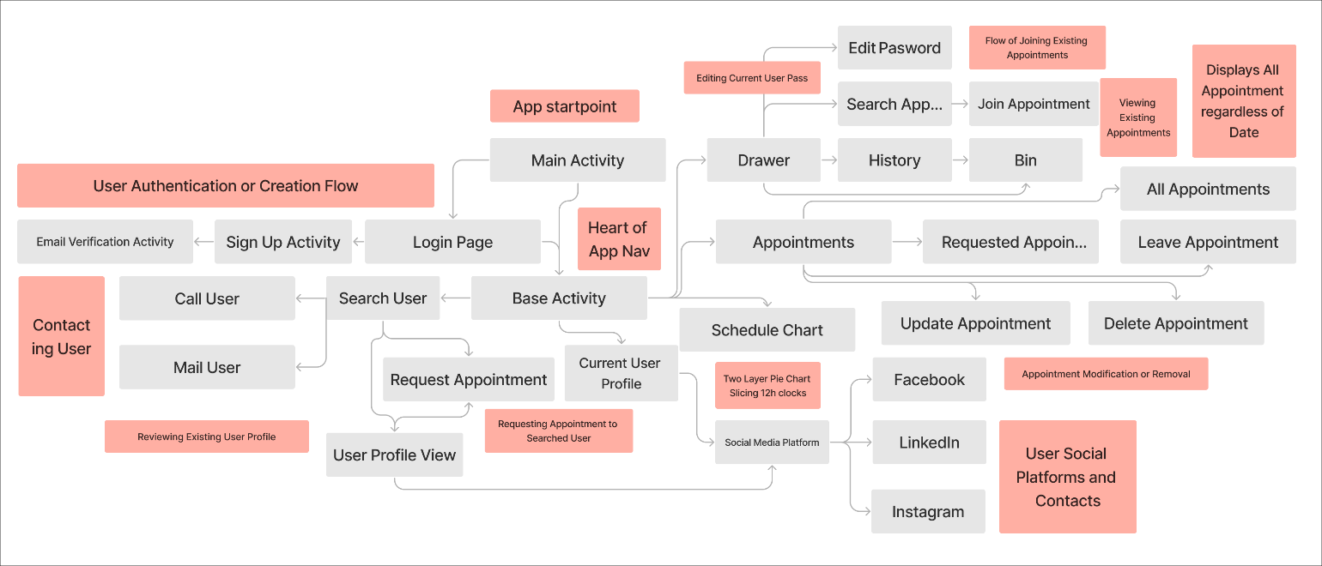

Fig 3.1: System Architecture

**3.2.1 Database Schema Description**

The database schema for our appointment management application is meticulously designed to efficiently handle and organize appointment data, user information, and their interrelations. The schema is structured around three primary nodes: Appointments Collection, Expired Database, and Users.

* **Appointments Collection Node:** This is a global collection of all appointments within the application. Each entry in this collection represents an individual appointment, detailing its specific attributes such as time, date, status, and other relevant details. An integral part of each appointment entry is the involvedUser node. This node contains keys referencing the Users node, effectively binding an appointment to multiple users. This structure allows for a many-to-many relationship, where each appointment can be associated with multiple users and vice versa.
* **Expired Database Schema:** This node functions as a global repository for all expired appointments. It serves as an archival record, keeping track of appointments that have passed their validity. This node is crucial for historical data analysis and for users who wish to review past appointments.
* **Users Node:** This node contains comprehensive information about all users of the application. It includes user-specific data such as contact information, preferences, and settings. Within each user's entry, there are two significant sub-nodes:
* **Appointments Node:** This sub-node holds keys that link back to the Appointments Collection. It represents the appointments associated with that user, facilitating quick retrieval and management of the user's current appointments.
* **Expired Appointments Node:** This is dedicated to storing keys of the user's expired appointments, providing a link back to the Expired Database. It serves as a personal historical record for each user.
* **Removed Appointments Node:** This sub-node maintains snapshots of valid appointments at the time of their removal. It acts as a 'bin' or 'trash' feature, preserving records of previously valid appointments for potential recovery or record-keeping purposes.

This database schema is designed to provide a robust, scalable, and efficient way of managing complex relationships between appointments and users. It ensures data integrity and easy accessibility, thereby enhancing the overall functionality of the application.

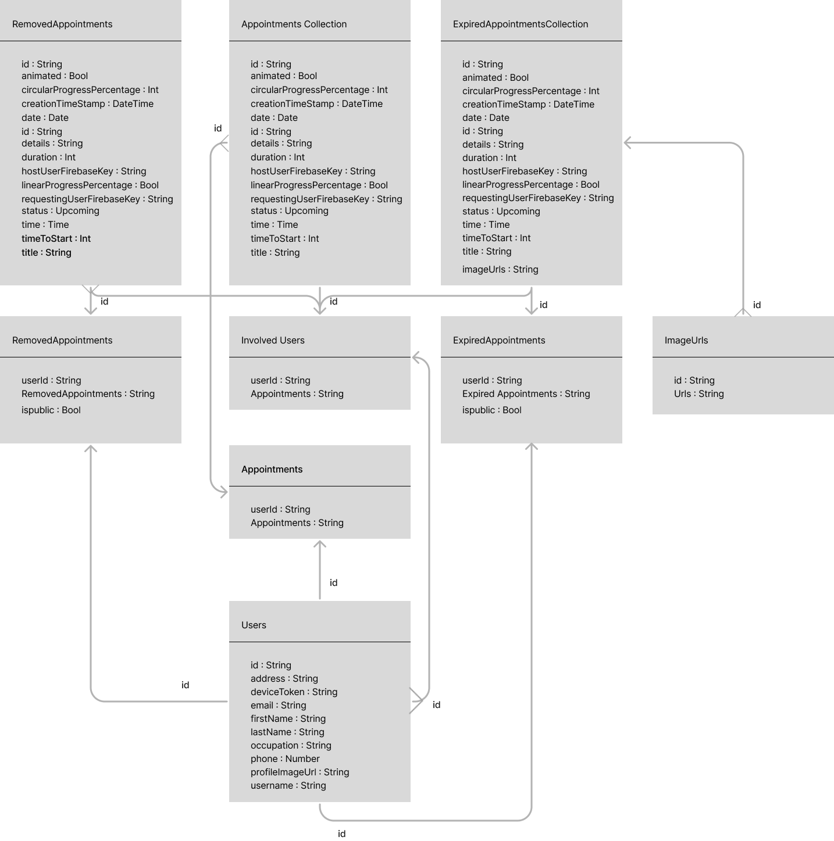

Fig 3.2: Database Schema

**3.2.2 Supported Pages**

The system architecture supports additional pages for enhanced functionality:

* **Search User Page:** Implements a Firebase database key search, allowing for subquery searches and displaying results in a card view.
* **Requesting Appointment Page:** Features a calendar and timer for setting appointment details and sends instant notifications upon appointment requests.
* **Mail Page:** Manages incoming appointment requests, allowing users to accept or reject them, and sends corresponding notifications.
* **Profile Page:** Displays and allows editing of user information and includes links to social platforms.
* **Expired Appointments Page:** Lists all expired appointments, with the functionality to view detailed information.
* **Trash Page:** Stores deleted appointments for record-keeping.
* **Schedule Page:** Visualizes appointment slots using a two-layer pie chart, representing AM and PM hours, providing an overview of the day's schedule. Each page is integrated to work seamlessly with others, ensuring a cohesive user experience. The application's backend uses threads and asynchronous tasks for dynamic updates, ensuring that the system remains responsive and efficient.

**3.3 Tools Used**

**3.3.1 Android Studio**

Android Studio played a pivotal role in the development of our appointment management application. As the official integrated development environment (IDE) for Android development, it provided a comprehensive suite of tools that were essential for efficient coding, debugging, and testing. Android Studio's user-friendly interface and powerful code editor greatly enhanced our productivity. Its built-in emulator allowed for immediate testing of the application under various Android versions and device types, ensuring broad compatibility and smooth user experiences. The IDE's Gradle-based build system made it easy to manage dependencies and customize builds, while its layout editor simplified the process of designing user interfaces, making the implementation of complex layouts more manageable.

**3.3.2 Java**

Java, being a versatile and widely used programming language, was chosen for its robustness and reliability. It enabled us to implement a range of functionalities, from basic user interactions to complex appointment scheduling and status updating algorithms. Java's object-oriented nature facilitated modular and scalable code development, which was crucial for maintaining and expanding the application's feature set. Additionally, Java's well-established libraries and frameworks provided valuable resources for handling database connections, user interface elements, and network communications, making it an ideal choice for developing a feature-rich Android application.

**3.3.3 Adobe Illustrator**

This tool was indispensable for creating custom, user-friendly icons, and graphics. Its vector-based graphics ensured high-quality visuals, enhancing the application's aesthetic appeal.

**3.3.4 Git and GitHub**

These were used for version control and team collaboration. Git allowed us to track changes and manage code effectively, while GitHub provided a platform for collaborative development, enabling team members to work simultaneously on different parts of the application.

**3.3.5 Figma**

Figma played a crucial role in our UI/UX design process. It enabled us to create and iterate on the app's mockup designs collaboratively. Its intuitive interface and real-time collaboration features made it easy to visualize and refine the user interface and experience before actual coding.

**3.3.6 Blender**

Used for generating 3D views, Blender helped in creating visually appealing representations of the application. This was particularly useful for marketing materials and presentations, where showcasing the app's functionality in a dynamic, three-dimensional space added an extra layer of engagement.

**3.3.7 Firebase Realtime Database**

Firebase Realtime Database played a pivotal role in our application, providing a cloud-hosted database. It allowed us to store and sync data between users in real-time, ensuring that all users always had access to the latest information. This functionality was especially important for successfully handling appointment calendars and user interactions efficiently.

**3.3.8 Firebase Authentication**

Firebase Authentication was integral to our security framework. It provided a comprehensive set of authentication features, enabling us to offer our users a safe, secure, and hassle-free login experience. This system supported various authentication methods, including email and password, and third-party providers, enhancing the application's accessibility and user trust.

**3.3.9 Firebase Cloud Messaging**

Firebase Cloud Messaging (FCM) was essential for delivering real-time notifications to users. It enabled us to send notifications about appointment updates, reminders, and other important alerts, enhancing user engagement and ensuring that users were always informed about their appointment schedules.

These tools collectively contributed to various aspects of the application's development, from design and programming to collaboration and version control. Each played a specific role, harmonizing together to bring the project to successful completion.

**4. Project Implementation**

**4.1 System Implementation**

The implementation of the appointment management application was a multifaceted process, involving several stages. Initially, the focus was on setting up a robust and scalable backend, which involved integrating Firebase for real-time database interactions. The front-end development, handled primarily through Android Studio, followed the design mockups created in Figma. We encountered challenges in ensuring real-time synchronization of appointment statuses across different user devices. This was resolved through the implementation of efficient database querying and update mechanisms, along with optimized use of threads and asynchronous tasks in Java.

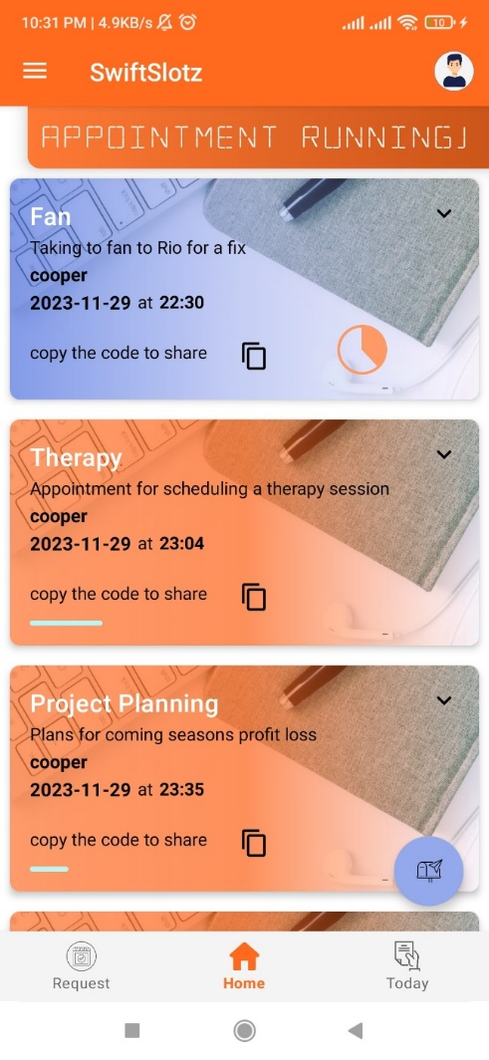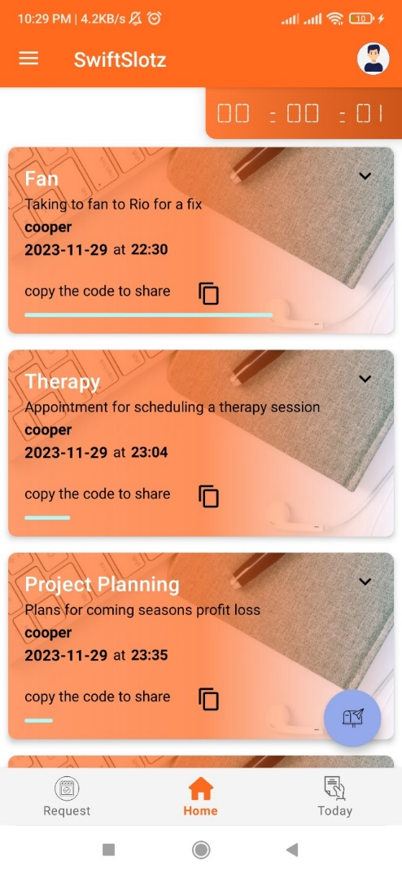Another significant challenge was the intuitive presentation of complex data, such as the dual-layer pie chart for schedule visualization. This required sophisticated programming, achieved through a combination of Java and Blender for 3D visualization, and rigorous testing for usability. Throughout the development process, continuous integration, and deployment, facilitated by Git and GitHub, enabled a smooth workflow and collaborative environment.

Fig 4.1: Appointments Upcoming Fig 4.2: Appointments Running

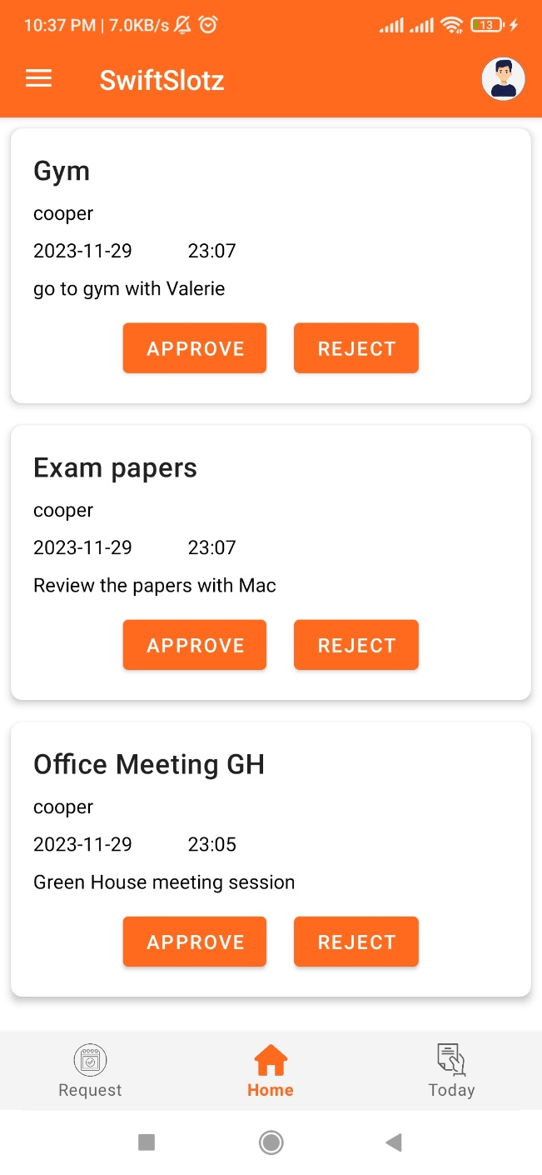

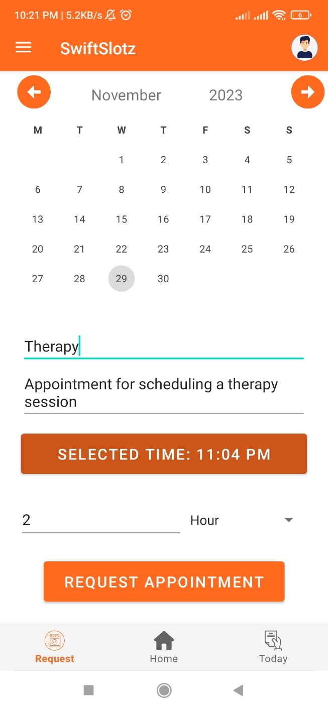

Fig 4.3: Requesting Appointment Fig 4.4: Incoming Requests

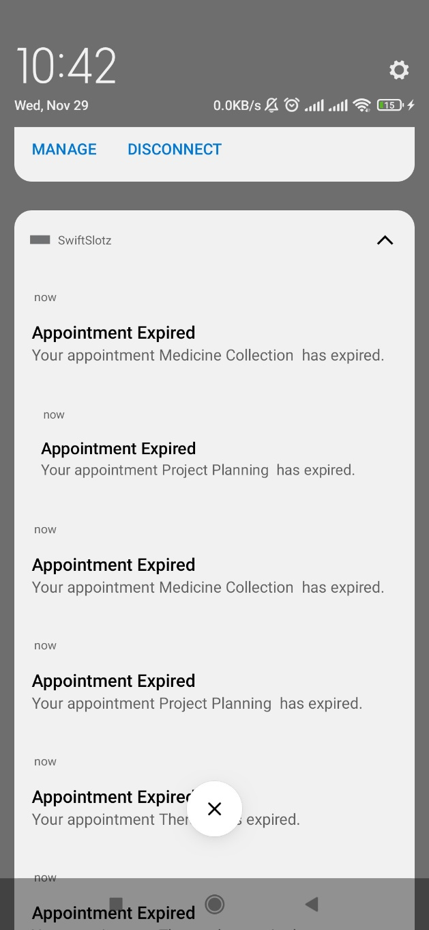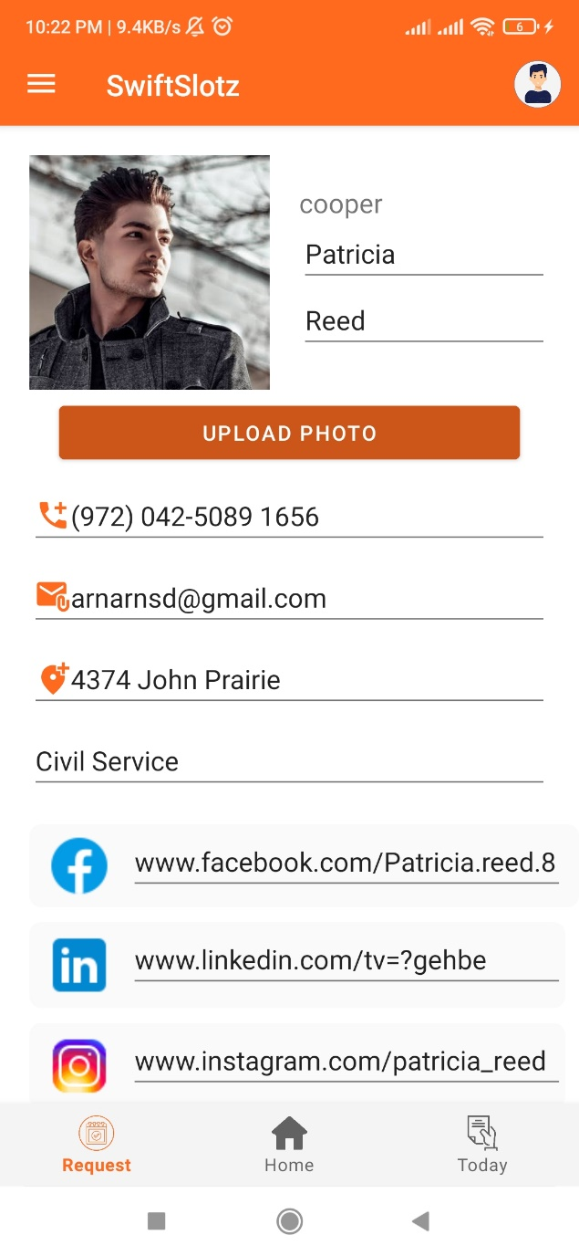

Fig 4.5: User Profile Fig 4.6: Appointment Status Notifications

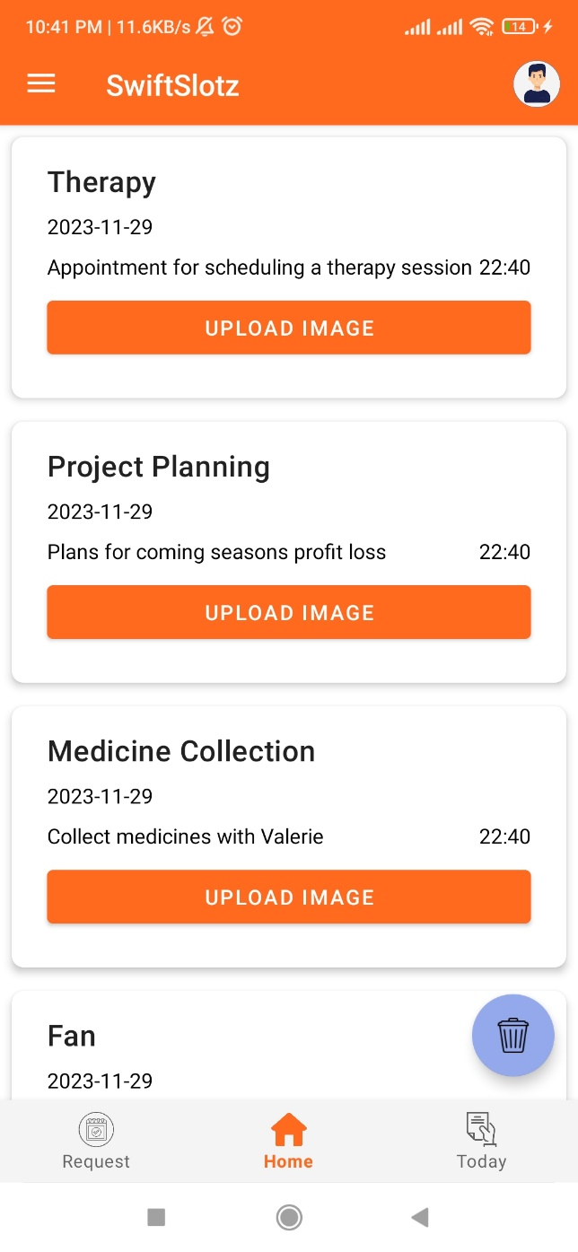

Fig 4.7: Expired Appointment details Fig 4.8: Expired Appointment lists

**4.2 Morality or Ethical Issues**

In developing the application, ethical considerations were paramount, particularly regarding user privacy and data security. We ensured compliance with data protection regulations like GDPR and secure user authentication. The application also provides users with clear privacy settings, allowing them to control their personal information and how it is shared. Ethical design principles were employed, ensuring that the application does not manipulate user behavior or promote addictive usage patterns.

**4.3 Socio-Economic Impact and Sustainability**

The app is designed to have a positive socio-economic impact by enhancing personal and professional productivity. By streamlining the process of appointment management, it allows users to better organize their time, leading to increased efficiency in both personal and professional settings. The application's user-friendly interface makes it accessible to a broad audience, reducing the digital divide. In terms of sustainability, the application promotes paperless appointment management, contributing to environmental conservation efforts. The scalable architecture ensures that the app can adapt to increasing user numbers and evolving user needs, making it a sustainable solution in the long term.

**4.4 Financial Analysis Budget**

The financial aspect of the project included initial development costs, such as expenditures for software tools, cloud services, and team remunerations. Development tools like Android Studio and Blender were free, but expenses were incurred for Adobe Illustrator and Figma subscriptions, and Firebase cloud services. The budget also accounted for ongoing maintenance costs, including server hosting fees, periodic updates, and customer support. A portion of the budget was allocated for marketing and promotional activities to increase app visibility and user acquisition. Future financial planning includes a monetization strategy, possibly through a freemium model, to ensure the app's long-term financial sustainability.

|  |  |
| --- | --- |
| Cost Item | Approximate Cost (Tk) |
| 1. Firebase Blaze Plan | 2,140 |
| 1. Adobe Illustrator | 3,745 |
| 1. Uizards | 1,284 |
| 1. PC as Development Platform | 107,000 |
| 1. Graphics Pad for Drawables | 10,200 |
| 1. Broadband Connection | 1,000 |
| 1. Android Device for Testing | 17,000 |
| 1. Professional Developer Consultation | 16,050 |
| 1. Cloud Storage and Backup Solution | 10,700 |
| 1. Testflight Testing Services | 5,350 |
| 1. Microsoft Project Subscription | 2,675 |
| 1. Legal and Compliance Consulting Fees | 535 |
| 1. Marketing and Promotion | 53,500 |
| 1. Miscellaneous Expenses | 2,140 |
| Net | 2,33,619 |

Table 4.4.1: Development Project Budget

**5. Conclusion**

**5.1 Conclusion and Challenges Faced**

The development of the appointment management application represents a significant step forward in digital time management tools. This project successfully integrated complex functionalities like real-time appointment tracking, dynamic user status updates, and a visually engaging interface into a cohesive, user-friendly application. Throughout the development process, we faced and overcame numerous challenges, such as ensuring real-time data synchronization across different devices and creating an intuitive yet detailed visual representation of users' schedules. These obstacles were met with innovative solutions, such as the use of advanced programming techniques in Java and leveraging the capabilities of tools like Firebase and Blender.

**5.2 Future Study**

Future enhancements for the application are outlined as follows:

* **Artificial Intelligence and Machine Learning Integration:** Implement AI and ML to provide predictive scheduling and personalized appointment suggestions, tailored to individual user behavior patterns.
* **Cross-Platform Compatibility:** Develop the application for various operating systems and devices, broadening accessibility, and user reach.
* **Integration with External Calendars and social media:** Explore deeper connections with external calendars and social media for a more comprehensive schedule management experience.
* **Ongoing User Experience Research:** Continually refine and adapt the application's interface and functionalities based on user feedback and evolving usage patterns.
* **Cost Approximation for Business Appointments:** Implement a feature where users can see an estimated cost when requesting appointments with business accounts, based on the duration of the appointment.
* **Time Slot Availability Warnings:** Introduce a system that alerts users if their requested time slot is unavailable or already booked for the appointment receiver.
* **Collision Detection in Scheduling:** Enable the application to identify potential conflicts with other appointments when approving a request, providing users with clear visibility of scheduling overlaps.
* **Automated Collision Resolution:** Utilize machine learning algorithms to automatically suggest alternatives or adjustments to resolve scheduling conflicts, enhancing the efficiency of appointment management.

Each of these enhancements aims to make the application more intelligent, user-friendly, and adaptable to the diverse needs of its users. By focusing on these areas, the application will not only improve current functionalities but also pioneer new standards in digital appointment management.

**References**

1. Android Studio Documentation [<https://developer.android.com/studio>]
2. Firebase Documentation [<https://firebase.google.com/docs>]
3. Java Programming Language Resources [[https://docs.oracle.com/javase/8/docs/]](https://docs.oracle.com/javase/8/docs/%5d)
4. Figma User Interface Design Guides [<https://www.figma.com/resources/>]
5. Adobe Illustrator Tutorials and Guides [<https://helpx.adobe.com/illustrator/tutorials.html>]
6. Blender 3D Modeling Resources[<https://www.blender.org/support/tutorials/>]
7. General Data Protection Regulation (GDPR) Compliance Guidelines [<https://gdpr-info.eu/>]
8. “Effective Java” by Joshua Bloch

Book Reference: Bloch, Joshua. "Effective Java". Addison-Wesley Professional, 3rd Edition, ISBN-13: 978-0134685991

1. “Android Programming: The Big Nerd Ranch Guide” by Bill Phillips and Chris Stewart
2. "Clean Code: A Handbook of Agile Software Craftsmanship" by Robert C. Martin
3. "Don't Make Me Think, Revisited: A Commonsense Approach to Web Usability" by Steve Krug
4. "The Design of Everyday Things" by Don Norman
5. "Android Programming for Beginners: Build in-depth, full-featured Android apps starting from zero programming experience, 2nd Edition" by John Horton
6. "Learning Java: An Introduction to Real-World Programming with Java" by Patrick Niemeyer and Daniel Leuck
7. "Hooked: How to Build Habit-Forming Products" by Nir Eyal
8. "About Face: The Essentials of Interaction Design" by Alan Cooper, Robert Reimann, David Cronin, and Christopher Noessel
9. "100 Things Every Designer Needs to Know About People" by Susan Weinschenk
10. "Color Accessibility Workflows" by Geri Coady
11. "The Elements of User Experience: User-Centered Design for the Web and Beyond" by Jesse James Garrett
12. Phillips, Bill, and Chris Stewart. "Android Programming: The Big Nerd Ranch Guide". Big Nerd Ranch Guides, 4th Edition, ISBN-13: 978-0135245125
13. Android Developers Blog:[<https://android-developers.googleblog.com/>]