# **CSC 431** <Project Name> System Architecture Specification (SAS)

**<Team number>**

|  |  |
| --- | --- |
| <Member Name> | <Role> |
| <Member Name> | <Role> |
| <Member Name> | <Role> |
| <Member Name> | <Role> |

# Version History

|  |  |  |  |
| --- | --- | --- | --- |
| Version | Date | Author(s) | Change Comments |
|  |  |  |  |
|  |  |  |  |
|  |  |  |  |
|  |  |  |  |

# Table of Contents

1. System Analysis 6

1.1 System Overview 6

1.2 System Diagram 6

1.3 Actor Identification 6

1.4 Design Rationale 6

1.4.1 Architectural Style 6

1.4.2 Design Pattern(s) 6

1.4.3 Framework 6

2. Functional Design 7

2.1 Diagram Title 7

3. Structural Design 8

4. Behavioral Design 9

# Table of Tables

<Generate table here>

# Table of Figures

<Generate table here>

### System Analysis

#### System Overview

The whole system is composed of Data Collection System, Room Inventory Management System, Customer Information Management System, Main Service. The data collection system uses the data source as the data management of the latter two systems. The main idea of Inventory Management is catching the data send the date to service to show the item if is available or not. For Customer Relationship Management is identify user information send information to service. The main server checks with the hotel system, and then needs to obtain data from the two systems and update the data.

#### System Diagram

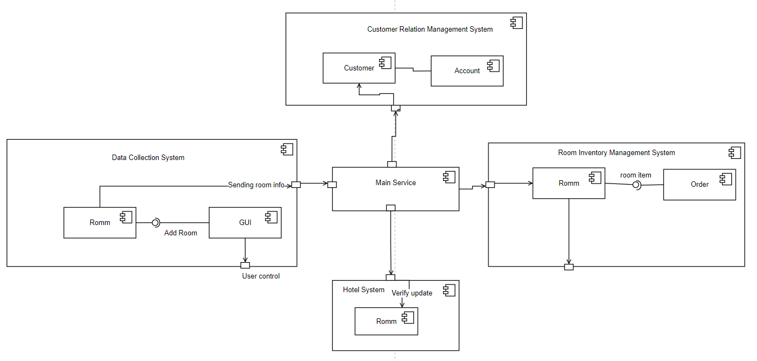

#### Actor Identification

Customers can add and resell their own rooms in the system.

Buyers interact with room searching method and payment method.

Main Service Confirm room and Upload room info method interact with System.

Data Collection System interact with data source such as room info or user info.

#### Design Rationale

##### Architectural Style

The system will use the client-server architecture, the server: is responsible for providing services to other subsystems, such as the database server to provide data storage and management services. Client: Request service from the server. Clients are usually independent subsystems. In a certain period of time, there may be multiple client programs running concurrently, such as data collection systems, inventory systems, and customer relationship management systems. The advantage of C/S is that it can give full play to the processing capabilities of the client, and a lot of work can be submitted to the server after being processed by the client. Make the client's response speed fast, can reduce the pressure on the server, and have higher security and stability.

##### Design Pattern(s)

MVC pattern: The MVC model represents the Model-View-Controller model used for hierarchical development of applications. The system is divided into three parts, and the model represents an object or JAVA POJO that accesses data. It can also have logic to update the controller when the data changes. The view represents the visualization of the data contained in the model. The controller acts on the model and the view. It controls the flow of data to model objects and updates the view when the data changes. It separates the view from the model. The MVC mode separates the interface data and operations of the system, which is more conducive to the development of each module.

Observer Pattern: Using the observer mode, when the state of an object changes, all objects that depend on it are notified and automatically updated. When the user successfully pays for the house, it will automatically notify the hotel and the person who resells the room.

##### Framework

Non-modifiable framework code: The framework code, in general, is not supposed to be modified, while accepting user-implemented extensions. In other words, users can extend the framework, but cannot modify its code. The program will use java as program language and using a .csv file to store all the room information, as a database.

### Functional Design

<Identify all significant workflows as sequence diagrams using the following format>

#### Diagram Title

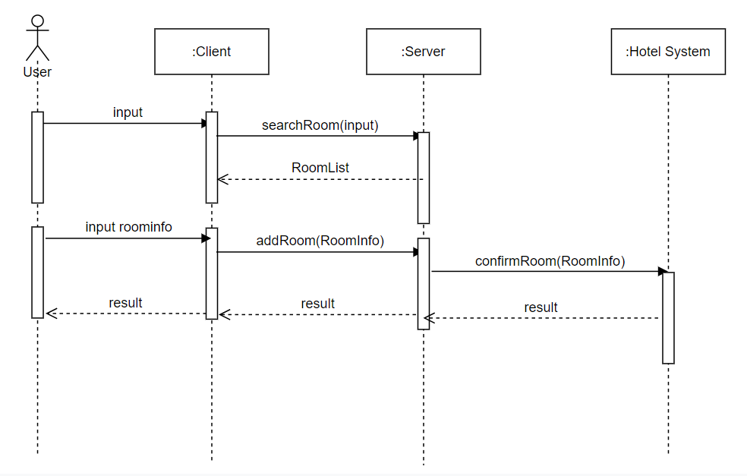

First, the user inputs room information to the client, and the customer service terminal requests all room information from the server to be displayed to the user. Users can choose to enter room information and add it to the server to resell their rooms. The system will verify the guest room, go to the Hotel backstage to verify the validity of the guest room and then return the result.

### Structural Design

