# 一張含有 文字, 美工圖案 的圖片 自動產生的描述 CSC 431 <Wudi> Software Requirements Specification (SRS)

**<Team 8>**

|  |  |
| --- | --- |
| <Dongyan Zhou> | <Role> |
| <Member Name> | <Role> |
| <Member Name> | <Role> |
| <Member Name> | <Role> |

# Version History

|  |  |  |  |
| --- | --- | --- | --- |
| Version | Date | Author(s) | Change Comments |
|  |  |  |  |
|  |  |  |  |
|  |  |  |  |
|  |  |  |  |

# Table of Contents

1. System Requirements 6

1.1 Functional Requirements 6

1.1.1 Requirement Title 6

1.2 Non-Functional Requirements 6

1.2.1 Requirement Title 6

2. System Constraints 7

2.1 Tool Constraints 7

2.1.1 Requirement Title 7

2.2 Language Constraints 7

2.2.1 Requirement Title 7

2.3 Platform Constraints 7

2.3.1 Requirement Title 7

2.4 Hardware Constraints 7

2.4.1 Requirement Title 7

2.5 Network Constraints 7

2.5.1 Requirement Title 8

2.6 Deployment Constraints 8

2.6.1 Requirement Title 8

2.7 Transition & Support Constraints 8

2.7.1 Requirement Title 8

2.8 Budget & Schedule Constraints 8

2.8.1 Requirement Title 8

2.9 Miscellaneous Constraints 8

2.9.1 Requirement Title 8

3. Requirements Modeling 10

3.1.1 Requirement Title 10

4. Evolutionary Requirements 11

4.1 Functional Requirements 11

4.1.1 Requirement Title 11

4.2 Non-Functional Requirements 11

4.2.1 Requirement Title 11

# Table of Tables

<Generate table here>

# Table of Figures

<Generate table here>

### System Requirements

#### Functional Requirements

< List all functional requirements in the following example format >

##### **Customer sell room**

|  |  |
| --- | --- |
| Title | Customer sell room |
| Description | The customer needs to sell the room that has been booked in the hotel for some reason |
| Priority | 0 |
| Precondition(s) | 1. The customer has booked a hotel room and paid 2. The customer cannot use the room for some reason |
| Basic Flow | Step1:Customer sends room information to our system  Step2:Our software confirms the room with hotel  Step3:After successful verification, uploads the room information to our published website.  Step4:Waiting for buyer to buy |
| Postconditions(s) | If someone buys it, then there is no cancellation fee, otherwise it still has to be paid. |
| Use Case Diagram | 3.1.1 |

##### **Buyer order room**

|  |  |
| --- | --- |
| Title | Buyer order room |
| Description | The buyer browses the hotel room information in the system and finds the room he needs to pay for the reservation. |
| Priority | 1 |
| Precondition(s) | 1. Someone resells hotel rooms 2. Room information exists in the system and has not been booked by payment |
| Basic Flow | Step1:The buyer browses the system and chooses the hotel room he wants to live in  Step2:Buyer pays to the system  Step3:The system automatically modifies the reservation information  Step4:The system informs the hotel and the reseller that the room has been sold  Step5: Buyer gets the room |
| Postconditions(s) | If the buyer successfully pays, then the room will be obtained, and the reseller will not have to pay the cancellation fee. |
| Use Case Diagram | 3.1.2 |

#### Non-Functional Requirements

< List all non-functional requirements in the following example format >

##### **Response time**

|  |  |
| --- | --- |
| Title | Response time |
| Description | The response time of the system should be very fast, the response time should not exceed 1.5 seconds during the general period and 4 seconds during the peak period. |
| Priority | 0 |
| Applicable FR(s) | All functional requirements should be this applicable to. |

##### **Data security**

|  |  |
| --- | --- |
| Title | Data security |
| Description | The personal information of system users should not be disclosed, and the use of such information requires user authorization. |
| Priority | 0 |
| Applicable FR(s) | All functional requirements should be this applicable to. |

##### **Reliability**

|  |  |
| --- | --- |
| Title | Reliability |
| Description | The system is robust and should be able to deal with various abnormal situations that occur during system operation, such as: human operation errors, illegal data input, hardware device failures, etc. The system should be able to handle them correctly and avoid them appropriately. |
| Priority | 0 |
| Applicable FR(s) | All functional requirements should be this applicable to. |

##### **Maintainability**

|  |  |
| --- | --- |
| Title | Maintainability |
| Description | After receiving the modification request, the general modification should be completed within 1 to 2 days; for the major requirement or design modification after the evaluation, it should be completed within 1 week. |
| Priority | 2 |
| Applicable FR(s) | All functional requirements should be this applicable to. |

### System Constraints

#### Tool Constraints

< List all tool constraints in the following example format >

|  |  |
| --- | --- |
| Title | AWS |
| Description | Amazon Web Services (AWS) is the world's most comprehensive and widely used cloud platform, providing more than 200 full-featured services from global data centers. |
| Priority | 1 |

#### Language Constraints

< List all language constraints in the following example format >

|  |  |
| --- | --- |
| Title | Java or python |
| Description | The software system is developed using java or python and deployed using Amazon servers. |
| Priority | 1 |

#### Platform Constraints

< List all platform constraints in the following example format >

|  |  |
| --- | --- |
| Title | Android or IOS and PC |
| Description | The system should provide mobile phones and computer platforms, which can be used by users at any time |
| Priority | 1 |

#### Hardware Constraints

< List all hardware constraints in the following example format >

|  |  |
| --- | --- |
| Title | Windows 10 |
| Description | Use windows 10 operating system to write programs |
| Priority | 2 |

#### Network Constraints

< List all network constraints in the following example format >

|  |  |
| --- | --- |
| Title | Network |
| Description | The network should be stable and reliable, and the user response time should not exceed 1.4 seconds under normal circumstances, and should not exceed 4 seconds during peak periods. |
| Priority | 1 |

#### Deployment Constraints

< List all deployment constraints in the following example format >

|  |  |
| --- | --- |
| Title | GUI interface, Web server, application server and DB |
| Description | This deployment method is suitable for complex business logic, our two systems and the central server. |
| Priority | 1 |

#### Transition & Support Constraints

< List all transition & support constraints in the following example format >

|  |  |
| --- | --- |
| Title | Transition & Support Constraints |
| Description | There is a backup server in the system, which can be used after the main server node is down. |
| Priority | 1 |

#### Budget & Schedule Constraints

< List all budget & schedule constraints in the following example format >

|  |  |
| --- | --- |
| Title | Budget & Schedule |
| Description | In the early stage, it is necessary to pull sponsor investment funds for hardware purchase and personnel development, and the system is expected to be completed in 3 months. |
| Priority | 1 |

#### Miscellaneous Constraints

< List all miscellaneous constraints in the following example format >

|  |  |
| --- | --- |
| Title | Personnel constraints |
| Description | The development team needs 20 people, of which 10 are responsible for the back-end, five are responsible for the front, 3 are responsible for testing, and 2 are responsible for operation and maintenance. |
| Priority | 1 |

### Requirements Modeling

< List all Use-case diagrams for the functional requirements in the following format>

##### **Sell room**

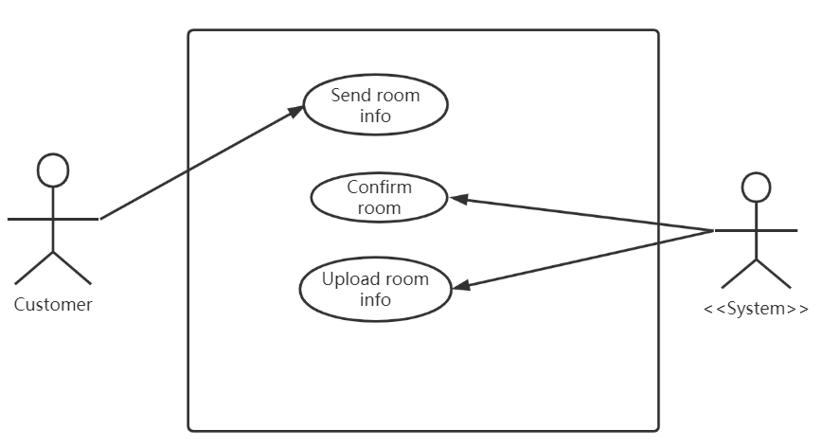

##### **Order room**

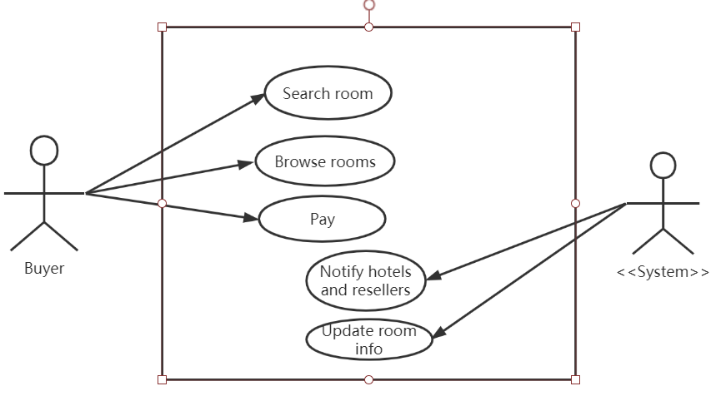

### Evolutionary Requirements

#### Functional Requirements

< List all functional requirements in the following example format >

##### **Customer sell room**

|  |  |
| --- | --- |
| Title | Customer sell room |
| Description | The customer needs to sell the room that has been booked in the hotel for some reason |
| Priority | 0 |
| Precondition(s) | 1. The customer has booked a hotel room and paid 2. The customer cannot use the room for some reason |
| Postconditions(s) | If someone buys it, then there is no cancellation fee, otherwise it still has to be paid. |
| Use Case Diagram | 3.1.1 |

##### **Buyer order room**

|  |  |
| --- | --- |
| Title | Buyer order room |
| Description | The buyer browses the hotel room information in the system and finds the room he needs to pay for the reservation. |
| Priority | 1 |
| Precondition(s) | 1. Someone resells hotel rooms 2. Room information exists in the system and has not been booked by payment |
| Postconditions(s) | If the buyer successfully pays, then the room will be obtained, and the reseller will not have to pay the cancellation fee. |
| Use Case Diagram | 3.1.2 |

#### Non-Functional Requirements

< List all non-functional requirements in the following example format >

##### **Response time**

|  |  |
| --- | --- |
| Title | Response time |
| Description | The response time of the system should be very fast, the response time should not exceed 1.5 seconds during the general period and 4 seconds during the peak period. |
| Priority | 0 |
| Applicable FR(s) | All functional requirements should be this applicable to. |

##### **Data security**

|  |  |
| --- | --- |
| Title | Data security |
| Description | The personal information of system users should not be disclosed, and the use of such information requires user authorization. |
| Priority | 0 |
| Applicable FR(s) | All functional requirements should be this applicable to. |

##### **Reliability**

|  |  |
| --- | --- |
| Title | Reliability |
| Description | The system is robust and should be able to deal with various abnormal situations that occur during system operation, such as: human operation errors, illegal data input, hardware device failures, etc. The system should be able to handle them correctly and avoid them appropriately. |
| Priority | 0 |
| Applicable FR(s) | All functional requirements should be this applicable to. |

##### **Maintainability**

|  |  |
| --- | --- |
| Title | Maintainability |
| Description | After receiving the modification request, the general modification should be completed within 1 to 2 days; for the major requirement or design modification after the evaluation, it should be completed within 1 week. |
| Priority | 2 |
| Applicable FR(s) | All functional requirements should be this applicable to. |