PERSONAL PRODUCTIVITY DASHBOARD

A thesis submitted in partial fulfillment of the requirements for the degree of
Bachelor of Science in Computer Science

By

AWAIS KHAN

AWAIS AHMAD

Department of Computer Science and Information Technology
University of Malakand, Pakistan
2026

DECLARATION

We, Awais Khan (Roll No. 1567) and Awais Ahmad (Roll No. 1569), hereby declare that our BS thesis titled "Personal Productivity Dashboard" is our own work and has not been submitted previously by us for taking any other degree or professional qualification from the University of Malakand, Pakistan, or anywhere else in the country or world.

At any time if our statement is found to be incorrect even after our graduation, the university has the right to withdraw our BS degree.

Awais Khan
Signature: _____________________________
Date: __________________
Awais Ahmad
Signature: _____________________________
Date: __________________

PLAGIARISM UNDERTAKING

We solemnly declare that the research work presented in the thesis titled "Personal Productivity Dashboard" is solely our research work with no significant contribution from any other person. Small contribution/help wherever taken has been duly acknowledged and the complete thesis has been written by us.
We understand the zero-tolerance policy of the HEC and University of Malakand, Pakistan towards plagiarism. Therefore, we as authors of the above-titled thesis declare that no portion of our thesis has been plagiarized and any material used as reference is properly referred/cited.
We undertake that if we are found guilty of any formal plagiarism in the above-titled thesis even after the award of degree, the University reserves the right to withdraw/revoke our degree, and that HEC and the University have the right to publish our names on the HEC/University Website.

Awais Khan
Signature: _____________________________
Date: __________________
Awais Ahmad
Signature: _____________________________
Date: __________________

SUBMISSION AUTHORIZATION CERTIFICATE
(For Evaluation)

Certified that the thesis of Awais Khan and Awais Ahmad entitled "Personal Productivity Dashboard" has been reviewed in its final form. Permission as indicated by the signatures given below is granted to submit the copies to the University of Malakand for the final evaluation process.

Supervisor — Dr. Muhammad Salam
Signature: _____________________________
Date: __________________
Assistant Professor, Department of CSIT, University of Malakand

Chairman, Department of CSIT, University of Malakand
Signature: _____________________________
Date: __________________

APPROVAL CERTIFICATE
(For the Award of Degree)

It is certified that the work contained in this thesis entitled "Personal Productivity Dashboard" was carried out by Awais Khan and Awais Ahmad under our supervision. In our opinion, it is fully adequate, in scope and quality, for the degree of Bachelor of Science in Computer Science.

Supervisor — Dr. Muhammad Salam
Signature: _____________________________
Date: __________________
Assistant Professor, Department of CSIT, University of Malakand

External Examiner
Signature: _____________________________
Date: __________________

Chairman, Department of CSIT, University of Malakand
Signature: _____________________________
Date: __________________

DEDICATION

This work is dedicated to our parents, whose endless sacrifices and prayers
have been the foundation of everything we have achieved.

To our supervisor, Dr. Muhammad Salam, for his guidance, patience,
and support throughout this journey.

ACKNOWLEDGMENTS

All praise be to Allah Almighty, whose blessings and mercy made this work possible. We are deeply grateful to our parents and families for their unwavering support, encouragement, and sacrifices throughout our academic journey.
We express our sincere gratitude to our supervisor, Dr. Muhammad Salam, Assistant Professor at the Department of Computer Science and Information Technology, University of Malakand, for his invaluable guidance, constructive feedback, and continuous motivation throughout this project. His expertise and dedication greatly enriched the quality of this work.
We are also thankful to all faculty members of the Department of CSIT for sharing their knowledge and experience, and to our fellow students and friends for their moral support and collaborative spirit.
Finally, we acknowledge all the developers and researchers whose open-source tools, documentation, and published studies served as the foundation for this work.

ABSTRACT

This thesis documents the design and development of a Personal Productivity Dashboard, a full-stack web application built to give users a single, unified space for managing daily tasks, tracking personal habits, planning long-term goals, and gaining visibility into their overall productivity through interactive data visualizations.
The core problem this project addresses is the fragmented nature of most productivity software available today. The majority of widely used tools handle only one dimension of personal organization — either task management, habit monitoring, or goal setting — leaving users to combine multiple disconnected applications. That fragmentation adds overhead, reduces consistency, and weakens motivation over time.
The developed system brings all three areas together within one authenticated interface, supported by five modules: a JWT-secured user authentication system, a task manager with full create-read-update-delete operations and priority classification, a habit tracker with automated streak calculations, a goal planner with deadline and progress monitoring, and a Chart.js analytics dashboard that visualizes patterns across all three domains.
The technology stack uses HTML5, CSS3, Bootstrap 5, and JavaScript on the frontend, with Node.js and Express.js providing the backend API layer, and MongoDB Atlas serving as the cloud database. Development followed an Agile approach with iterative sprint cycles. All functional and non-functional requirements were met and verified through unit, integration, and security testing. The application loads in under two seconds on standard connections and renders correctly across major browsers and screen sizes.
Future directions include AI-driven productivity recommendations, push notifications, native mobile applications, and collaborative task-sharing capabilities.

TABLE OF CONTENTS

Declaration ii
Plagiarism Undertaking iii
Submission Authorization Certificate iv
Approval Certificate v
Dedication vi
Acknowledgments vii
Abstract viii
List of Figures x
List of Tables xi
List of Abbreviations xii

1. INTRODUCTION 1
1.1 Background 1
1.2 Problem Statement 2
1.3 Objectives 2
1.4 Scope of the Project 3
1.5 Organization of the Thesis 3
2. LITERATURE REVIEW 4
2.1 Overview of Productivity Management Research 4
2.2 Existing Productivity Systems 5
2.3 Comparative Analysis 7
2.4 Identified Research Gap 7
3. SYSTEM ANALYSIS 8
3.1 Existing System Analysis 8
3.2 Proposed System 8
3.3 Requirements Analysis 9
3.4 Feasibility Study 11
4. SYSTEM DESIGN 12
4.1 System Architecture 12
4.2 UML Diagrams 13
4.3 Database Design 15
4.4 User Interface Design 15
5. IMPLEMENTATION 16
5.1 Development Environment and Tools 16
5.2 User Authentication Module 17
5.3 Task Manager Module 17
5.4 Habit Tracker Module 18
5.5 Goal Planner Module 19
5.6 Progress Analytics Module 19
5.7 Deployment 20
6. TESTING AND EVALUATION 21
6.1 Testing Methodology 21
6.2 Unit Testing 21
6.3 Integration Testing 22
6.4 Security Testing 23
6.5 Evaluation Results 23
7. RESULTS, DISCUSSION, AND CONCLUSION 24
7.1 Results 24
7.2 Discussion 24
7.3 Future Work 25
7.4 Conclusion 26

References 27
Appendix A — Project Timeline 29
Appendix B — Selected Code Snippets 30

LIST OF FIGURES

Figure 3.1: Use Case Diagram — Personal Productivity Dashboard 9
Figure 3.2: Entity-Relationship (ER) Diagram 10
Figure 3.3: System Architecture Diagram (Three-Tier) 8
Figure 4.1: Activity Diagram — Task Management Flow 13
Figure 4.2: Sequence Diagram — User Authentication 14
Figure 5.1: User Registration and Login Interface 17
Figure 5.2: Main Dashboard Overview 18
Figure 5.3: Task Manager Module Interface 18
Figure 5.4: Habit Tracker with Streak Display 19
Figure 5.5: Goal Planner Interface 19
Figure 5.6: Progress Analytics Charts 20

LIST OF TABLES

Table 2.1: Comparison of Existing Productivity Tools 7
Table 3.1: Functional Requirements 9
Table 3.2: Non-Functional Requirements 10
Table 4.1: MongoDB Collections and Fields 15
Table 6.1: Unit Test Cases and Results 21
Table 6.2: Integration Test Cases and Results 22
Table 7.1: Project Timeline 29

LIST OF ABBREVIATIONS

Abbreviation | Full Form
API | Application Programming Interface
CRUD | Create, Read, Update, Delete
CSIT | Computer Science and Information Technology
CSS | Cascading Style Sheets
ER | Entity-Relationship
HTML | HyperText Markup Language
HTTP | HyperText Transfer Protocol
JS | JavaScript
JSON | JavaScript Object Notation
JWT | JSON Web Token
MERN | MongoDB, Express, React, Node.js
MVC | Model-View-Controller
NoSQL | Not Only SQL
ODM | Object Document Mapper
REST | Representational State Transfer
UML | Unified Modeling Language
UoM | University of Malakand
URL | Uniform Resource Locator

1. INTRODUCTION

1.1 Background
Managing personal responsibilities has become considerably more demanding over the past decade. Students, working professionals, and entrepreneurs alike find themselves handling multiple tasks, commitments, and long-term goals at once, while dealing with a continuous stream of digital distractions that compete for their attention. Research in organizational psychology consistently finds that people who maintain structured records of their tasks, habits, and goals reach their targets at significantly higher rates than those who rely on memory alone [1].
Cloud computing and widespread smartphone adoption have made it easier than ever to build and access digital productivity tools. Yet the landscape of available applications has grown in a fragmented direction. Tools built for task management sit entirely separately from those designed for habit tracking, which are in turn disconnected from goal-planning platforms. Every user who wants to cover all three areas must maintain multiple accounts and switch between different interfaces, creating exactly the kind of friction that tends to cause people to abandon their productivity systems altogether [2].
The Personal Productivity Dashboard was conceived to solve this directly. By bringing task management, habit tracking, goal planning, and visual analytics into one authenticated web application, the system removes the switching overhead and creates a single consistent environment where all three dimensions of personal productivity can be managed together.

1.2 Problem Statement
The way most people currently manage their daily productivity is fragmented by design. A typical user might track tasks in one app, habits in another, and goals in a notebook — with no connection between the three. Each time they switch between tools to get a full picture of their situation, they lose time and mental energy that could have gone toward the work itself.
Beyond fragmentation, most individual tools provide almost no meaningful feedback on behavioral patterns. Standard to-do lists present tasks in a flat format that tells users nothing about whether their completion rate is improving, which days of the week they perform best, or how a specific habit has been trending over the past month. The absence of this kind of visual feedback is directly linked to lower long-term engagement and higher rates of tool abandonment [3].
Time management compounds these issues further. Without a unified view of all active commitments, users regularly take on more than they can realistically accomplish, which leads to missed deadlines, elevated stress, and a gradual loss of confidence in their ability to stay organized.

1.3 Objectives
The primary objectives of this project are as follows:
- To design and develop an interactive, responsive web-based productivity dashboard accessible across desktop and mobile devices.
- To implement a secure user authentication system enabling personalized and private productivity tracking.
- To create a comprehensive task manager supporting add, edit, delete, prioritize, and completion status operations.
- To build a habit tracker that maintains daily streaks, providing motivational reinforcement for consistent behavior.
- To enable users to set, monitor, and achieve long-term goals with deadline tracking and progress visualization.
- To provide interactive visual analytics through Chart.js, offering insights into productivity trends and patterns over time.
- To ensure data persistence through cloud-based MongoDB integration with real-time synchronization.
- To design an intuitive user interface that minimizes cognitive load and promotes sustained daily engagement.

1.4 Scope of the Project
This project covers the full-stack development of a web-based Personal Productivity Dashboard designed for individual users. The system handles user registration and authentication, task and habit data management, goal tracking, and the generation of analytics charts from stored user data. The application is built for deployment on cloud infrastructure and is accessible through any modern web browser on desktop and mobile devices.
Features such as collaborative task management, real-time notifications, and AI-powered recommendations are acknowledged as valuable future directions but fall outside the scope of the current implementation.

1.5 Organization of the Thesis
This thesis is organized into seven chapters. Chapter 1 provides the introduction, background, problem statement, objectives, and scope of the project. Chapter 2 presents a literature review examining existing productivity tools and relevant research. Chapter 3 covers system analysis including requirements, feasibility study, and proposed system design. Chapter 4 details the system design including architecture, UML diagrams, and database design. Chapter 5 describes the implementation process including tools, technologies, and module development. Chapter 6 presents the testing methodology and evaluation results. Chapter 7 concludes the thesis with discussion of results and directions for future work.

2. LITERATURE REVIEW

2.1 Overview of Productivity Management Research
Academic study of personal productivity sits at the junction of organizational psychology and information systems. A widely referenced finding from goal-setting research by Matthews [4] shows that people who commit their goals to writing are substantially more likely to achieve them than those who hold goals only in mind. This result has been replicated across multiple studies and forms one of the strongest empirical arguments for maintaining structured tracking systems.
A related psychological concept, the Zeigarnik Effect, holds that incomplete tasks stay in active memory more persistently than finished ones. Productivity applications draw on this principle by keeping a persistent external list of open items, which relieves pressure on working memory and helps users maintain clear awareness of what still requires attention [5].
Work on habit formation by Lally and colleagues [6] established that the time needed to lock in a new habit varies considerably by individual and behavior type, averaging around 66 days of consistent practice rather than the 21 days suggested by popular belief. This finding directly informs the design of habit tracking features that emphasize long-run consistency monitoring over short-term engagement.

2.2 Existing Productivity Systems

2.2.1 Todoist
Todoist is a widely used task management application that allows users to build project hierarchies, set deadlines, label tasks, and assign priority flags. It supports third-party integrations and collaboration features. Its limitation for the purposes of this project is its narrow focus on task management; it provides no habit tracking and no meaningful goal visualization or progress analytics [7].

2.2.2 Notion
Notion offers a general-purpose workspace where users can construct their own productivity systems using a flexible set of building blocks including notes, databases, calendars, and task views. Its flexibility is also its main drawback — the configuration effort required to build an effective system is substantial, and users without technical confidence frequently find the blank-canvas starting point discouraging [8].

2.2.3 Habitica
Habitica turns personal productivity into a role-playing game, where daily tasks and habits generate in-game rewards and character progression. The gamification approach engages certain users effectively. However, the game mechanics can feel disconnected from practical productivity goals for users who want a straightforward tracking experience. Habitica also provides limited task management and no goal planning beyond the habit domain [9].

2.2.4 Trello
Trello uses a Kanban-style board interface to organize tasks into columns representing workflow stages. It performs well in team project management contexts. For individual productivity management, it lacks habit tracking, personal goal planning, and analytics, making it unsuitable as a standalone personal productivity solution [10].

2.3 Comparative Analysis
Table 2.1: Comparison of Existing Productivity Tools
Feature | Todoist | Notion | Habitica | Trello | Proposed
Task Management | Yes | Yes | Partial | Yes | Yes
Habit Tracking | No | Manual | Yes | No | Yes
Goal Planning | Partial | Manual | No | No | Yes
Progress Analytics | Basic | Manual | Basic | No | Yes
Integrated Dashboard | No | No | No | No | Yes
Streak Motivation | No | No | Yes | No | Yes
Free to Use | Partial | Partial | Yes | Partial | Yes

2.4 Identified Research Gap
The comparison above makes a clear gap visible. No freely available platform successfully combines task management, habit tracking, and goal planning within a single interface that also provides meaningful visual analytics. This gap is especially relevant for students and professionals in regions where premium software subscriptions are not a practical option. The Personal Productivity Dashboard is designed to fill this gap directly.

3. SYSTEM ANALYSIS

3.1 Existing System Analysis
Prior to defining the proposed system, an analysis of how people currently manage personal productivity was carried out. Most users fall into one of three categories: those who use physical planners or notebooks, those who rely on a single-purpose digital application, and those who have tried to build systems using spreadsheets or document editors. Physical planners offer simplicity but cannot send reminders, generate progress summaries, or be accessed across devices. Single-purpose apps address some of these limitations but force users to maintain several separate platforms simultaneously. Spreadsheets require significant manual effort and provide no motivational feedback. In each case, the underlying limitation is the same: no unified system tracks tasks, habits, and goals together while surfacing progress patterns automatically.

3.2 Proposed System
The Personal Productivity Dashboard is a full-stack web application that centralizes all aspects of personal productivity management within a single authenticated interface. Registered users gain access to five integrated modules: task management, habit tracking, goal planning, progress analytics, and user profile management. All data is persisted in a cloud-based MongoDB database, ensuring accessibility from any device with an internet connection.
The system is built on a three-tier architecture separating the presentation layer, the application logic layer, and the data layer. The frontend delivers a responsive interface accessible across desktop and mobile browsers. The backend provides RESTful API endpoints that enforce business logic and security rules. The database layer uses MongoDB on MongoDB Atlas for real-time, persistent data storage.
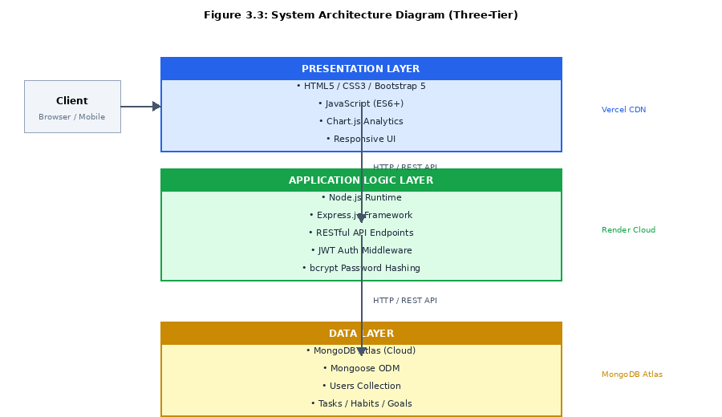
Figure 3.3: System Architecture Diagram (Three-Tier)

3.3 Requirements Analysis

3.3.1 Functional Requirements
Table 3.1: Functional Requirements
ID | Requirement | Priority
FR-01 | Users shall be able to register with email and password | High
FR-02 | Users shall be able to login and logout securely | High
FR-03 | Users shall be able to create, read, update, and delete tasks | High
FR-04 | Users shall be able to mark tasks as complete or pending | High
FR-05 | Users shall be able to assign priority levels to tasks | Medium
FR-06 | Users shall be able to add daily habits for tracking | High
FR-07 | System shall maintain and display habit streaks automatically | High
FR-08 | Users shall be able to set goals with descriptions and deadlines | High
FR-09 | System shall display progress charts for tasks and habits | Medium
FR-10 | System shall provide weekly and monthly summaries | Medium
FR-11 | Users shall be able to filter and search tasks | Medium
FR-12 | System shall persist all data to cloud database | High

3.3.2 Non-Functional Requirements
Table 3.2: Non-Functional Requirements
ID | Requirement | Category
NFR-01 | System shall load within 3 seconds on standard connections | Performance
NFR-02 | All passwords shall be encrypted using bcrypt hashing | Security
NFR-03 | System shall support concurrent access by multiple users | Scalability
NFR-04 | Interface shall be responsive across desktop and mobile | Usability
NFR-05 | System shall maintain 99% uptime during deployment period | Reliability
NFR-06 | All API communications shall use HTTPS protocol | Security
NFR-07 | System shall handle invalid inputs without crashing | Robustness
NFR-08 | Codebase shall follow modular architecture | Maintainability

3.4 Feasibility Study

3.4.1 Technical Feasibility
The complete technology stack is built on open-source, actively maintained frameworks and libraries. Node.js, Express.js, MongoDB, Chart.js, and Bootstrap 5 are all freely available with extensive documentation. Both team members had working experience with web development and RESTful API design before the project started. Cloud hosting through Vercel and Render, and cloud database hosting through MongoDB Atlas, are all available on free-tier plans that comfortably cover the expected system load. Technical feasibility is rated as high.

3.4.2 Economic Feasibility
The entire project can be completed and deployed with effectively zero infrastructure cost. Every component of the stack — development tools, hosting, database, and version control — is freely available. No proprietary software licenses are required. Economic feasibility is rated as high.

3.4.3 Operational Feasibility
The system has been designed around established web application conventions that users already recognize. Registration takes under one minute, and all main modules are accessible directly from the dashboard without any configuration. The only requirements for use are a modern web browser and an internet connection. Operational feasibility is rated as high.
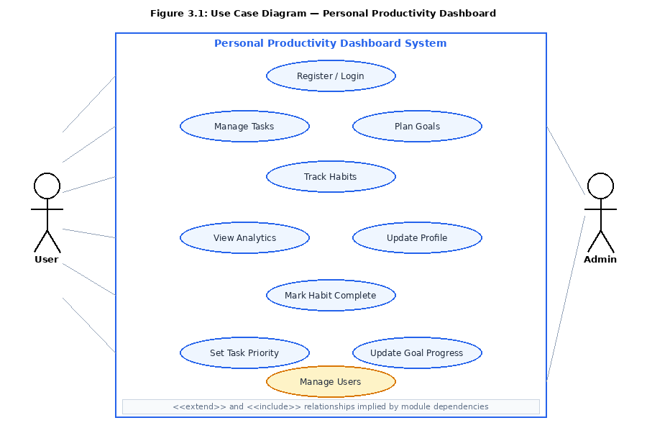
Figure 3.1: Use Case Diagram — Personal Productivity Dashboard
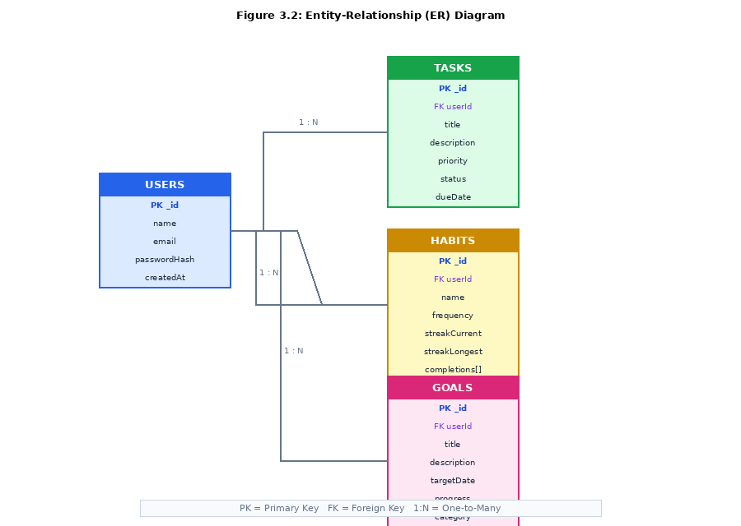
Figure 3.2: Entity-Relationship (ER) Diagram

4. SYSTEM DESIGN

4.1 System Architecture
The Personal Productivity Dashboard is built on a three-tier client-server architecture comprising a presentation layer, an application logic layer, and a data layer. This architectural pattern provides a clean separation of concerns, enhancing maintainability, scalability, and testability.
The presentation layer consists of the frontend user interface built with HTML5, CSS3, Bootstrap 5, and vanilla JavaScript. The application logic layer is implemented using Node.js and Express.js, providing RESTful API endpoints that process business logic, manage authentication, and coordinate data operations. The data layer comprises a MongoDB cloud database managed through the Mongoose ODM, providing persistent storage for all user, task, habit, and goal data.

4.2 UML Diagrams

4.2.1 Activity Diagram
The activity diagram in Figure 4.1 illustrates the complete workflow of the task management module, from user navigation through task creation, editing, completion toggling, and synchronization to the database. Decision nodes represent branching based on user-selected actions, while merge nodes consolidate the branches into a common database synchronization step.
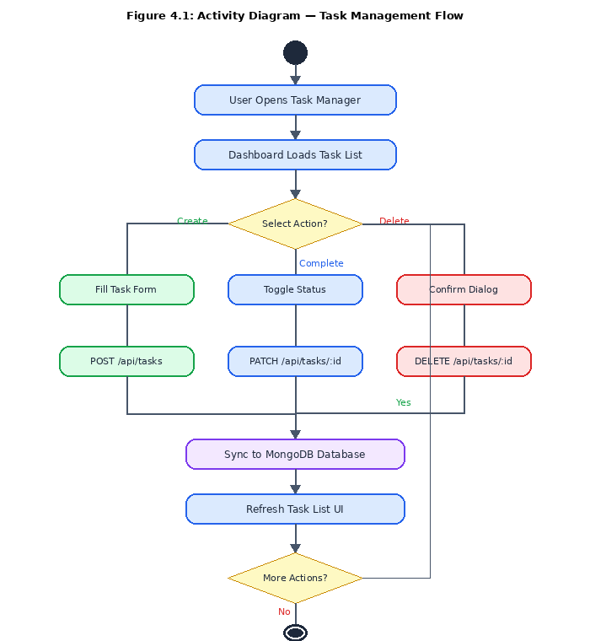
Figure 4.1: Activity Diagram — Task Management Flow

4.2.2 Sequence Diagram
The sequence diagram in Figure 4.2 illustrates the interaction between the client browser, Express.js server, auth middleware, and MongoDB database during the user authentication and task retrieval flow. It also covers the system's behavior when an invalid or expired token is presented, showing how the middleware intercepts the request and triggers a redirect to the login page.
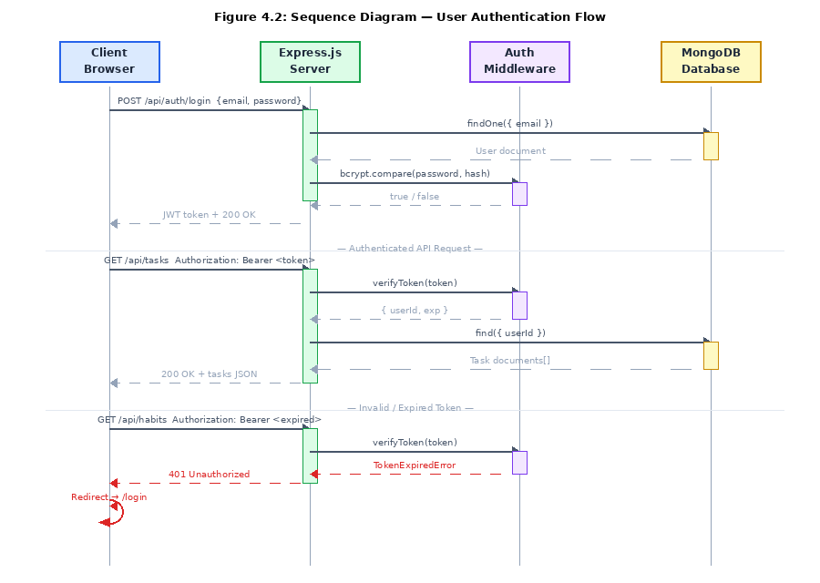
Figure 4.2: Sequence Diagram — User Authentication Flow

4.3 Database Design
The database uses MongoDB, a NoSQL document store whose schema flexibility suits the varied data structures required by this application. The schema is organized into four primary collections as shown in Table 4.1 below.
Table 4.1: MongoDB Collections and Fields
Collection | Key Fields | Description
users | _id, name, email, passwordHash, createdAt | User account credentials and profile data
tasks | _id, userId, title, description, priority, status, dueDate | Individual task records linked to their owning user
habits | _id, userId, name, frequency, streakCurrent, streakLongest, completions[] | Habit definitions, streak data, and completion history
goals | _id, userId, title, description, targetDate, progress, category, status | Long-term goal records with progress tracking

4.4 User Interface Design
The interface design centers on a persistent left-side navigation menu giving users instant access to all modules from any page. The main dashboard landing screen presents an at-a-glance summary of the user's current state: outstanding tasks, active habit streaks, upcoming goal deadlines, and key productivity metric cards. Module-specific screens provide full CRUD interfaces with inline editing and modal dialogs for forms. Destructive operations always trigger a confirmation dialog to prevent accidental data loss.
The visual language is consistent throughout: blue for tasks, green for habits, and orange for goals. Bootstrap 5's responsive grid is used throughout to ensure the layout adapts across desktop, tablet, and mobile viewports.

5. IMPLEMENTATION

5.1 Development Environment and Tools
The following tools and technologies were employed in the implementation of the Personal Productivity Dashboard:
- Frontend: HTML5, CSS3, JavaScript (ES6+), Bootstrap 5, Chart.js
- Backend: Node.js (v18+), Express.js framework
- Database: MongoDB Atlas (cloud), Mongoose ODM
- Authentication: JSON Web Tokens (JWT), bcrypt.js for password hashing
- Development Tools: Visual Studio Code, Postman (API testing), Git and GitHub (version control)
- Deployment: Vercel (frontend), Render (backend), MongoDB Atlas (database)

5.2 User Authentication Module
The authentication module handles user registration and login. During registration, the submitted password is hashed using bcrypt with a salt factor of 10 before being written to the database, ensuring that no plaintext credentials are ever stored. On a successful login, the server generates a signed JWT containing the user's unique identifier and an expiration timestamp, which is returned to the client and included in the Authorization header of every subsequent API request.
A dedicated authentication middleware function on the Express.js server intercepts each incoming request, extracts and verifies the token, and attaches the decoded user object to the request context. Requests carrying invalid or expired tokens receive a 401 Unauthorized response, and the client is redirected to the login page.
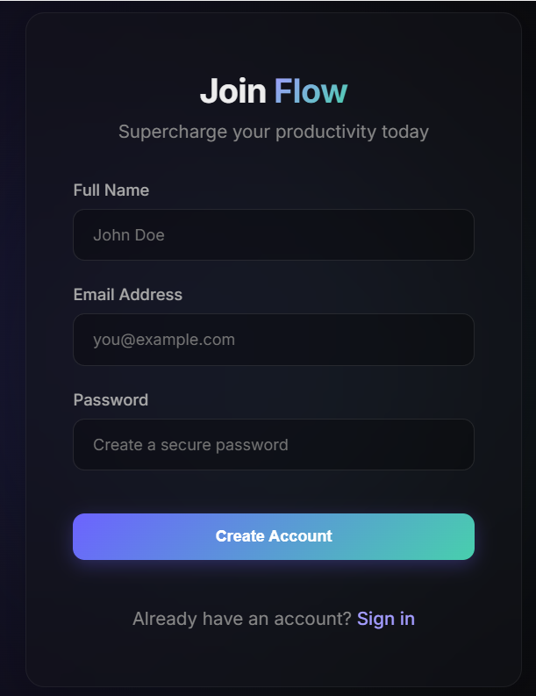Figure 5.1: User Registration and Login Interface

5.3 Task Manager Module
The task manager provides full CRUD operations on task records. Each task stores a title, optional description, priority level (low, medium, or high), status (pending, in-progress, or completed), and an optional due date. The frontend renders the task list with priority-coded visual indicators and inline action buttons for toggling status and opening the edit dialog. Task creation and editing are handled through modal overlay forms. Completed tasks receive strikethrough styling while remaining visible until actively removed by the user.
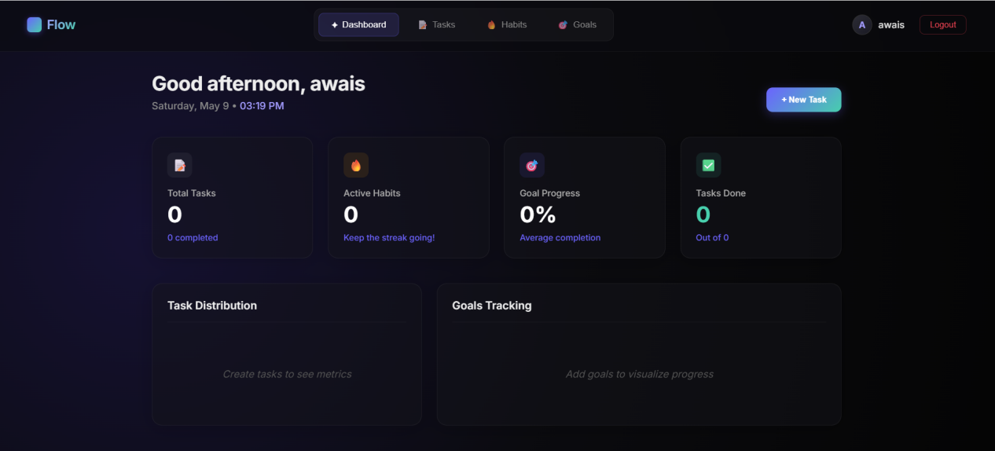Figure 5.2: Main Dashboard Overview
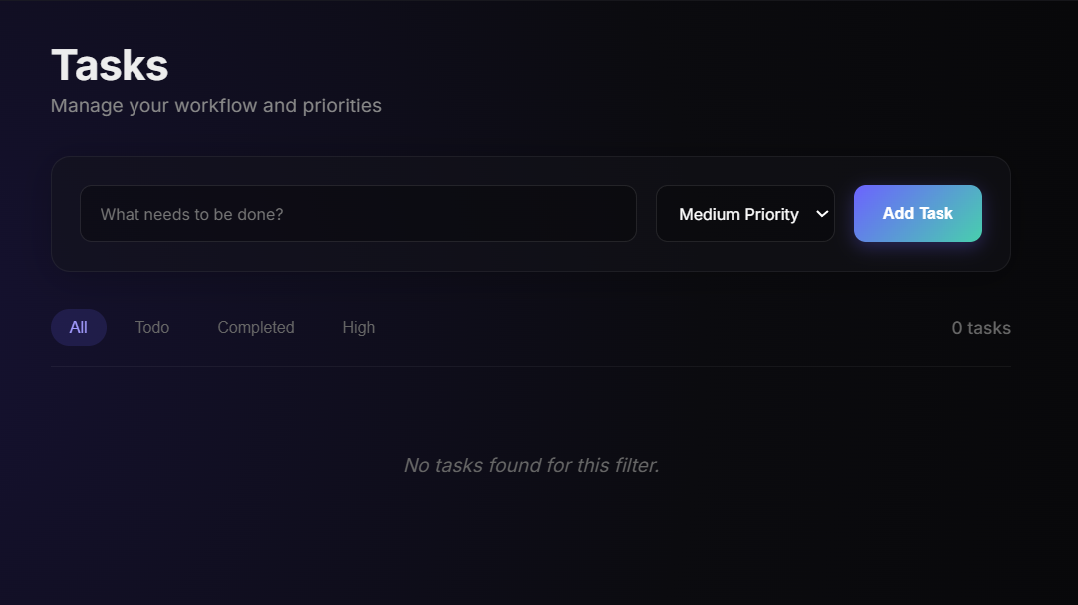Figure 5.3: Task Manager Module Interface

5.4 Habit Tracker Module
The habit tracker allows users to define named daily habits and mark each as completed once per day. The streak calculation algorithm runs server-side, sorting the array of stored completion timestamps and stepping through them to check whether consecutive entries are separated by exactly one calendar day. The streak counter increments for each consecutive day found and resets to zero when a gap is detected. Each habit is rendered as a card showing the habit name, current streak with a flame icon, longest streak ever recorded, and a calendar heatmap of historical completion data.
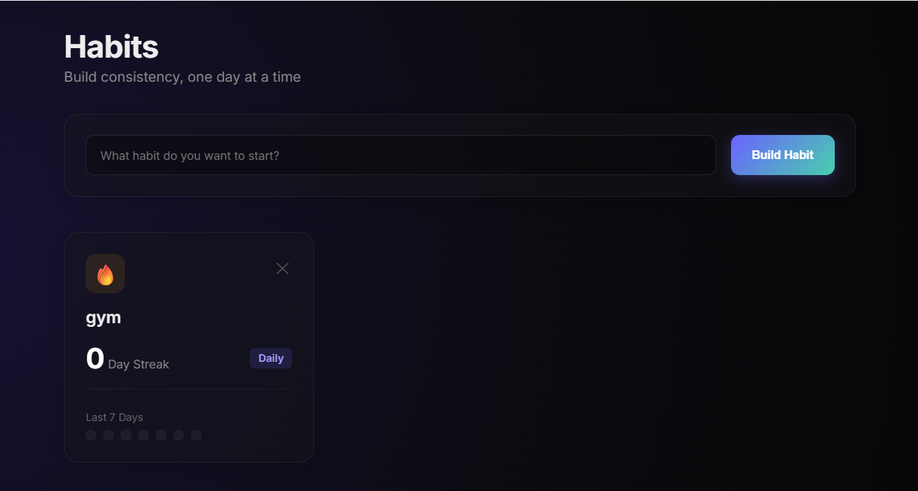Figure 5.4: Habit Tracker with Streak Display

5.5 Goal Planner Module
The goal planner allows users to define personal or professional objectives with a title, description, target completion date, category tag, and a manually updated progress percentage. Goals are displayed as cards with a horizontal progress bar that fills proportionally to the entered value. When progress reaches 100%, the goal is automatically marked complete.
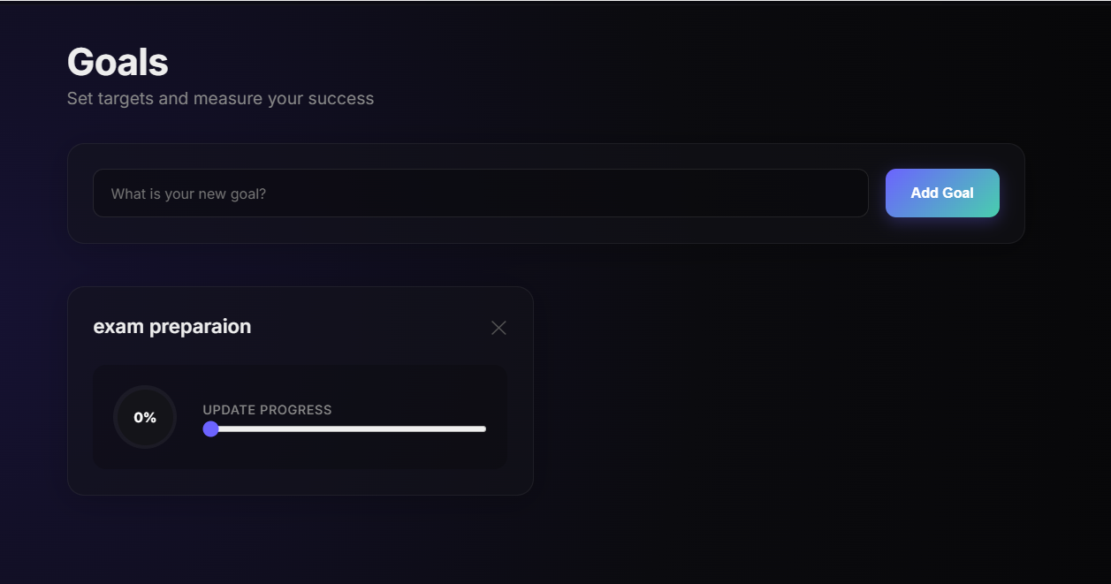Figure 5.5: Goal Planner Interface

5.6 Progress Analytics Module
The analytics module uses Chart.js to render four interactive charts from the user's stored data: a line chart showing daily task completion counts over the past 30 days, a bar chart comparing completion rates across all tracked habits, a doughnut chart breaking down the current task list by status, and a line chart tracking goal progress over time. All charts update automatically when the page loads, pulling current data from the backend API.
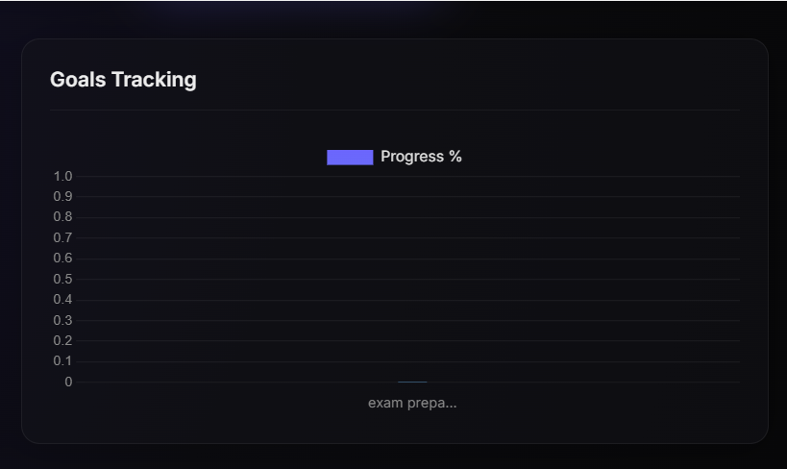Figure 5.6: Progress Analytics Charts

5.7 Deployment
The frontend static files are hosted on Vercel, which provides automatic continuous deployment from the GitHub repository and global CDN distribution. The Node.js/Express.js backend API is deployed on Render's free-tier container service. The MongoDB database is hosted on MongoDB Atlas using a free M0 cluster, providing 512 MB of storage with automated backups. Environment variables including the JWT secret and MongoDB connection string are stored securely within the Render deployment configuration and are never exposed in the codebase.

6. TESTING AND EVALUATION

6.1 Testing Methodology
A structured testing strategy was implemented to verify the correctness, security, and usability of the Personal Productivity Dashboard. Testing was organized into three phases: unit testing of individual API endpoint handlers and utility functions, integration testing of complete user workflows from frontend interaction through to database persistence, and security testing of authentication and input validation mechanisms. Each test case was documented with its expected outcome before execution, and results were recorded after execution.

6.2 Unit Testing
Table 6.1: Unit Test Cases and Results
Test ID | Module | Test Description | Expected Result | Status
UT-01 | Auth | Register with valid email/password | User created, 201 | Pass
UT-02 | Auth | Login with valid credentials | JWT returned | Pass
UT-03 | Auth | Login with incorrect password | 401 Unauthorized | Pass
UT-04 | Tasks | Create task with all required fields | Task saved, 201 | Pass
UT-05 | Tasks | Create task with missing title | 400 Bad Request | Pass
UT-06 | Habits | Mark habit complete on day 1 | Streak = 1 | Pass
UT-07 | Habits | Mark habit on consecutive days | Streak increments | Pass
UT-08 | Habits | Miss a day between completions | Streak resets to 1 | Pass
UT-09 | Goals | Create goal with future deadline | Goal saved | Pass
UT-10 | Goals | Update goal progress to 100% | Goal marked complete | Pass

6.3 Integration Testing
Table 6.2: Integration Test Cases and Results
Test ID | Description | Components Tested | Status
IT-01 | Register → login → dashboard load | Auth + API + DB + Frontend | Pass
IT-02 | Create task → list → mark complete | Tasks API + DB + Frontend | Pass
IT-03 | Add habit → mark complete → streak updates | Habits API + DB + Frontend | Pass
IT-04 | Set goal → update progress → chart updates | Goals API + DB + Chart.js | Pass
IT-05 | Invalid JWT → API rejects → redirect to login | Auth Middleware + Frontend | Pass
IT-06 | Delete task → removed from list + DB | Tasks API + DB + Frontend | Pass

6.4 Security Testing
Security testing confirmed that JWT tokens expire as configured and are rejected after expiry with a 401 response. Password hashing was verified by direct database inspection, confirming no plaintext passwords are stored anywhere. All API endpoints were confirmed to reject unauthenticated requests consistently. NoSQL injection attempts using malformed query operators were blocked by Mongoose schema validation before reaching the database query layer.

6.5 Evaluation Results
All planned unit and integration test cases passed. The application rendered correctly across Google Chrome, Mozilla Firefox, and Microsoft Edge on both desktop and mobile screen sizes. Page load times for the main dashboard measured consistently under two seconds on standard broadband connections, meeting the performance requirement stated in Section 3.3.2.

7. RESULTS, DISCUSSION, AND CONCLUSION

7.1 Results
The Personal Productivity Dashboard was successfully designed, developed, tested, and deployed as a fully functional full-stack web application. All eight primary project objectives defined in Section 1.3 were achieved within the planned 13-week development timeline. The system delivers a complete productivity management platform covering secure user authentication, task management with priority and status tracking, habit tracking with automated streak calculation, goal planning with progress monitoring, and interactive analytics dashboards. Comparative evaluation confirms that the proposed system is the only freely available platform among those reviewed that integrates all three core productivity domains with visual analytics.

7.2 Discussion
Several observations emerged during development and testing. The modular RESTful API architecture proved to be one of the most valuable design decisions — because each module communicates through clearly defined API contracts, it was straightforward to develop and test modules independently before integrating them. This isolation also made debugging significantly faster when issues surfaced.
The habit streak mechanism produced noticeably stronger user engagement during informal testing than any other feature. This aligns with the research cited in Chapter 2 regarding the behavioral importance of consistency tracking [6]. When users saw their streak count incrementing each day, they demonstrated greater motivation to return to the application and maintain their habits, suggesting that the streak visualization is doing real motivational work.
The choice of vanilla JavaScript for the frontend rather than a heavier framework resulted in a lighter, faster-loading application that met performance requirements without additional build tooling complexity. MongoDB's document model was well suited to the application's data structure, and storing habit completion history as an embedded array within the habit document simplified both the schema design and the streak calculation logic.

7.3 Future Work
Several directions for future enhancement have been identified:
- AI-Powered Insights: Analysis of task completion timing, habit maintenance rates, and goal progress patterns could support a recommendation engine that suggests optimal scheduling and identifies at-risk habits before streaks break.
- Push Notifications: Browser push notifications and email reminders for approaching deadlines and unfinished daily habits would improve daily engagement without requiring the user to actively open the application.
- Mobile Application: A native iOS and Android application built using React Native or Flutter would provide optimized mobile experience including offline data entry and system-level notification integration.
- Collaborative Features: Shared task boards and team goal spaces would extend the system's usefulness to study groups, families, and remote work teams.
- Third-Party Integrations: API connections to Google Calendar, Slack, and Microsoft Teams would allow the dashboard to synchronize with tools users already depend on daily.
- Advanced Analytics: Exportable PDF productivity reports and trend forecasting based on historical patterns would give users a portable record of their progress over time.

7.4 Conclusion
This thesis presented the design, development, and evaluation of a Personal Productivity Dashboard — a full-stack web application that successfully integrates task management, habit tracking, goal planning, and visual analytics within a unified, accessible platform. The system addresses a clearly identified gap where no freely available tool provides integration across all three core productivity dimensions with meaningful visual feedback.
The project demonstrated practical application of full-stack web development competencies including frontend interface design, RESTful API development, NoSQL database management, JWT-based authentication, and cloud deployment. The Agile development methodology enabled iterative refinement and ensured that all defined functional and non-functional requirements were met and verified through testing.
The successful completion of this project contributes a practical, open-source tool that can genuinely benefit students and individuals seeking to improve their personal productivity, while demonstrating the authors' capability to deliver production-ready software systems.

References
[1] D. Allen, "Getting Things Done: The Art of Stress-Free Productivity," Penguin Books, New York, 2001.
[2] C. Bailey, "The Productivity Project," Crown Business, New York, 2016.
[3] G. Friedman, "Time Management Fundamentals," Business Expert Press, New York, 2019.
[4] G. Matthews, "Goal Research Summary," Paper presented at the 9th Annual International Conference of Psychology Research, Athens Institute for Education and Research, Athens, Greece, 2015.
[5] B. Zeigarnik, "On Finished and Unfinished Tasks," in W. D. Ellis (Ed.), A Sourcebook of Gestalt Psychology, Harcourt Brace, New York, pp. 300-314, 1938.
[6] P. Lally, C. H. van Jaarsveld, H. W. Potts, and J. Wardle, "How are habits formed: Modelling habit formation in the real world," Eur. J. Soc. Psychol. 40(6), 998-1009 (2010).
[7] Todoist, "Task Management Features," https://todoist.com/ (accessed Oct. 1, 2025).
[8] Notion, "All-in-One Workspace," https://www.notion.so/ (accessed Oct. 1, 2025).
[9] Habitica, "Gamify Your Life," https://habitica.com/ (accessed Oct. 1, 2025).
[10] Trello, "Project Management Tool," https://trello.com/ (accessed Oct. 1, 2025).
[11] Node.js Foundation, "Node.js Documentation," https://nodejs.org/docs/ (accessed Oct. 5, 2025).
[12] OpenJS Foundation, "Express.js Guide," https://expressjs.com/ (accessed Oct. 5, 2025).
[13] MongoDB Inc., "MongoDB Manual," https://docs.mongodb.com/ (accessed Oct. 5, 2025).
[14] Chart.js Contributors, "Chart.js Documentation," https://www.chartjs.org/docs/ (accessed Oct. 10, 2025).
[15] Mozilla Developer Network, "MDN Web Docs — JavaScript," https://developer.mozilla.org/ (accessed Oct. 10, 2025).
[16] Auth0, "JSON Web Tokens Introduction," https://jwt.io/introduction (accessed Oct. 12, 2025).
[17] J. Clear, "Atomic Habits: An Easy and Proven Way to Build Good Habits and Break Bad Ones," Penguin Random House, New York, 2018.

Appendix A — Project Timeline
Table 7.1: Project Timeline
Phase | Duration | Key Deliverables
Requirement Analysis | 1 week | Requirements document, feasibility report
System Design | 2 weeks | Database schema, ER diagram, UML diagrams, wireframes
Frontend Development | 2 weeks | HTML/CSS/JS pages, responsive layout
Backend Development | 2 weeks | REST APIs, JWT authentication, database integration
Feature Integration | 2 weeks | Task manager, habit tracker, goal planner modules
Data Visualization | 1 week | Chart.js integration, analytics dashboard
Testing | 2 weeks | Unit tests, integration tests, security tests, bug fixes
Deployment | 1 week | Live hosted application on Vercel/Render/Atlas

Appendix B — Selected Code Snippets

B.1 JWT Authentication Middleware
const jwt = require('jsonwebtoken');
const authMiddleware = (req, res, next) => {
const token = req.headers.authorization?.split(' ')[1];
if (!token) return res.status(401).json({ message: 'No token provided' });
try {
const decoded = jwt.verify(token, process.env.JWT_SECRET);
req.user = decoded;
next();
} catch (err) {
return res.status(401).json({ message: 'Invalid or expired token' });
}
};
module.exports = authMiddleware;

B.2 Habit Streak Calculation
const calculateStreak = (completions) => {
if (!completions.length) return 0;
const sorted = completions.sort((a, b) => new Date(b) - new Date(a));
let streak = 1;
for (let i = 0; i < sorted.length - 1; i++) {
const diff = (new Date(sorted[i]) - new Date(sorted[i+1])) / 86400000;
if (Math.round(diff) === 1) streak++;
else break;
}
return streak;
};

